
空谷数字体验平台 - 用户操作手册
KGU Digital experience platform - User Operating Manual

Document status  文档状态 | [√] 初稿  [ ] 评审通过  [ ] 修改  [ ]发布  [ ] 作废 | Documentation  文档标识 | KGU Digital experience platform-User Operating Manual  空谷数字体验平台-用户操作手册
Document status  文档状态 | [√] 初稿  [ ] 评审通过  [ ] 修改  [ ]发布  [ ] 作废 | Current Version  当前版本 | V1.1
Document status  文档状态 | [√] 初稿  [ ] 评审通过  [ ] 修改  [ ]发布  [ ] 作废 | Author  作者 | Gaice
Document status  文档状态 | [√] 初稿  [ ] 评审通过  [ ] 修改  [ ]发布  [ ] 作废 | Manufacturer  厂商 | Suzhou KGU Network Technology Co.,Ltd.  苏州空谷网络科技有限公司
Document status  文档状态 | [√] 初稿  [ ] 评审通过  [ ] 修改  [ ]发布  [ ] 作废 | Completion Date  完成日期 | September 2025  2025年9月

Document version historical table
文档版本历史表
Version Number  版本号 | Author  作者 | Operate  操作 | Date  日期 | Illustrate  说明
V1.0 | Gaice | Create  创建 | September 2025  2025年9月

Table Of Contents - 目录

1 System Overview -系统概述 4
1.1 System Introduction -系统介绍 4
1.1.1 System components -系统组成部分 4
1.1.2 System features -系统特性 5
1.1.3 Typical application scenarios -典型应用场景 6
1.2 Main functions -主要功能 7
1.2.1 Content Management-内容管理 8
1.2.2 Personalization-个性化 8
1.2.3 Customer Data Management-客户数据管理 9
1.2.4 E-commerce Integration-电子商务集成 9
1.2.5 Marketing Automation-营销自动化 10
1.2.6 Search and Discovery-搜索与发现 10
1.2.7 Analytics and Reporting-数据分析与报告 11
1.2.8 Multi-language and Multi-region Support-多语言与多区域支持 11
1.2.9 Integration and Extensibility-集成与扩展性 11
1.2.10 Security and Compliance-安全性与合规性 12
1.3 Runtime environment-运行环境 12
1.2.1 Operating platform-运行平台 12
1.2.2 Hardware requirements-硬件要求 12
2 System account-系统账号 13
2.1 Account login-账号登录 13
2.2 Password recovery-密码找回 13
3 Interface Layout - 界面布局 15
3.1 Top Information Bar - 顶部信息栏 15
3.2 Left Navigation Bar -左侧导航栏 17
4 Function Description - 功能说明 18
4.1 Digital Desktop - 数字桌面 18
4.1.1 Pending Tasks - 待办事项 19
4.1.2 Work Order Information - 工单信息 20
4.1.3 After-sales Service - 售后服务 23
4.1.4 Operating Status -运行状态 24
4.1.5 Server Information-服务器信息 25
4.1.6 Domain Name Information-域名信息 25
4.1.7 Today's Traffic-今日流量 26
4.1.8 Visited Columns-访问栏目 26
4.1.9 Latest Content-最新内容 27
4.1.10 Data Analysis-数据分析 27
4.1.11 Regional Distribution-地域分布 29
4.1.12 Resolution Analysis-分辨率分析 30
4.1.13 Browser Analysis-浏览器分析 30
4.2 Application Center-应用中心 31
4.2.1 Basic Information-基本信息 31
4.2.2 Configuration Center-配置中心 33
4.2.3 Column Management-栏目管理 40
4.2.4 Data Model-数据模型 49
4.2.5 Data Dictionary-数据字典 51
4.2.6 Tag Management-标签管理 53
4.2.7 Friendship Links-友情链接 54
4.2.8 Advertisement management-广告管理 55
4.2.9 Style Management-风格管理 57
4.2.10 Sitemap-网站地图 59
4.2.11 Operation Log-操作日志 60
4.2.12 Redirection Settings-重定向设置 60
4.3 Message Management-消息管理 61
4.3.1 Message Management-留言管理 61
4.3.2 Subscription Email-订阅邮箱 63
4.4 Membership Management-会员管理 63
4.4.1 Membership List-会员列表 65
4.4.2 Membership Roles-会员角色 68
4.4.3 Membership Authentication-会员认证 72
4.5 User Management-用户管理 73
4.5.1 User List-用户列表 73
4.5.2 User Roles-用户角色 75
4.5.3 Department Management-部门管理 77
4.6 Content Management-内容管理 77
4.6.1 General Options-常规选项 78
4.6.2 Model Parameters-模型参数 81
4.6.3 Associated Data-关联数据 81
4.7 Data Analysis-数据分析 82
4.7.1 Operation Overview-运营概况 82
4.7.2 Access Software Analysis-访问软件分析 83
4.7.3 Source Analysis-来源分析 84
4.7.4 Location Analysis-所在地分析 85
4.7.5 Visitor Summary Table-访客总表 86
4.8 KB Knowledge Management-KB知识管理 90
4.8.1 Course Management-课程管理 91
4.8.2 Lecturer Configuration-讲师配置 93
4.8.3 Transaction Orders-交易订单 94
4.8.4 Invoice Management-开票管理 95
4.9 Mall Management-商城管理 95
4.9.1 Commodity Management-商品管理 95
4.9.2 Transaction Orders-交易订单 114
4.9.3 Pre-sale Orders (Not Open)-预售订单（未开放） 119
4.9.4 After-sales Management (No Data)-售后管理（暂无数据） 119
4.9.5 Promotion Management-促销管理 123
4.9.6 Review Management-评价管理 130
4.9.7 Inquiry Order-询价订单 133
4.9.8 Invoice Management-发票管理 138
4.9.9 Mall Settings-商城设置 140
4.10 Points Mall-积分商城 142
4.10.1 Points Commodities-积分商品 142
4.10.2 Points Orders-积分订单 142
4.10.3 Points Records-积分记录 142
4.10.4 Points Configuration-积分配置 143
4.11 Contract Management-合同管理 143
4.12 Recruitment Module-招聘模块 143
4.12.1 Recruitment List-招聘列表 143
4.12.2 Recruitment Management-招聘管理 147
4.12.3 Job Classification-职位分类 148
4.12.4 Interview Questions-面试题目 149
4.13 Language Management-语言管理 149
4.14 KGU Cloud (Old Framework, to be Adjusted and Upgraded)-空谷云（老框架，待调整升级） 149
4.15 System Settings-系统设置 150
4.15.1 Organization/Personnel/Role-机构/人员/角色 150
4.15.2 Permission Configuration-权限配置 152
4.15.3 Template Configuration-模板配置 156
4.15.4 Workflow-工作流 156
4.15.5 Others-其它 161
4.16 Marketing Management-营销管理 161
4.16.1 Promotion Links-推广链接 162
4.16.2 Collection Form-采集表单 164
4.16.3 Lottery Activity-抽奖活动 167
4.16.4 Activity Single Page-活动单页 169
4.16.5 Email Marketing-邮件营销 170
图清单 183

1 System Overview -系统概述

1.1 System Introduction -系统介绍
The Kgu Digital Experience Platform (KXP) is an integrated technology system designed to assist organizations in managing, delivering, and optimizing customer experiences across multiple digital channels. It encompasses not only traditional content management functionalities but also integrates Customer Relationship Management (CRM), e-commerce, data analysis, and marketing automation, forming a unified platform to provide personalized, coherent, and continuous customer engagement.
空谷数字体验平台（Kgu Digital Experience Platform，KXP）是一种集成的技术系统，旨在帮助组织管理、交付和优化跨多个数字渠道的客户体验。它不仅包括传统的内容管理功能，还整合了客户关系管理（CRM）、电子商务、数据分析和营销自动化等功能，形成一个统一的平台，以提供个性化、连贯和持续的客户互动。

1.1.1 System components -系统组成部分
Content Management System (CMS): CMS is the core component of the KGU Digital Experience Platform (KXP), utilized for creating, managing, and publishing digital content. The CMS within the KGU Digital Experience Platform (KXP) supports multi-channel content delivery, encompassing websites, mobile applications, social media, Internet of Things devices, and more.
Customer Data Platform (CDP): Collects and integrates customer data from various touchpoints to form a unified customer view. CDP enables the Kongoo Digital Experience Platform (KXP) to provide personalized content recommendations and experience optimization based on customer behavior and preferences.
E-commerce functions: Provides online transactions, shopping cart management, payment processing, and other functions. Integrates with CRM and CMS to provide a personalized shopping experience.
Marketing automation: Supports cross-channel marketing activities, including email marketing, social media marketing, advertising deployment, etc. It can adjust marketing strategies in real-time based on customer data.
Data Analysis and Intelligence: Through data analysis tools, the KGU Digital Experience Platform (KXP) can monitor customer behavior, evaluate content effectiveness, and provide decision support. The Kgu Digital Experience Platform (KXP) also integrates artificial intelligence (AI) and machine learning (ML) to achieve automated customer experience optimization.
Integration and Scalability: The Kgu Digital Experience Platform (KXP) boasts open APIs and flexible integration capabilities, enabling seamless integration with various existing enterprise systems (such as ERP, CRM, HRM, etc.), ensuring data consistency and process coherence.
内容管理系统（CMS）：CMS是空谷数字体验平台（KXP）的核心部分，用于创建、管理和发布数字内容。空谷数字体验平台（KXP）中的CMS支持多渠道内容交付，包括网站、移动应用、社交媒体、物联网设备等。
客户数据平台（CDP）：收集和整合来自不同接触点的客户数据，形成统一的客户视图。CDP 使得空谷数字体验平台（KXP）能够根据客户的行为和偏好进行个性化内容推荐和体验优化。
电子商务功能：提供在线交易、购物车管理、支付处理等功能。与CRM和CMS集成，可以提供个性化的购物体验。
营销自动化：支持跨渠道的营销活动，包括电子邮件营销、社交媒体营销、广告投放等。能够根据客户数据实时调整营销策略。
数据分析与智能化：通过数据分析工具，空谷数字体验平台（KXP）可以监控客户行为，评估内容效果，并提供决策支持。空谷数字体验平台（KXP）还整合人工智能（AI）和机器学习（ML），实现自动化的客户体验优化。
集成与扩展性：空谷数字体验平台（KXP）具有开放的API和灵活的集成能力，能够与企业现有的各种系统（如ERP、CRM、HRM等）进行无缝对接，确保数据的统一和流程的连贯。

1.1.2 System features -系统特性
Unified management: Manage customer experiences across multiple channels through the KGU Digital Experience Platform (KXP) to ensure brand consistency.
Personalization: Leverage customer data to achieve precise content and product recommendations, thereby enhancing user satisfaction and conversion rates.
Flexibility and scalability: It can expand functions and services according to enterprise needs, and supports custom development and third-party tool integration.
Real-time capability: Through real-time data analysis and feedback mechanisms, we can quickly respond to market changes and customer demands.
Security and Compliance: Implement data protection measures to ensure the security of customer information and meet the requirements of localization of information technology innovation, graded protection, GDPR (General Data Protection Regulation of the European Union), and CCPA (California Consumer Privacy Act).
统一管理：通过空谷数字体验平台（KXP）管理多个渠道的客户体验，确保品牌一致性。
个性化：利用客户数据，实现精准的内容和产品推荐，提升用户满意度和转化率。
灵活性与扩展性：可以根据企业需求扩展功能和服务，支持定制开发和第三方工具集成。
实时性：通过实时数据分析和反馈机制，快速响应市场变化和客户需求。
安全性与合规性：提供数据保护措施，确保客户信息的安全，并满足国产化信创、等级保护、GDPR（欧盟通用数据保护条例）和CCPA（加州消费者隐私法案）的要求。

1.1.3 Typical application scenarios -典型应用场景
E-commerce website: Enhance conversion rates and customer loyalty through personalized recommendations and precise marketing.
Content-driven enterprises: such as news media, which distribute content through multiple channels and optimize user experience.
Customer support platform: Integrate multiple support channels (such as phone, email, social media) to provide a consistent customer service experience.
The Digital Experience Platform (KXP) plays a crucial role in modern digital marketing and customer relationship management, serving as a vital tool for enterprises' digital transformation.
The KGU Digital Experience Platform (KXP) is a standardized, composable, and scalable digital experience solution for marketing service scenarios. It encompasses a CMS (Content Management System), B2B/B2C e-commerce system, KB (Knowledge Base) system, community system, membership system, no-code thematic system, CDP (Customer Data Platform) data analysis system, and digital asset management system, making the construction of marketing service scenarios simpler, more flexible, and more efficient.
电子商务网站：通过个性化推荐和精准营销提升转化率和客户忠诚度。
内容驱动型企业：如新闻媒体，通过多渠道发布内容并优化用户体验。
客户支持平台：整合多个支持渠道（如电话、邮件、社交媒体）提供一致的客户服务体验。
空谷数字体验平台（KXP）在现代数字营销和客户关系管理中起着至关重要的作用，是企业数字化转型的重要工具。
空谷数字体验平台（KXP）是标准化、可组合 、可拓展营销端服务场景数字体验解决方案，涵盖CMS内容管理系统、B2B/B2C商城系统、KB知识管理系统、社区系统、会员系统、无代码专题系统、CDP数据分析系统、数字资产管理系统等，让搭建营销端服务场景更简单、更灵活、更高效。

1.2 Main functions -主要功能
The KGU Digital Experience Platform (KXP) is a standardized, composable, and scalable digital experience solution for marketing service scenarios. It encompasses a CMS (Content Management System), B2B/B2C e-commerce system, KB (Knowledge Base) system, community system, membership system, no-code thematic system, CDP (Customer Data Platform) data analysis system, and digital asset management system, making the construction of marketing service scenarios simpler, more flexible, and more efficient.
Here are some core features of KXP:
空谷数字体验平台（KXP）是标准化、可组合 、可拓展营销端服务场景数字体验解决方案，涵盖CMS内容管理系统、B2B/B2C商城系统、KB知识管理系统、社区系统、会员系统、无代码专题系统、CDP数据分析系统、数字资产管理系统等，让搭建营销端服务场景更简单、更灵活、更高效。
以下是 KXP 的一些核心功能：

1.2.1 Content Management-内容管理
Multi-channel content management: Supports content creation, editing, and addition, covering multiple digital channels such as websites, mobile applications, social media, and IoT devices.
Content publishing and distribution: Content can be published and distributed according to different channels and target audiences, ensuring consistency and relevance.
Version control and workflow: Provides version management and workflow functions for content, supporting team collaboration and content approval.
多渠道内容管理：支持内容的创建、编辑和新增，覆盖多个数字渠道，如网站、移动应用、社交媒体和物联网设备。
内容发布与分发：可以根据不同的渠道和受众群体进行内容的发布和分发，确保一致性和相关性。
版本控制和工作流：提供内容的版本管理和工作流功能，以支持团队协作和内容审批。

1.2.2 Personalization-个性化
User personas and segmentation: By analyzing user data, generate user personas and segment customer groups, thereby providing personalized content and recommendations.
Dynamic content customization: Based on user behavior, preferences, and historical data, dynamically adjust page content and layout to enhance user experience.
Behavioral Trigger: Trigger specific content display or operation based on users' real-time behaviors, such as recommending products, sending coupons, etc.
用户画像与细分：通过分析用户数据，生成用户画像并进行客户群体细分，进而提供个性化的内容和推荐。
动态内容定制：根据用户的行为、偏好和历史数据，动态调整页面内容和布局，以提升用户体验。
行为触发器：基于用户的实时行为触发特定的内容展示或操作，如推荐产品、发送优惠券等。

1.2.3 Customer Data Management-客户数据管理
Customer Data Platform (CDP): Integrates and manages customer data from various touchpoints to form a unified customer view.
Data analysis and insight: Provides powerful data analysis capabilities for understanding customer behavior, predicting trends, and formulating strategies.
Privacy and Compliance: Ensure the secure management of customer data, adhering to domestic information technology innovation, graded protection, GDPR (General Data Protection Regulation) and CCPA (California Consumer Privacy Act) privacy protection regulations.
客户数据平台（CDP）：整合和管理来自不同接触点的客户数据，形成统一的客户视图。
数据分析与洞察：提供强大的数据分析功能，用于了解客户行为、预测趋势和制定策略。
隐私与合规性：确保客户数据的安全管理，符合国产化信创、等级保护、GDPR（欧盟通用数据保护条例）和CCPA（加州消费者隐私法案）隐私保护法规。

1.2.4 E-commerce Integration-电子商务集成
Product Information Management (PIM): Manage and update product information, supporting synchronous display across multiple channels.
Shopping experience optimization: Optimize customers' shopping experience through personalized recommendations, fast checkout, and other functions to improve conversion rates.
Order management and tracking: Integrate an order management system to achieve full-process management and tracking from order placement to shipment.
产品信息管理（PIM）：管理和更新产品信息，支持多渠道同步展示。
购物体验优化：通过个性化推荐、快速结账等功能优化客户的购物体验，提高转化率。
订单管理与跟踪：集成订单管理系统，实现从下单到发货的全流程管理和跟踪。

1.2.5 Marketing Automation-营销自动化
Cross-channel marketing activities: Support the planning and execution of various marketing activities, such as email marketing, social media marketing, and advertising.
Customer journey management: Designing and managing the interaction journey of customers at different touchpoints to ensure a seamless experience.
Real-time marketing: Adjust marketing strategies based on real-time data, and conduct immediate marketing interventions and content push.
跨渠道营销活动：支持多种营销活动的策划和执行，如电子邮件营销、社交媒体营销、广告投放等。
客户旅程管理：设计和管理客户在不同接触点的交互旅程，确保无缝体验。
实时营销：基于实时数据调整营销策略，进行即时的营销干预和内容推送。

1.2.6 Search and Discovery-搜索与发现
Intelligent search: Provides advanced search functions to help users quickly find the content or products they need.
Recommendation engine: Provides personalized product or content recommendations by analyzing user behavior and interests.
智能搜索：提供先进的搜索功能，帮助用户快速找到所需内容或产品。
推荐引擎：通过分析用户行为和兴趣，提供个性化的产品或内容推荐。
语义搜索与自然语言处理：利用 AI 技术提升搜索体验，理解用户的搜索意图。

1.2.7 Analytics and Reporting-数据分析与报告
Multi-channel data analysis: Integrate data from different channels to provide comprehensive customer behavior analysis and business performance analysis.
Customized reports: Support the generation of customized reports to meet the needs of different departments and roles.
KPI Monitoring: Monitor key performance indicators (KPIs) in real-time to assist businesses in quickly identifying issues and making necessary adjustments.
多渠道数据分析：整合来自不同渠道的数据，提供全面的客户行为分析和业务绩效分析。
定制报告：支持生成定制化报告，满足不同部门和角色的需求。
KPI 监控：实时监控关键绩效指标（KPI），帮助企业快速识别问题并作出调整。

1.2.8 Multi-language and Multi-region Support-多语言与多区域支持
Localized content management: Support content management in multiple languages and regions to ensure that global users can enjoy a localized experience.
Regionalization settings: Adjust the platform's functions and content display according to the needs of different markets.
本地化内容管理：支持多语言、多区域的内容管理，确保全球用户都能获得本地化的体验。
区域化设置：根据不同市场的需求，调整平台的功能和内容展示。

1.2.9 Integration and Extensibility-集成与扩展性
Open API: Provides an open API interface to facilitate integration with other enterprise systems (such as CRM and ERP).
Plugins and extensions: Support third-party plugins and extensions to meet specific business needs.
Seamless integration: Seamlessly connect with social media platforms, payment gateways, logistics services, etc., to enhance the overall capabilities of the platform.
开放 API：提供开放的 API 接口，方便与企业的其他系统（如 CRM、ERP）进行集成。
插件与扩展：支持第三方插件和扩展，满足特定业务需求。
无缝集成：与社交媒体平台、支付网关、物流服务等无缝对接，提升平台的整体能力。

1.2.10 Security and Compliance-安全性与合规性
Data protection: Provides functions such as data encryption and access control to ensure the security of customer information.
Compliance management: Support compliance management for domestic information technology innovation, classified protection, GDPR (General Data Protection Regulation) and CCPA (California Consumer Privacy Act) regulations, ensuring that data processing processes comply with legal requirements.
数据保护：提供数据加密、访问控制等功能，确保客户信息的安全。
合规管理：支持国产化信创、等级保护、GDPR（欧盟通用数据保护条例）和CCPA（加州消费者隐私法案）法规的合规性管理，确保数据处理过程符合法律要求。

1.3 Runtime environment-运行环境

1.2.1 Operating platform-运行平台
Windows 9/9/10/11/ CentOS9.6 64bit

1.2.2 Hardware requirements-硬件要求
Minimum configuration requirements for running the server:
Processor: Intel® Pentium® 2X2.6 GHz Memory size: 4 GB
System type: CentOS 9.6 64-bit system
运行服务器最低配置要求：
处理器: Intel® Pentium® 2X2.6 GHz内存大小：4 GB
系统类型：CentOS9.6 64位系统

2 System account-系统账号

2.1 Account login-账号登录
The login address for the management backend of the KGU Digital Experience Platform (KXP) is: http://server.kgu.cn:24019
Members need to use their account, password, and verification code to log in. The following are the relevant requirements for logging in:
1. The password must contain at least three types of characters from numbers and special characters, and its length should be between 8 and 20 characters.
2. If the wrong password is entered consecutively 5 times, the account will be locked for 15 minutes.
3. Clicking on the verification code can refresh it to ensure secure login.
空谷数字体验平台（KXP）管理后台的登录地址为：http://server.kgu.cn:24019
会员需要使用账户、密码和验证码进行登录操作。以下是登录的相关要求：
1、密码需要包含数字字符特殊字符中的至少三种并目长度在8到20位之间。
2、如果连续输入错误密码5次，账户会被锁定15分钟。
3、点击验证码可以刷新验证码，以确保安全登录。
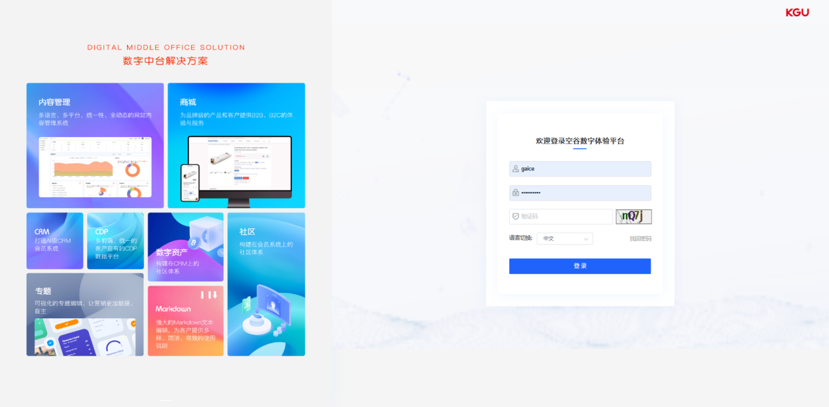
图 2.1 Account login-账号登录

2.2 Password recovery-密码找回
Above the login button on the login interface is the password recovery entry:
登录界面登录按钮上方为找回密码入口：
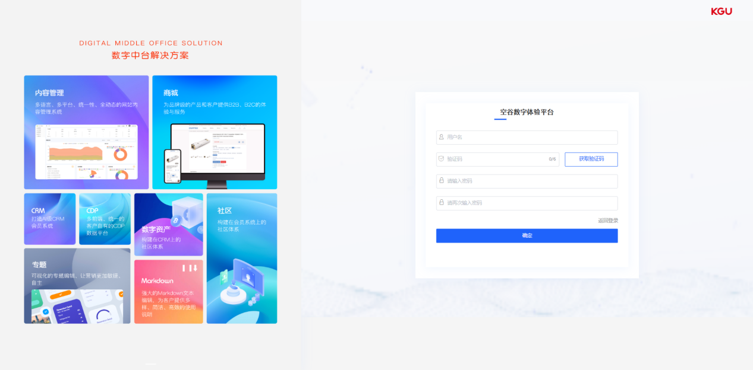
图 2.2 Password recovery-密码找回
After clicking on "Retrieve Password", the password retrieval interface will open. On this interface, you need to complete the following steps to reset your password:
1. Fill in the username of the user who needs to retrieve their password.
2. The system will automatically send an SMS verification code to the mobile phone number reserved for the account.
3. Enter the new password and confirm it by re-entering it.
4. If the verification code is entered correctly and the two new passwords match, the password reset for the corresponding account can be completed.
The password recovery page provides an entry to return to the login page, making it convenient for users to return to the login page.
点击【找回密码】后，将打开找回密码界面。在该界面上，您需要完成以下步骤来重置密码：
1、填写需要找回密码的用户名。
2、系统会自动向该账户预留的手机发送短信验证码。
3、输入新的密码，并再次确认输入新密码。
4、如果验证码输入正确，并且新密码的两次输入一致，即可完成对应账户的密码重置。
找回密码页面提供了返回登录页的入口，方便用户回到登录页面。

3 Interface Layout - 界面布局
The KGU Digital Experience Platform (KXP) system adopts a framework layout of a top information bar, left navigation bar, and right content area to ensure a clear structure and provide a simple and easy-to-use interactive experience.
空谷数字体验平台（KXP）系统采用了顶部信息栏、左侧导航栏和右侧内容区域的框架进行布局，以确保结构清晰明了，并提供简洁易用的交互体验。
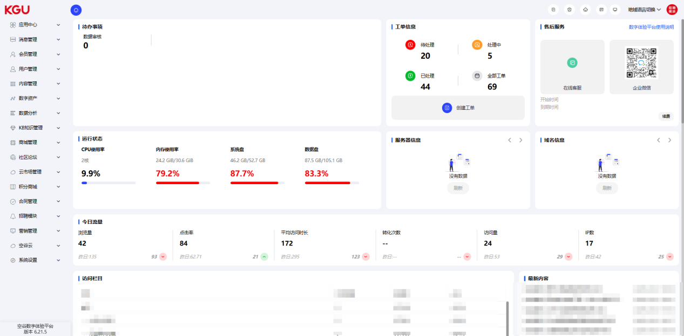
图 3 Interface Layout -界面布局

3.1 Top Information Bar - 顶部信息栏
The top information bar displays commonly used quick operations, including the following functions:
Breadcrumbs: Used to display the labels of the opened column pages, facilitating quick navigation for users.
Ticket: This is the entry to the KGU ticket system. Click the button to enter the ticket system login page. The ticket system is used for problem feedback, follow-up, and other matters after project delivery. After project delivery, if you encounter any project-related issues, you can report them to our company through the ticket system. Upon receiving the corresponding ticket, our company will promptly arrange for the relevant staff to handle it. You can log in to the ticket system to track the status and other information of a specific ticket.
Recycle Bin: The system features a recycle bin function, allowing users to retrieve data that has been mistakenly deleted in content management. This prevents permanent data loss caused by accidental operations or misjudgments.
Official website homepage: Provides an entrance to the front-end official website homepage, allowing users to easily access the official website.
Workflow processing: Through the workflow processing function, you can easily access the workflow page that needs your attention, and handle and view your pending and completed tasks.
Background Desktop: Serving as the desktop entry point for the membership system management software of the KGU Digital Experience Platform (KXP), it facilitates users in accessing the background management interface.
Regional language switching: Includes regional switching and multi-language switching entries, which enable unified backend management of sub-site content and multi-language content.
Avatar account information: Provides an editing interface for personal information, including functions such as personal center, password modification, and logout.
In this way, the layout of the top information bar in the membership system management software of the KGU Digital Experience Platform (KXP) becomes clearer and more straightforward, providing users with convenient operation and navigation functions.
顶部信息栏展示了常用的快捷操作，包括以下功能：
面包屑：用于显示已开启的栏目页标签，方便用户快速定位。
工单：为空谷工单系统入口，点击按键即可进入工单系统登录页面。工单系统用于项目交付后的问题反馈、跟进等事项，在项目交付后，如遇到项目相关的问题，可通过工单系统反馈至我司。我司在接到相应工单后，会及时安排对应的工作人员进行处理。您可登录工单系统跟踪具体某个工单的状态等信息。
回收站：系统具有回收站功能，在内容管理中误删除的数据可以从回收站中找回，避免了因意外操作或错误判断导致的永久性数据丢失。
官网首页：提供了前台官网首页的入口，让用户轻松访问官方网站。
工作流处理：通过工作流处理功能，可以方便地进入需要自己处理的工作流页面，处理和查看自己的待办和已办事项。
后台桌面：作为空谷数字体验平台（KXP）会员系统管理软件的桌面入口，方便用户进入后台管理界面。
地域语言切换：包括地域切换和多语言切换入口，通过这些功能实现了分站内容和多语言内容的统一后台管理。
头像账号信息：提供了个人信息的编辑入口，包括个人中心、修改密码和退出登录等功能。
这样，顶部信息栏在空谷数字体验平台（KXP）会员系统管理软件中的布局更加清晰明了，为用户提供了便捷的操作和导航功能。
图 3.1 Top Information Bar -顶部信息栏

3.2 Left Navigation Bar -左侧导航栏
The left navigation bar serves as a crucial functional entry point in the management backend, enabling easy digital content management operations such as adding, editing, querying, and deleting content.
The left navigation bar primarily features seventeen core modules, encompassing Application Center, Message Management, Member Management, User Management, Content Management, Data Analysis, Knowledge Base (KB) Management, Mall Management, Points Mall, Cloud Market Management, Contract Management, Recruitment Module, Language Management, KGU Cloud, System Settings, and Marketing Management. These modules comprehensively cover the primary functions and management requirements of the system, enabling users to conveniently navigate to the desired functional modules.
Through the left navigation bar, administrators can quickly access and manage content across different modules. Whether it's adding new content, editing, querying, or deleting existing content, users can directly navigate to the corresponding functional module through the left navigation bar, enhancing management efficiency and operational convenience.
The clear and straightforward navigation structure and functional layout make the operation of the management backend more intuitive and efficient, providing users with a user-friendly experience.
左侧导航栏是管理后台的关键功能入口，通过它可以轻松进行内容的新增、编辑、查询和删除等数字内容管理操作。
主要有十七个核心模块的左侧导航栏，包括应用中心、消息管理、会员管理、用户管理、内容管理、数据分析、KB知识管理、商城管理、积分商城、云市场管理、合同管理、招聘模块、语言管理、空谷云、系统设置、营销管理。这些模块涵盖了系统的主要功能和管理需求，让用户可以方便地导航到所需的功能模块。
通过左侧导航栏，管理员可以快速访问和管理不同模块的内容。无论是新增新的内容，还是对现有内容进行编辑、查询或删除操作，都可以通过左侧导航栏直接定位到相应的功能模块，提高管理效率和操作便捷性。
这样清晰明了的导航结构和功能布局，使得管理后台的操作更加直观和高效，为用户提供了友好的使用体验。
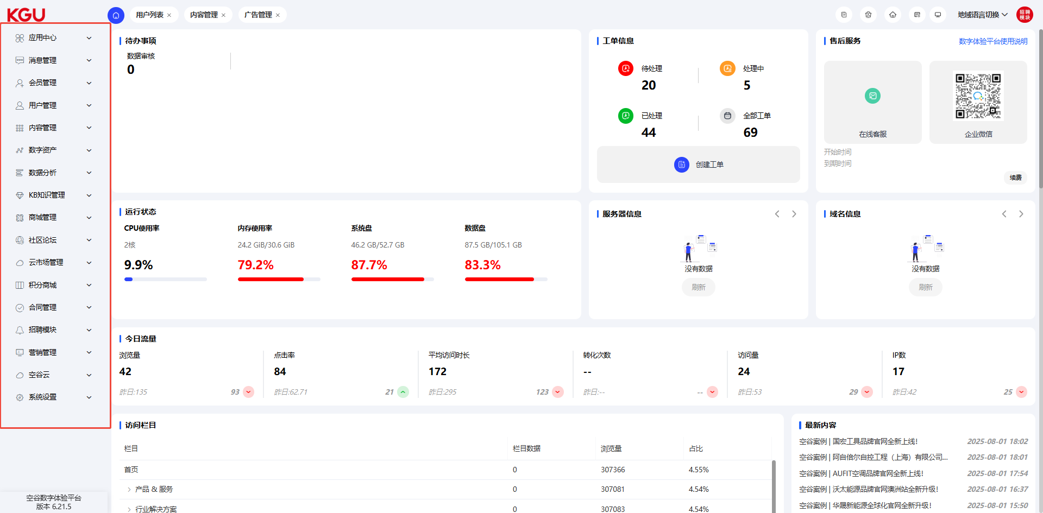
图 3.2 Left Navigation Bar -左侧导航栏

4 Function Description - 功能说明

4.1 Digital Desktop - 数字桌面
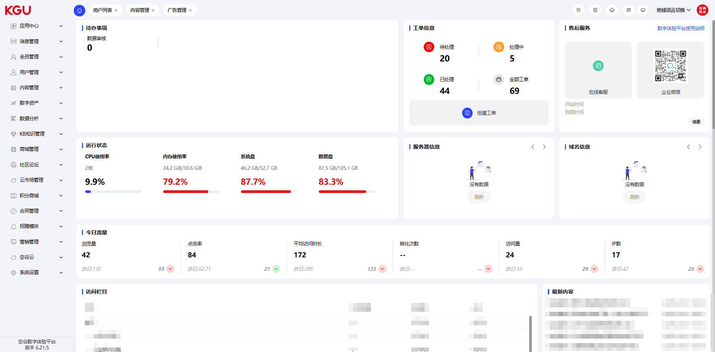
图 4.1 Digital Desktop -数字桌面
The digital desktop is designed to meet the usage needs of backend users, featuring sections for pending tasks and work order information. It can monitor the server's operating status, displaying server information and domain name information. At the same time, it can present the business data of the digital portal from multiple dimensions, including functions such as today's traffic, visited columns, latest content, data analysis, search engines, regional distribution, resolution analysis, and browser analysis.
数字桌面针对后台用户使用需求，设置待办事项、工单信息板块；并可以监测服务器的运行状态，展示服务器信息、域名信息；同时也能多维度展示数字门户的业务数据。包含今日流量、访问栏目、最新内容、数据分析、搜索引擎、地域分布、分辨率分析、浏览器分析等功能。

4.1.1 Pending Tasks - 待办事项
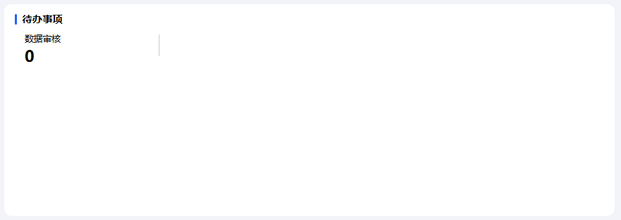
图 4.1.1 Pending Tasks -待办事项
The pending tasks section displays the pending matters under the current backend account, which are the categories of pending tasks in the workflow page, such as data review, contract review, member review, etc.
待办事项显示该后台账号下待处理的事务，即工作流页面中待办任务的类别，如数据审核、合同审核、会员审核等。

4.1.2 Work Order Information - 工单信息
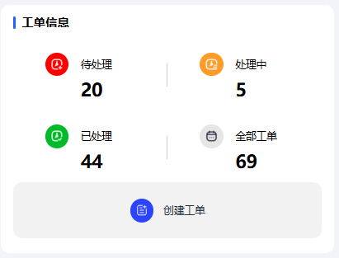=
图 4.1.2(1) Work Order Information -工单信息
Customers can submit work orders in the management backend, and after-sales staff will respond to the work orders.
Note: The work orders here serve the same purpose as the "Work Orders" in section "3.1.2 Work Orders". The difference is that no login operation is required here to create a work order, while the work order system in section "3.1.2 Work Orders" requires a login operation before use.
The "Create Work Order" button below opens the work order creation page, where you need to fill in various information. Items marked with "*" are mandatory. After completion, click the "Submit" button to finish submitting the work order, and the work order information will be synchronized to the customer service terminal.
客户可在管理后台提交工单，售后工作人员会对工单进行答复。
备注：此处的工单与章节“3.1.2 工单”作用一致，区别是此处不需要进行登录操作即可创建工单。章节“3.1.2 工单”的工单系统在使用前需要先进行登录操作。
下方“创建工单”按键可打开创建工单页面，填写各项信息，其中“*”标记为必填项。完成后，点击“提交”按键即完成提交工单操作，工单信息同步至客服端。
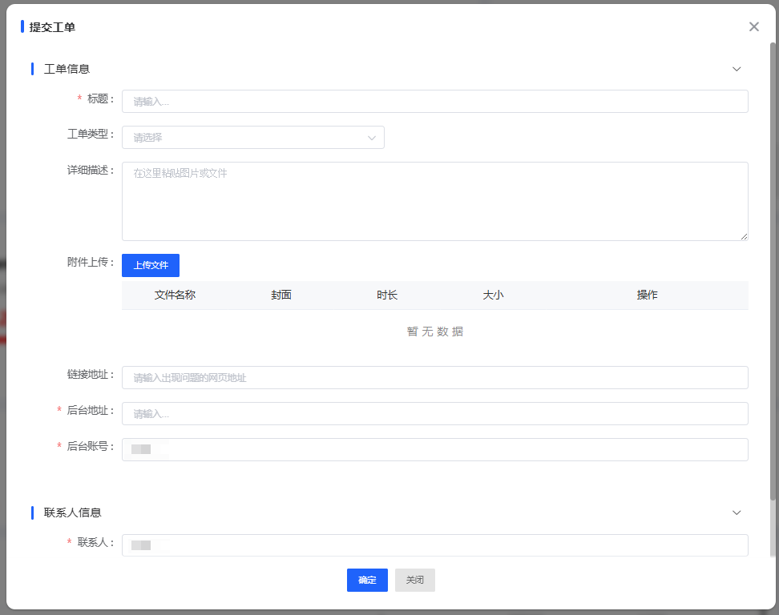
图 4.1.2(2) Work Order Information -工单信息
Four sets of data are listed above the work order creation section: pending work orders, work orders in progress, completed work orders, and all work orders. Clicking on each set of data opens the work order list page, where you can view all work orders of the project under each status.
创建工单上方罗列了四组数据，分别为待处理状态工单、处理中状态工单、已处理状态工单及全部工单。单击进入各项数据，可打开工单列表页面，查看该项目各状态下的所有工单。
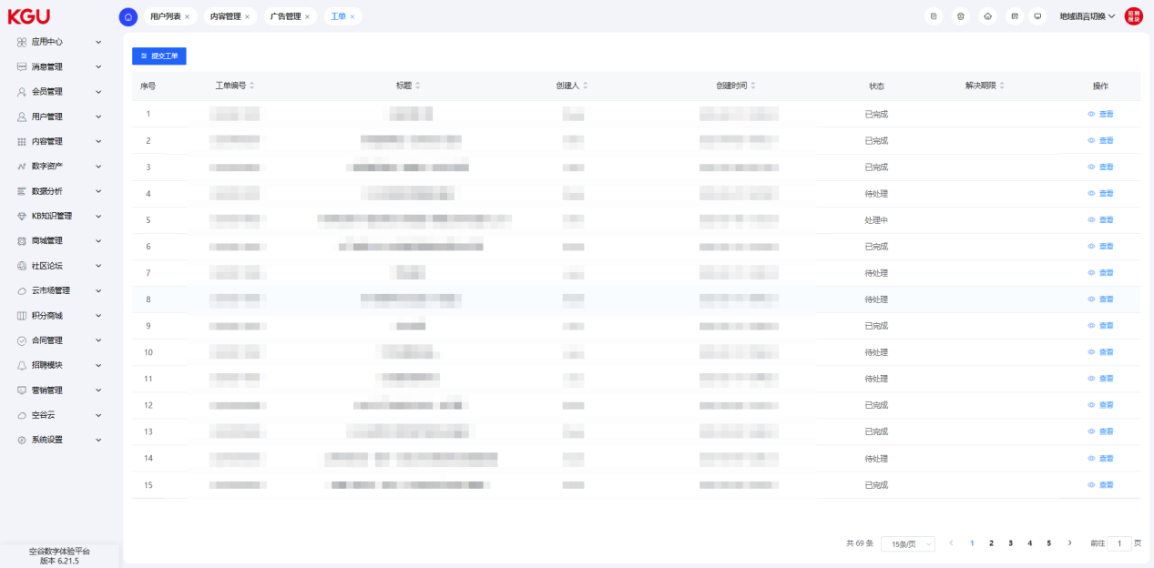
图 4.1.2(3) Work Order Information -工单信息
Opening the work order page, the top section contains work order search and filtering tools. You can directly search by work order title or filter the list by work order status. Click "Search" on the right to display the results matching the search and filtering criteria in the list below. Click "Reset" on the right to clear the title search and status filtering fields above and restore the full work order list.
Clicking the "View" button next to the work order information allows you to view the detailed content of the work order, and you can add reply content for the work order below.
开启工单页面，上方为工单搜索及筛选工具，可直接对工单标题进行搜索，或通过工单状态进行列表筛选，点击右侧搜索，即可在下方列表得出符合搜索与筛选条件的结果；点击右侧重置，可对上方标题搜索与状态筛选栏进行清空重置，恢复全部工单列表。
点击工单信息后的查看按键，即可查看工单信息的详细内容，同时可在下方对该条工单添加回复补充内容。

4.1.3 After-sales Service - 售后服务
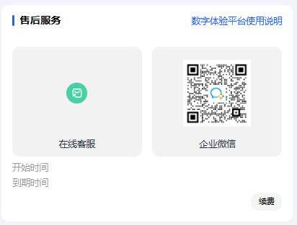
图 4.1.3 After-sales Service -售后服务
Clicking the "Renewal" button in the after-sales service module allows you to contact customer service staff directly in the dialog box. You can also scan the customer service staff's enterprise WeChat QR code to add enterprise WeChat for consultation.
Clicking "KXP User Guide" above allows you to download the KXP user guide document.
The start and expiration dates of after-sales service are shown below. If renewal is needed, you can contact customer service staff.
售后服务模块中的续费按键，点击可在对话框中与客服人员直接联络；也可扫描客服人员的企业微信二维码，添加企业微信进行咨询。
点击上方的数字体验平台使用说明，即可下载数字体验平台使用说明文件。
下方为售后服务的开始与到期时间，如需续费，可与客服人员联系。

4.1.4 Operating Status -运行状态
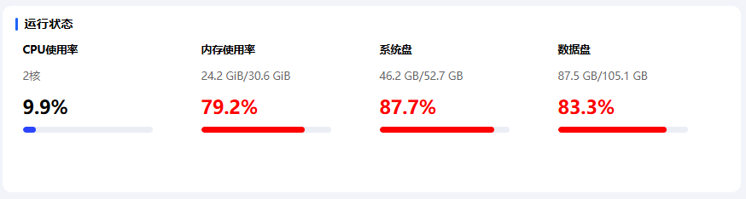
图 4.1.4 Operating Status -运行状态
The operating status reflects various data of the website server, including CPU usage, memory usage, system disk usage, and data disk usage. Currently, the usage rates of the above items are within the normal range.
When the CPU usage is too high, it will greatly affect the normal use of the website. If such a situation is encountered, please contact our after-sales colleagues in a timely manner for assistance in troubleshooting.
When the usage ratio of memory, system disk, or data disk is too high, you can contact our after-sales colleagues for assistance in troubleshooting.
运行状态体现了网站服务器的各项数据，包括CPU使用率、内存使用率、系统盘使用率与数据盘使用率。目前上述内容的使用率均属正常范围。
当 CPU使用率过高时，会极度影响网站的正常使用，如遇到此类情况，请及时与我司售后同事联系进行协助排查。
当内存使用率、系统盘、数据盘的使用占比过高时，可联系我司售后同事协助进行排查。

4.1.5 Server Information-服务器信息
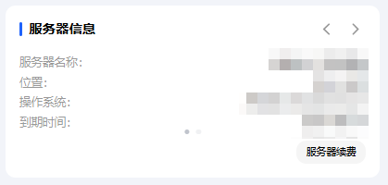
图 4.1.5 Server Information-服务器信息
The server information indicates the name, location, operating system, and expiration date of the server used by the website. If renewal is needed, you can contact customer service staff.
服务器信息标明了网站所用服务器的名称、位置、操作系统及到期时间，如需续费，可与客服人员联系。

4.1.6 Domain Name Information-域名信息
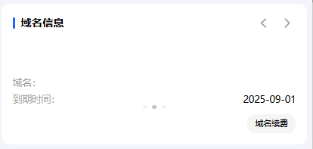
图 4.1.6 Domain Name Information-域名信息
The domain name information indicates the domain name and expiration date of the server used by the website. If renewal is needed, you can contact customer service staff.
域名信息标明了网站所用服务器的域名与到期时间，如需续费，可与客服人员联系。

4.1.7 Today's Traffic-今日流量
图 4.1.7 Today's Traffic-今日流量
Today's traffic refers to the browsing situation of the website on the current day, including the total number of views today, the click rate of the website today, the average access duration of the website today, the number of conversions, the total number of visits today, and the number of visiting IPs today.
今日流量为当日网站被浏览情况，包括今日被浏览总量、网站今日被点击率、网站今日平均被访问时长、转化次数、今日被访问总量与今日访问IP数量。

4.1.8 Visited Columns-访问栏目
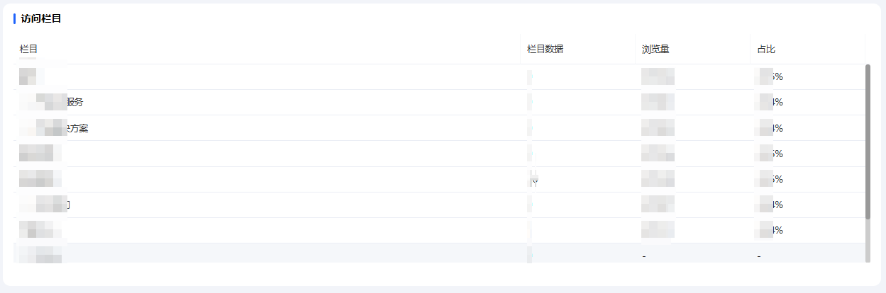
图 4.1.8 Visited Columns-访问栏目
Visited columns refer to the access situation of each column of the website. The column data is the total number of data items in the column, the number of views is the total number of times the page has been viewed, and the proportion is the percentage of the page's views to the total views.
访问栏目为网站各栏目的被访问情况，栏目数据为该栏目的总数据条数，浏览量为该页面被浏览的总次数，占比为该页面浏览量占总浏览量的比例。

4.1.9 Latest Content-最新内容
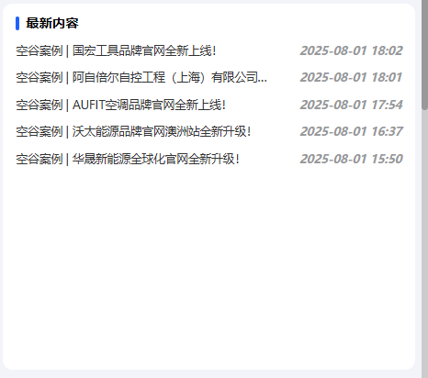
图 4.1.9 Latest Content-最新内容
The latest content displays the recently updated list content in the system (list content refers to product lists, news, cases, etc.).
最新内容展示了系统中最近更新的列表内容（列表内容指产品列表、新闻、案例等）。

4.1.10 Data Analysis-数据分析
Data analysis includes access data and search engines. The filter box on the right allows you to select the site, time range, and query method for data query.
数据分析包括访问数据与搜索引擎。右侧筛选框可选择查询数据的站点、时间区间与查询方式。

Access Data-访问数据
Access data refers to a line chart of data such as page views, average access duration, bounce rate, number of visitors, and number of IPs. You can select the data to be displayed in the data label at the top right.
访问数据指浏览量、平均访问时长、跳出率、访客数、IP数等数据的折线统计图，可在右上数据标签选择要显示的数据。
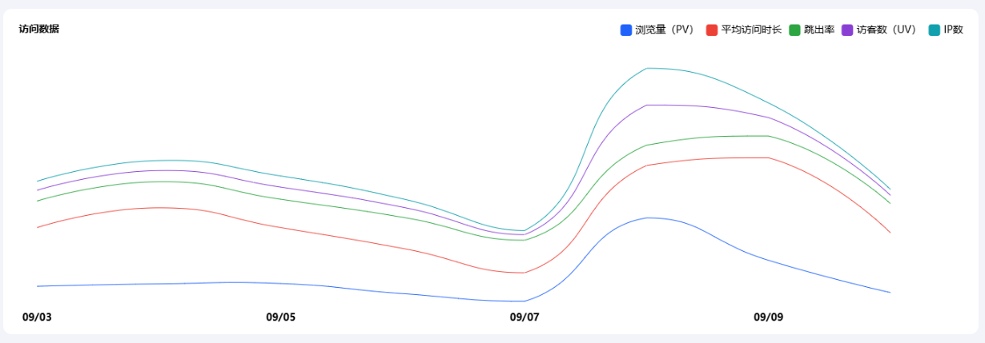
图 4.1.9.1 Access Data-访问数据

Search Engines-搜索引擎
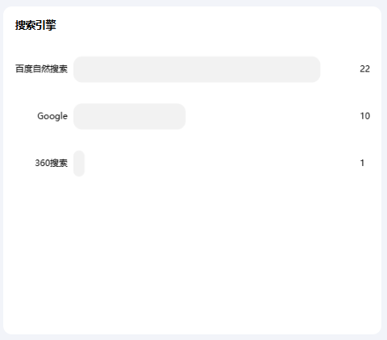
图 4.1.9.2 Search Engines-搜索引擎
The search engine section of data analysis counts the frequency of visitors entering through different search engines. Users can view data from different search engine sources through a bar chart. The search engine supports Baidu natural search, Baidu paid promotion, Bing, 360 Search, Google, Shenma Search, Haosou, Yahoo, Toutiao, and Youdao Search as data sources.
数据分析搜索引擎板块统计了通过不同搜索引擎进入访客的频次，用户可以通过条形占比图来查看不同搜索引擎来源的数据。搜索引擎支持百度自然搜索、百度付费推广、搜索、Bing、360搜索、Google、神马搜索、好搜、Yahoo、头条、有道搜索引擎等作为数据源。

4.1.11 Regional Distribution-地域分布
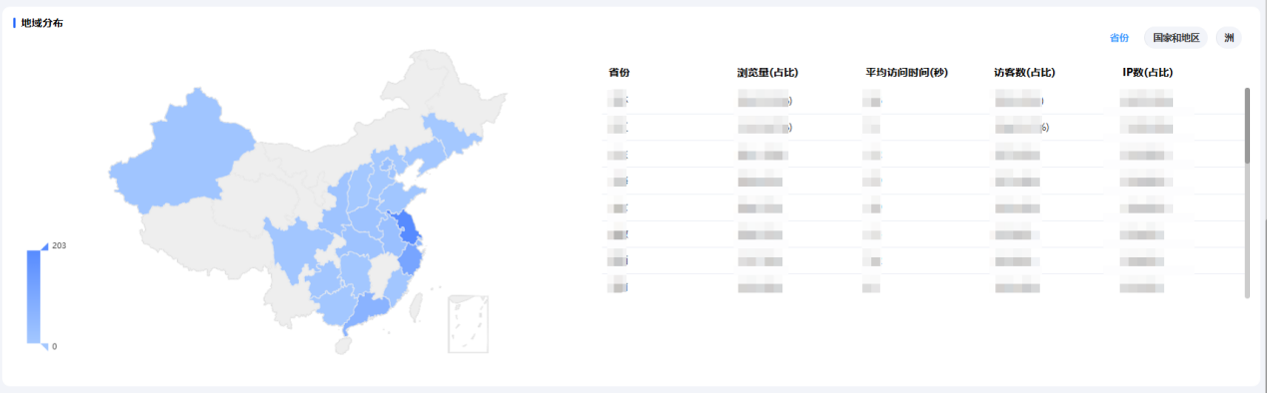
图 4.1.10 Regional Distribution-地域分布
Regional distribution is a statistical analysis that displays the source regions of visitors based on a time range, and supports display by continent, country, and province.
地域分布是基于时间范围展示访问者来源区域的统计分析，支持按洲，国家、省份展示。

4.1.12 Resolution Analysis-分辨率分析
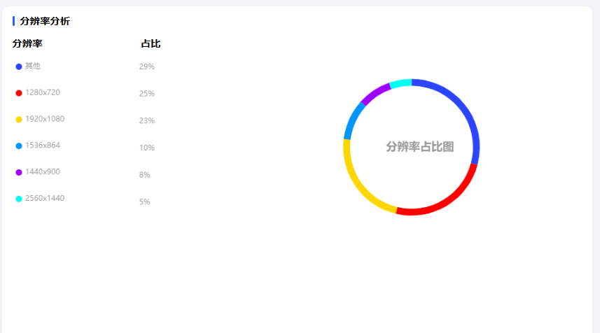
图 4.1.11 Resolution Analysis-分辨率分析
It displays the statistical analysis of device resolution access quantities in the form of a ring chart based on a time range.
基于时间范围采用环形占比图的形式展示设备分辨率访问数量统计和分析。

4.1.13 Browser Analysis-浏览器分析
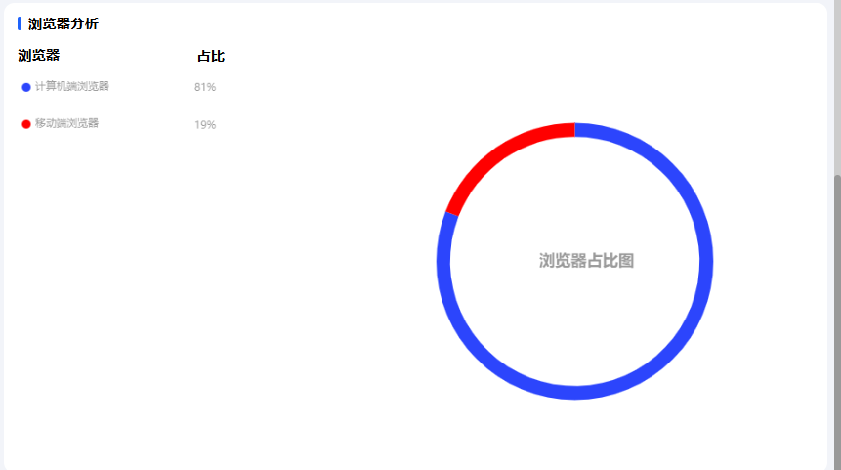图 4.1.12 Browser Analysis-浏览器分析
It displays the statistical analysis of access quantities from PC or mobile terminals in the form of a ring chart based on a time range.
基于时间范围采用环形占比图的形式展示PC端或者移动端的访问数量统计和分析。

4.2 Application Center-应用中心

4.2.1 Basic Information-基本信息
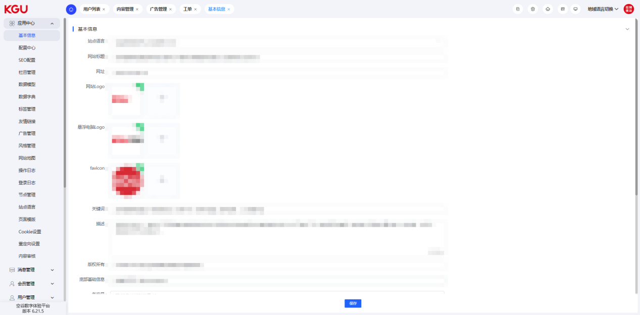
图 4.2.1 Basic Information-基本信息
Site Language: Switch the background to different site languages to modify the basic information settings of different language sites.
Website Title: Set the title of the front-end website, which refers to the website title on the web page tab.
Website URL: Set the jump address of the [Home] icon at the top right corner of the CMS homepage.
Website Logo: Set the website logo, which is displayed in the header navigation bar.
Floating Computer Logo: Set the website logo, whose display position is not fixed and is configured by the front-end.
Favicon: Set the website logo, which is displayed before the website title.
Keywords: Set website keywords for website SEO configuration.
Description: Set the website description for website SEO configuration.
Copyright: Set the website copyright, which is usually displayed at the bottom footer of the web page.
Bottom Basic Information: Set the basic information of the website.
Filing Number: Set the website filing number, which is usually displayed at the bottom footer of the web page.
Today's Page Views: Display the number of page views of the website today.
Total Page Views: Display the total number of page views of the website.
站点语言：将背景切换至不同站点语言，以修改不同语言站点的基本信息设置。
网站标题：设置前台网站标题，这里指网页标签上的网站标题。
网址：设置CMS首页右上角【主页】图标的跳转地址。
网站logo：设置网站logo，显示于头部导航栏。
悬浮电脑logo：设置网站logo，显示位置不固定，由前端配置。
Favicon：设置网站logo，显示于网站标题前。
关键词：设置网站关键词，用于网站SEO配置。
描述：设置网站描述，用于网站SEO配置。
版权所有：设置网站版权所有，通常显示在网页页脚底部。
底部基础信息：设置网站基本信息。
备案号：设置网站备案号，通常显示在网页页脚底部。
当天浏览量：显示网站的当天浏览量。
总浏览量：显示网站的总浏览量。

4.2.2 Configuration Center-配置中心
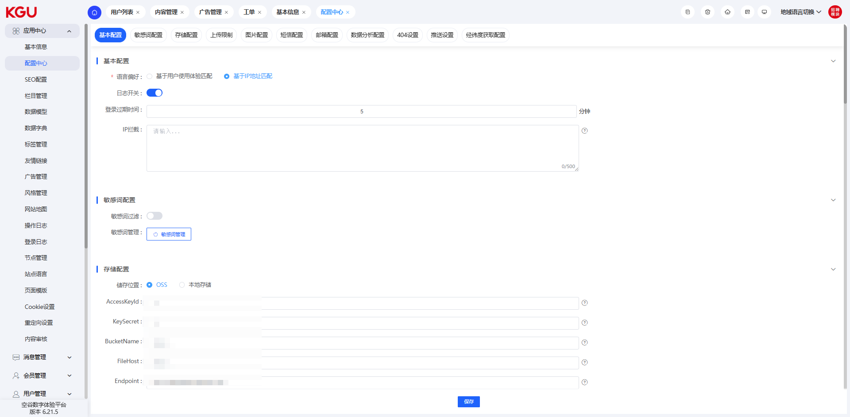
图 4.2.2 Configuration Center-配置中心
The configuration center provides basic configuration, sensitive word configuration, storage configuration, upload parameters, SMS configuration, email configuration, data analysis configuration, email message prompts, image configuration, 404 settings, push settings, and latitude and longitude acquisition configuration.
配置中心提供基本配置、敏感词配置、存储配置、上传参数、短信配置、邮箱配置、数据分析配置、邮件消息提示、图片配置、404设置、推送设置和经纬度获取配置。

Basic Configuration-基本配置
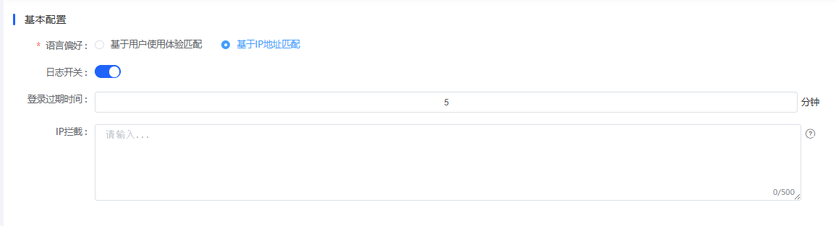
图 4.2.2(1) Basic Configuration-基本配置
Language Preference: Detect the front-end visitor's environment language (operating system or browser). If the environment language exists in the KXP language list, open the front-end version of KXP corresponding to the environment language; if not, open the default language. The language here refers to the language of the CMS itself.
语言偏好：检测前台访问者的环境语言（操作系统或者浏览器），如该环境语言存在于数字体验平台语言列表，则打开对应环境语言的数字体验平台前端版本；不存在，则打开默认语言。这里的语言是指 CMS自身的语言。
例如：数字体验平台包含中文和英语，默认语言为中文，环境语言为英语，则打开英文；环境语言为德语，则打开中文。
日志开关：后台操作日志开关，开启则记录后台操作日志，关闭则不记录后台操作日志。
登录过期时间：设置后台的账号登录时长，过期则自动退出登录。
IP拦截：可以拦截设定的IP地址，禁止该IP地址访问网站。

Sensitive Word Configuration-敏感词配置
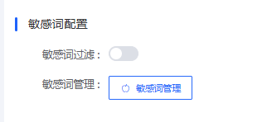
图 4.2.2(2) Sensitive Word Configuration-敏感词配置
Configure sensitive word information to block sensitive words in content management and prevent some inappropriate words from appearing on the front-end of the website.
After setting sensitive words, when adding content in the rich text editor of content management, if the content contains sensitive words, the system will pop up a prompt.
配置敏感词信息，可以拦截内容管理中的敏感词，避免不一些不良词汇出现在网站的前台中。
设置敏感词后，在内容管理的富文本编辑器中添加内容时，如果内容中包含了敏感词，系统会弹出提示。

Storage Configuration-存储配置
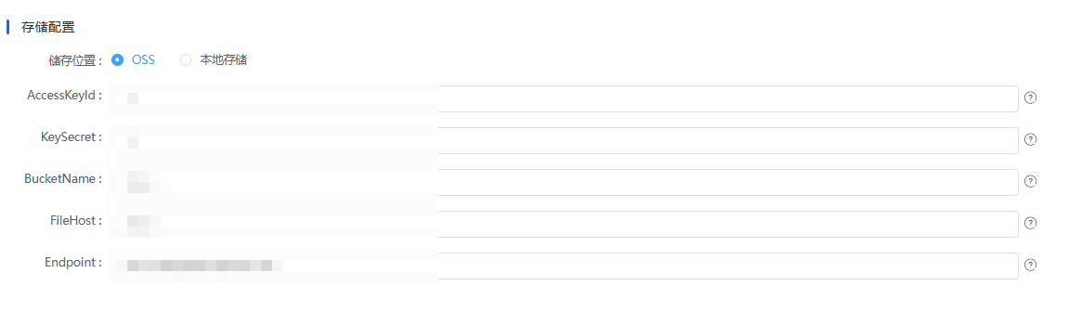
图 4.2.2(3) Storage Configuration-存储配置
In the storage configuration function, you can manage the storage function of the entire site, enable and disable storage, set the storage time of the entire site, the storage time of the homepage, the storage time of column pages, and the storage time of content pages. Here, you can also set the modules that are updated synchronously when content is updated.
The storage function supports manual storage update. Click the "Update Now" button in the corresponding area to do so.
存储配置功能中，可以管理整个站点的存储功能，可进行存储的启用和禁用，同时可设置整站存储时间、主页存储时间、栏目存储时间、内容页面存储时间，在这里也可以设置在内容更新时同步更新的模块。
存储功能支持手工更新存储，点击对应区域的立即更新按钮即可。

Upload Restrictions-上传限制
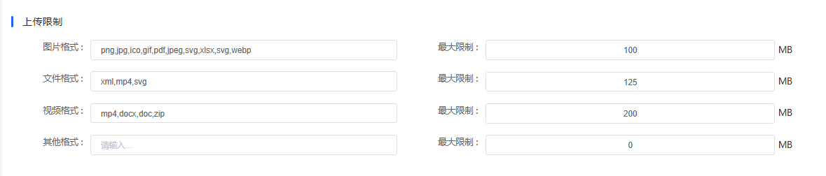
图 4.2.2(4) Upload Restrictions-上传限制
In the upload restriction configuration, you can change the restrictions on the size of user profile files, upload file formats, storage methods, and other information. If the upload size exceeds the limit or the uploaded file does not conform to the defined format, the user cannot upload the corresponding data.
在上传限制配置中，可更改用户配置文件大小的限制、上传文件格式、存储方式等信息。超过上传大小限制及上传文件与定义的格式不符合时，用户将无法上传相应的资料。

Image Configuration-图片配置
In the image configuration function, you can configure the image watermark parameters of the entire site.
Watermark Type: Image watermark is a watermark set based on image content. Text watermark is a watermark set based on text content.
Watermark Transparency: Set the transparency effect of the watermark displayed on the image.
Watermark Position: Set the display position of the watermark on the image.
图片配置功能中，可配置整个站点中的图片水印参数.
水印类别：图片水印为基于图片内容设置的水印。文字水印为基于文字内容设置的水印。
水印透明度：设置水印在图片上显示6+的透明度效果。
水印位置：设置水印在图片上的显示位置。

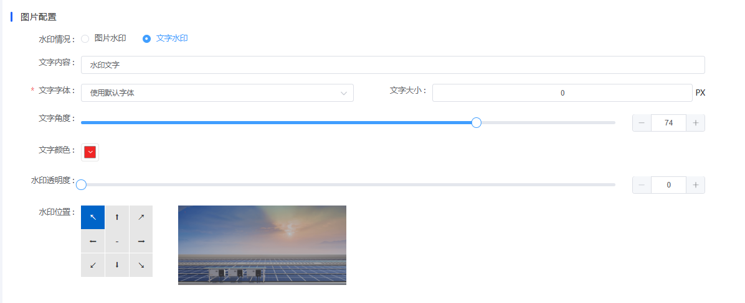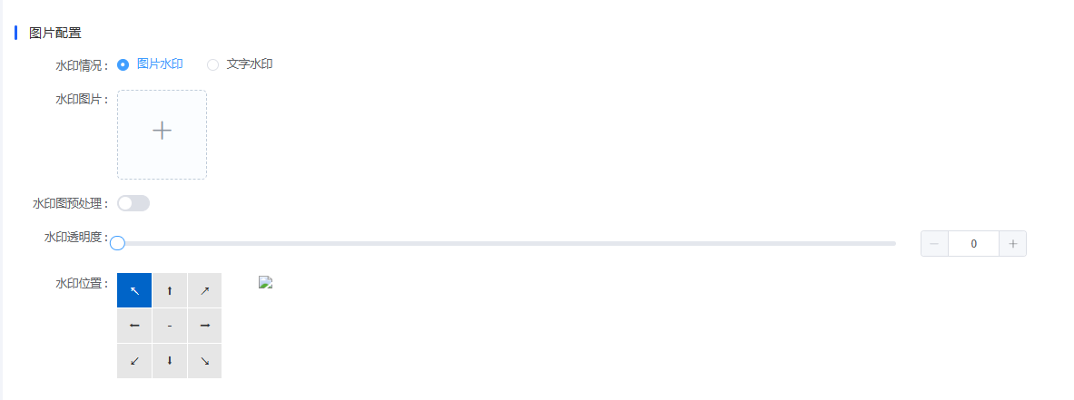
图 4.2.2(5) Image Configuration-图片配置

SMS Configuration-短信配置
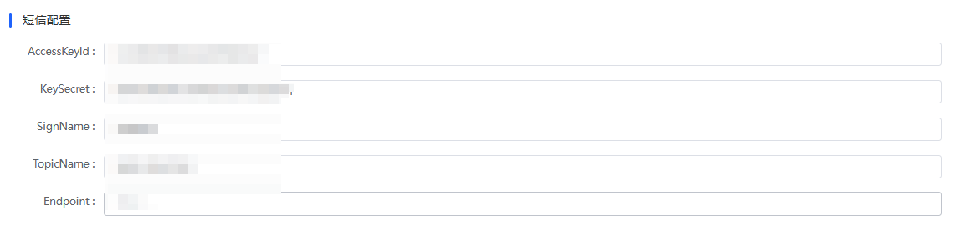
图 4.2.2(6) SMS Configuration-短信配置
In the SMS configuration, users can configure the parameters for the website to send SMS messages to realize the function of sending SMS verification codes. This function can only be supported by the system after cooperation with the SMS service provider. It is recommended that users modify this configuration only if they are familiar with the parameters; otherwise, do not modify this configuration.
在短信配置中，用户可以配置网站下发短信的参数，以实现短信验证码的下发功能。此功能需要与短信服务端合作后，系统方可支持。建议用户在熟悉参数的前提下进行修改，否则请勿修改此项配置。

Email Configuration-邮箱配置
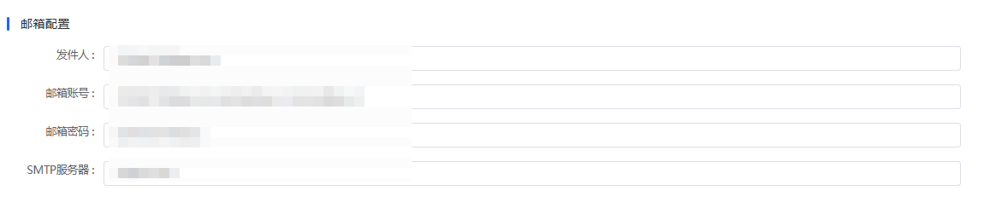
图 4.2.2(7) Email Configuration-邮箱配置
The email configuration function is used to send notification emails to users. For example, when a user registers, email verification is required, and the success of sending the verification information depends on this configuration. It is recommended that users modify this configuration only if they are familiar with the parameters; otherwise, do not modify this configuration.
邮箱配置功能用于给用户下发通知邮件，例如：用户在注册的时候，需要进行邮箱验证，验证信息的发出是否成功则基于此项配置。建议用户在熟悉参数的前提下进行修改，否则请勿修改此项配置。

Data Analysis Configuration-数据分析配置

图 4.2.2(8) Data Analysis Configuration-数据分析配置
Data configuration needs to be used in conjunction with Baidu's statistics function. Before using this function, users need to apply for a statistics account on Baidu Statistics first, and then fill in the corresponding information in this area.
The application address for Baidu Statistics is: https://tongji.baidu.com/
数据配置需要配合百度的统计功能进行使用。在使用本功能前，需要用户先在百度统计申请一个统计账号，然后再将对应的信息填写到本区域。
百度统计的申请地址为：https://tongji.baidu.com/

404 Settings-404 设置
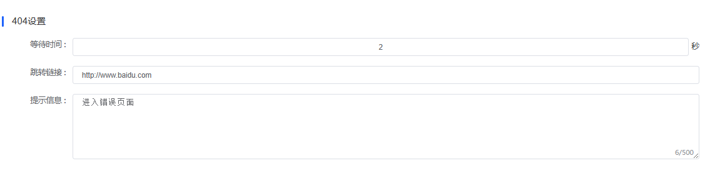
图 4.2.2(9) 404 Settings-404 设置
When a user accesses a non-existent page in the system, the system will automatically redirect to the 404 page to remind the user, so as to improve the user experience. In the 404 settings, you can set the waiting time for redirection and the address of the redirected page.
当用户访问系统中不存在的页面时，系统会自动跳转到404页面，对用户进行提醒，以提供用户体验。在404设置中，可以设置等待跳转的时间和跳转的页面地址。

Push Settings-推送设置

图 4.2.2(10) Push Settings-推送设置
Push settings are used to control the website's permission to push information to you. When the switch is turned on, the website can actively push various types of information to you, such as platform activity reminders, content update notifications, and important system messages. If you turn off this switch, the website will stop actively pushing the above information, which helps reduce unnecessary information interference. You can flexibly switch the status of this function according to your needs for receiving information.
推送设置用于控制网站向您推送信息的权限。当开关开启时，网站可主动向您推送各类信息，如平台活动提醒、内容更新通知、重要系统消息等 ；若您关闭此开关，网站将停止主动推送上述信息，有助于减少非必要信息干扰，您可依据自身对信息接收的需求，灵活切换该功能状态 。

Latitude and Longitude Acquisition Configuration - 经纬度获取配置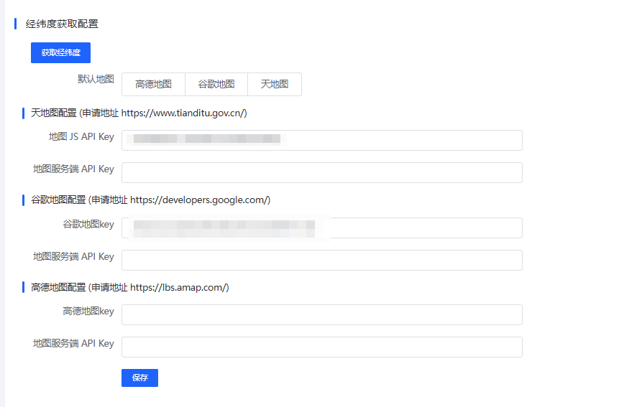
图 4.2.2(11) Latitude and Longitude Acquisition Configuration - 经纬度获取配置
Click the "Get Latitude and Longitude" button to trigger the system to obtain the latitude and longitude information of the current relevant location, which is used in scenarios such as map positioning.
点击 “获取经纬度” 按钮，可触发系统获取当前相关位置的经纬度信息，用于地图定位等场景 。

4.2.3 Column Management-栏目管理
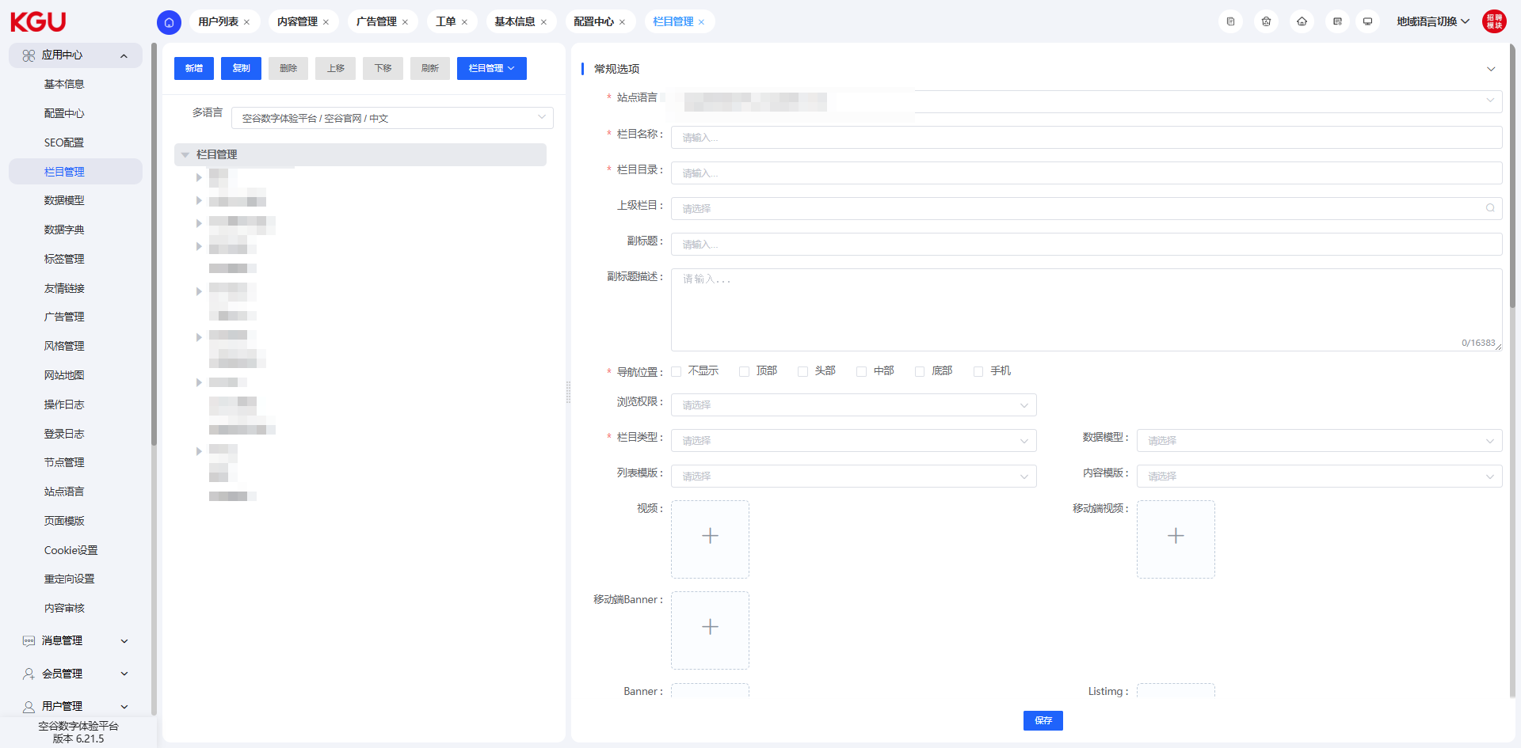
图 4.2.3 Column Management-栏目管理
In the column management interface, you can manage all columns of the official website, configure column-related information, enable and disable related columns, etc. Through the column management function, you can manage the layout of the entire site, which is one of the core functions of the entire management system.
在栏目管理界面，可以管理整个官网栏目、配置栏目相关的信息、启用和禁用相关栏目等。通过栏目管理功能，可以对整个站点的布局进行管理，是整个管理系统的核心功能之一。

Add/Copy Column-新增/复制栏目
It is not recommended for ordinary users to add/copy columns. Generally, this operation is configured and managed by website developers. Users should only perform this operation when they are familiar with this function to avoid display errors of the site.
不建议普通用户进行新增/复制栏目的操作，一般该操作由网站开发人员进行配置管理，用户需要对本功能有熟悉了解时再进行相应的操作，避免造成站点的显示错误问题。

Delete-删除
After selecting a column, click the "Delete" button and confirm in the pop-up dialog box to remove the entire column information. This operation should be performed with caution. Deleting a column will affect the corresponding column of the official website page and make it inaccessible.
选中某个栏目后，点击删除按钮，并在弹出的对话框内点击确认，将移除整个栏目信息。该操作应谨慎进行，删除栏目后，会对官网页面的相应栏目造成影响，导致不可访问。

Move Up/Move Down-上移、下移
Used to quickly change the order of the corresponding column. After moving up or down, the order value of the column will increase or decrease accordingly based on the order values of the columns above and below.
用于快速跳转相应栏目的排序，进行上移或下移操作后，栏目的排序值将根据上下栏目的排序值进行相应的增加或减小。

Refresh-刷新
Used to clear the cached data of the column management module. In individual cases, the content of the column management may be updated, but the front-end of the official website may not be updated. In this case, you can try to fix this problem by clicking the "Refresh" button to clear the cache.
用于清空栏目管理模块的缓存数据。个别情况下，会出现更新了栏目管理内容，但官网前端未更新的现象。此时可通过点击刷新按钮，清空缓存的方式来尝试是否可修复此问题。

General Options Function-常规选项功能
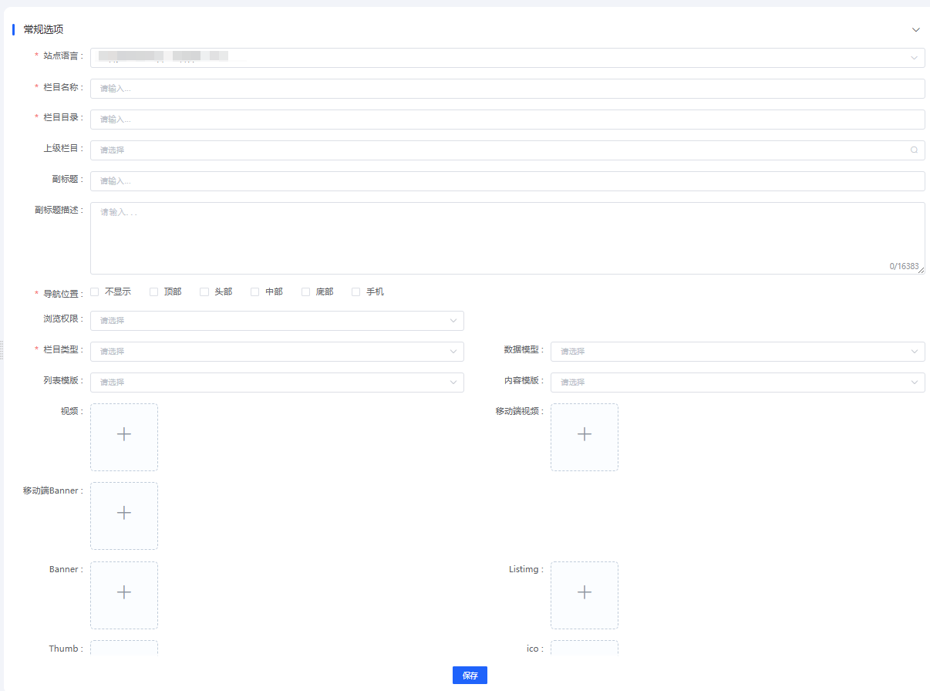
图 4.2.3(1) Column Management-栏目管理
In the general options function, users can set the column name, directory, and parent column, and configure the corresponding browsing permissions and set the display position of the column.
Site Language: Used for multi-language site projects with the same columns, allowing quick switching of site languages for editing operations of corresponding columns.
Column Name: In most cases, this column name is used for the display of each column on the front-end page of the official website.
Column Directory: Used for the URL of the column. The value here is related to the code logic and is maintained by developers. Ordinary users should not attempt to edit it. Currently, the URLs of some pages are customized, and the customized URLs are implemented through the SEO URL field in the general options. It is recommended to keep the URL data of existing pages unchanged during later maintenance.
Parent Column: When this column (B) belongs to a certain column (A), the parent column of B should be configured as: A.
Subtitle: Used for some columns, usually for the display of some fields on the front-end page (e.g., "About Us").
Subtitle Description: Used for some columns, usually for the display of some fields on the front-end page (e.g., "About Us", product category descriptions in product categories, etc.).
Navigation Position: KXP's navigation positions use three types: "Not Displayed", "Header", and "Footer".
Not Displayed: Used for columns that do not need to be displayed in the header and footer, such as some columns on the homepage.
Header: If this column needs to be displayed in the header, check this item.
Footer: If this column needs to be displayed in the footer, check this item.
Browsing Permission: Not used, please ignore.
Column Type: Divided into "List Column" and "Single Page Column".
List Column: If there are multiple pieces of data under this column, set it as a list column.
Single Page Column: If no multiple pieces of data need to be configured under this column, set it as a single page column, such as: senior speeches, privacy policies, legal terms, etc.
Data Model: The data model is used for content management. In content management, when the fields of the general options cannot meet the needs, some fields will be set in the data model for the realization of project logic. When the data in the column needs this requirement, the data model can be configured here. The addition and editing operations of the data model are located in the left navigation bar - Application Center - Data Model. The operation of the data model should usually be performed by developers, and ordinary users can also perform some basic information editing operations on the model.
List Template: Please ignore.
Content Template: Please ignore.
Video, Mobile Banner, Banner, Listimg, Thumb, ico: Set the icon of the column as needed. Usually, only update operations are performed here, and deletion and replacement operations can be performed at the location of the original resource.
Regarding the size of the material, since there are many columns and each has differences, here is a way to view the size of the existing picture (taking products as an example):
Place the mouse on the icon resource, and the following view will appear:
在常规选项功能中，用户可以进行栏目名称、目录及上级栏目的设置，同时可以在此配置对应的浏览权限，设置栏目显示的位置。
站点语言：用于具有相同栏目的多语言站点项目，可快捷的切换站点语言进行相应栏目的编辑操作。
栏目名称：大部分情况下，此栏目名称用于官网前端页面各栏目的展示；
栏目目录：用于栏目的 url，这里的值涉及到代码的逻辑，由开发人员进行维护，普通用户请不要尝试编辑；当前部分页面的url使用了自定义，自定义的 url是通过常规选项内的 SEO URL字段来实现的。建议后期维护时保持既有页面的 url数据不变。
上级栏目：当此栏目（B）属于某个栏目（A）时，应将 B的上级栏目处配置为：A
副标题：部分栏目使用，通常用于前端页面的部分字段显示（如：关于我们）
副标题描述：部分栏目使用，通常用于前端页面的部分字段显示（如：关于我们、产品类别内的产品类别描述等）
导航位置：kxp的导航位置使用了“不显示”、“头部”、“底部”这 3种类型：
不显示：用于不需要显示在页眉及页脚的栏目，如：首页的一些栏目；
头部：如果此栏目需要显示在页眉处，则勾选此项；
底部：如果此栏目需要显示在页脚处，则勾选此项；
浏览权限：未使用，请忽视；
栏目类型：分为列表栏目、单页栏目
列表栏目：若此栏目下存在多条数据，则设置为列表栏目.
单页栏目：若此栏目下无需配置多条数据，则设置为单页栏目，如：高层致辞、隐私政策、法律条款等；
数据模型：数据模型用于内容管理，在内容管理内，当常规选项的字段无法满足需求时，会在数据模型内设置一些字段用于项目逻辑的实现。当栏目内的数据需要这种需求时，这里就可以配置数据模型。数据模型的新增、编辑操作位于左侧导航栏 - 应用中心 - 数据模型。对于数据模型的操作通常应当由开发人员来进行，普通用户也可针对模型进行一些基本信息的编辑操作。
列表模板：请忽略；
内容模板：请忽略；
视频、移动端Banner、Banner、Listimg、Thumb、ico：根据需要设置栏目的icon。这里通常进行一些更新操作即可，可在原资源的位置上进行删除替换操作。
关于素材的尺寸，因栏目较多且各有差异，这里提供查看已有图片的尺寸方式（以产品为例）：
将鼠标至于icon资源上，可出现下述视图：

图 4.2.3(2) Column Management-栏目管理

Click the "+" button;
Right-click in the pop-up preview view, download the picture to the device, and then obtain the size data of the icon resource through the file properties.
点击“+”按钮；
在弹出的预览视图内点击鼠标右键，将图片下载至设备内，随后通过文件属性的方式获得icon资源的尺寸数据。

Total Site Count, Homepage Count, List Count: Please ignore.
New Window: Invalid field, please ignore.
Status: When turned off, the column is no longer displayed on the front-end of the official website.
Sort: The sorting of each column follows the order from large to small. The larger the sort value, the higher the column is displayed.
整站条数、首页条数、列表条数：请忽略；
新窗口：无效字段，请忽略；
状态：当关闭时，栏目不再显示在官网前端；
排序：各栏目的排序遵循从大到小的排序方式，排序值越大，栏目越靠前。

Advanced Options-高级选项
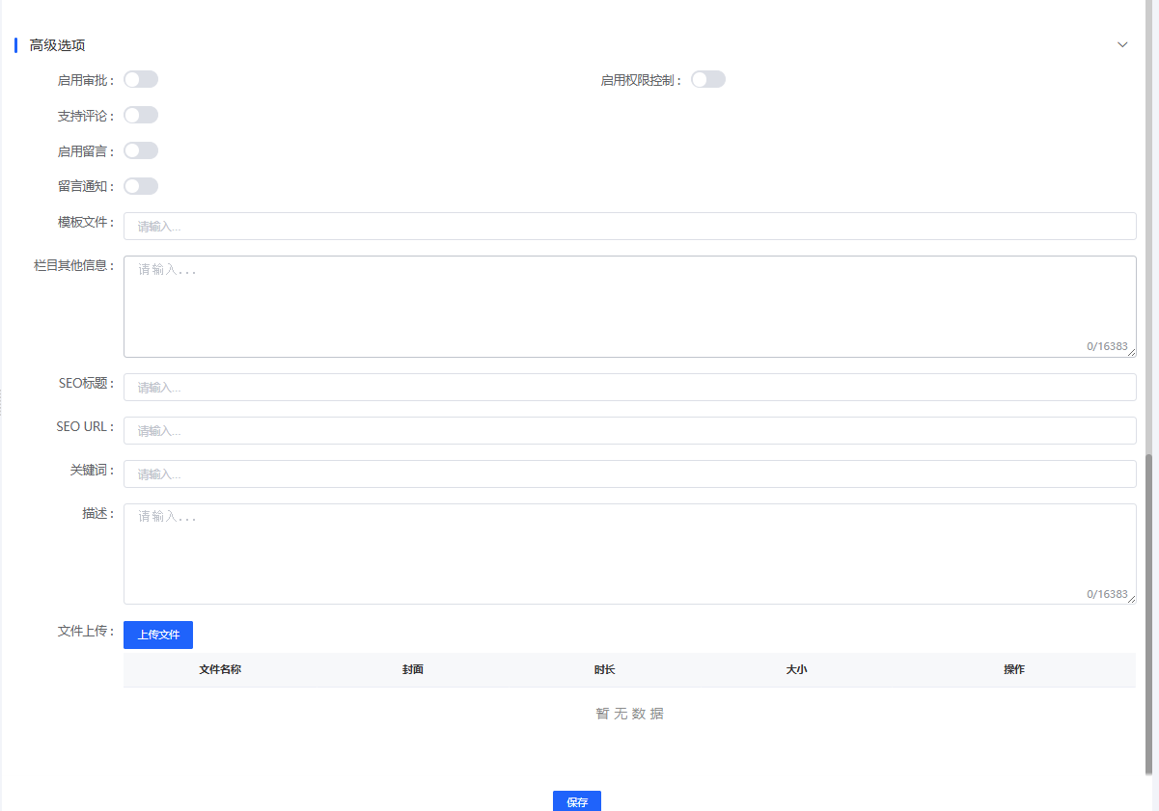
图 4.2.3(3) Column Management-栏目管理
Enable Approval: After enabling approval, operations such as adding, editing, and deleting data in the column will first undergo an approval process, and will take effect only after the approval is completed. After enabling approval, you need to select a pre-set process name. For specific content, refer to the description of the workflow in this document. When this switch is not turned on, accounts with corresponding module permissions in content management can directly perform data operations, such as adding, editing, deleting, etc.
Enable Permission Control: When permission control is enabled, when performing data operations on the column, the system will first verify whether the user role has the permissions to add, edit, delete, query, etc., for the data of the column. If there is no corresponding permission, the user will receive an error message when performing data operations. The data permissions for the column can be set in [User Management] - [User Role] - [Column Authorization].
Support Comments: Please ignore.
Message Column: Enable this function when this column is a message page. The message page refers to the form page (Contact Us, Consult Now, Download Application) on the front-end page and the search results (this item is used for the front-end search box view and is automatically enabled). Do not modify this function unless you are a developer.
Template File: Maintained by developers, do not modify.
Other Column Information: Please ignore.
SEO-related Fields: Currently, due to the custom operation of page routing, some columns' SEO URL fields are occupied, resulting in these fields being unable to be used for SEO optimization of the columns. It is recommended not to perform SEO optimization through the SEO fields in column management, but through the SEO fields in the corresponding content management.
Some columns occupy the SEO URL field in column management, and these values can be updated. Updating them will affect the URL of the corresponding front-end page. Please operate with caution.
File Upload: Please ignore.
启用审批：启用审批后，该栏目的数据新增、编辑、删除等操作将会首先执行审批操作，待审批完成后方可生效。启用审批后需要选择提前设置好的流程名称。具体内容参考此文档内关于工作流的描述。当此开关未开启时，默认具有内容管理相应模块权限的账号可直接进行数据操作，如：新增、编辑、删除等操作。
启用权限控制：当启用权限控制后，对该栏目进行数据操作时，会先校验该用户角色是否拥有此栏目的数据新增、编辑、删除、查询等权限，若没有相应权限，则用户进行数据操作时，会提示错误信息。针对该栏目的数据权限，可在【用户管理】 - 【用户角色】 - 【栏目授权】处进行设置。
支持评论：请忽略；
留言栏目：当此栏目为留言页面时，开启此功能。留言页面是指前端页面内的表单页面（联系我们、立即咨询、下载申请）及搜索结果（此项用于前端的搜索框视图，自动开启）启用该功能，非开发人员请勿修改。
模板文件：由开发人员维护，请勿修改；
栏目其他信息：请忽略；
SEO相关字段：目前由于页面路由的自定义操作，占用了部分栏目的 SEO URL字段，导致这些字段无法进行栏目的 SEO优化。建议不要通过栏目管理内的 SEO字段进行 SEO优化，而是通过相应的内容管理内的 SEO字段进行优化。
部分栏目占用了栏目管理内的 SEO URL字段，这些值可以被更新，更新后会影响前端相应页面的url。请谨慎操作。
文件上传：请忽略。

4.2.4 Data Model-数据模型
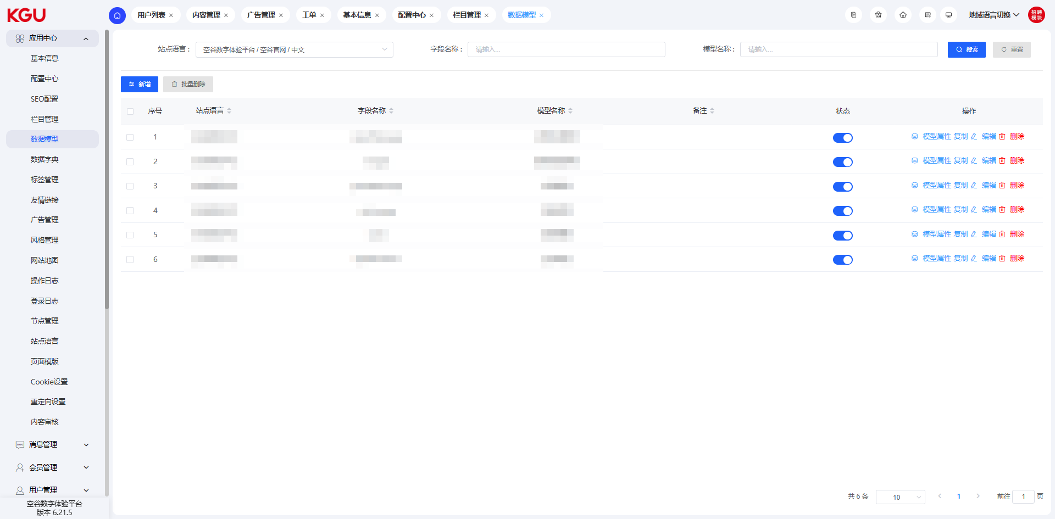
图 4.2.4 Data Model-数据模型
On the data model page, you can set the page data model and configure flexible display modules to meet the user's requirements for displaying page content.
在数据模型页面，可以进行页面数据模型的设置，配置灵活多变的展示模块，从而满足用户对页面内容的展示要求。

Add Data Model-新增数据模型
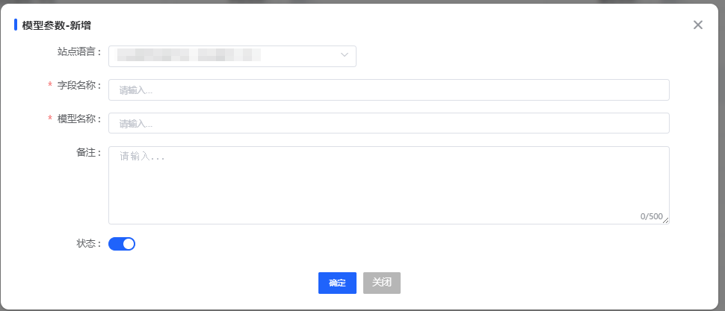
图 4.2.4(1) Add Data Model-新增数据模型
Click "Add" in the upper left corner of the interface to add a model. When adding a model, you can set the language version, field name, model name, remark information, and sort order of the model. Fill in complete information to facilitate subsequent management operations.
点击界面左上角新增，可以进行模型的新增操作，新增模型时，可以设置模型的语言版本、字段名称、模型名称、备注信息及排序。填写完善的信息，以方便后续的管理操作。

Set Model Attributes-设置模型属性
After adding the model, click "Model Attributes" on the interface to set the attributes.
完成模型的新增后，点击界面上的模型属性，即可进行属性设置。
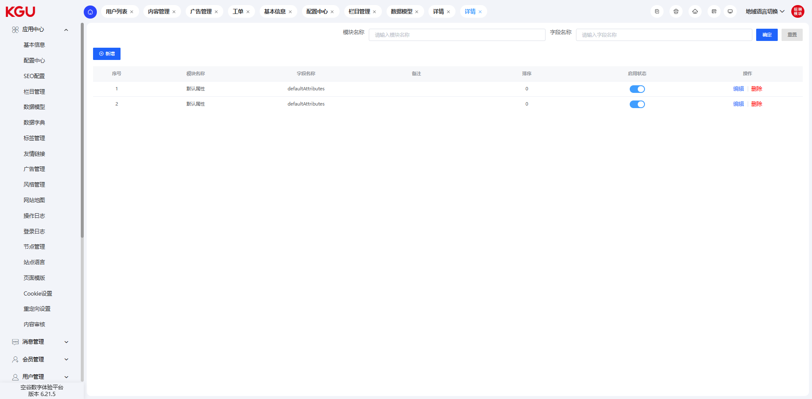
图 4.2.4(2) Set Model Attributes-设置模型属性
Multiple different attributes can be set under the same model to meet more complex page configuration requirements. After configuring the model, corresponding calls need to be set to realize the function. This function requires certain development capabilities to set up; otherwise, the configured function cannot be displayed on the front-end page.
在同一模型下，可以设置多条不同的属性，以满足更加繁杂的页面配置。完成模型的配置后，需要设置对应的调用才可实现。此功能需要有一定的开发能力才可进行设置，否则配置的功能无法达到前台展示的页面。

4.2.5 Data Dictionary-数据字典
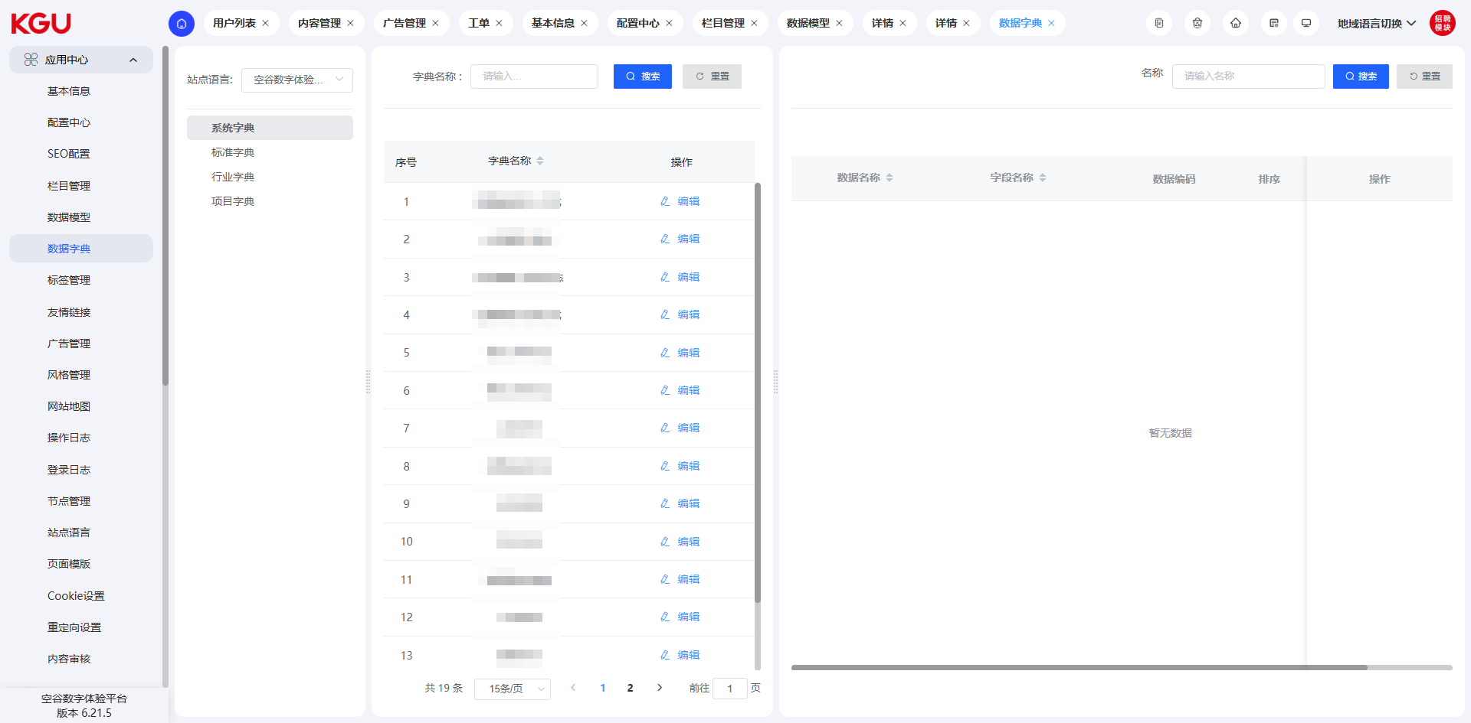
图 4.2.5 Data Dictionary-数据字典
On the data dictionary page, you can manage the data parameters of the entire site. Through the setting of the data dictionary, flexible configuration of different options can be realized, so as to achieve the result of one-time development and free configuration.
在数据字典页面可以管理整个站点的数据参数，通过数据字典的设置，可以实现不同选项的灵活配置，从而达到一次开发，自由配置的结果。

Add Type-新增类型
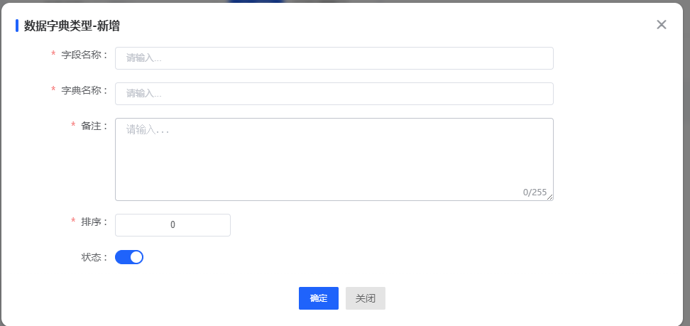
图 4.2.5(1) Add Type-新增类型
You can perform the operation of adding a type in the upper left corner of the interface. When adding a type, you need to fill in the type identifier, type name, data type, sort order, and status switch.
可以在界面的左上角进行新增类型的操作，新增类型时，需要填写类型标识、类型名称、数据类型、排序及状态开关。

Add Data Dictionary-新增数据字典
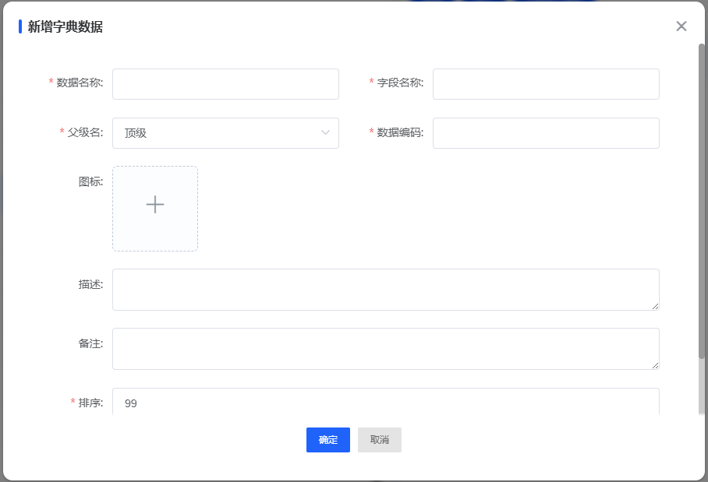
图 4.2.5(2) Add Data Dictionary-新增数据字典
In the "Add Dictionary Data" interface, you can enter information such as data name and field name (items marked with "*" are mandatory), select the parent level (default is top-level), set the code and sort order, and also upload icons and add description remarks. The status switch controls activation. After filling in the information and clicking "Confirm", the newly added dictionary data will be entered into the system. Later, these dictionary data can be called on other function pages for scenarios such as standardized data association and display, realizing unified maintenance and reuse of basic data.
在 “新增字典数据” 界面，可录入数据名称、字段名称等信息（带 * 为必填 ），选定父级（默认顶级 ）、设置编码、排序，还能上传图标、补充描述备注，通过状态开关控制启用。完成信息填写点击 “确定”，新增的字典数据会录入系统，后续可在其他功能页面调用这些字典数据，用于标准化数据关联、展示等场景 ，实现基础数据的统一维护与复用 。

4.2.6 Tag Management-标签管理
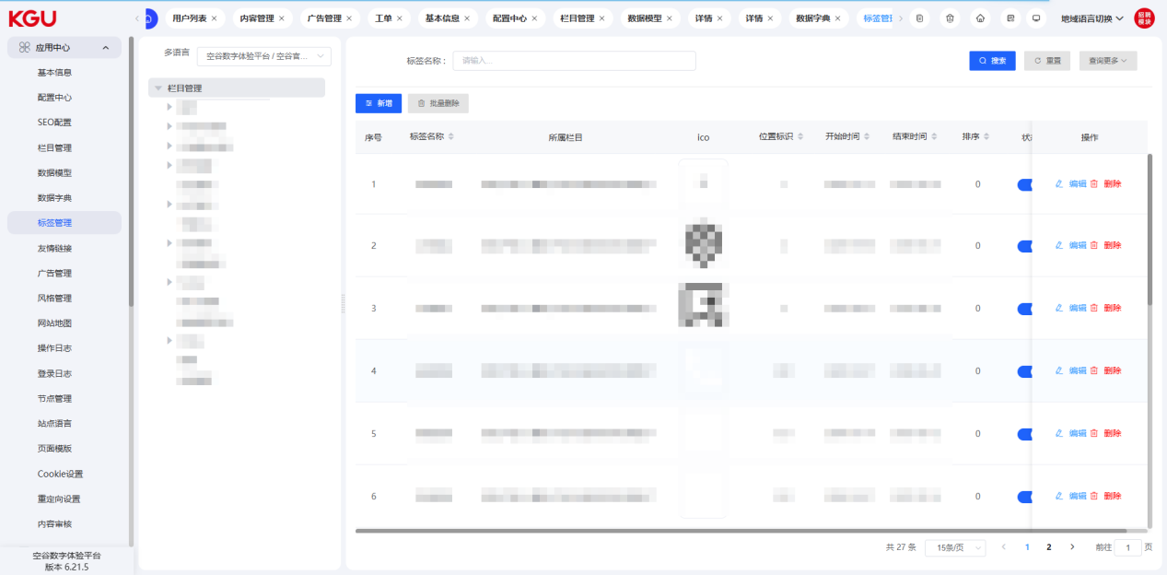
图 4.2.6 Tag Management-标签管理
Through the tag management function, you can flexibly configure the unconventional fields displayed on the page, which is a flexible supplement to the page content. It can reduce the secondary development of customized page content, shorten the development cycle, and improve delivery efficiency. You only need to configure the page data through the configuration function, and then the front-end program can call it. The tag function needs secondary development capabilities to realize; otherwise, the newly added data cannot be referenced and called.
通过标签管理功能，可以灵活配置页面中展示的非常规字段，是页面内容的灵活补充，可以减少页面定制内容的二次开发，降低开发周期，提高交付效率。仅需要通过配置功能对页面数据进行配置，即可供前端程序调用。
标签功能需要有二次开发能力才可以实现，否则新增的数据无法引用和调用。

Add Tag-新增标签
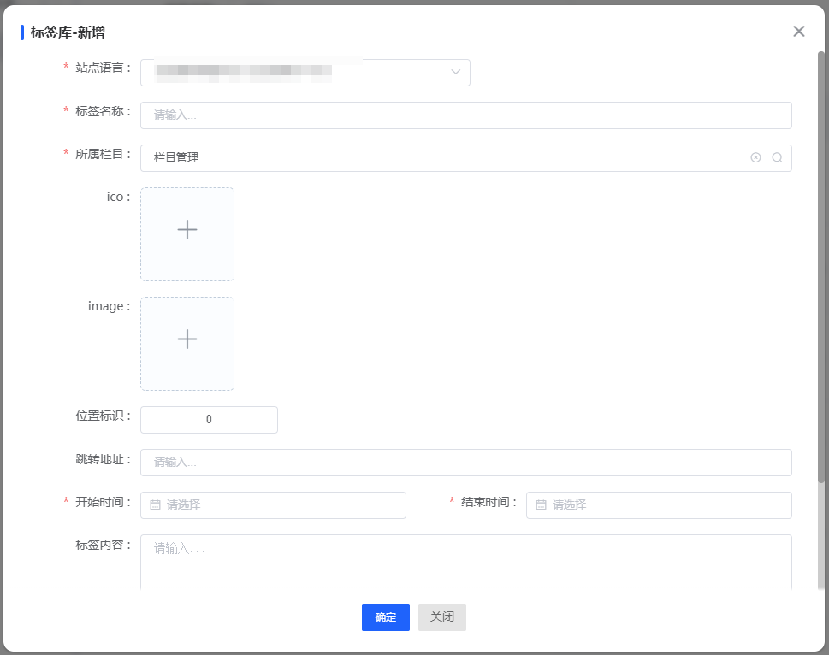
图 4.2.6(1) Tag Management-标签管理
When adding a tag, you can set the site language, tag name, corresponding column, icon, start and end time, tag content information and other related fields. The completeness of the information is conducive to subsequent maintenance operations.
新增标签时，可以设置站点语言、标签名称、所属栏目、图标、开始结束时间、标签内容信息等相关字段，信息的完整度有利于后续的维护操作。

4.2.7 Friendship Links-友情链接

图 4.2.9 Friendship Links-友情链接
The friendship link function can manage the friendship link data of the site, which is one of the conventional functions of the CMS.
友情链接功能可以管理站点的友情链接数据，是CMS常规功能之一。

Add Friendship Link-新增友情链接
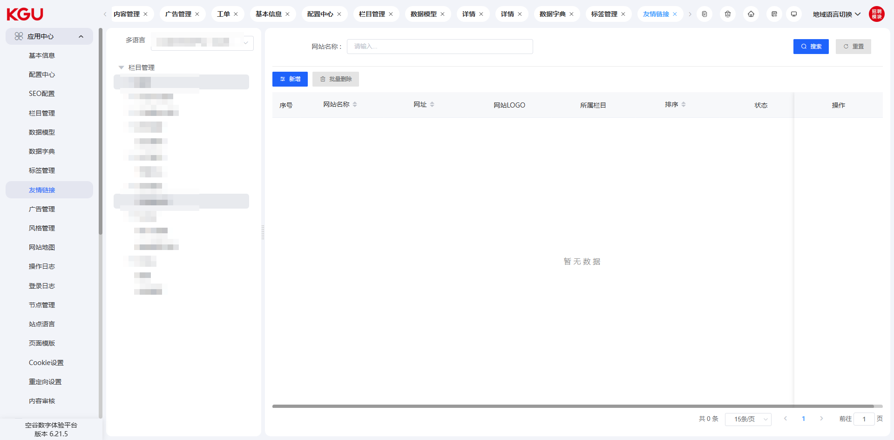
图 4.2.9(1) Add Friendship Link-新增友情链接
Click "Add Friendship Link" in the upper left corner to set the site language, website name, URL, logo, corresponding column and other information.
The friendship link supports batch deletion operations. After checking, click "Batch Delete" to do so.
点击左上角新增友情链接，可设置站点语言，网站名称、网址、Logo、所属栏目等信息。
友情链接支持批量的删除操作，勾选后，点击批量删除即可。

4.2.8 Advertisement management-广告管理
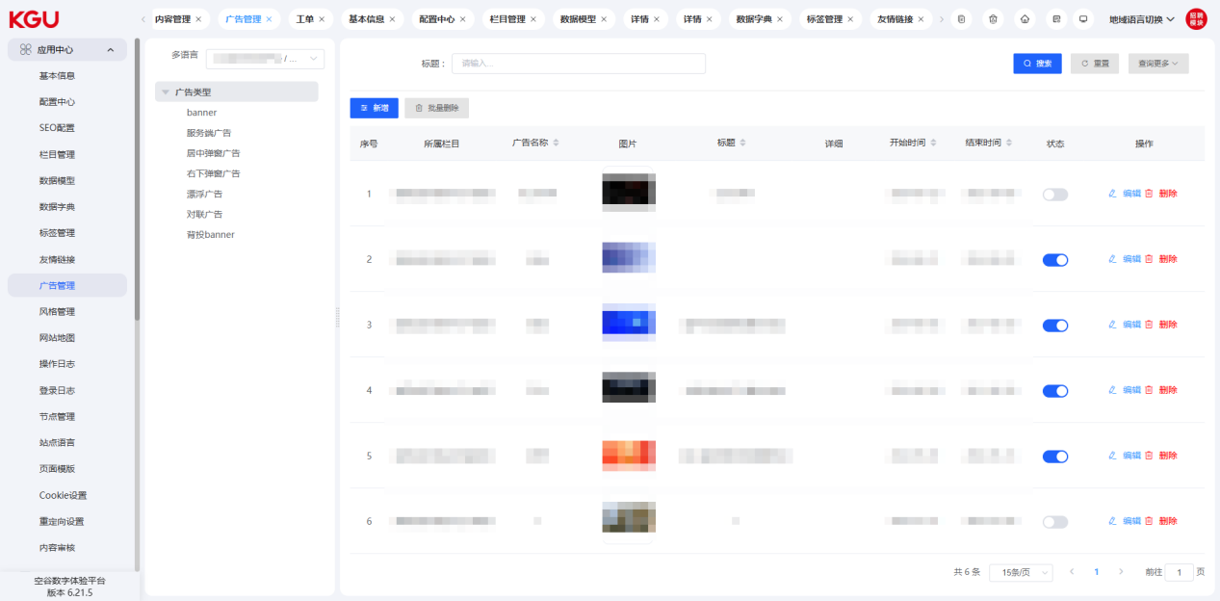
图 4.2.9 Advertising Management-广告管理
The system supports the setting and management of various types of advertisements (Banners). Users can set homepage Banners, background advertisements, column advertisements, floating advertisements, lower right pop-up advertisements, center pop-up advertisements, and server-side advertisements.
Users can flexibly set different advertising promotion methods based on different operation strategies.
系统支持多种广告（Banner）的设置管理操作，用户可以设置首页Banner、背投广告、对联广告、漂浮广告、右下弹窗广告、居中弹窗广告、服务端广告。
用户可以基于不同的运营策略，灵活设置不同的广告推广方式。

Add Advertisement-新增广告
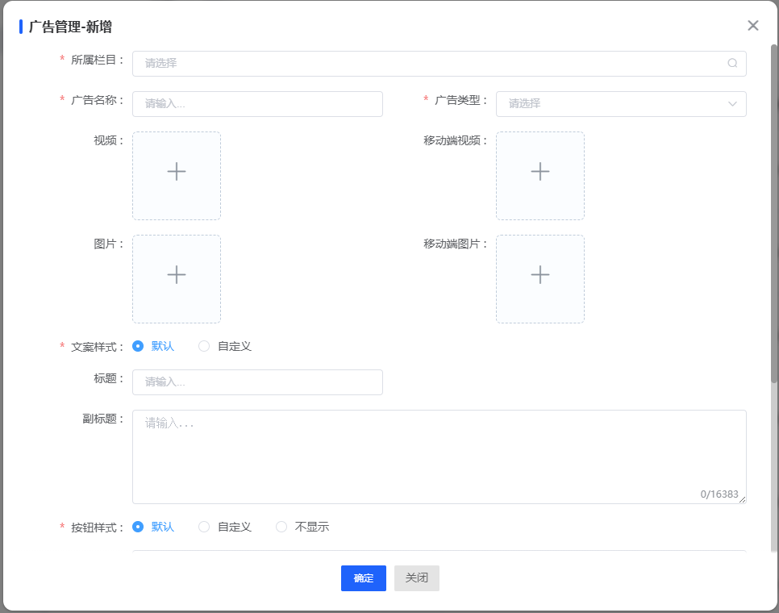
图 4.2.9(1) Add Advertisement-新增广告
Although the display positions, methods, sizes, and effects of advertisements are different, the entry and method for adding advertisements are the same. After clicking "Add Advertisement" on the interface, users can fill in the corresponding information for the advertisement.
Users can set the advertisement name, advertisement type, corresponding column, advertisement image, jump link, sub-station, start time, end time, description, sort order, etc.
After completing the settings, click "Save" to configure the advertisement content.
Note: If the set advertisement is not displayed on the front-end, you need to check whether the start and end times are correct and whether the current advertisement is enabled.
虽然广告展示的位置、方式、大小、效果不同，但新增广告的入口及方法是相同的，用户点击界面上的新增广告后，可以对广告进行相应信息的填写。
用户可以设置广告名称、广告类型、所属栏目、广告图片、跳转链接、分站、开始时间、结束时间、描述、排序等。
完成设置后，点击保存即可实现广告内容的配置。
注意：如果设置的广告没有在前端展示，需要检查一下开始结束时间是符合及当前广告是否启用。

4.2.9 Style Management-风格管理
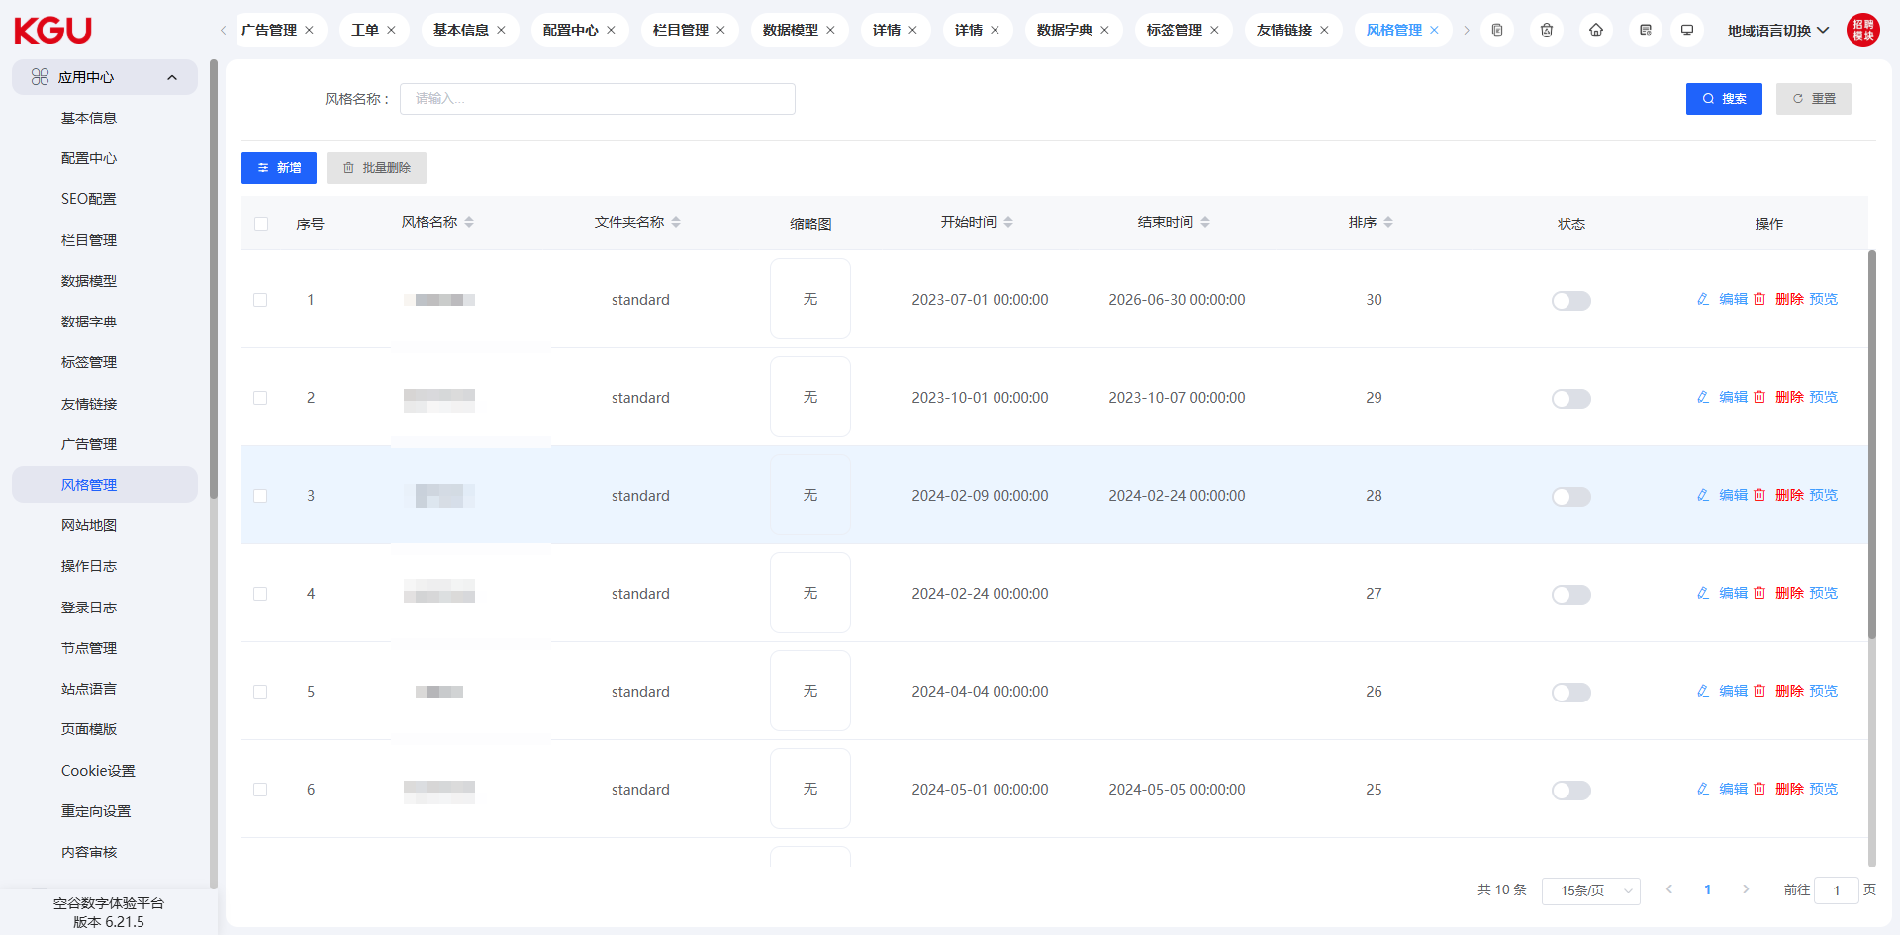
图 4.2.8 Style Management-风格管理
The system supports the skin change function. Through style management, you can change the skin of the website.
系统支持换肤功能，通过风格管理，可以对网站进行换肤操作。

Add Style-新增风格
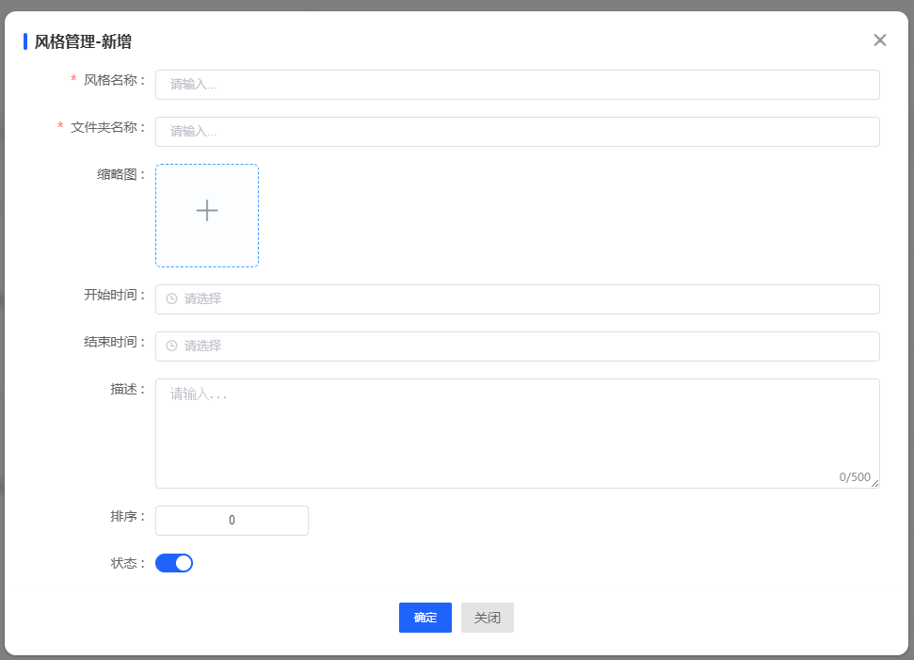
图 4.2.8(1) Add Style-新增风格
Style management needs to set up and develop the interface in accordance with KGU's requirements and specifications; otherwise, problems such as interface deformation and distortion may occur.
风格管理需要按空谷的要求规范进行界面的设置和开发，否则会造成界面变形、失真等问题产生。

4.2.10 Sitemap-网站地图
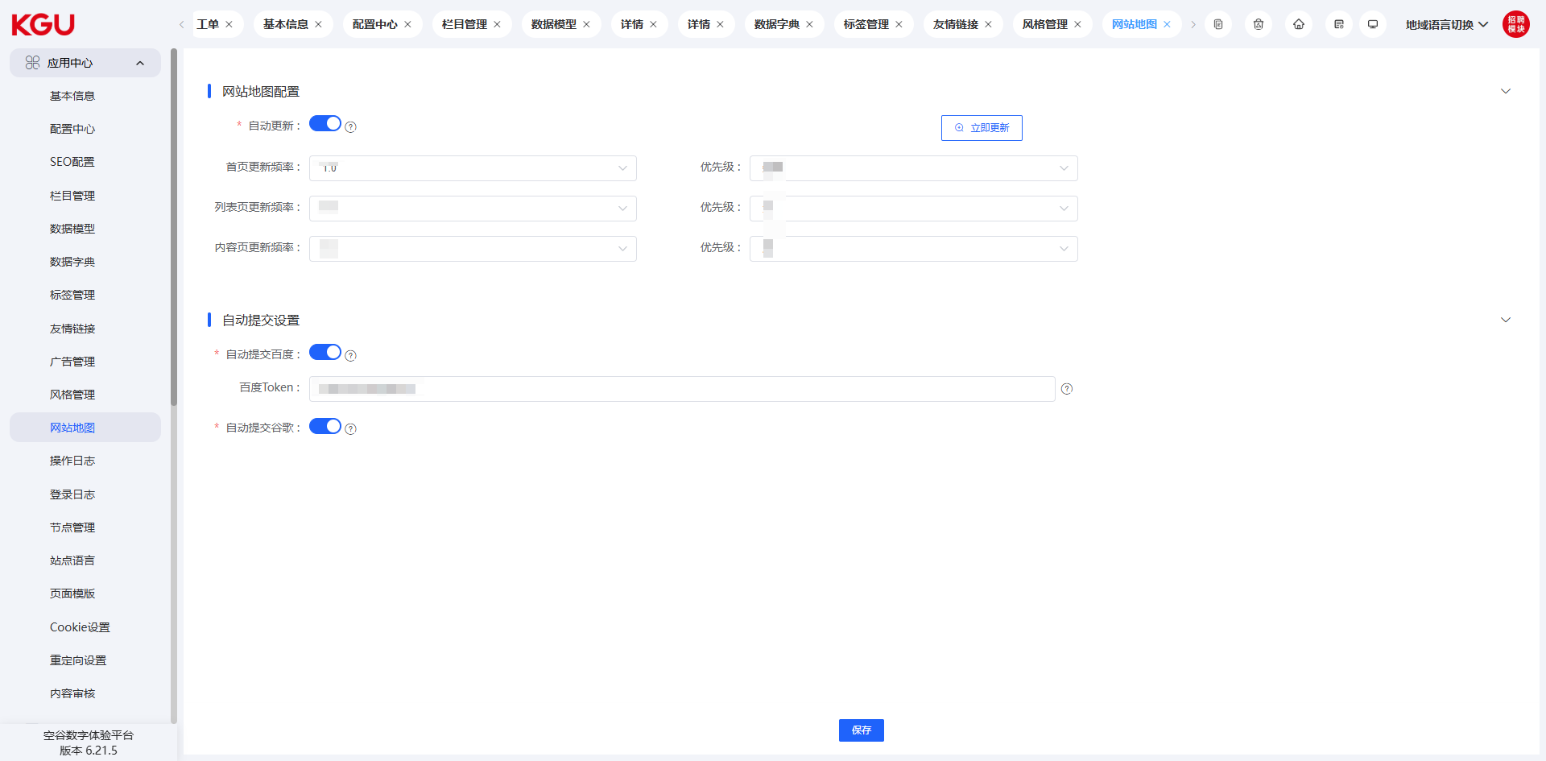
图 4.2.10 Sitemap-网站地图
The sitemap function is designed to facilitate search engines to crawl and identify page content. A standardized sitemap format is more conducive to the SEO optimization of the site.
The system supports the automatic refresh function of the sitemap. Users can set the corresponding refresh frequency.
网站地图功能是为了方便搜索引擎收录识别页面的内容，规范的网站地图格式更利于站点的SEO优化。
系统支持网站地图的自动刷新功能，用户可以设置对应的刷新频率。

4.2.11 Operation Log-操作日志
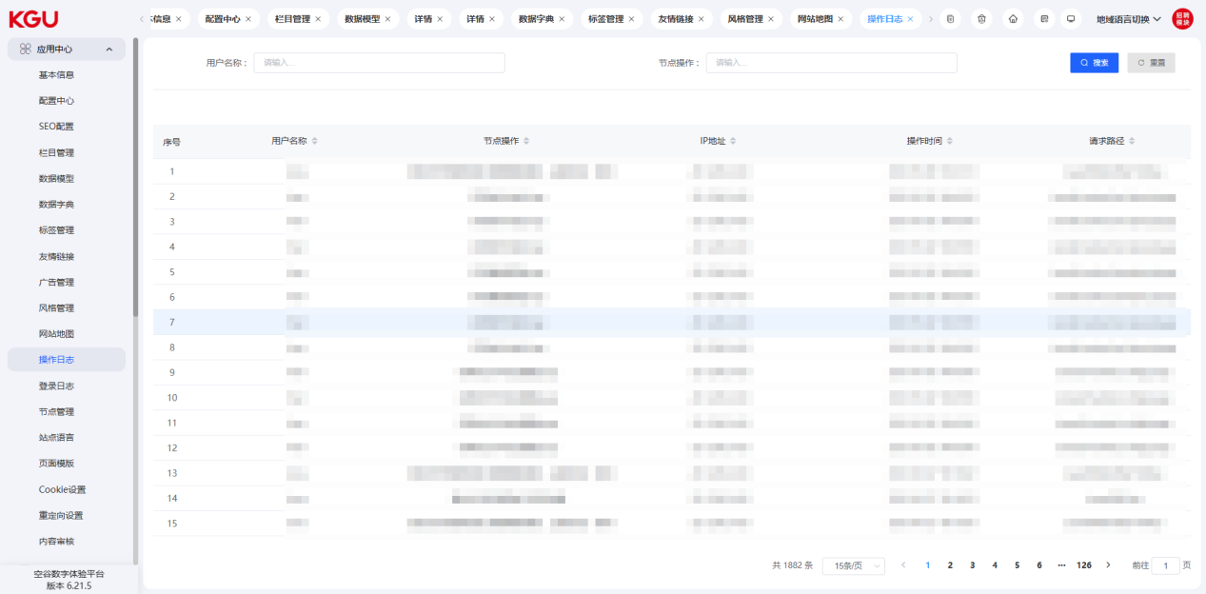
图 4.2.11 Operation Log-操作日志
The operation log interface of the system records the operation information of all users in the current system, which can help customers trace problems and define responsibilities.
系统的操作日志界面记录了当前系统所有的用户的操作信息，可以帮助客户进行问题的追溯和责任的界定。

4.2.12 Redirection Settings-重定向设置
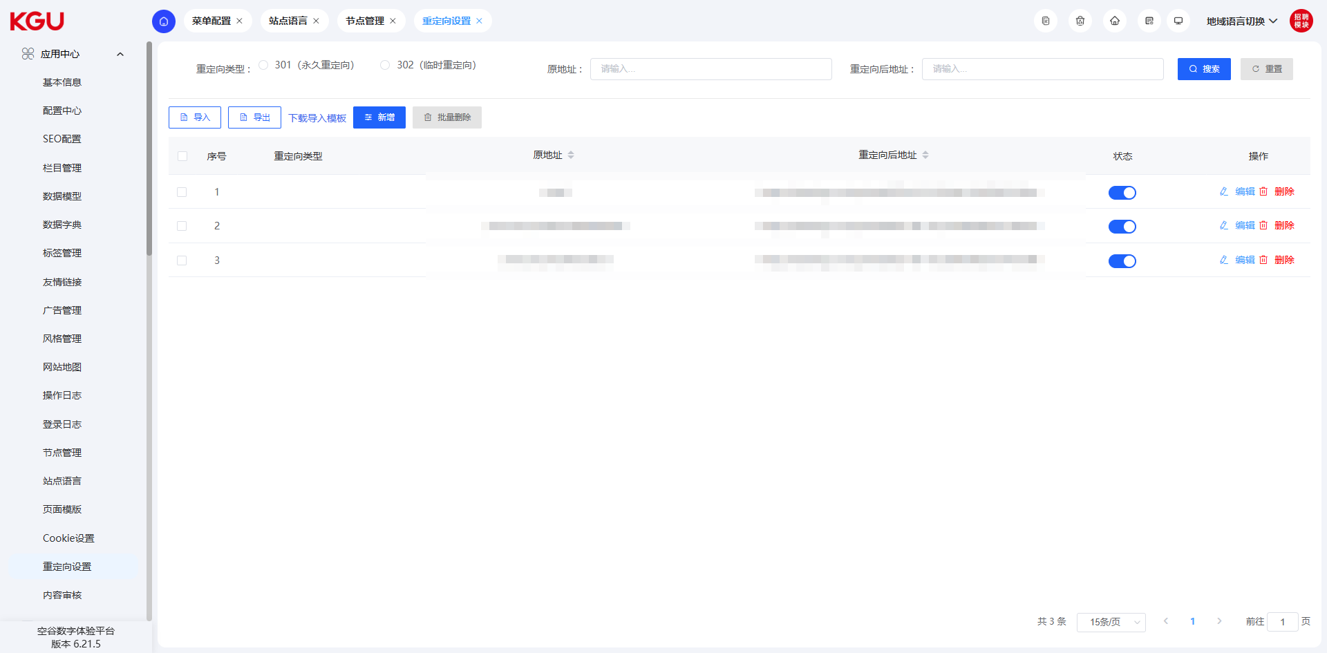
图 4.2.12 Redirection Settings-重定向设置
The system supports the redirection function. When the URL of a website page changes, redirection can guide the old wrong link to the new correct page, avoiding users accessing the 404 error page and improving the user experience.
系统支持重定向功能，当网站的页面 URL 发生变更，通过重定向可以将旧的错误链接引导至新的正确页面，避免用户访问到 404 错误页面，提升用户体验。

4.3 Message Management-消息管理

4.3.1 Message Management-留言管理
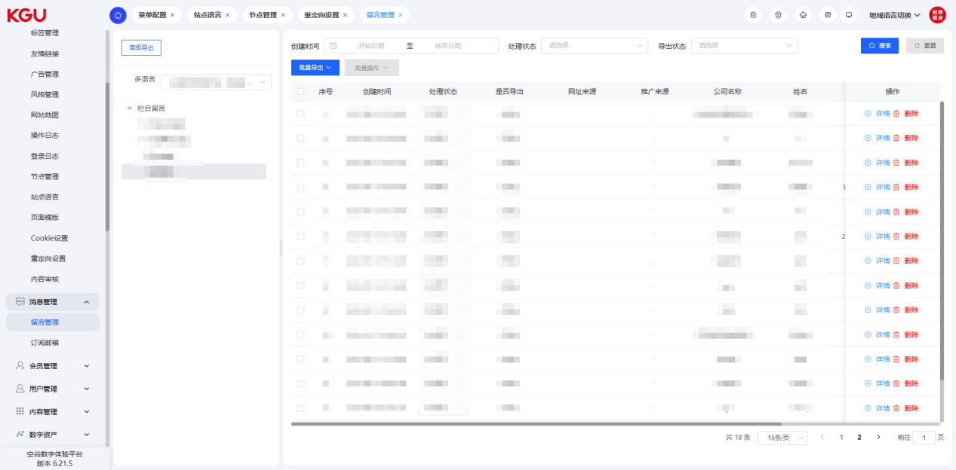
图 4.3.1(1) Message Management-留言管理
On the message management page, you can view all message information left by customers in the message board. The message content includes name, company, mobile phone number, email, column directory, message title, message details, and message time.
在留言管理页面，可以查看所有客户在留言板中的留言信息。留言内容包括姓名、公司、手机号、邮箱、栏目目录、留言标题、留言详情、留言时间。
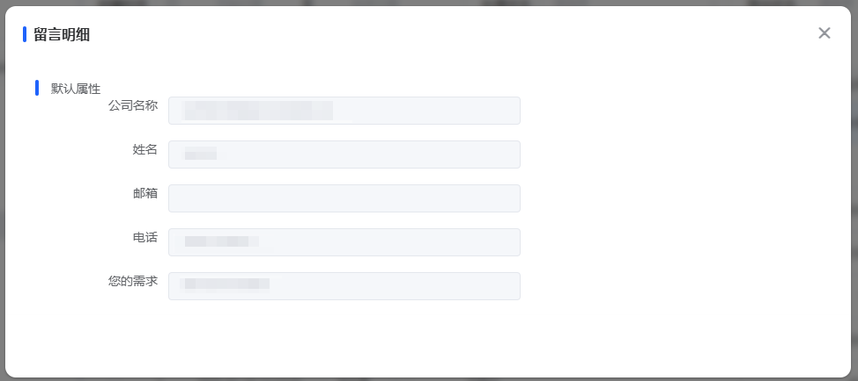
图 4.3.1(2) Message Management-留言管理
The system supports modifying the display status of messages. Through the disable function, the display of messages can be canceled.
系统支持留言显示状态的修改，通过禁用功能，可以取消留言的显示。
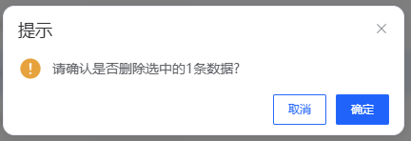
图 4.3.1(3) Message Management-留言管理
Find the message to be deleted on the message management list page and click the "Delete" button to delete it.
在留言管理列表页面查找要删除的留言，点击删除按钮即可删除。

4.3.2 Subscription Email-订阅邮箱
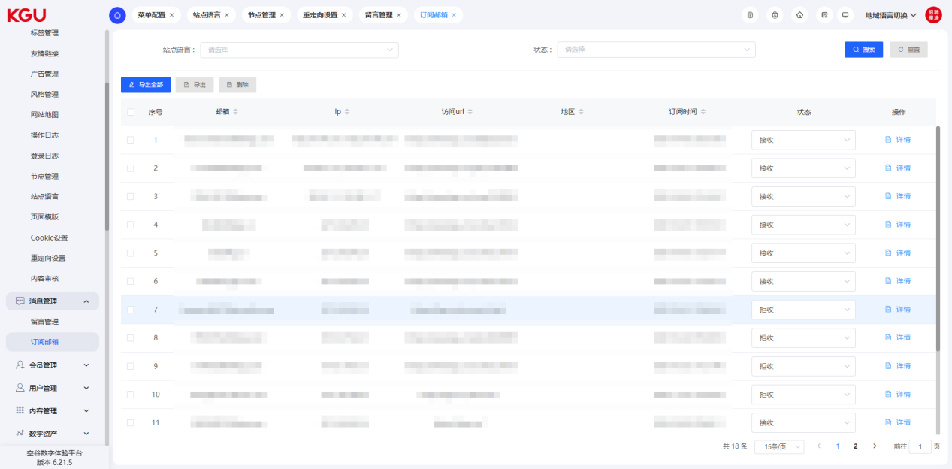
图 4.3.2(1) Subscription Email-订阅邮箱
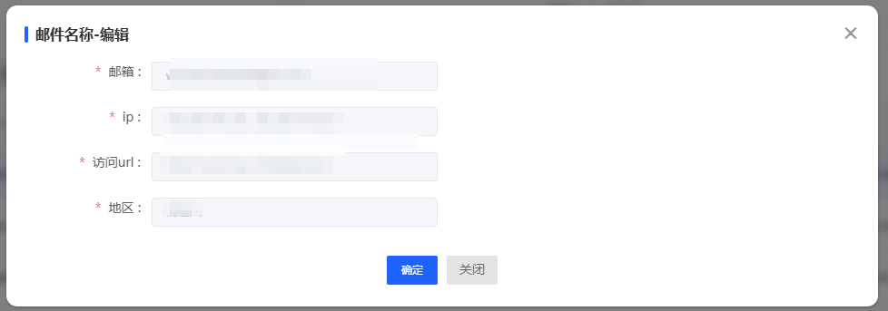
图 4.3.2(2) Subscription Email-订阅邮箱
On the subscription email page, you can view the email information left by all customers in the information submission. The content includes name, site language, email, IP, access URL, and region.
Find the email to be deleted on the subscription email list page and click the "Delete" button to delete it.
在订阅邮箱页面，可以查看所有客户留资中的邮箱信息，内容包括姓名、站点语言、邮箱、IP、访问URL、地区。
在订阅邮箱列表页面查找要删除的邮箱，点击删除按钮即可删除。

4.4 Membership Management-会员管理
The membership system allows visitors to fill in the registration form online and become system members immediately after system review. Front-end members can maintain their personal registration information by themselves, including modification and deletion. If a member forgets their password, they can retrieve it through online password query. A membership management interface is set up in the backend, where administrators can classify, query, and delete member information by date and name.
The membership management function is divided into three main modules: membership management, membership roles, and membership levels. The system supports members having multiple roles and can set membership settings for different language versions and different sub-sites as needed. The membership management function can fully manage all membership information registered on the website and provide convenient services and management for members.
By optimizing and refining the functions of the membership system, it can efficiently manage member information, flexibly set member roles and levels, and provide personalized services and management functions to improve member experience and satisfaction.
会员系统允许浏览者在线填写注册表，经过系统审核后即时成为系统会员。前台会员可以自行维护个人注册信息，包括修改和删除。如果会员忘记密码，可以通过在线查询密码来找回。后台设置了会员管理界面，管理员可以根据日期和姓名对会员信息进行分类查询和删除。
会员管理功能分为三个主要模块：会员管理、会员角色和会员等级。该系统支持会员拥有多个角色，并且可以根据需要设置不同语言版本和不同分站的会员设置。会员管理功能够全面管理在网站注册的所有会员信息，为会员提供便利的服务和管理。
通过优化和细化会员系统的功能，使其能够高效地管理会员信息，灵活设置会员角色和等级，并提供个性化的服务和管理功能，以提升会员的体验和满意度。

4.4.1 Membership List-会员列表
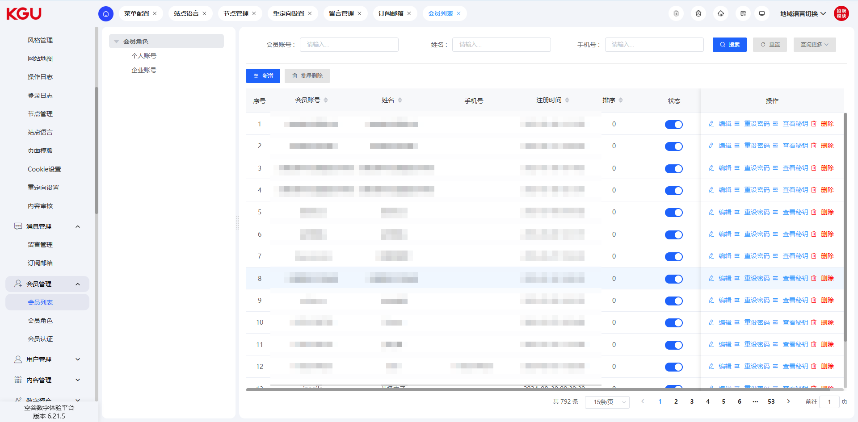
图 4.4.1 Membership List-会员列表
The system provides comprehensive membership management functions. After a visitor registers as a member on the front-end, the back-end can edit, authenticate, manage addresses, modify passwords, add, and delete members.
The membership management function supports filtering by membership role, gender, and status, and also provides search functions by creation time and key fields (account, name, mobile phone number). In this way, administrators can easily filter and search for members according to different conditions to better manage and serve members. The system's membership management function can meet diverse needs and improve the efficiency and convenience of membership management.
系统提供了全面的会员管理功能。访客在前台注册成为会员后，后台可实现对会员进行编辑、认证、地址管理、密码修改、增加和删除等操作的功能。
会员管理功能支持会员角色、性别、状态筛选，同时还提供了按照创建时间和关键字段（账号、姓名、手机号码）进行搜索的功能。这样，管理员可以方便地根据不同条件对会员进行筛选和搜索，以便更好地管理和服务会员。系统的会员管理功能能够满足多样化的需求，提高会员管理的效率和便利性。

Add Member-新增会员
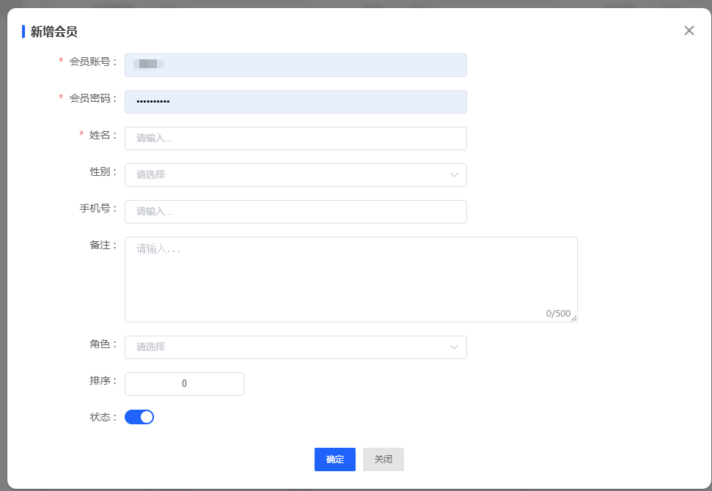
图 4.4.1(1) Add Member-新增会员
By clicking the "Add Member" operation in the upper left corner, you can add a new member. When adding a member, you can set the following field information: member account, password, name, gender, mobile phone number, remarks, role, sort order, etc.
In addition, you can control whether a member can log in to the system through the member status. This function provides a wealth of field options, allowing you to flexibly set member information and manage and control it as needed.
通过点击左上角的新增会员操作，可以进行会员新增。在新增会员时，您可以设置以下字段信息：会员账号、密码、姓名、性别、手机号、备注、角色、排序等。
此外，您还可以通过会员状态来控制会员是否能够登录系统。这样的功能提供了丰富的字段选项，使得您可以灵活地设置会员的信息，并根据需要对其进行管理和控制。

Password Modification-密码修改
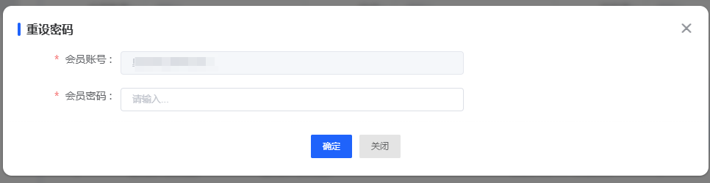
图 4.4.1(2) Password Modification-密码修改
In the management backend, you can directly modify a member's password. Since the user has passed identity verification when logging in to the management backend, no further verification is required when modifying the password, and the modification can be performed directly, improving the convenience and efficiency of the operation.
在管理后台中，您可以直接修改会员的密码。由于用户在登录管理后台时已经通过身份验证，因此在修改密码时无需再次验证，可以直接进行修改操作，提高了操作的便捷性和效率。

Edit and Delete - 编辑及删除
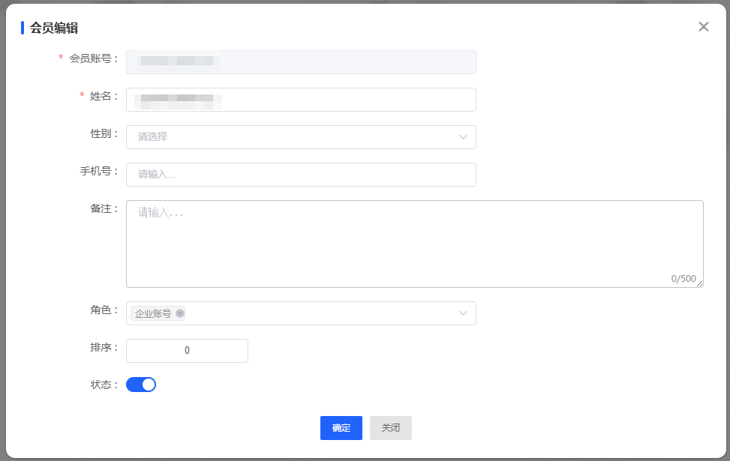
图 4.4.1(3) Password Modification-密码修改
The management backend provides functions for editing and deleting member information, including modifying and updating member data and deleting operations.
This optimization enables the management backend to have comprehensive member information management capabilities. You can flexibly perform editing and deletion operations to meet different management needs.
管理后台提供了对会员信息进行编辑和删除的操作功能，包括对会员资料的修改和更新以及删除操作。
这一优化使得管理后台具备了全面的会员信息管理能力，您可以灵活地进行编辑和删除操作，以满足不同的管理需求。

4.4.2 Membership Roles-会员角色
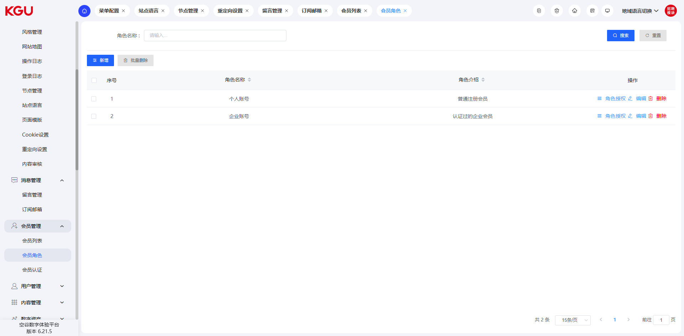
图 4.4.2 Membership Roles-会员角色
Roles are preset in the system according to business management needs. Each role in the system corresponds to clear system permissions and is composed of multiple minimum permission particles.
Functional Permissions: Functional permissions are the basic units for the system to implement permission control. By dividing permissions for functional modules, rough-grained division of member permissions is realized. Members with different roles can view the same data fields, but the functional operations they can perform are different.
Data Permissions: Data permissions are relatively fine-grained permission controls, which realize the difference in data visibility among members with different roles in the same module. When members with different roles access the same module, limited by their role permissions, the data fields they can see will be different.
Menu Permissions: Menu permissions are used to control the menu page content visible to the current account.
The membership role management interface provides settings for different membership roles. The relationship between members, roles, and permissions is many-to-many. That is, a member can be assigned multiple roles, and a role can be assigned to multiple members; at the same time, a role can have multiple permissions, and a permission can be assigned to multiple roles. Through the setting of this association relationship, flexible management of members, roles, and permissions is realized.
角色是根据业务管理需求预先在系统中设定的，在系统中每个角色都对应着明确的系统权限，是由多个最小权限颗粒组成的。
功能权限：功能权限是系统执行权限控制的基本单元。通过对功能模块进行权限划分，实现了会员权限的粗颗粒度划分。不同角色的会员可以查看相同的数据字段，但其能够执行的功能操作却有所不同。
数据权限：数据权限是相对细颗粒度的权限控制，它实现了不同角色会员在同一模块中的数据可见性差异。不同角色会员在访问同一模块时，受限于其拥有的角色权限，能够看到的数据字段会有所差异。
菜单权限：菜单权限用于控制当前账号所能看到的菜单页面内容。
会员角色管理界面提供了对不同会员角色的设置。会员、角色和权限之间的关系是多对多的，即一个会员可以被赋予多个角色，一个角色可以被赋予多个会员；同时，一个角色可以拥有多项权限，而一项权限可以被赋予多个角色。通过这种关联关系的设置，实现了会员、角色和权限的灵活管理。

Add Role-新增角色
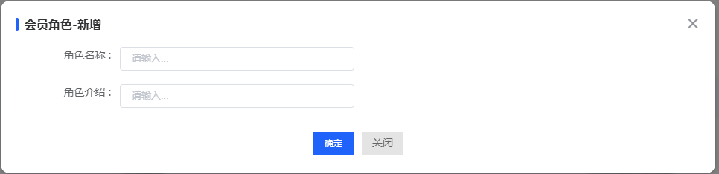
图 4.4.2(1) Add Role-新增角色
By clicking the "Add Role" button in the upper left corner, you can create a role. When creating a role, you need to fill in the following information: role name and role description. In addition, the role can be controlled to be enabled or not through the status button. When creating a member, only enabled roles can be selected as the member's role.
With this optimization, you can easily create roles and set related attributes. The enable status of roles can be flexibly switched to ensure that only enabled roles are available for selection, making the role assignment of members more convenient and accurate.
通过点击左上角的新增角色按钮，可以进行角色的创建操作。在创建角色时，您需要填写以下信息：角色名称、角色介绍。此外，角色可以通过状态按钮控制是否启用。在创建会员时，只能选择已启用的角色作为会员角色。
通过这一优化，您可以方便地创建角色并设置相关属性。角色的启用状态可以灵活开关，确保只有已启用的角色可供选择，使得会员的角色分配更加便捷精确。

Role Permission Setting-角色权限设置
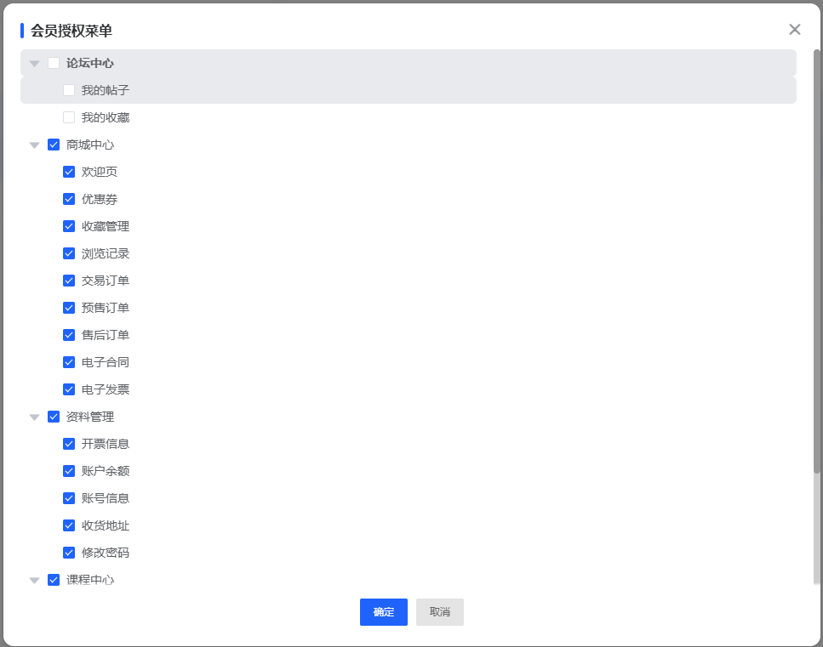
图 4.4.2(2) Role Permission Setting-角色权限设置
Find the role to be operated in the role management list, and then use the node authorization function to assign different permissions to the role.
When assigning permissions, you only need to simply check the corresponding functional modules to complete the operation.
With this optimization, you can easily assign the required permissions to roles. Using the node authorization function, you only need to check the corresponding functional modules to quickly complete the permission assignment. This simple permission assignment method makes the permission management of roles more flexible and efficient.
在角色管理列表中找到需要操作的角色，然后使用节点授权功能，可以为该角色分配不同的权限。
在进行权限分配时，只需要简单地勾选对应的功能模块即可完成操作。
通过这一优化，您可以轻松为角色分配所需的权限。使用节点授权功能，您只需勾选相应的功能模块，即可快速完成权限的分配。这种简便的赋权方式使得角色的权限管理更加灵活高效。

4.4.3 Membership Authentication-会员认证
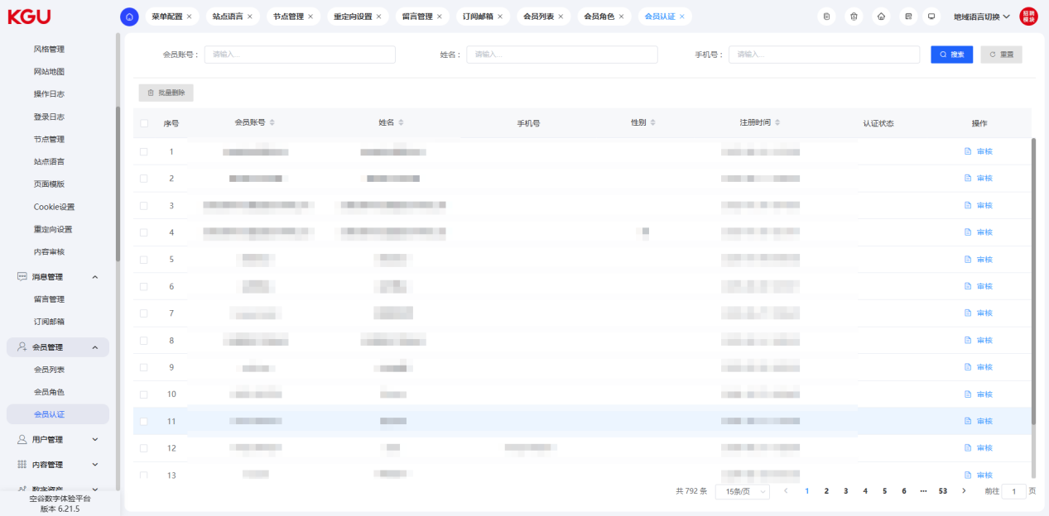
图 4.4.3(1) Membership Authentication-会员认证
Visitors fill in the member registration information on the front-end. The membership authentication can display the submitted data. The administrator clicks "Approve" or "Reject" to complete the authentication.
访客在前台填写会员注册信息，会员认证可展示提交的数据，管理员点击同意或拒绝，即可完成认证。
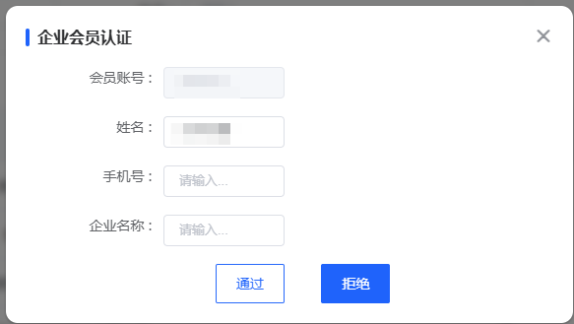
图 4.4.3(2) Membership Authentication-会员认证

4.5 User Management-用户管理

4.5.1 User List-用户列表
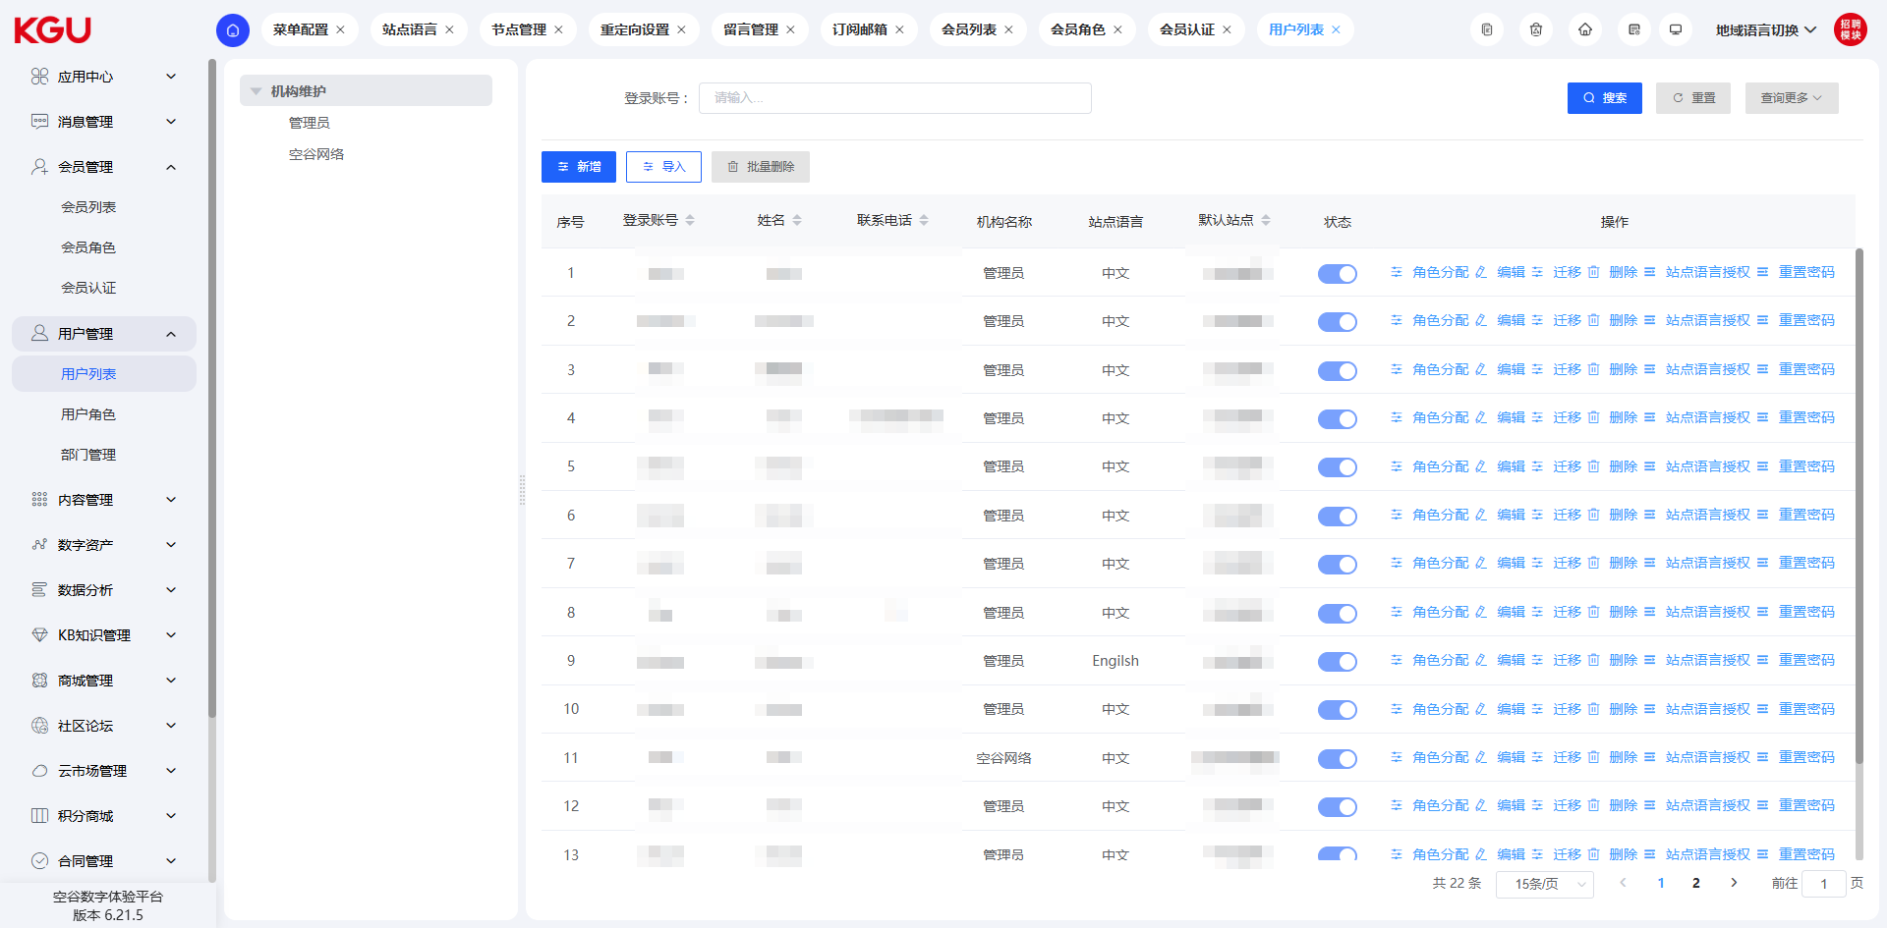
图 4.5.1 User List-用户列表
RBAC (Role-Based Access Control) means: Role-Based Access Control. It indirectly grants permissions to users by associating users with roles and roles with permissions.
On the user management page, you can perform management operations on the login users of the management backend.
RBAC（Role-Based Access Control）即：基于角色的权限控制。通过角色关联用户，角色关联权限的方式间接赋予用户权限。
在用户管理页面，可以进行管理后台登录用户的管理操作。

Add/Edit User-新增/编辑用户
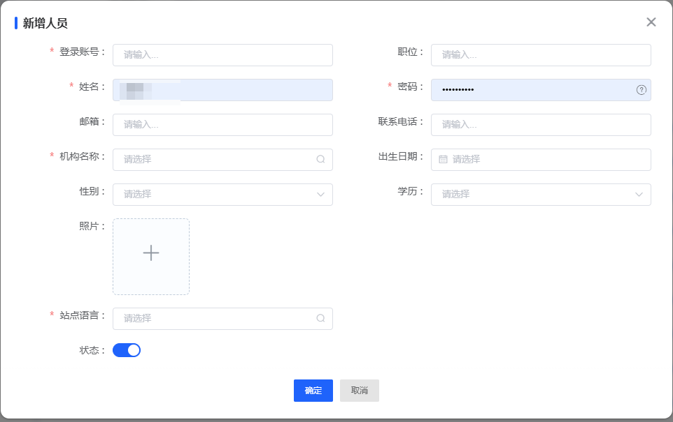
图 4.5.1(1) Add/Edit User-新增/编辑用户
Click "Add User" in the upper left corner to add a user. When adding a user, you can set the user's login account, position, name, password, email, contact phone number, organization name, date of birth, gender, education background, photo, site language, etc.
The user's account and password need to be kept in mind to avoid being unable to log in to the system due to forgetting. The contact phone number needs to be a real mobile phone number, so that the password can be reset through the SMS verification code when the password is forgotten.
Before creating a user, you need to create a role first. If a user account is not bound to a role, the user cannot log in to the system. When the user attempts to log in, the system will prompt "No Permission".
点击左上角的新增用户，可以进行用户新增的操作。新增用户时，可以设置用户登录账号、职位、姓名、密码、邮箱、联系电话、机构名称、出生日期、性别、学历、照片、站点语言等。
用户的账号密码需要牢记，避免因忘记而无法登录系统。联系电话需要填写真实的手机号码，这样可以在忘记密码时，通过短信验证码进行密码重置操作。
在创建用户之前，要先创角色，如果用户账号没有绑定角色，那么该用户无法登录系统。用户尝试登录后，系统会提示无权限。

4.5.2 User Roles-用户角色
On the role management interface, you can view all user roles set in the current system. Through the user role function, you can modify and configure the role of the current account.
Permissions are collections of resources. The resources here refer to all content in the software, including modules, menus, pages, fields, operation functions (add, delete, modify, query), etc. In terms of specific permission configuration, there are various forms currently. Permissions can be divided into: menu permissions, operation permissions, and data permissions.
在角色管理界面，可以查看当前系统设置的所有用户角色。通过用户角色功能，可以修改配置当前账号的角色。
权限是资源的集合，这里的资源指的是软件中所有的内容，包括模块、菜单、页面、字段、操作功能（增删改查）等等。具体的权限配置上，目前形式多种多样，可以将权限分为：菜单权限、操作权限和数据权限。
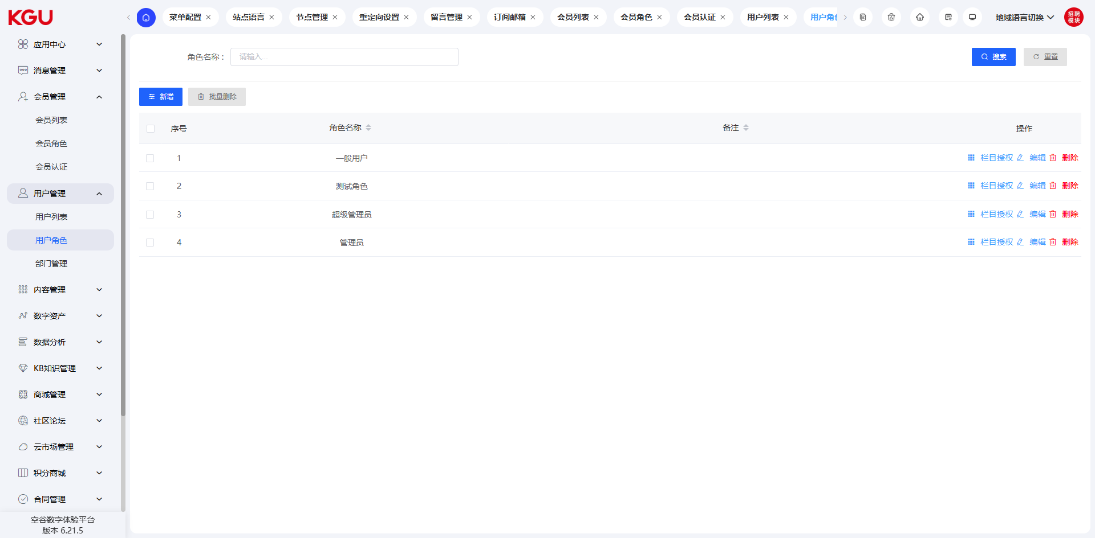
图 4.5.2 User Roles-用户角色

Column Permissions-栏目权限
On the role management interface, you can set the menu permissions of the corresponding role. By checking the corresponding menu, you can grant the menu access permission to the corresponding role.
在角色管理界面，可以设置对应角色的菜单权限，通过勾选对应的菜单，即可赋予对应角色的菜单访问权限。
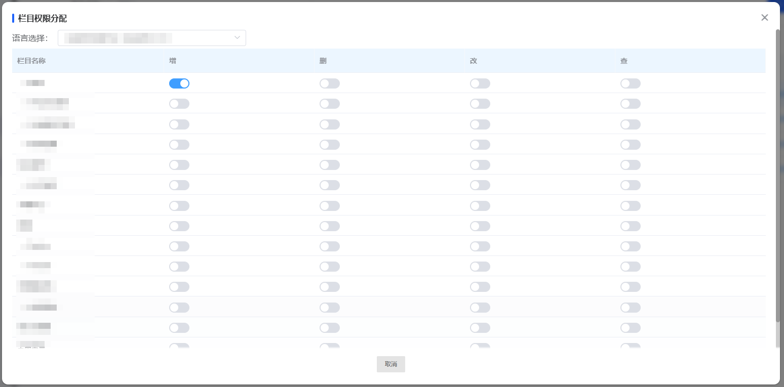
图 4.5.2(1) Column Permissions-栏目权限

Add Role-新增角色
Multiple roles can be created according to actual business needs. When adding a role, the following fields are required: role name, role code, and remarks.
可根据实际的业务需要，创建多个角色。新增角色时，需要下述字段：角色名称，角色编码，备注。
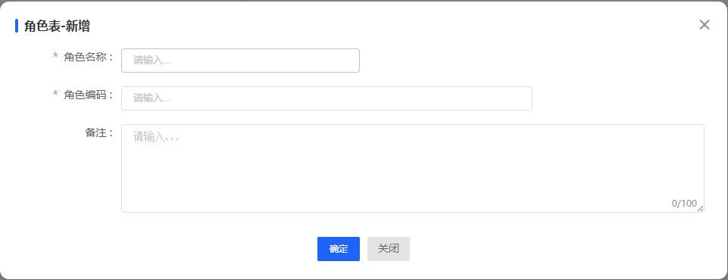
图 4.5.2(2) Add Role-新增角色

4.5.3 Department Management-部门管理
Department management is the management of user groups. You can create different user groups here according to actual needs.
部门管理是对用户分组的管理，可在这里根据实际需要创建不同的用户分组。
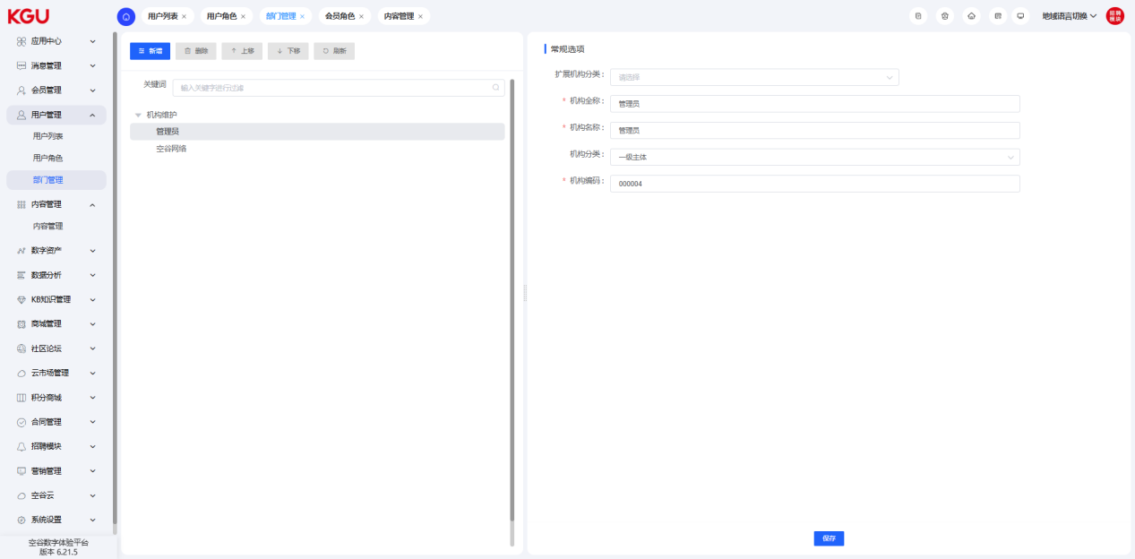
图 4.5.3 Department Management-部门管理

4.6 Content Management-内容管理
Content management is used to manage the data assets of the digital portal, including functions of querying, adding data, deleting, batch deleting, copying, and editing.
内容管理用于对数字门户的数据资产进行管理，包括查询、新增数据、删除、批量删除、复制、编辑的功能。
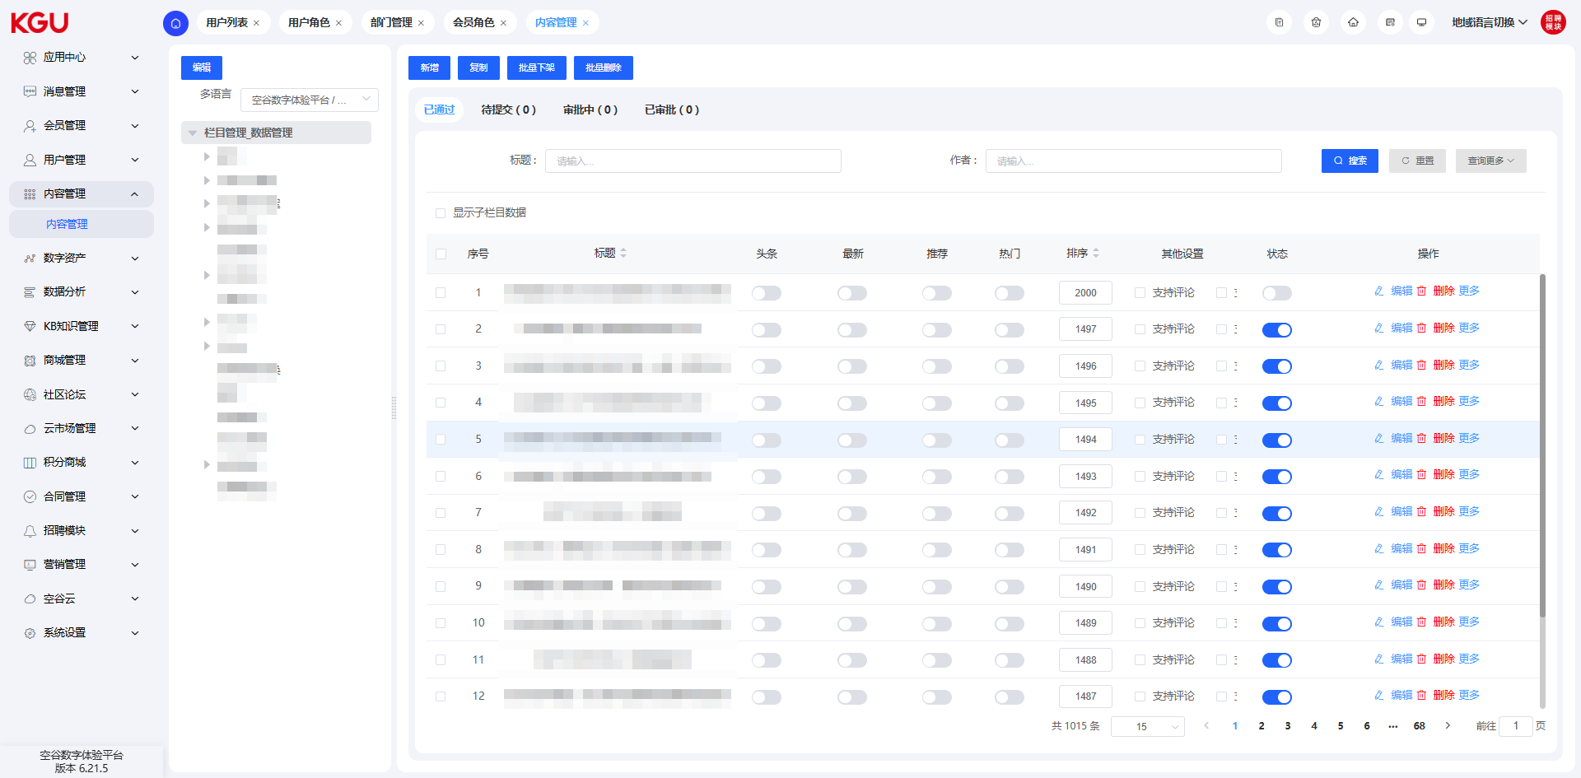
图 4.6 Content Management-内容管理

4.6.1 General Options-常规选项
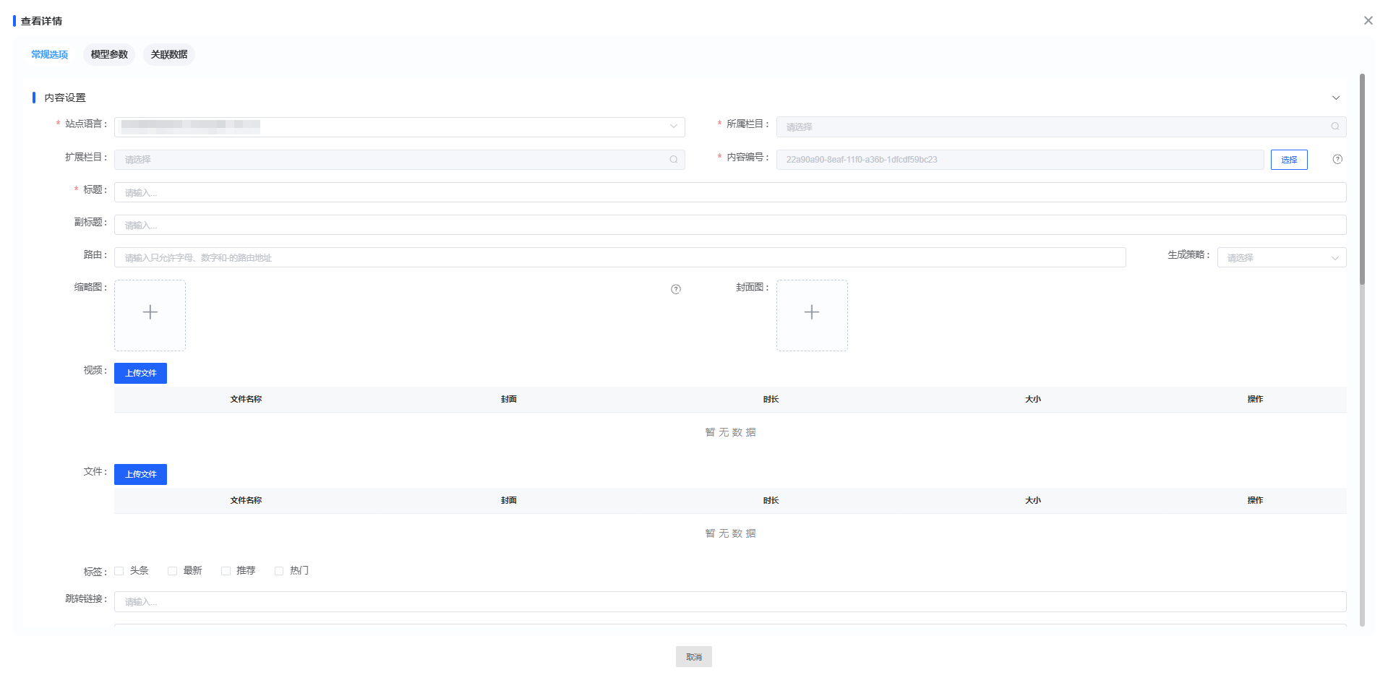
图 4.6.1(1) General Options-常规选项
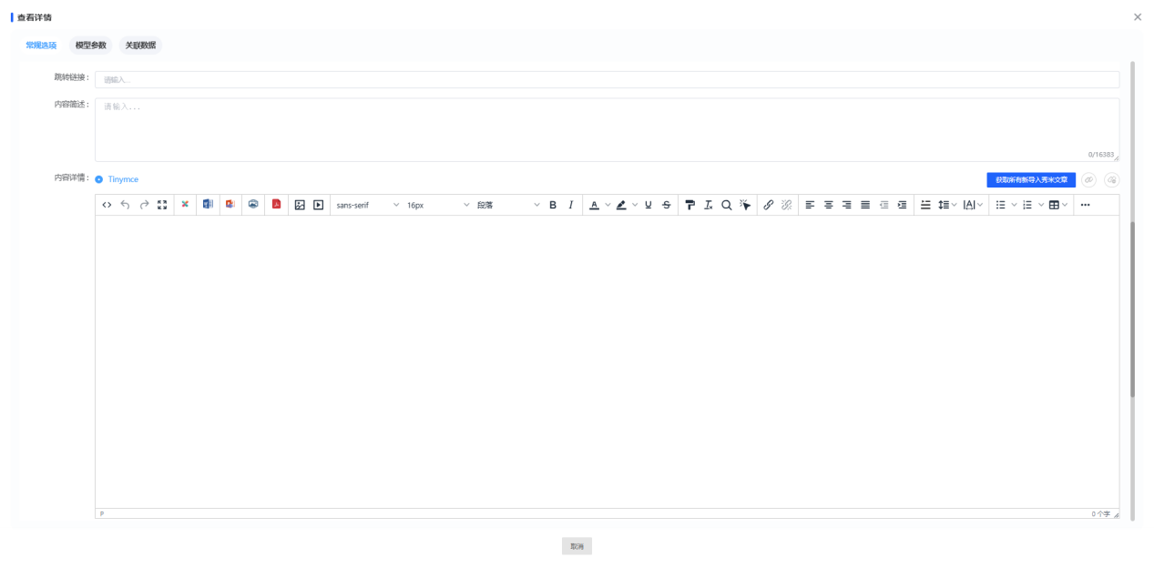图 4.6.1(2) General Options-常规选项
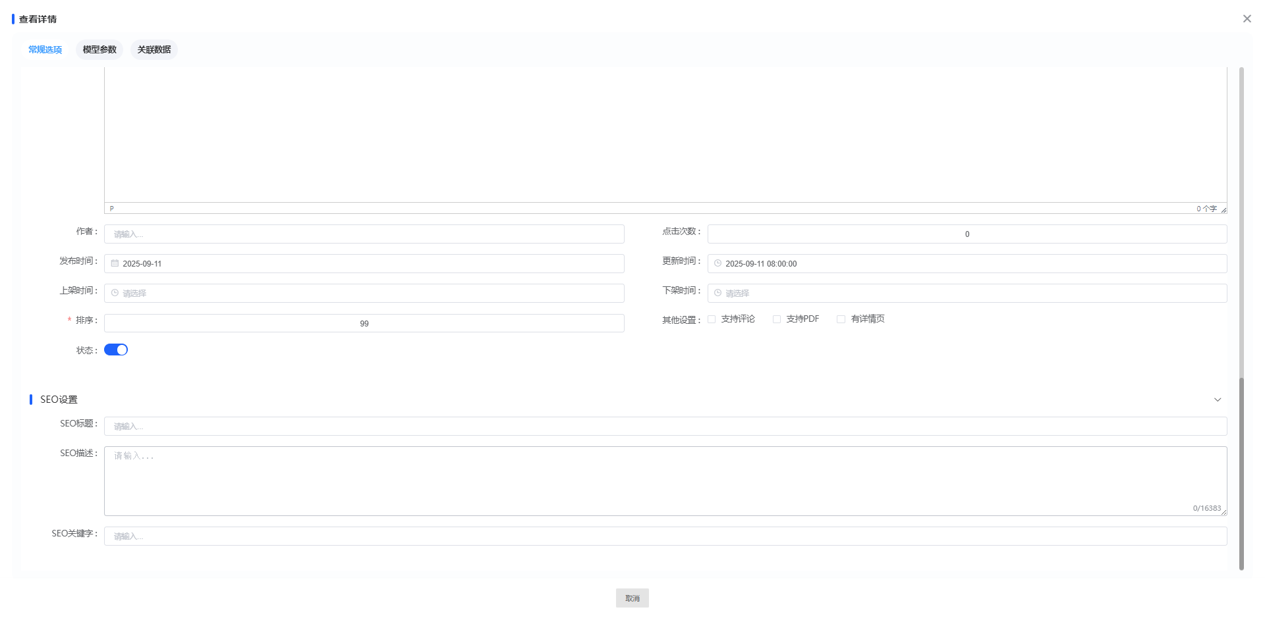
图 4.6.1(3) General Options-常规选项
Site Language: Select the language.
Corresponding Column: Select the position where the data needs to be displayed.
Extended Columns: Usually not used. It will be selected when a piece of data needs to be used in multiple places at the same time, and multiple selections are allowed.
Title: The article title displayed on the website.
Subtitle: Rarely used, usually used for the first-level title under the main title.
Jump Link: Note that http needs to be added manually.
Headline, Recommendation, Latest, Popular: Selected when the data needs to be displayed on the homepage or in a fixed position. Recommendation and Popular are commonly used.
Thumbnail: The picture attached to the article.
Cover Image: Will be noted in the document when it needs to be used.
Video: The default size is 50MB. Currently, large videos need to be compressed if they need to be uploaded.
Summary: The small text content under the title when it is recommended as popular.
Content: The main content.
Release Time: The release time of the article.
Update Time: The update time will be used for sorting. No selection is required; it will be automatically updated after editing.
Offline Time: After this time, the status will be automatically turned off.
Status: Need to be manually clicked to enable.
站点语言：选择语言
所属栏目：选择数据需要显示的位置
扩展栏目：通常不会使用，当一条数据需要在多个地方同时使用时会选择，可以多选
标题：网站上面显示的文章标题
副标题：用处较少通常大标题下的一级标题会用
跳转链接：需要注意手动增加http
头条，推荐，最新，热门：需要把数据放到首页展示或者固定位置展示是选择，推荐，热门常用
缩略图：文章附带的图片
封面图：需要使用时会在文档内备注
视频：默认50MB 需要上传大视频目前需要压缩
简述：在热门推荐时，标题下面的小字内容用
内容：正文内容
发布时间：文章发布时间
更新时间：排序会用更新时间，不需要选择 编辑后自动更新
下架时间：到了该时间，状态自动关闭
状态：需要手动点击开启

4.6.2 Model Parameters-模型参数
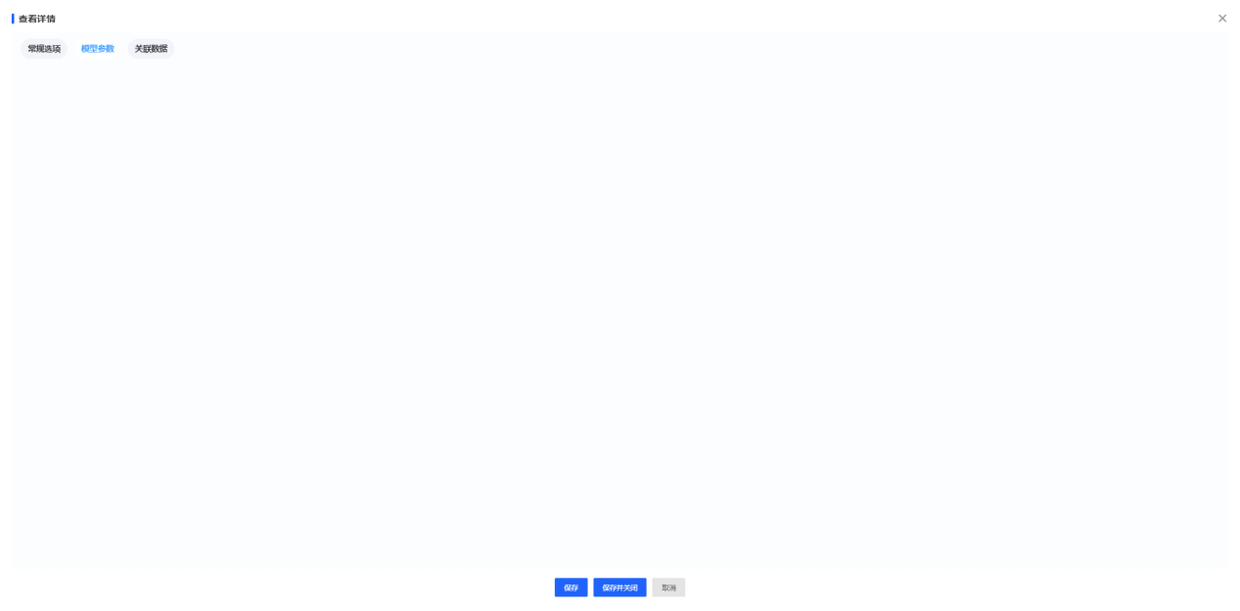
图 4.6.2 Model Parameters-模型参数
It contains some text boxes and image upload boxes, and you can choose to fill them in voluntarily.
里面对应一些文本框和图片上传框，自主选择填写。

4.6.3 Associated Data-关联数据
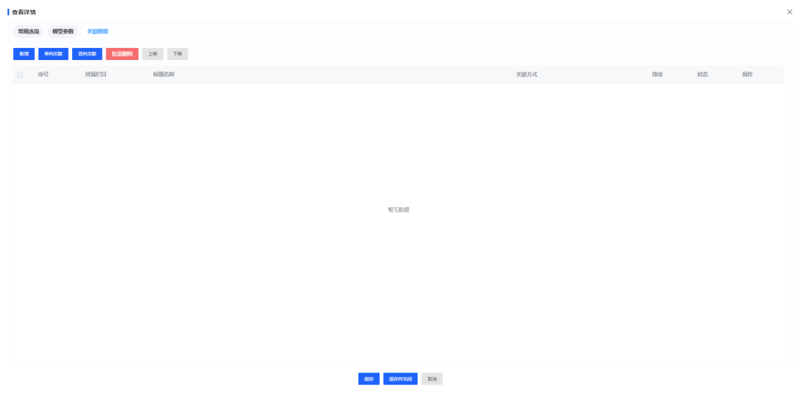
图 4.6.3 Associated Data-关联数据
Column Directory: The column where the data associated with this data is located.
Title: Select the title of the associated data. Click "Query" to query the data.
Associated Articles: After selecting the data, click the right arrow to complete the association.
栏目目录：赫本条数据关联的数据在那个栏目下
标题：选择所关联数据的标题 点击查询后查询出数据
关联文章：选择好数据后，点击向右箭头即可

4.7 Data Analysis-数据分析
The data analysis function is divided into four modules: visitor summary table, source analysis, location analysis, and software analysis.
数据分析功能分为访客总表、来源分析、所在地分析、软件分析共四个模块。

4.7.1 Operation Overview-运营概况
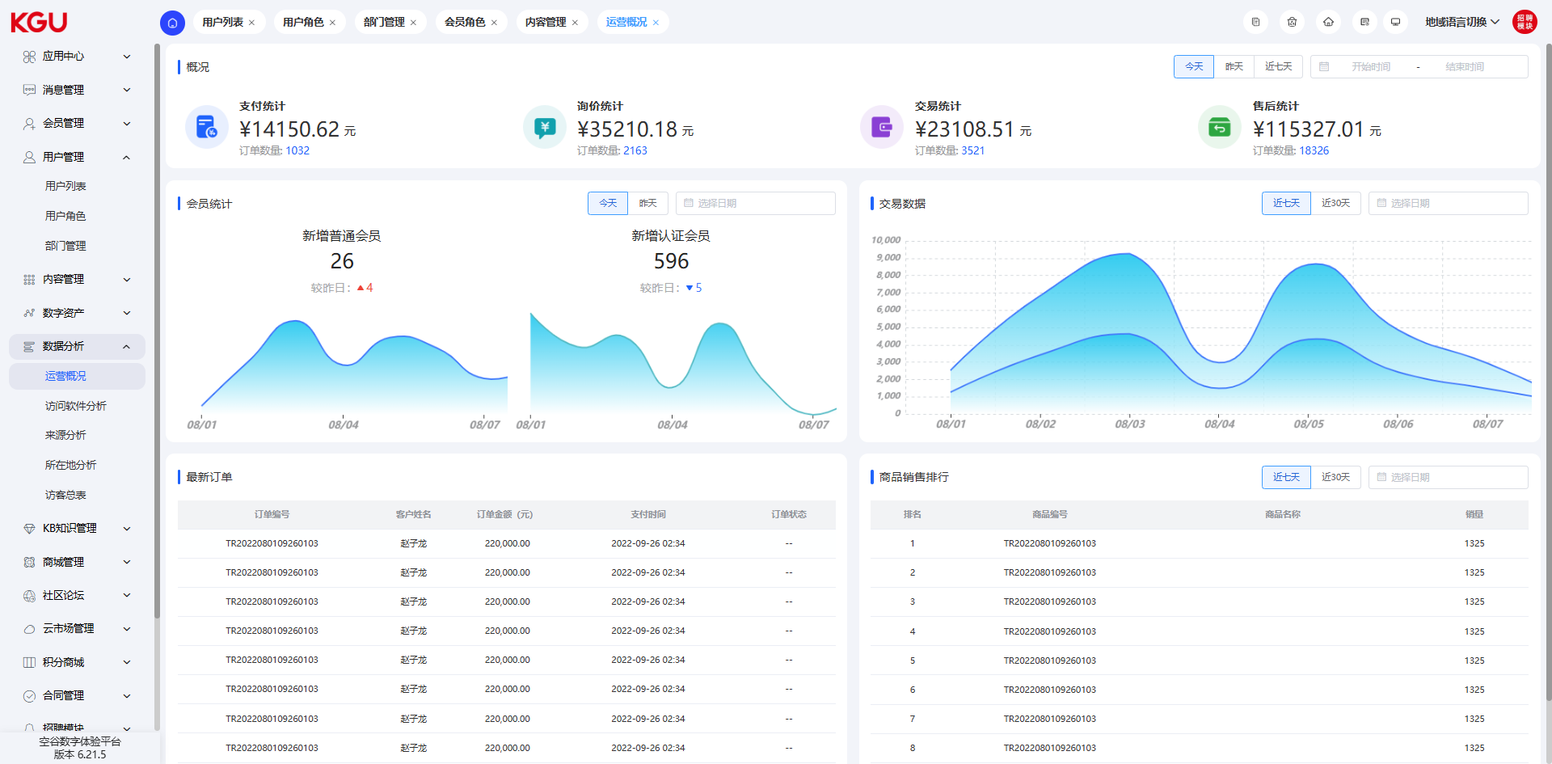
图 4.7.1 Operation Overview-运营概况
The operation overview module is mainly used to analyze the operation status of the mall and provides the following functions:
Overview: This function provides statistics on payment, inquiry, transaction, and after-sales amounts. You can query the statistical information according to different time ranges (such as today, yesterday, the past 7 days, the past month, or select a specific date) to understand the changing trend of the operation status.
运营概况模块主要用于分析商城的运营状况，并提供以下功能：
概况：该功能提供对支付、询价、交易以及售后金额的统计。您可以根据不同的时间范围（如今天、昨天、近7天、近一个月或选择特定日期）查询统计信息，从而了解运营状况的变化趋势。

4.7.2 Access Software Analysis-访问软件分析
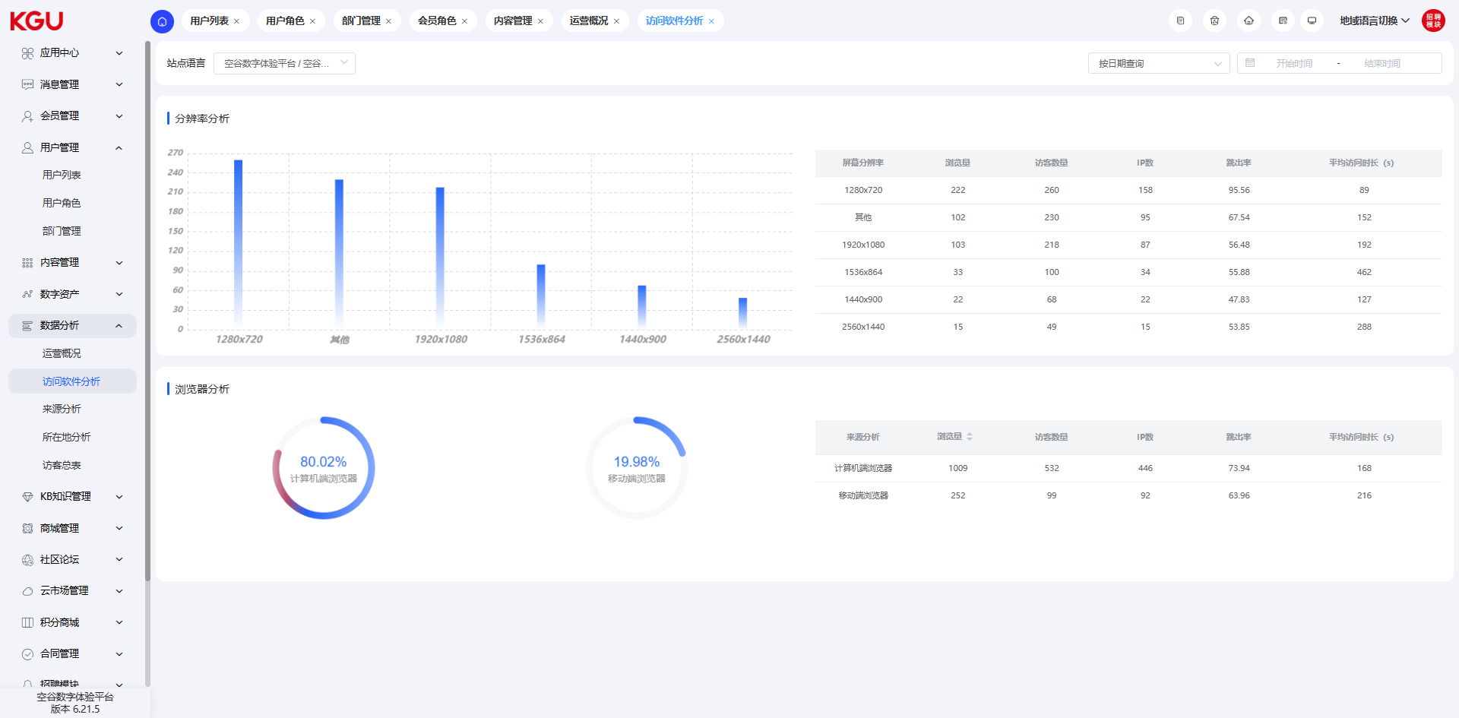
图 4.7.2 Access Software Analysis-访问软件分析
Access software analysis includes resolution analysis and browser analysis:
Resolution Analysis: Counts the page views, number of visitors, number of IPs, bounce rate, and average access duration under different screen resolutions (such as 1920x1080, 1280x720, etc.), and presents them through bar charts and tables to help understand the screen adaptation of users' devices.
Browser Analysis: Displays the page views, number of visitors, number of IPs, bounce rate, and average access duration of computer and mobile browsers through pie charts and tables, which is used to know the distribution of browser terminals accessed by users.
访问软件分析包括分辨率分析，浏览器分析：
分辨率分析：统计不同屏幕分辨率（如 1920x1080、1280x720 等 ）下的浏览量、访客数、IP 数、跳出率、平均访问时长，通过柱状图和表格呈现，助于了解用户设备屏幕适配情况。
浏览器分析：以饼图和表格展示计算机端、移动端浏览器的浏览量、访客数、IP 数、跳出率、平均访问时长，用于知晓用户访问的浏览器终端分布 。

4.7.3 Source Analysis-来源分析
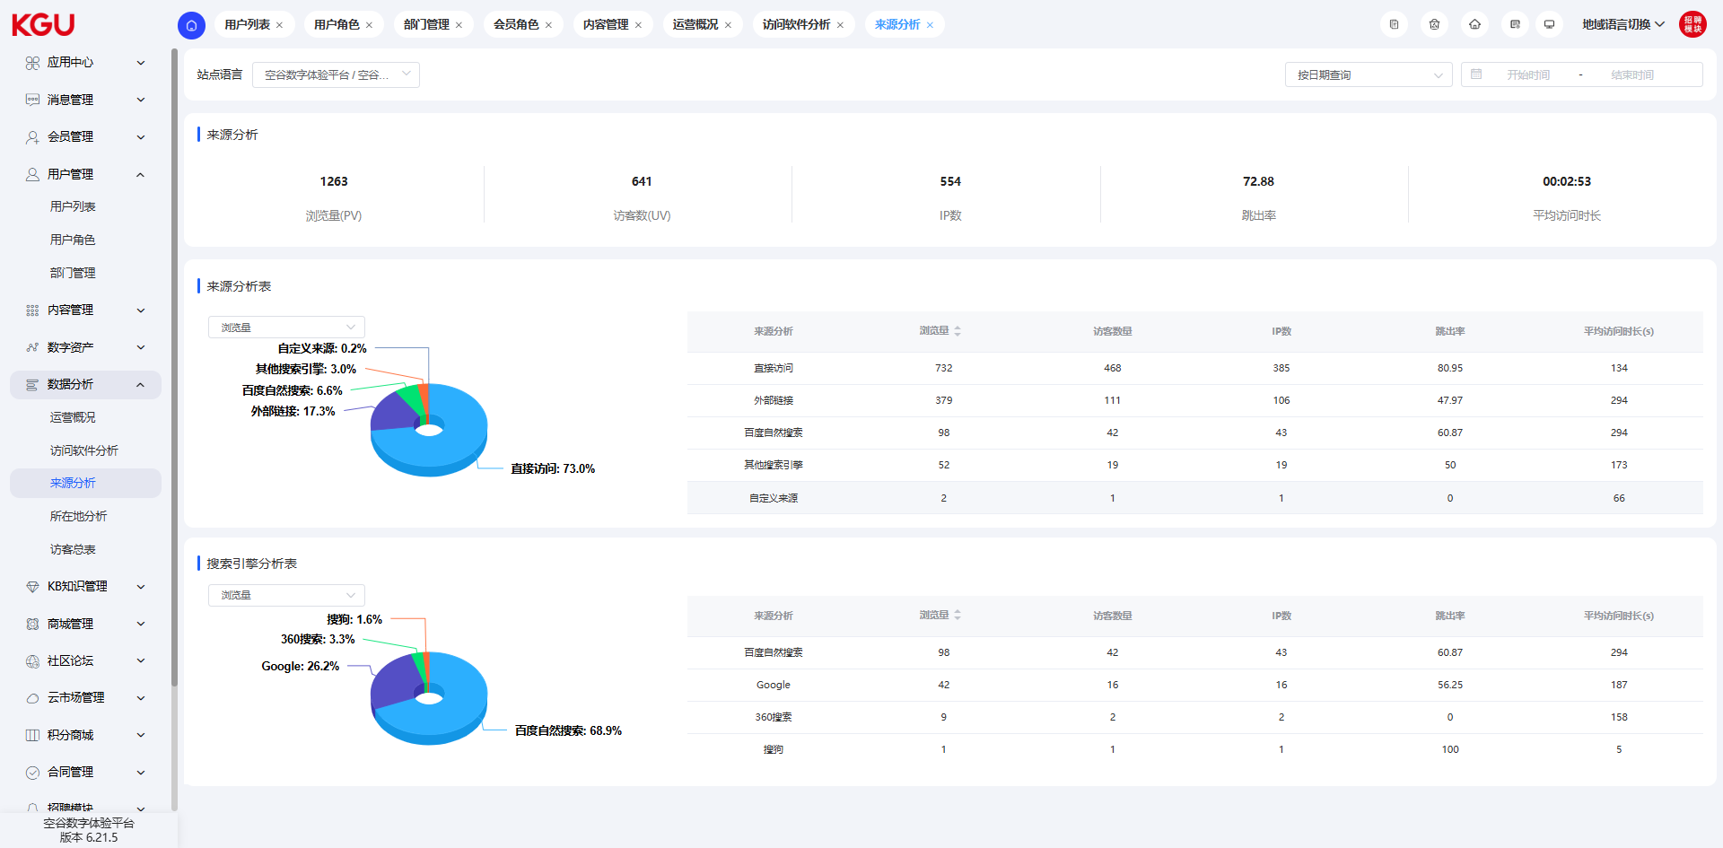
图 4.7.3(1) Source Analysis-来源分析
Source analysis includes user source analysis chart, source analysis table, and search engine analysis table. Source analysis can help operators analyze user sources to judge the effect of promotion and assist in formulating promotion decisions. Users can filter the access summary table by specifying the date and time range.
来源分析包括用户来源分析图，来源分析表和搜索引擎分析表。来源分析可以帮助运营人员分析用户来源判断投放效果和协助投放决策制定。用户可以通过指定日期和时间范围筛选访问总表。
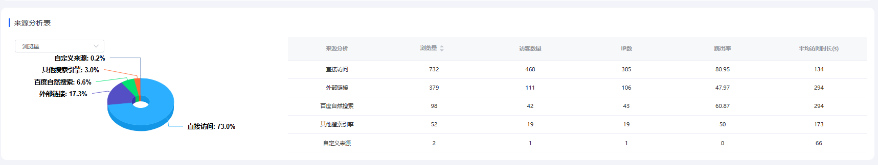
图 4.7.3(2) Source Analysis-来源分析
The source analysis table includes source analysis, page views, number of visitors, number of IPs, bounce rate, and average access duration (seconds).
来源分析表包括来源分析、浏览量、访客数量、IP数、跳出率和平均访问时长(s)。
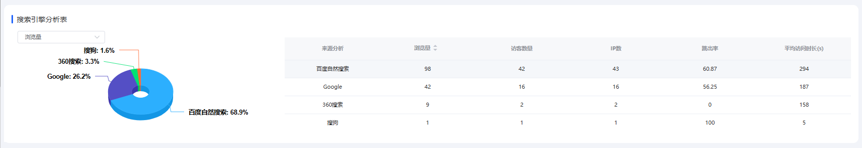
图 4.9.3(3) Source Analysis-来源分析
The search engine analysis table includes source analysis, page views, number of visitors, number of IPs, bounce rate, and average access duration (seconds).
搜索引擎分析表包括来源分析、浏览量、访客数量、IP数、跳出率和平均访问时长(s)。

4.7.4 Location Analysis-所在地分析
Location analysis includes a regional analysis chart and a regional analysis table, which are statistical analyses of the source regions of users. Users can filter the access status by specifying the date and time range.
所在地分析包括地域分析图和地域分析表，是用户来源区域的统计分析。用户可以通过指定日期和时间范围筛选访问实况。
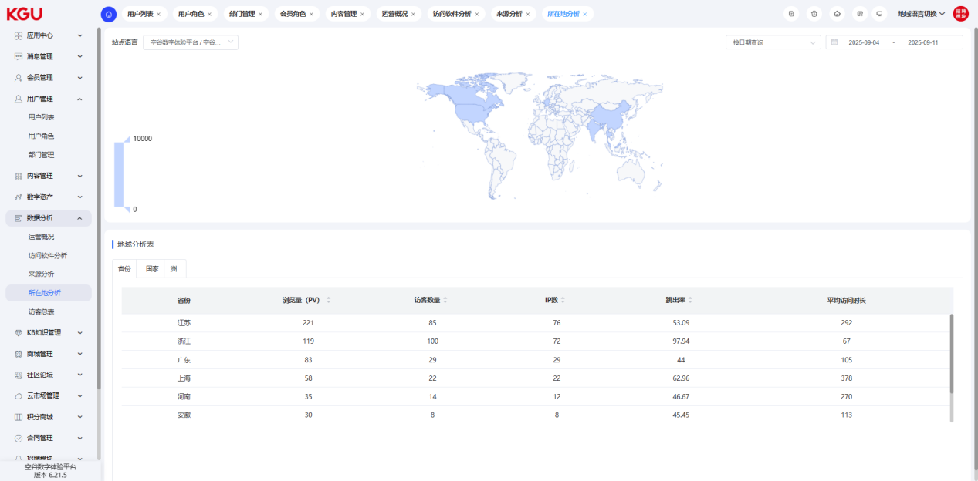
图 4.7.4(1) Location Analysis-所在地分析
The regional analysis chart uses different colors to distinguish and display the amount of data from user access sources, allowing operators to more intuitively understand the geographical distribution of users.
地域分析图通过不同的颜色区分显示用户访问来源的数据量多少，运营者可以更加直观的了解用户地域分布。
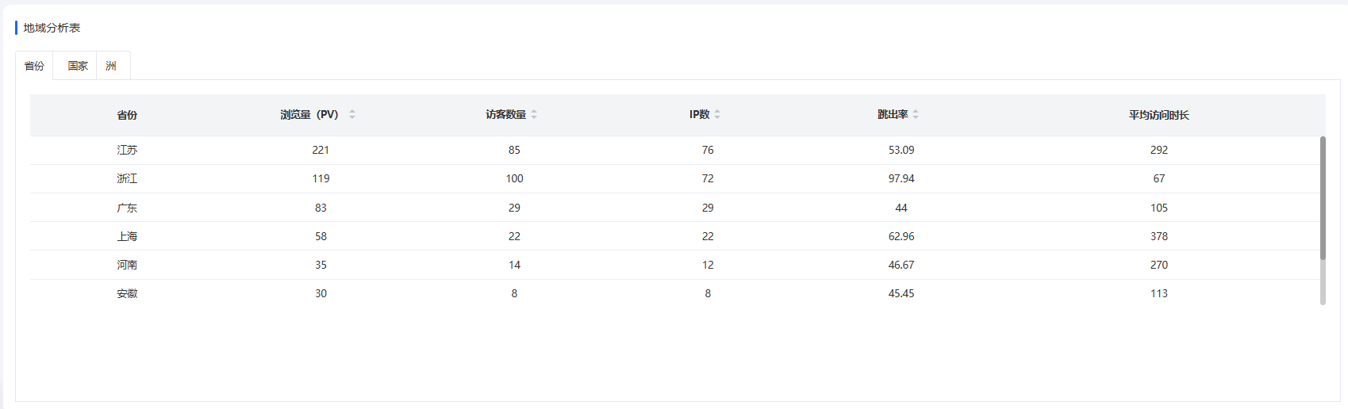
图 4.7.4(2) Location Analysis-所在地分析
The regional analysis table counts and analyzes the number of user visits by province, country, and continent. Statistical data from various dimensions such as page views, number of visitors, number of IPs, bounce rate, and average access duration are used to support decision-making for refined operations.
地域分析表按省份、国家、洲统计并分析用户访问数量。通过浏览量、访客数量、IP数、跳出率，平均访问时长各个维度的统计数据来为精细化运营做决策支撑。

4.7.5 Visitor Summary Table-访客总表
The visitor summary table can provide an overview of the website's access situation and user access preference data. The visitor summary table includes the visitor trend chart, the number and comparison of new and old visitors, top 10 search terms, top 10 visited pages, top 10 entry pages, and top 10 source websites.
Users can filter the access summary table by specifying the date and time range.
访客总表可以总览网站的访问情况及用户访问偏好的数据。访客总表包含访客趋势图，新老访客数量及对比、top10搜索词、top10受访页面，top10入口网页，top10来源网站信息。
用户可以通过指定日期和时间范围筛选访问总表。
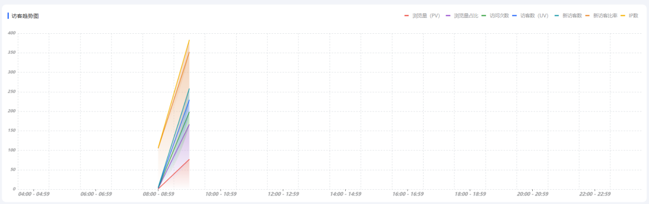
图 4.7.5(1) Visitor Summary Table-访客总表
The visitor trend chart includes page views (PV), page view ratio, number of visits, number of visitors (UV), number of new visitors, new visitor ratio, and number of IPs.
访客趋势图包括浏览量（PV）、浏览量占比、访问次数、访客数（UV）、新访客数、新访客比率、IP数。
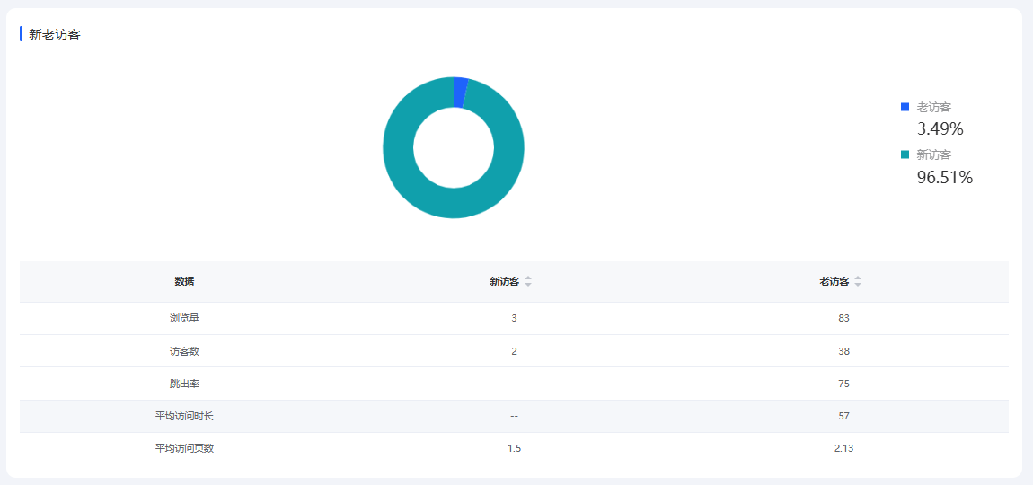
图 4.7.5(2) Visitor Summary Table-访客总表
The number and comparison of new and old visitors include the proportion of new and old visitors, page views, number of visitors, bounce rate, average access duration, and average number of accessed pages.
新老访客数量及对比包括新老访客占比、浏览量、访客数、跳出率、平均访问时长和平均访问页数。
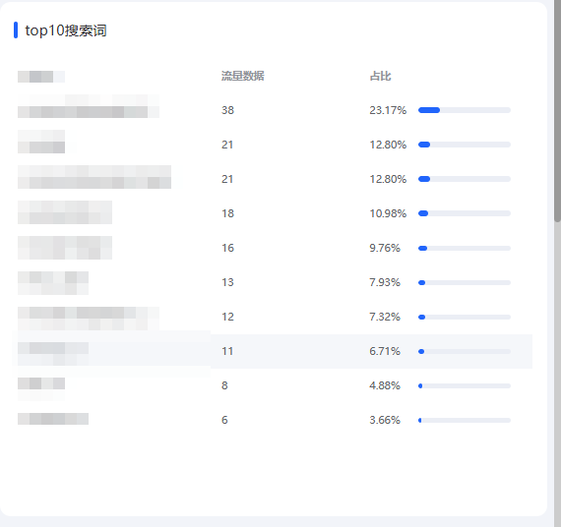
图 4.7.5(3) Visitor Summary Table-访客总表
The top 10 search terms include search terms, traffic proportion, and quantity.
top10搜索词包括搜索词、流量占比和数量。
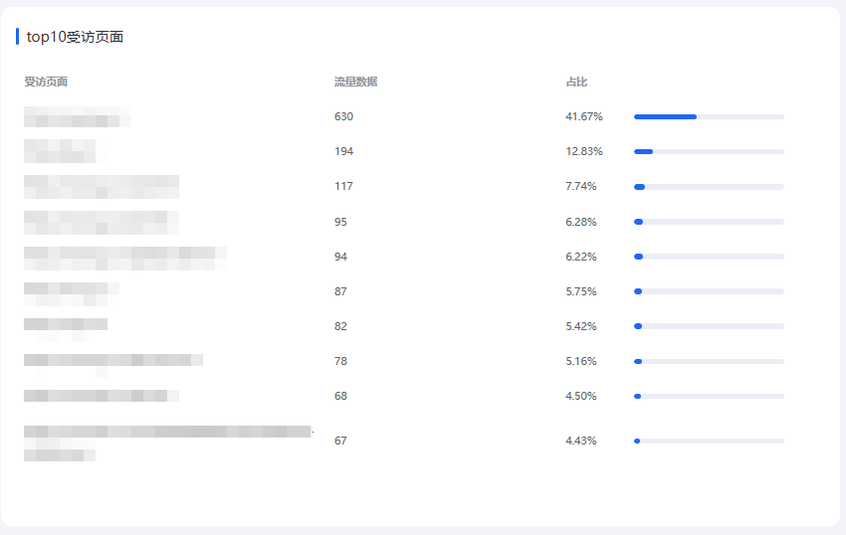
图 4.7.5(4) Visitor Summary Table-访客总表
The top 10 visited pages include visited pages, traffic proportion, and quantity.
top10受访页面包括受访页面、流量占比和数量。
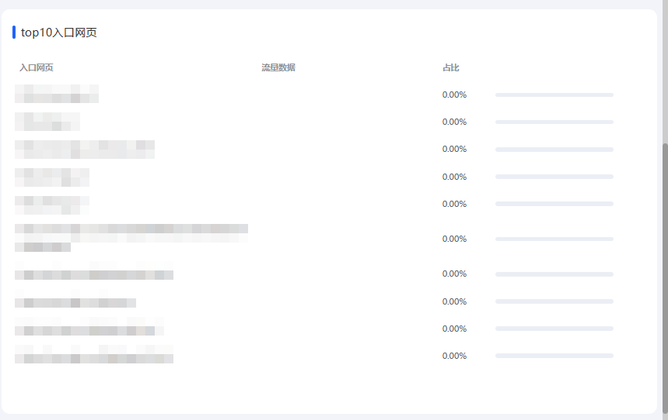
图 4.7.5(5) Visitor Summary Table-访客总表
The top 10 entry pages include entry pages, traffic proportion, and quantity.
top10入口网页包括入口网页、流量占比和数量。
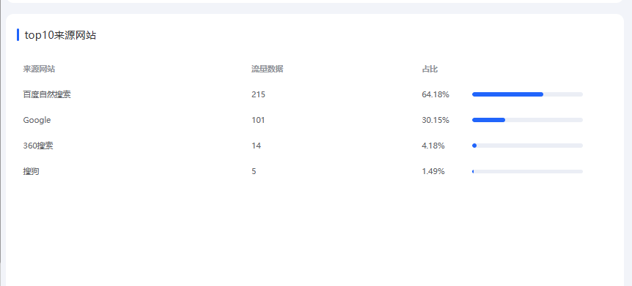
图 4.7.5(6) Visitor Summary Table-访客总表
The top 10 source websites include source websites, traffic proportion, and quantity.
top10来源网站包括来源网站、流量占比和数量。

4.8 KB Knowledge Management-KB知识管理
The knowledge management function is mainly used for internal information and knowledge sharing of enterprises, and can also be used for internal enterprise assessments and channel assessments. Knowledge management is divided into 4 modules: course management, lecturer configuration, transaction orders, and invoice management. Course management is mainly used for creating courses, managing chapters, and filling content. At the same time, different course categories can be created to subdivide different knowledge structures. Lecturer configuration is mainly used for maintaining lecturer information and associating different courses. Transaction orders are mainly used for paid courses. When a course requires payment, corresponding orders can be generated through payment. For paid courses, corresponding invoices can be supported.
知识管理功能主要应用于企业内部的信息与知识共享，也可以应用于企业内部以及对渠道的考核。 知识管理共分为知识管理共分为4个模块，分别为课程管理，讲师配置，交易订单以及开票管理。课程管理主要应用于课程的创建章节的管理以及内容填充，同时也可以创建不同的课程分类，以便可以细分不同的知识结构。讲师配置主要应用于讲师信息的维护以及关联不同的课程。交易订单主要应用于收费课程，当课程需要收费时，可以通过付费产生对应的订单。针对付费的课程，可以支持开具相应的发票。

4.8.1 Course Management-课程管理
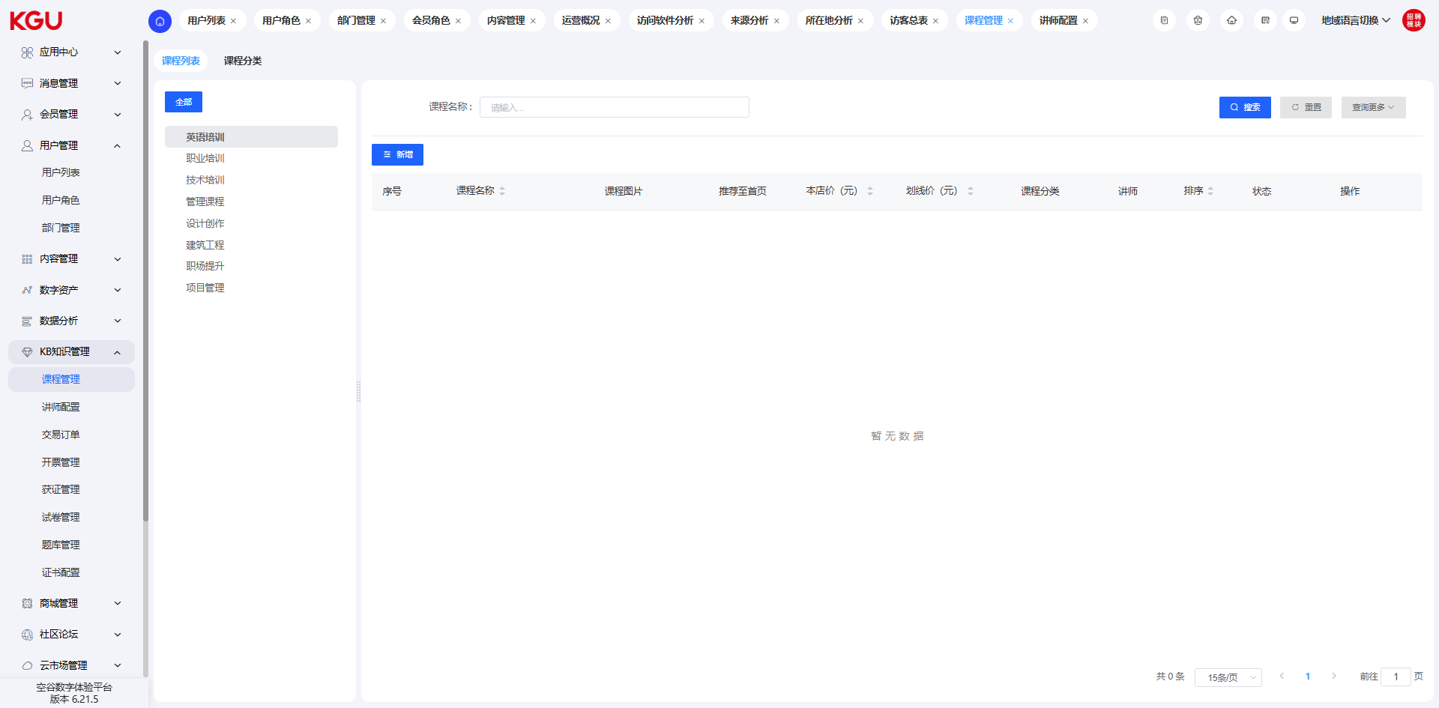
图 4.8.1 Course Management-课程管理

Course Creation-课程创建
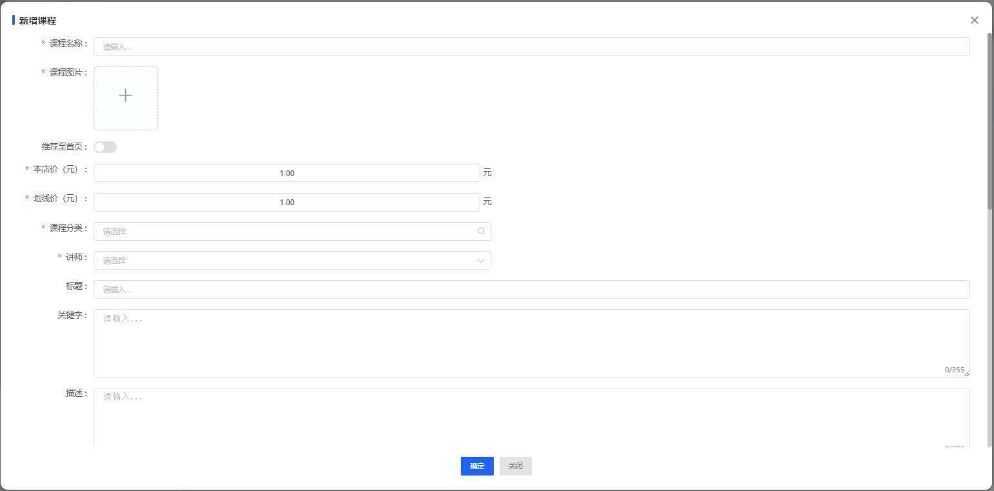
图 4.8.1(1) Course Creation-课程创建
During the course creation process, you can associate the corresponding lecturer, set different categories, and set detailed course introductions to complete the creation of the corresponding course.
创建课程过程中，可以关联对应讲师、设置不同的分类及设置详细课程介绍即可完成对应课程的创建。

Chapter Management-章节管理
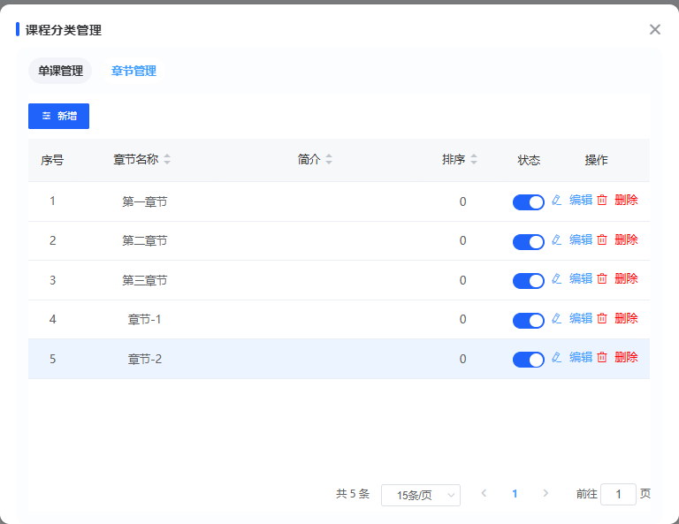
图 4.8.1(2) Chapter Management-章节管理
In chapter management, different chapters can be set to classify the content of course knowledge points clearly. Each chapter contains different single-course content.
在章节管理中，可以设置不同的章节，让课程知识点的内容分类明确，章节下面包含不同的单课内容。

Course Classification-课程分类
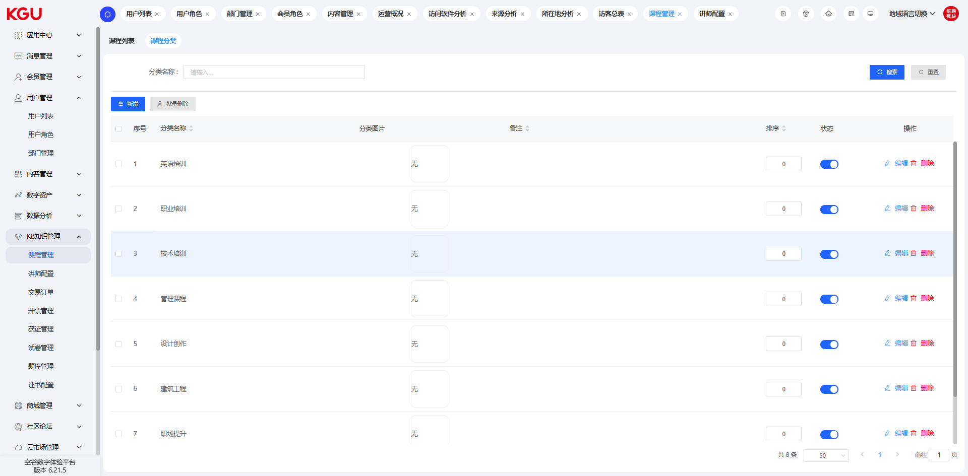
图 4.8.1(3) Course Classification-课程分类
In the course management function, users can create different course categories for classifying and managing courses. Course classification supports the creation of hierarchical classifications.
在课程管理功能中，用户可以创建不同的课程分类，以便对课程进行分类管理，课程分类支持层级分类的创建。

4.8.2 Lecturer Configuration-讲师配置
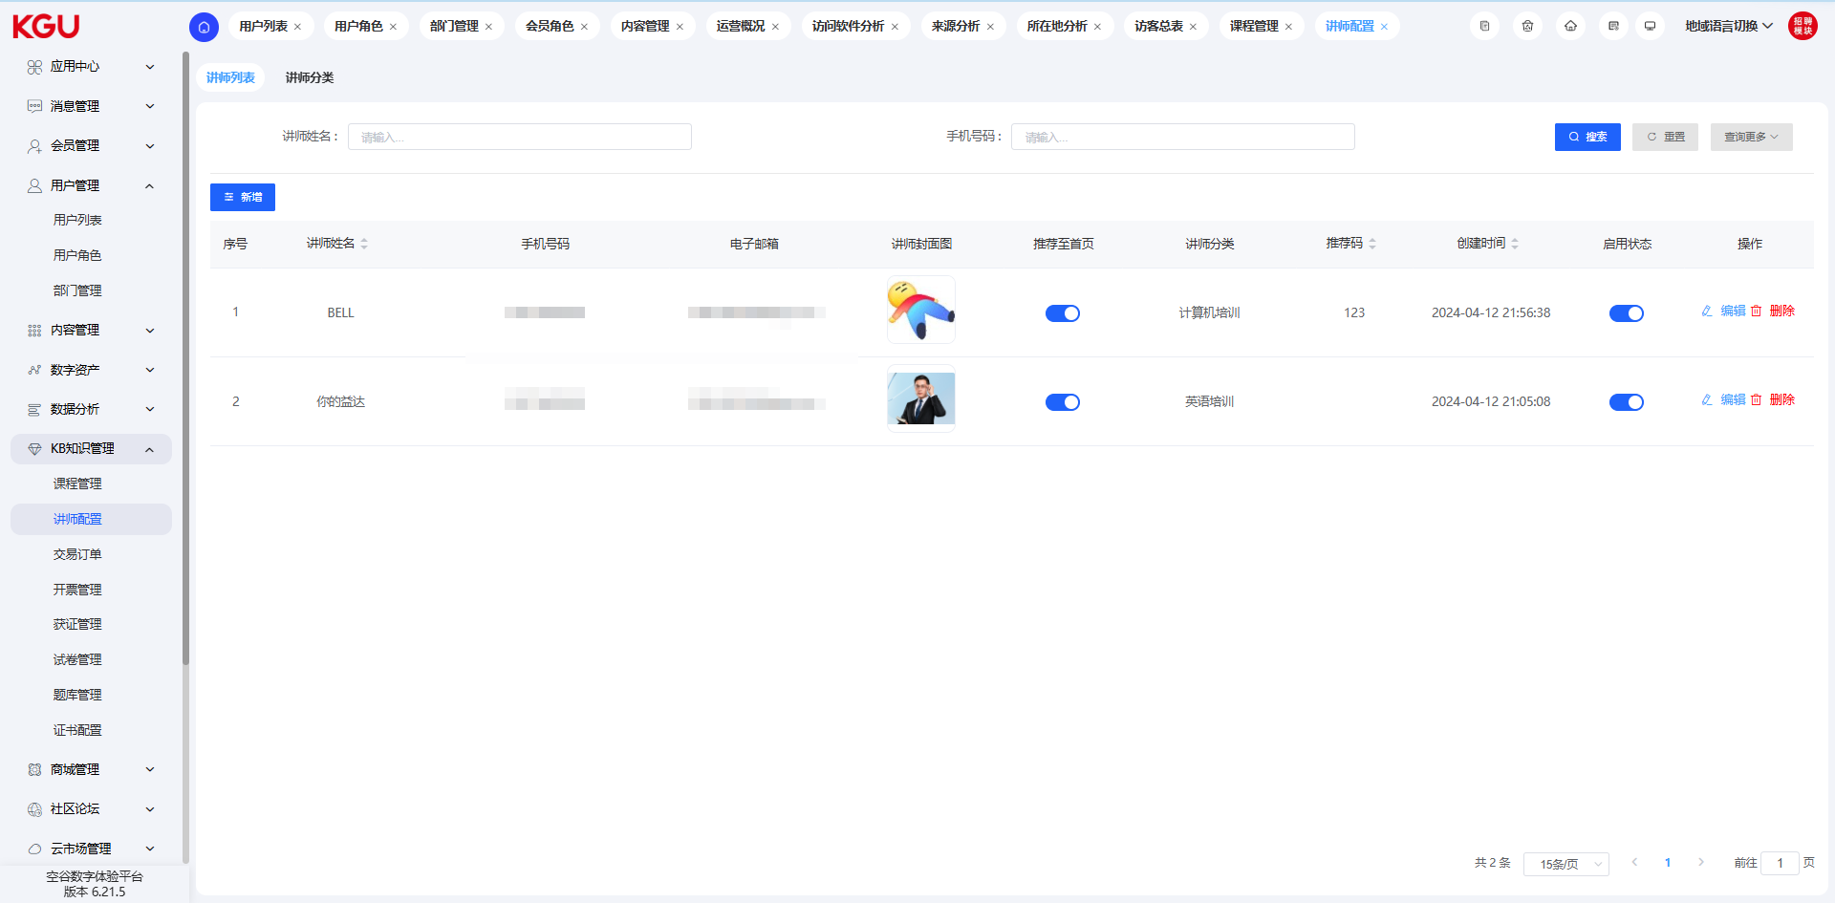
图 4.8.2 Lecturer Configuration-讲师配置
In the lecturer configuration function, you can set information related to lecturers, such as name, gender, mobile phone number, email address, lecturer industry, cooperation status, etc. The creation and management of this information allows enterprises to better understand the lecturer's information and content to better match the needs of different courses.
At the same time, a corresponding lecturer center can be created for the same lecturer to display the course information created by the lecturer.
在讲师配置功能中，可以设置与讲师相关的信息，如：姓名、性别、手机号、电子邮箱、讲师行业、合作情况等信息。这些信息创建与管理可以让企业更好的了解讲师的信息与内容，以便更好的匹配不同课程的需要。
同时，对应同一讲师也可以创建相应的讲师中心，用来展示该老师创建的课程信息。

4.8.3 Transaction Orders-交易订单
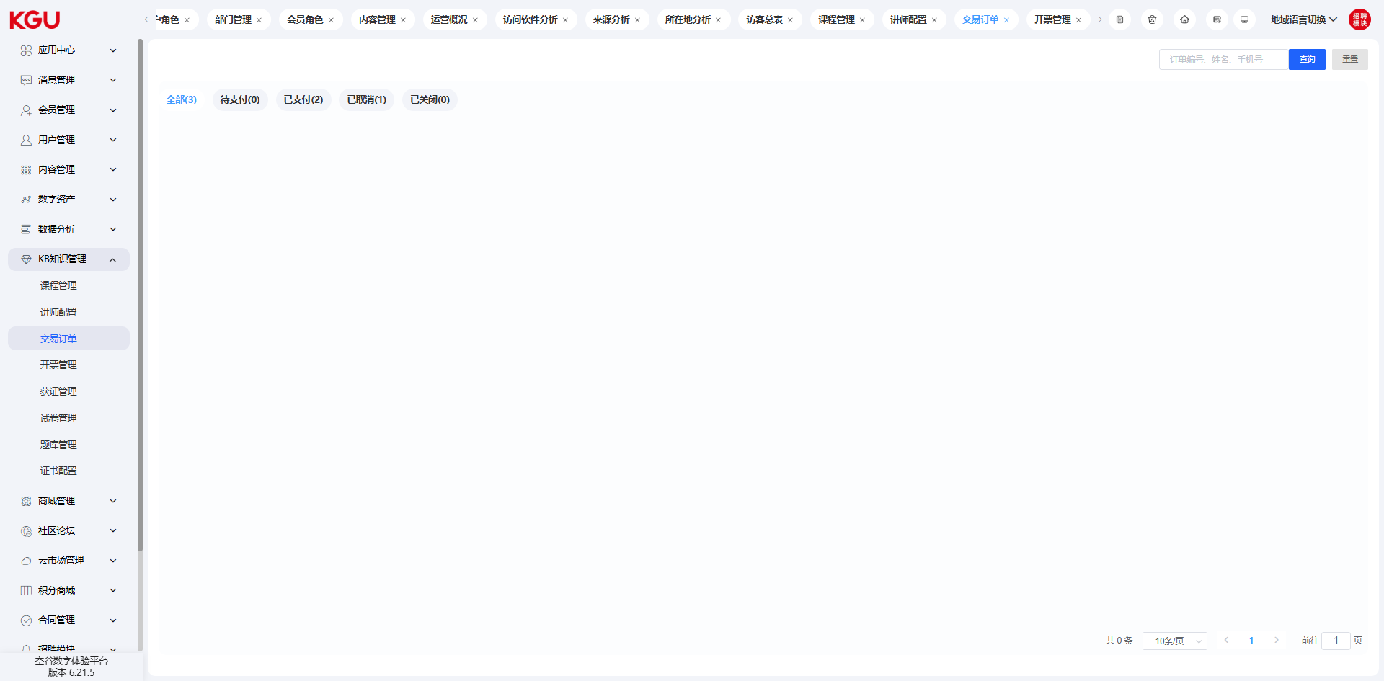
图 4.8.3 Transaction Orders-交易订单
For courses that require user registration or purchase, corresponding management can be performed in transaction orders. When a user registers or purchases, the system will create a transaction order. Through transaction orders, you can view the user's purchase situation and the progress of order processing.
对应需要用户报名或者购买的课程，可以在交易订单中进行相应的管理。当用户进行报名或者购买的时候，系统会创建交易订单。通过交易订单，可以查看用户的购买情况及订单的处理进度。

4.8.4 Invoice Management-开票管理
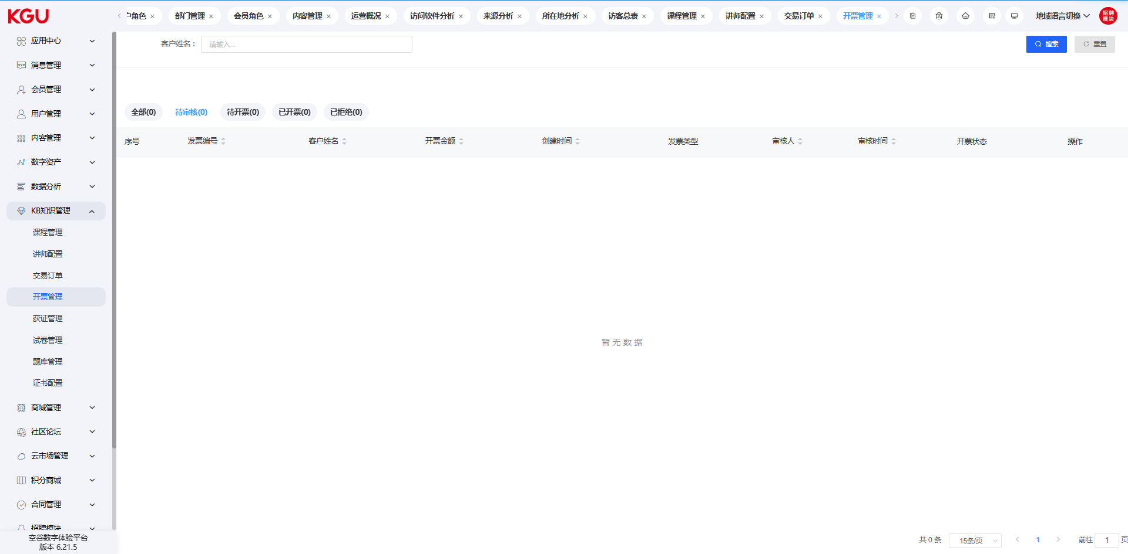
图 4.8.4 Invoice Management-开票管理
reviewed in the management backend. After the review is passed, invoicing operations can be performed and the corresponding invoice information can be uploaded for users to download and use.
Invoices support both special invoices and ordinary invoices, and also support batch application and batch management functions.
对应用户进行过支付的订单，可以在用户中心进行发票的申请，所申请的发票可以在管理后台进行审核，审核通过后，可以进行开票操作，并上传对应的发票信息，以便用户进行下载使用。
发票支持专票和普票两种，同时支持批量申请和批量管理的功能。

4.9 Mall Management-商城管理

4.9.1 Commodity Management-商品管理
The commodity management module provides the following functions:
Commodity Query: Quickly query commodity information through keywords, filter conditions, etc., facilitating users to search and browse commodities and quickly locate the required commodities.
Commodity Addition: Supports adding new commodity information, including detailed attributes such as commodity name, description, price, inventory, and pictures, for display and sales in the mall. Users can easily create new commodities and fill in relevant information.
Commodity Deletion: Allows users to delete specified commodities, clean up invalid or unnecessary commodity information, and ensure data cleanliness and validity. Users can select the commodities to be deleted, confirm the operation, and remove the commodities from the system.
Batch Deletion: Provides a batch deletion function, enabling users to delete multiple commodities at the same time and improve operation efficiency. If users need to delete multiple commodities at one time, the commodity management module provides a batch deletion function to help users complete the operation quickly.
Commodity Editing: Allows users to edit and update existing commodities, including modifying commodity information, price adjustments, inventory updates, etc., to maintain the accuracy and timeliness of commodity information. Users can select the commodities that need to be edited and perform corresponding modification and update operations.
Commodity Shelving: Supports shelving commodities to make them visible in the mall and available for purchase. Users can shelve the prepared commodities so that customers can browse, purchase and enjoy services.
商品管理模块提供以下功能：
商品查询：通过关键字、筛选条件等方式快速查询商品信息，方便用户进行商品搜索和浏览，快速定位所需商品。
商品添加：支持添加新的商品信息，包括商品名称、描述、价格、库存、图片等详细属性，以便于商城展示和销售。用户可以方便地创建新的商品，并填写相关信息。
商品删除：允许用户删除指定的商品，清理无效或不需要的商品信息，确保数据的整洁和有效性。用户可以选择要删除的商品，并确认操作，从系统中移除商品。
批量删除：提供批量删除功能，使用户能够同时删除多个商品，提高操作效率。如果用户需要一次性删除多个商品，商品管理模块提供了批量删除功能，帮助用户快速完成操作。
商品编辑：允许用户对已有商品进行编辑和更新，包括修改商品信息、价格调整、库存更新等，保持商品信息的准确性和时效性。用户可以选择需要编辑的商品，并进行相应的修改和更新操作。
商品上架：支持将商品上架，使其在商城中可见并可以进行购买。用户可以将准备好的商品上架，以便顾客浏览、购买和享受服务。
商品下架：允许用户将商品下架，从商城中移除或停止销售，控制商品的可见性和购买状态。当商品无效或不再需要销售时，用户可以选择将其下架，停止在商城中展示和销售。
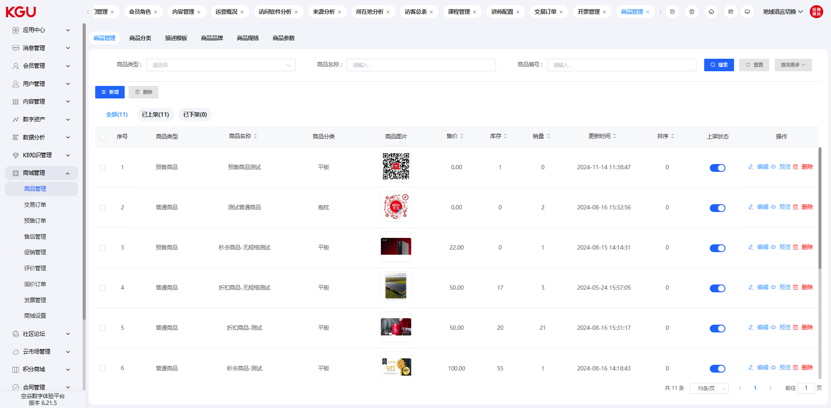
图 4.9.1 Commodity Management-商品管理
Commodity Unshelving: Allows users to unshelve commodities, remove them from the mall or stop selling, and control the visibility and purchase status of commodities. When a commodity is invalid or no longer needs to be sold, users can choose to unshelve it and stop displaying and selling it in the mall.
通过以上功能，商品管理模块能够帮助用户轻松管理商城中的商品信息，实现对商品的有效管理和优化，提供良好的用户购物体验。用户可以快速查询、添加、删除、编辑商品，并根据需求进行上架和下架操作，以满足商城的商品管理需求。

Commodity Management-商品管理
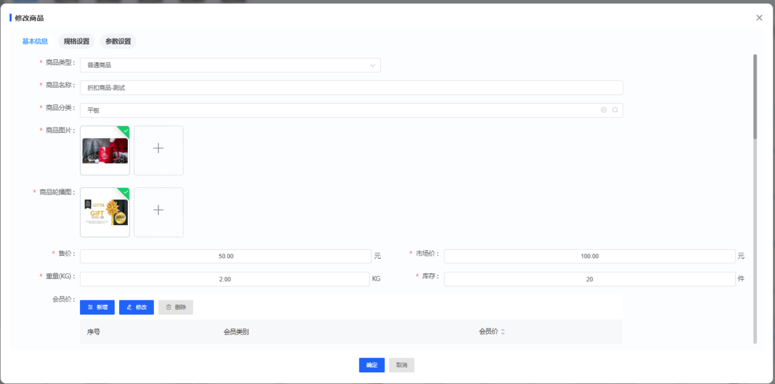
图 4.9.1(1) Commodity Management-商品管理
Commodity Name: Displays the name of the commodity, used to identify the name information of the commodity.
Commodity Number: The unique code of the commodity, identified by Arabic numerals, used to distinguish different commodities.
Commodity Picture: The cover picture of the commodity, used to display the appearance characteristics of the commodity and attract users' attention.
Commodity Category: The category to which the commodity belongs, used for classifying, managing and displaying the commodity.
Unit Price: The sales price unit of the commodity, representing the price of each unit of the commodity.
Inventory: The inventory quantity of the commodity, representing the quantity of the commodity currently owned by the merchant.
Tags: Tags used to distinguish commodity characteristics, such as new products, high-quality products, best-selling products, which can be used to display different tags on the front-end to help users quickly identify commodity characteristics.
Picture Library: A series of pictures displayed on the commodity detail page, used to display multiple perspectives and details of the commodity.
Cost Price: The cost price of the commodity, representing the price cost of the merchant's purchase of the commodity.
Freight Module: The freight strategy adopted by the commodity, including free shipping, weight-based pricing, distance-based pricing, etc.
Domestic/Imported: The production location of the commodity, indicating whether it is domestic or imported, helping users understand the origin information of the commodity.
Market Price: The market price of the commodity, representing the price level of the commodity in the market.
Member Price: Divided into ordinary members and corporate members, the price set for different members, used to provide preferential prices for specific members.
Salable Status: Identifies whether the commodity is salable.
Summary: A brief overview of the commodity, summarizing the main features and selling points of the commodity in a few sentences.
Commodity Description: A long text description of the detailed information of the commodity, providing detailed introduction, specification parameters, features and other detailed information of the commodity.
Weight: The weight of the commodity, used to describe the weight information of the commodity.
Start Time: The start time of the commodity display.
End Time: The end time of the commodity display.
Release Time: The release time of the commodity.
Sort: Controls the display order of commodities in the list.
Salable Status: Identifies whether the commodity is salable.
商品名称：展示商品的名称，用于标识商品的名称信息。
商品编号：商品的唯一代号，使用阿拉伯数字标识，用于区分不同商品。
商品图片：商品的封面图片，用于展示商品的外观特征和吸引用户的注意。
商品分类：商品所属的分类，用于将商品进行分类管理和展示。
单价：商品的销售价格单位，表示每个单位商品的价格。
库存：商品的库存数量，表示商家当前拥有的商品数量。
标签：用于区分商品特性的标签，如新品、精品、热销，可用于前台展示不同的标签，帮助用户快速辨识商品特征。
图库：展示在商品详情页的一系列图片，用于展示商品的多个视角和细节。
成本价：商品的成本价格，表示商家采购商品的价格成本。
运费模块：商品采用的运费策略，包括免运费、按重量计费、按距离计费等。
国产/进口：商品的生产地，标明是国产还是进口，帮助用户了解商品的产地信息。
市场价：商品的市场价格，表示商品在市场上的价格水平。
会员价：分普通会员和企业会员，针对不同会员设定的价格，用于提供特定会员的优惠价格。
可售状态：标识商品是否可售
简述：对商品的简短概述，用几句话概括商品的主要特点和卖点。
商品描述：商品详细信息的长文本描述，提供商品的详细介绍、规格参数、特色等详细信息。
重量：商品的重量，用于描述商品的重量信息。
开始时间：商品展示的开始时间。
结束时间：商品展示的结束时间。
发布时间：商品的发布时间。
排序：控制商品在列表中的显示顺序。
可售状态：标识商品是否可售。

Commodity Classification-商品分类
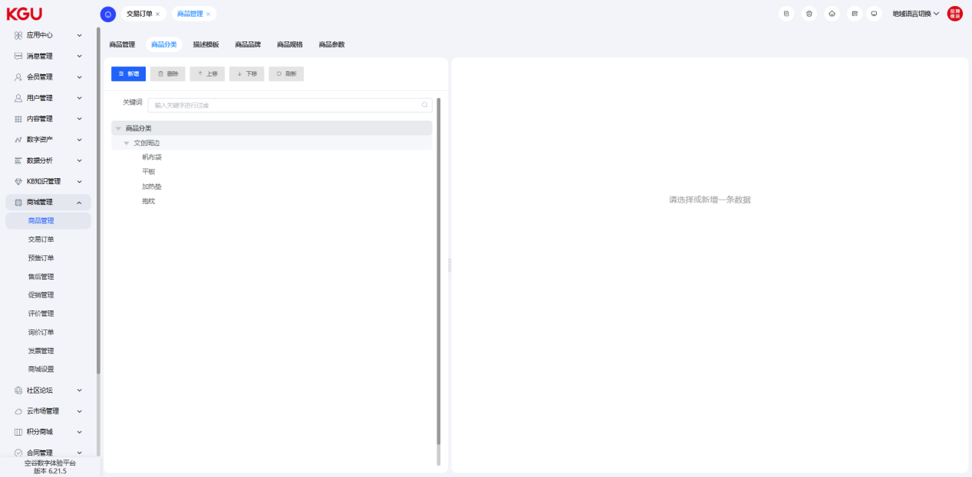
图 4.9.1(2) Commodity Classification-商品分类
The commodity classification management module is used for classifying and managing commodities, providing the following functions:
Query: Quickly find specific commodity categories through the query function, which can be located using keywords, filter conditions, etc.
Add Data: Easily add new commodity categories and fill in relevant information to create new categories, including category name, description, icon, etc., to ensure the completeness and accuracy of category information.
Delete: Supports deleting commodity categories that are no longer needed to ensure the cleanliness and validity of category information. A confirmation prompt can be provided when deleting to avoid misoperation.
Batch Deletion: Provides a batch deletion function, allowing users to delete multiple commodity categories at the same time and improve operation efficiency. Multiple categories can be selected for batch deletion, or selection conditions can be provided for batch deletion.
Edit: Allows users to edit existing commodity categories, including modifying category names, adjusting category levels, updating descriptions, etc. The editing function can provide a user-friendly interface in the background to facilitate users to make modification operations.
商品分类管理模块用于对商品进行分类管理，提供以下功能：
查询：通过查询功能快速查找特定的商品分类，可以使用关键字、筛选条件等方式进行定位。
添加数据：方便地添加新的商品分类，填写相关信息以创建新的分类，包括分类名称、描述、图标等，以确保分类信息完整和准确。
删除：支持删除不再需要的商品分类，确保分类信息的整洁性和有效性。删除时可以提供确认提示，以避免误操作。
批量删除：提供批量删除功能，让用户能够同时删除多个商品分类，提高操作效率。可以通过勾选多个分类进行批量删除操作，或者提供选择条件进行批量删除。
编辑：允许用户对已有的商品分类进行编辑，包括修改分类名称、调整分类层级、更新描述等。编辑功能可在后台提供友好的界面，方便用户进行修改操作。
通过以上优化功能，商品分类管理模块能够帮助您轻松管理和维护商品分类。您可以快速查询和定位所需的分类，方便地添加新的分类并填写相关信息，删除不需要的分类，进行批量删除操作以提高效率，以及对已有分类进行编辑和调整。这样，您可以确保商品被正确组织和展示在适当的分类中，提供给用户更好的购物体验
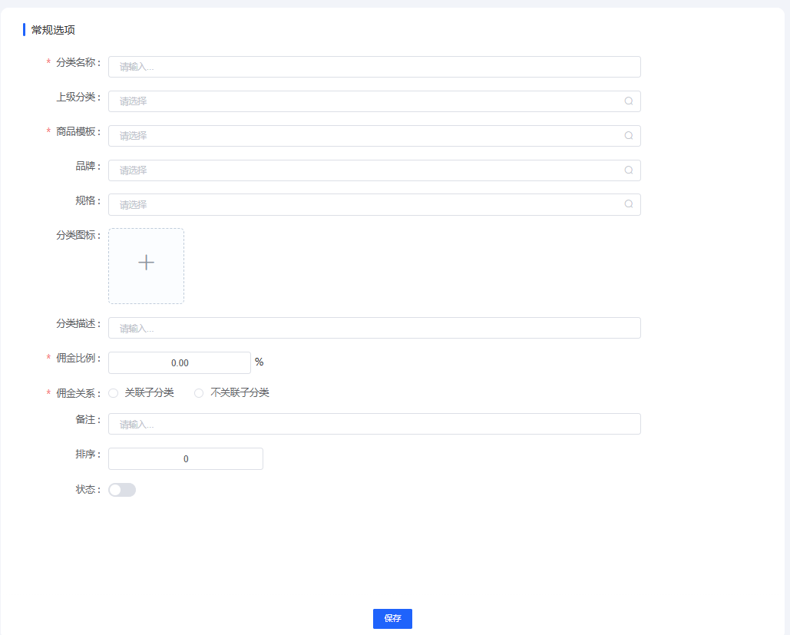
图 4.9.1(2) Commodity Classification-商品分类
Classification editing module includes the following functions:
Category Name: Used to identify and describe the category, which can clearly express the meaning and purpose of the category.
Parent Category: Specify the parent category to which this category belongs to realize the hierarchical relationship between categories. In this way, a multi-level classification structure can be established to better organize and manage commodities.
Category Icon: Add a visual icon to the category for displaying the category in the interface. Icons can enhance the recognizability of the category and allow users to understand the category content more intuitively.
Description: Provide a field for describing the category, which can include relevant explanations and information. Descriptions can help users better understand the meaning and characteristics of the category.
Sort: Use the sort value to control the display order of categories in the list, with smaller numbers having higher priority. In this way, the arrangement order of categories can be customized to ensure that important categories can be displayed first.
Recommendation: Mark certain categories as recommended categories through a button or option to highlight their importance or particularity. Recommended categories can be highlighted in the interface to attract users' attention.
Status: Used to control the status of the category. The default is enabled, which means the category is in a usable state. Through status control, certain categories can be enabled or disabled easily, and category management can be carried out flexibly.
分类编辑模块包括以下功能：
分类名称：用于标识和描述该分类，可以清晰地表达分类的含义和用途。
上级分类：指定该分类所属的上级分类，实现分类之间的层级关系。这样可以建立多级分类结构，更好地组织和管理商品。
分类图标：为分类添加一个可视化的图标，用于在界面中显示该分类。图标可以增强分类的可识别性，让用户更直观地了解分类内容。
描述：提供一个字段用于描述该分类，可以包含相关的说明和信息。描述可以帮助用户更好地理解分类的含义和特点。
排序：使用排序值来控制分类在列表中的显示顺序，数字越小优先级越高。这样可以自定义分类的排列顺序，确保重要的分类能够优先展示。
推荐：通过一个按钮或选项，将某些分类标记为推荐分类，以突出它们的重要性或特殊性。推荐的分类可以在界面中得到突出显示，吸引用户的注意。
状态：用于控制分类的状态，默认开启表示该分类处于可用状态。通过状态控制，可以方便地启用或禁用某些分类，灵活地进行分类管理。

Description Template-描述模板
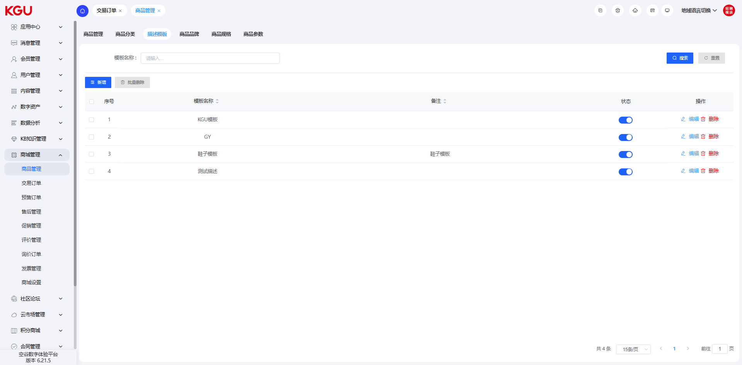
图 4.9.1(3) Description Template-描述模板
The description template management module is used to manage commodity description templates, providing the following functions:
Query: Quickly find description templates through keywords or filter conditions. Users can enter keywords or use filter conditions to query, so as to quickly locate the required templates.
Add Description Template: Create a new description template and fill in relevant information. Users can easily add new description templates, including template name, description content, etc., to meet the needs of different commodity descriptions.
Delete Description Template: Delete the specified description template, which will be removed from the system after confirmation. Users can select the description template to be deleted and perform the confirmation operation to remove the unnecessary template from the system.
Batch Deletion: Delete multiple description templates at the same time to facilitate batch operations. If users need to delete multiple description templates at one time, the description template management module provides a batch deletion function to improve operation efficiency.
Edit Description Template: Modify and update the existing description templates. Users can select the description templates that need to be edited and perform corresponding modification and update operations to ensure the accuracy and timeliness of the description template information.
描述模板管理模块用于管理商品描述模板，提供以下功能：
查询：通过关键字或筛选条件快速查找描述模板。用户可以输入关键字或使用筛选条件进行查询，以便快速定位所需的模板。
添加描述模板：创建新的描述模板，并填写相关信息。用户可以方便地添加新的描述模板，包括模板名称、描述内容等，以满足不同商品描述的需求。
删除描述模板：删除指定的描述模板，确认后将从系统中移除。用户可以选择要删除的描述模板，并进行确认操作，从系统中移除不需要的模板。
批量删除：同时删除多个描述模板，方便批量操作。如果用户需要一次性删除多个描述模板，描述模板管理模块提供了批量删除功能，提高操作效率。
编辑描述模板：对已存在的描述模板进行修改和更新。用户可以选择需要编辑的描述模板，并进行相应的修改和更新操作，保证描述模板信息的准确性和时效性。
通过描述模板管理功能，您可以方便地管理和维护商品描述模板。查询和筛选功能帮助您快速定位所需的模板，添加数据功能支持新建模板，删除和批量删除功能可实现模板的移除，编辑功能则保证模板信息的更新和维护。这些功能的提供使得商品描述模板的管理更加便捷和高效，帮助您提升商品描述的质量和效率。
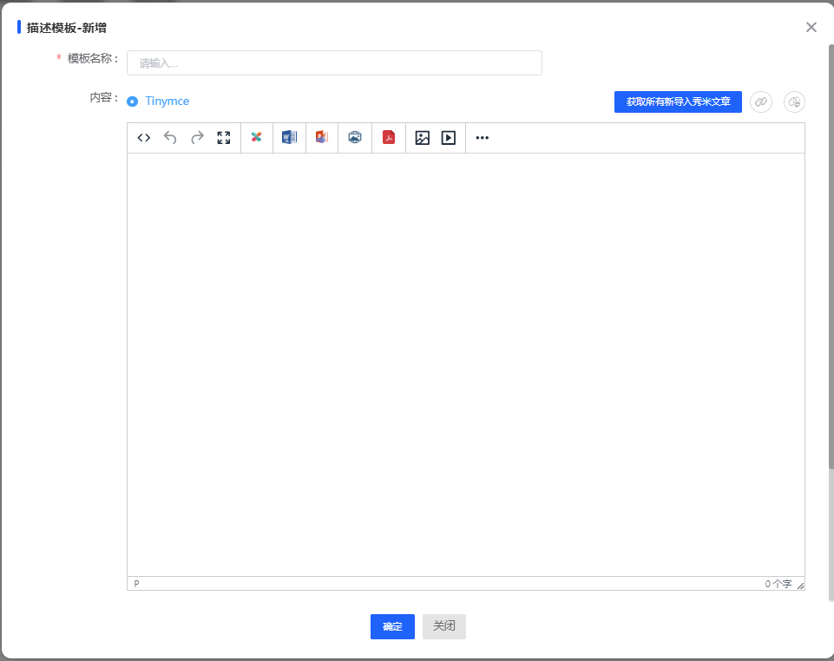
图 4.9.1(3) Description Template-描述模板
Commodity Description: The long picture of the commodity details. Detailed commodity description information can be added to the template. Through the commodity description template, you can display the characteristics, specifications, usage instructions and other detailed information of the commodity in a combination of pictures and text, providing users with a more comprehensive understanding and reference.
Remarks: Remarks information, which can add additional explanations or remarks. You can add remark information in the description template to provide some specific precautions, special instructions or other relevant information to help users better understand and use the commodity.
Sort: The sort value controls the display order, which is used to specify the display order of the template in the list. By setting the sort value, you can control the arrangement order of the description templates in the list to better organize and manage the display order between different templates.
Status: The status of the description template, which is enabled by default and can control whether the template is available. You can set the description template to enabled or disabled status according to needs to control the availability of the template. Templates in the disabled status will not be displayed or used on the front-end, while templates in the enabled status can be used normally.
商品描述：商品详情的长图，可以在模板中添加详细的商品描述信息。通过商品描述模板，您可以将商品的特性、规格、使用说明等详细信息以图文结合的方式展示出来，提供给用户更全面的了解和参考。
备注：备注信息，可以添加额外的说明或备注。您可以在描述模板中添加备注信息，用于提供一些特定的注意事项、特殊说明或其他相关信息，以帮助用户更好地理解和使用商品。
排序：排序值控制显示顺序，用于指定模板在列表中的展示顺序。通过设置排序值，您可以控制描述模板在列表中的排列顺序，以便更好地组织和管理不同模板之间的展示顺序。
状态：描述模板的状态，默认为开启状态，可以控制模板是否可用。您可以根据需要将描述模板设置为开启或关闭状态，以控制模板的可用性。关闭状态的模板将不会在前台展示或被使用，而开启状态的模板则可以正常使用。

Commodity Brand-商品品牌
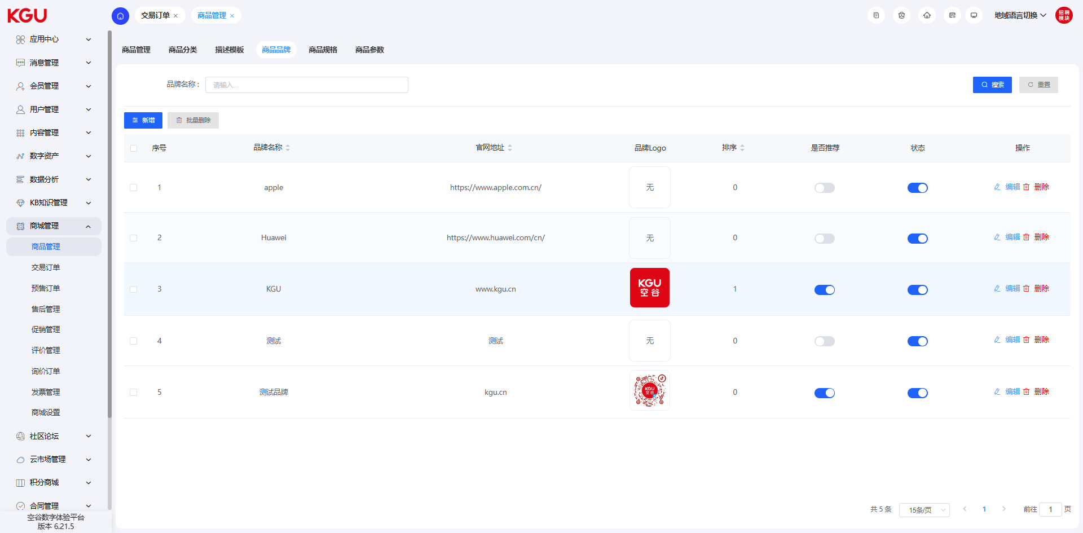
图 4.9.1(4) Commodity Brand-商品品牌
The commodity brand management function helps users effectively manage the commodity brands of the digital portal and ensure the accuracy, consistency and integrity of brand information. Through these functions, users can easily add, edit and delete commodity brands, and maintain the manageability and maintainability of brands.
Commodity brand management is an important functional module of the digital portal, which is used for the overall management of commodity brands. It provides the following main functions:
Query: Quickly find commodity brands through keywords, filter conditions or other search methods to quickly locate the required brands.
Add Data: Create new commodity brands and fill in relevant information, including brand name, brand description, brand logo, etc. Through the add data function, you can easily create new brands and make necessary filling and configuration.
Delete: Delete the specified commodity brand, which will be deleted from the system after confirmation. You can select the brand to be deleted and perform the confirmation operation to remove the brand from the system.
Batch Deletion: Supports deleting multiple commodity brands at the same time to facilitate batch operations. If you need to delete multiple brands at one time, the commodity brand management module provides a batch deletion function to help you improve operation efficiency.
Copy: Copy the existing commodity brands to create similar brand instances and reduce repetitive operations. Through the copy function, you can quickly create brands similar to the existing ones, saving time and labor.
Edit: Modify and update the existing commodity brands, including modifying brand names, brand descriptions, brand logos and other information. You can select the brand that needs to be edited and perform corresponding modification and update operations to maintain the accuracy and practicality of the brand information.
商品品牌管理功能帮助用户有效管理数字门户的商品品牌，确保品牌信息的准确性、一致性和完整性。通过这些功能，用户可以轻松地添加、编辑和删除商品品牌，维护品牌的可管理性和可维护性。
商品品牌管理是数字门户的一个重要功能模块，用于全面管理商品品牌。它提供以下主要功能：
查询：通过关键字、筛选条件或其他搜索方式快速查找商品品牌，以便快速定位所需的品牌。
添加数据：创建新的商品品牌并填写相关信息，包括品牌名称、品牌描述、品牌标识等。通过添加数据功能，您可以方便地创建新的品牌，并进行必要的填写和配置。
删除：删除指定的商品品牌，确认后将从系统中删除。您可以选择要删除的品牌，并进行确认操作，以便从系统中移除该品牌。
批量删除：支持同时删除多个商品品牌，方便批量操作。如果您需要一次性删除多个品牌，商品品牌管理模块提供了批量删除功能，帮助您提高操作效率。
复制：复制现有的商品品牌，用于创建类似的品牌实例，减少重复操作。通过复制功能，您可以快速创建与现有品牌相似的品牌，节省时间和劳动力。
编辑：对已存在的商品品牌进行修改和更新，包括修改品牌名称、品牌描述、品牌标识等信息。您可以选择需要编辑的品牌，并进行相应的修改和更新操作，以保持品牌信息的准确性和实用性。
商品品牌管理功能帮助用户有效管理数字门户的商品品牌，确保品牌信息的准确性、一致性和完整性。通过这些功能，用户可以轻松地添加、编辑和删除商品品牌，维护品牌的可管理性和可维护性。这些功能的提供使得商品品牌管理更加便捷和高效。
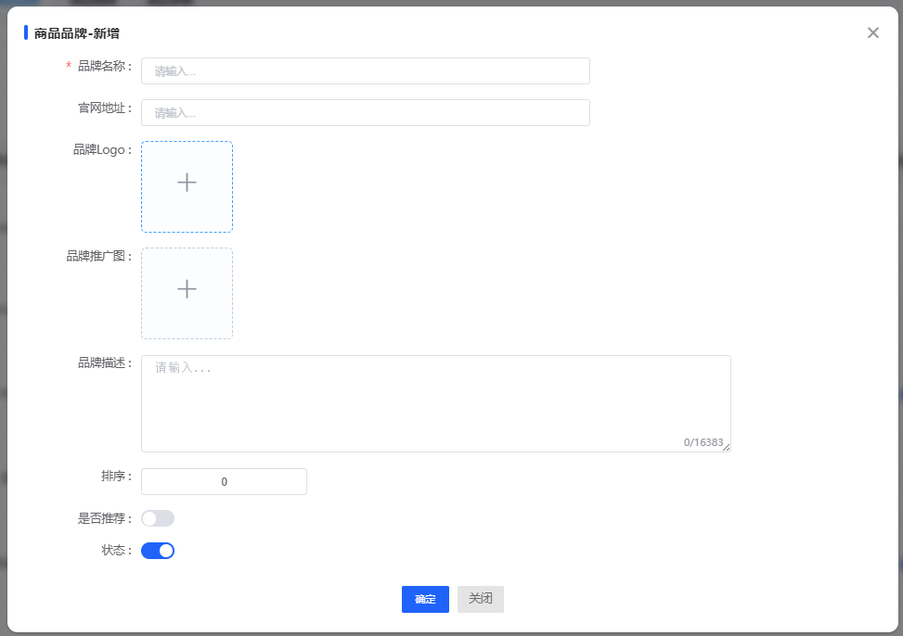
图 4.9.1(5) Commodity Brand-商品品牌
Brand Name: The name of the brand, used to identify the uniqueness of the brand.
Official Website Address: The official website address of the brand, used to display the online official resources of the brand.
Brand Logo: The iconic icon or logo of the brand, used to identify and display the brand image.
Brand Promotion Picture: Pictures used for brand promotion and publicity, which can be advertising posters, promotional posters, etc.
Brand Description: A detailed explanation and description of the brand, including the characteristics, historical background, core values, etc. of the brand.
Sort: The sort value is used to control the display order of the brand in the list, with smaller values ranking first.
Recommendation: Used to identify whether to set the brand as a recommended brand. Recommended brands usually have higher weight and display priority.
Status: Used to identify the status of the brand. The enabled status means the brand is visible and available, while the disabled status means it is not displayed on the front-end.

品牌名称：品牌的名称，用于标识品牌的唯一性。
官网地址：品牌的官方网站地址，用于展示品牌的在线官方资源。
品牌logo：品牌的标识性图标或徽标，用于识别和展示品牌形象。
品牌推广图：用于品牌推广和宣传的图片，可以是广告海报、宣传海报等。
品牌描述：对品牌的详细说明和描述，包括品牌的特点、历史背景、核心价值等。
排序：排序值用于控制品牌在列表中的显示顺序，数值越小越靠前。
是否推荐：用于标识是否将该品牌设置为推荐品牌，推荐品牌通常具有较高的权重和展示优先级。
状态：用于标识品牌的状态，开启状态表示品牌可见和可用，关闭状态则不在前台展示。

Commodity Specification-商品规格
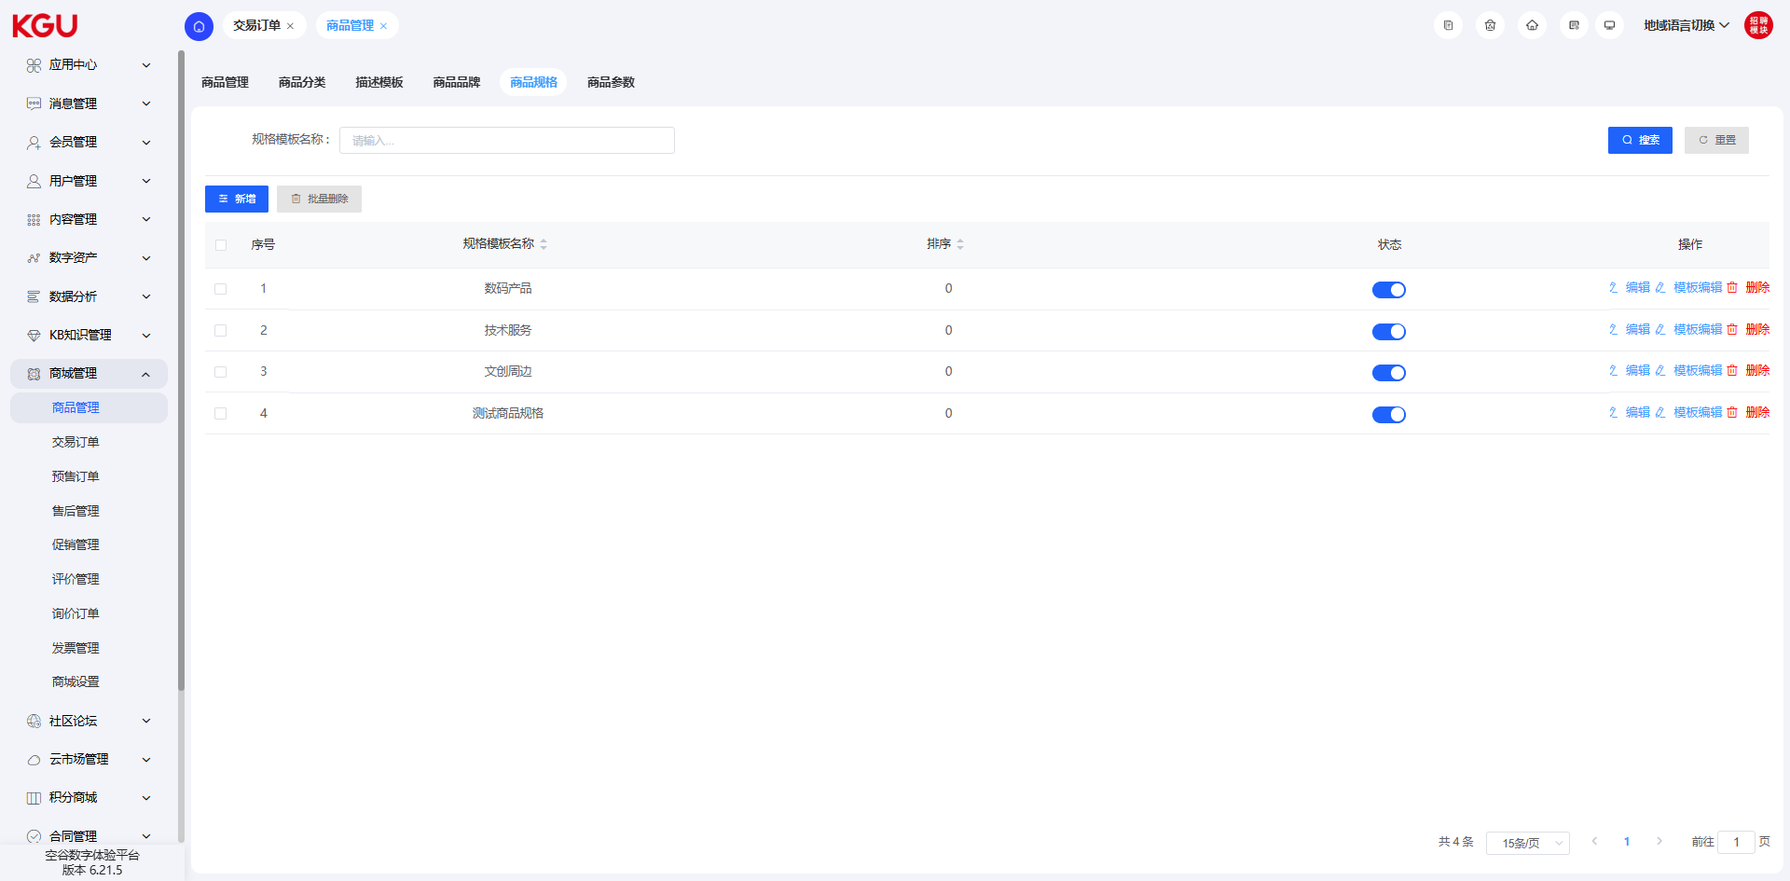
图 4.9.1(6) Commodity Specification-商品规格
The commodity specification management module provides the following functions to effectively manage commodity specifications:
Query: Quickly find specific commodity specifications through keywords or filter conditions.
Add Data: New commodity specifications can be added, and relevant information can be filled in to create new specifications.
Delete: Specified commodity specifications can be deleted and removed from the system after confirmation.
Batch Deletion: Supports deleting multiple commodity specifications at the same time to improve operation efficiency.
商品规格管理模块提供了以下功能，旨在对商品规格进行有效管理：
查询：通过关键字或筛选条件快速查找特定的商品规格。
添加数据：可以添加新的商品规格，填写相关信息以创建新的规格。
删除：可以删除指定的商品规格，确认后将其从系统中移除。
批量删除：支持同时删除多个商品规格，提高操作效率。
编辑：可以对已有的商品规格进行编辑和更新，包括修改规格名称、调整规格选项等。
通过这些功能，商品规格管理模块能够帮助您轻松管理和维护商品规格。您可以方便地查询和定位所需的规格，添加新的规格并填写相关信息，删除不需要的规格，进行批量删除操作以提高效率，以及对已有规格进行编辑和调整。这样，您可以确保商品规格被正确管理和展示，提供给用户更准确和详细的商品选择信息。
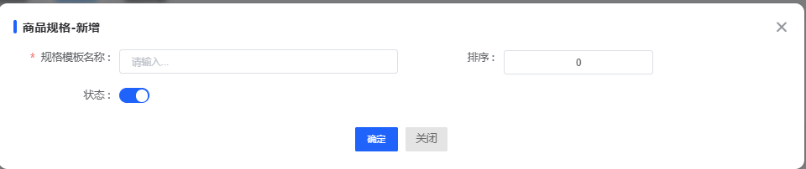
图 4.9.1(7) Commodity Specification-商品规格
Edit: Existing commodity specifications can be edited and updated, including modifying specification names, adjusting specification options, etc.
Template Name: Used to identify the name of the specification template.
Name: The name of the specification, such as color. Different specification items can be added by adding specifications.
Value: The specific value of the specification and the sorting method, such as red, blue, etc. The value field can be used for classification and sorting of specification items.
Sort: Controls the order of the specification templates when displayed. By setting the sort value, the display order of the specification templates can be adjusted.
Status: The default is disabled and needs to be enabled manually. The status of the specification template can be switched manually to determine whether to display the specification template.
模板名称：用于标识规格模板的名称。
名称：规格的名称，例如颜色。可通过新增规格来添加不同的规格项。
数值：规格的具体数值以及排序方式，例如红色、蓝色等。数值字段可用于规格项的分类和排序。
排序：控制规格模板在展示时的顺序。通过设定排序值，可以调整规格模板的显示顺序。
状态：默认为关闭状态，需要手动开启。可以手动切换规格模板的状态，以决定是否显示该规格模板。

4.9.2 Transaction Orders-交易订单
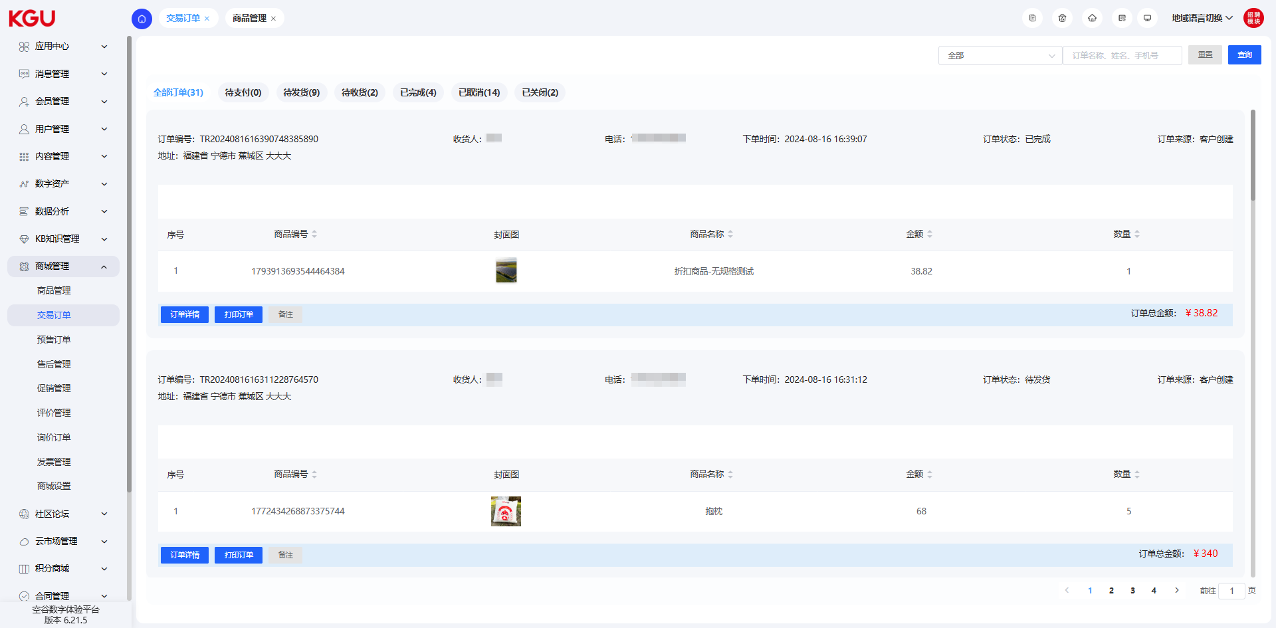
图 4.9.2(1) Transaction Orders-交易订单

Pending Payment-待支付待支付
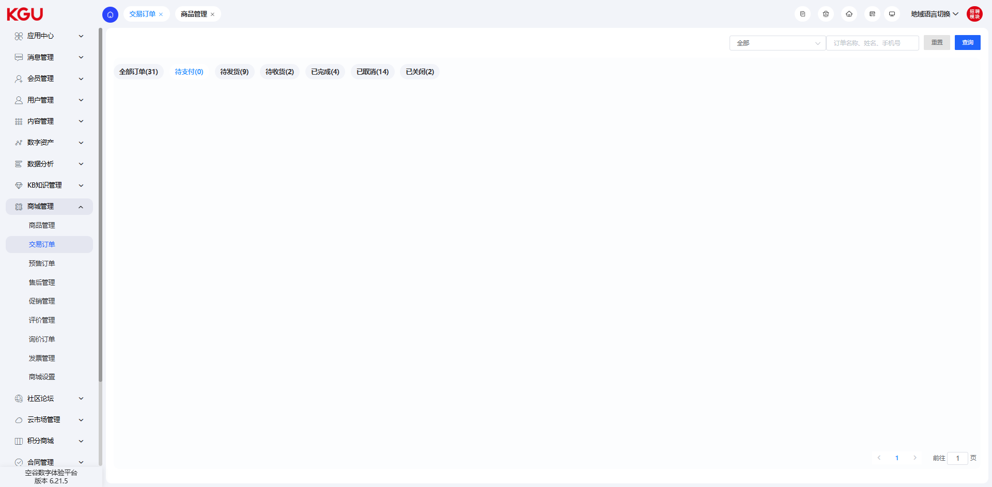
图 4.9.2(2) Transaction Orders-交易订单
After the customer successfully places an order, if the UnionPay B2B or scan code payment method is selected but the payment is not completed within 30 minutes, the order will be automatically converted to the "Cancelled" status.
For orders under corporate-to-corporate remittance and distributors, there is no time limit, that is, the order will not be automatically cancelled.
This setting can remind customers to complete the payment in time and ensure the timely processing of orders, while providing more flexible payment time for corporate-to-corporate remittance and distributor orders.
客户下单成功后，如果选择银联B2B或扫码支付方式，但在30分钟内未完成支付，订单将自动转为已取消状态。
对于公对公汇款和分销商下的订单，没有时间限制，即订单不会自动取消。
这样的设置可以提醒客户及时完成支付，并确保订单及时处理，同时为公对公汇款和分销商订单提供更灵活的支付时间。

Pending Shipment - 待发货
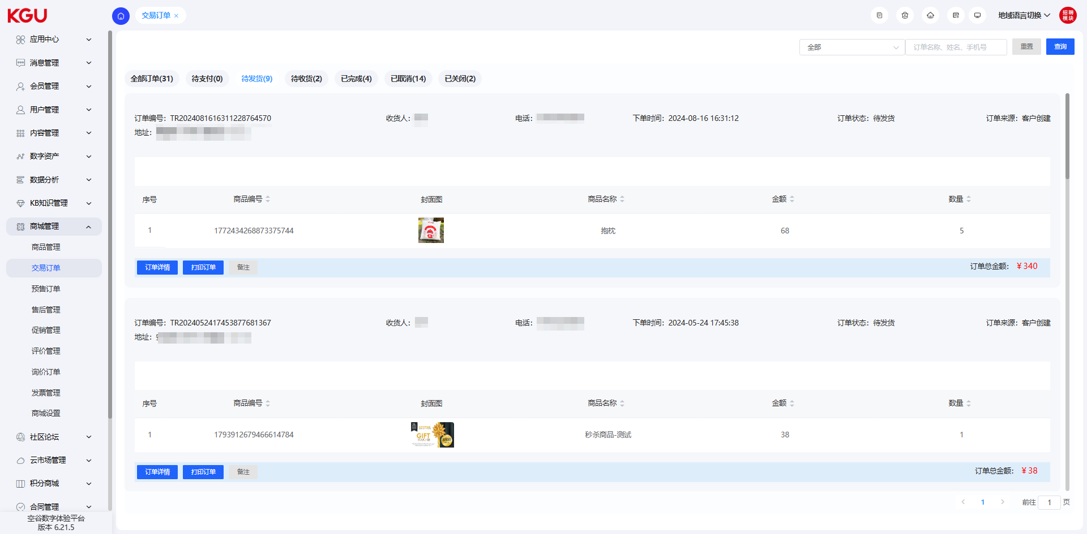
图 4.9.2(3) Transaction Orders-交易订单

When the pending review order is successfully pushed to the NBMP system, the order status will change to the "Pending Shipment" status. This indicates that the order has passed the review and is ready for shipment. In the "Pending Shipment" status, you can fill in the shipment information, including the courier company, waybill number and other relevant information. After filling in, the order status will be further updated to the "Pending Receipt" status.
当待审核的订单成功推送到NBMP系统后，订单的状态将转变为代发货状态。这表示订单已经通过审核，并准备进行发货操作。在代发货状态下，您可以填写发货信息，包括快递公司、运单号等相关信息。填写完毕后，订单的状态将进一步更新为待收货状态。

Pending Receipt-待收货
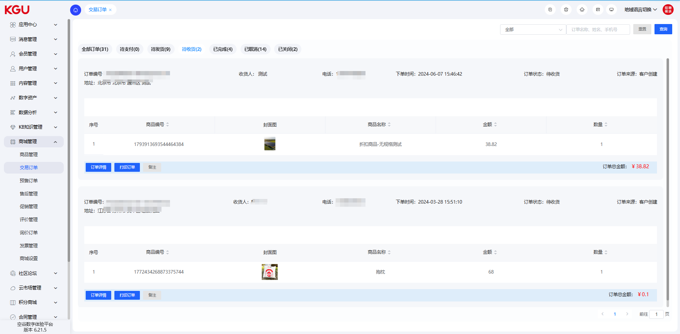
图 4.9.2(4) Transaction Orders-交易订单

In the "Pending Receipt" status, the customer can track the logistics information of the order and prepare to receive the goods. Once the customer confirms receipt and clicks the "Sign for Receipt" button, the order status will be transferred to "Completed". This indicates that the order has been successfully delivered to the customer and the entire purchase process has been completed. The "Completed" order status indicates that the transaction has been successfully completed and the customer has received the purchased goods.
在待收货状态下，客户可以追踪订单的物流信息，并准备接收商品。一旦客户确认收货，并点击签收按钮，订单的状态将流转为已完成。这表示订单已经成功交付给客户并完成了整个购买流程。已完成的订单状态表明交易顺利完成，并且客户已经收到了所购买的商品。

Completed-已完成
After receiving the goods, if the customer finds that the goods are damaged or needs to return or refund for other reasons, they can apply for a return or refund. Once the application is successful, the order status will be transferred to the "Transferred to After-sales" status. This indicates that the order has entered the after-sales processing stage, and the customer will conduct further communication and negotiation with the customer service or after-sales team to resolve the return and refund issues. In the "Transferred to After-sales" status, relevant personnel will handle the customer's return request and arrange the return process and refund matters. Please note that the specific return and refund policies and processes may vary by merchant.
客户收到货后如果发现商品有损坏或其他原因需要退货退款，可以申请退货退款。一旦申请成功，订单的状态将流转为已转售后状态。这表示订单已经进入售后处理阶段，客户将与客服或售后团队进行进一步沟通和协商，以解决退货退款事宜。在已转售后状态下，相关人员将处理客户的退货请求，并安排退货流程和退款事宜。请注意，具体的退货退款政策和流程可能因商家而异。

Cancelled-已取消
Orders cancelled by users on the front-end will be displayed as "Cancelled".
用户在前台取消的订单会显示为已取消。
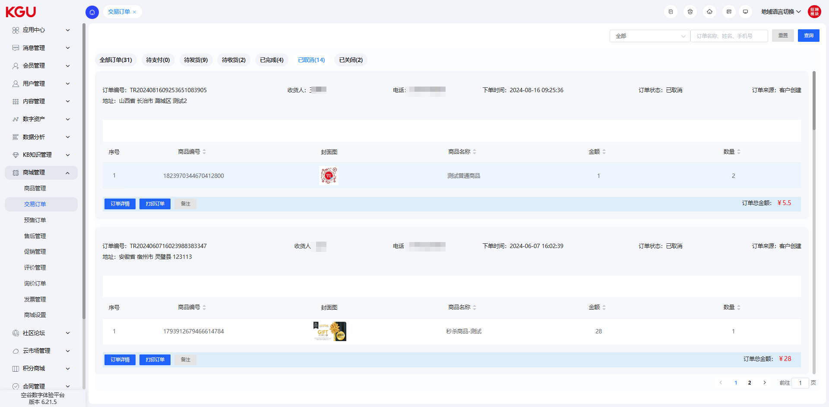
图 4.9.2(5) Transaction Orders-交易订单

Closed-已关闭
Orders closed by administrators in the management backend will be displayed as "Closed".
管理人员在管理后台关闭的订单会显示为已关闭。
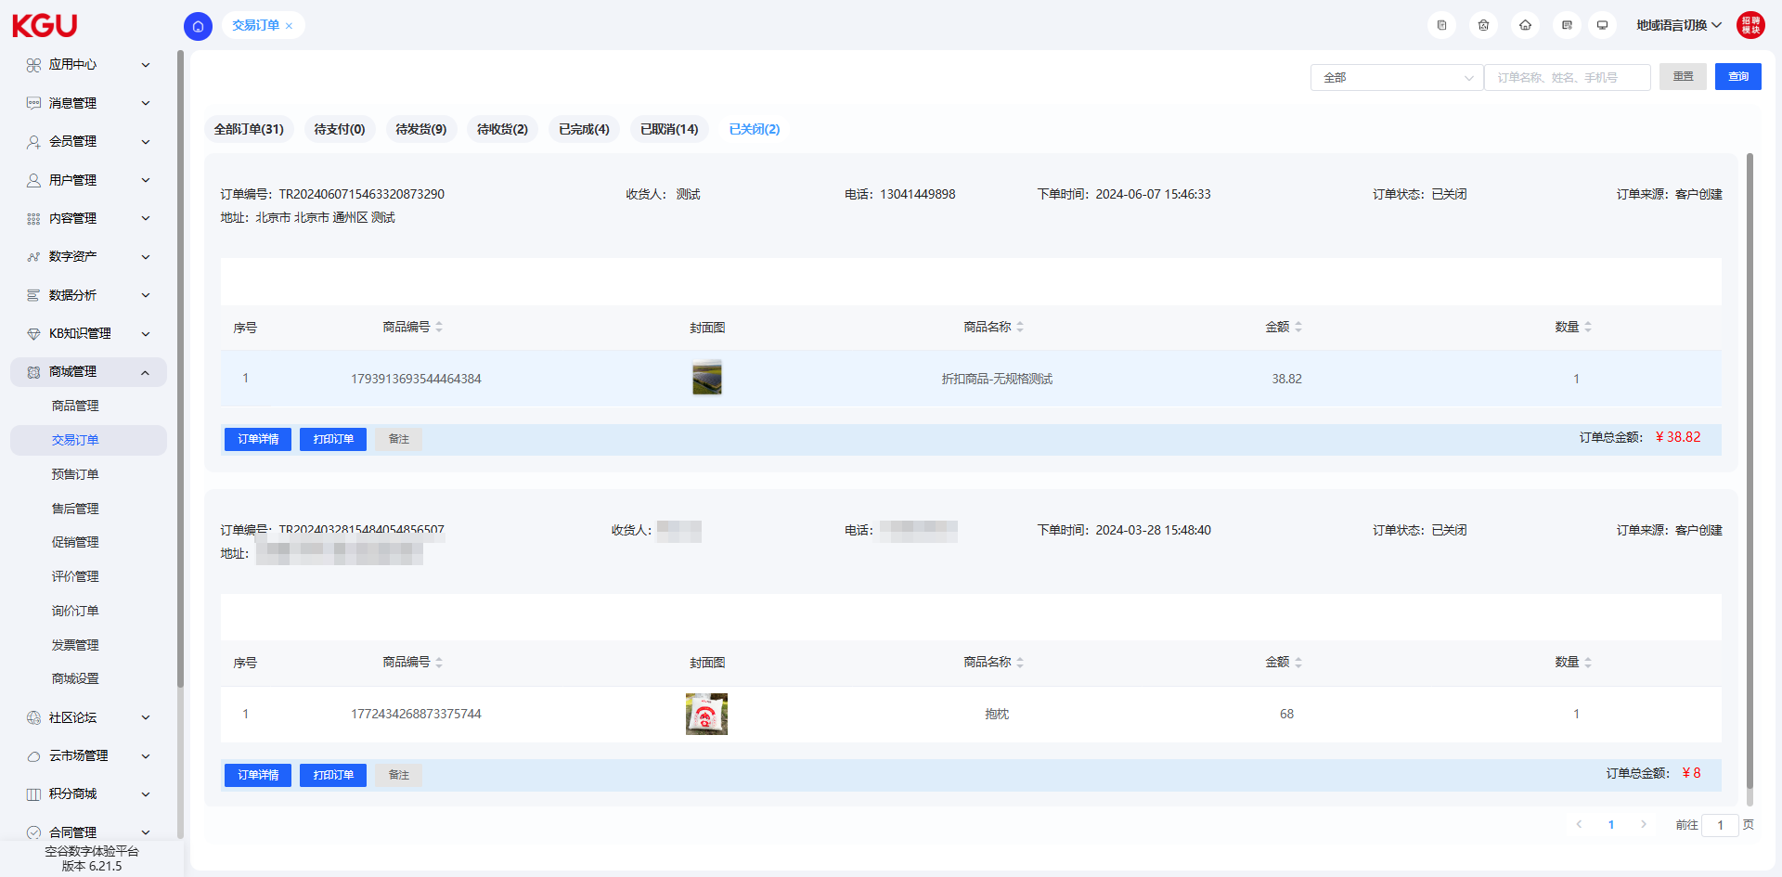
图 4.9.2(6) Transaction Orders-交易订单

4.9.3 Pre-sale Orders (Not Open)-预售订单（未开放）
The pre-sale order function refers to a function that allows users to place orders in advance before the official launch of the product or the provision of services. Compared with the ordinary order function, the pre-sale order function adds an order confirmation function. Only the confirmed orders will become real orders, and other processes are the same as normal orders.
预售订单功能是指在商品正式上市或提供服务之前，允许用户提前下单预订的一种功能。预售订单较普通订单功能，增加了订单确认功能，仅确认后的订单才会成为真正的订单，其他流程与正常订单一致。

4.9.4 After-sales Management (No Data)-售后管理（暂无数据）

Pending Review - 待审核
When a customer submits a return or refund application, the administrator will review the application reason. If the review result is reasonable, the administrator will change the order status to "Pending Return" and wait for the customer to return the goods.
If the review result is unreasonable, the administrator will change the order status to "Rejected" and notify the customer that the application has been rejected. In this case, the customer can submit the return or refund application again on the "Transferred to After-sales" page for re-review.
Through such a process, your system can conduct a strict review of return and refund applications to ensure that reasonable applications can be processed in a timely manner, while providing customers with the opportunity to submit applications again to solve any possible problems.
当客户提交退货退款申请后，管理员会对申请理由进行审核。如果审核结果为合理，管理员会将订单状态变更为"待退货"状态，等待客户进行退货操作。
如果审核结果为不合理，管理员会将订单状态变更为"已拒绝"，并通知客户申请被拒绝。在这种情况下，客户可以在已转售后页面再次提交退货退款申请，以便重新进行审核。
通过这样的流程，您的系统可以对退货退款申请进行严格的审核，确保合理的申请能够得到及时处理，同时为客户提供再次提交申请的机会，以便解决任何可能出现的问题。

Pending Return - 待退货
When a customer needs to return goods, they can click the "Upload Logistics Number" button on the front-end and fill in the logistics number for the return. After that, the customer can click the "Confirm" button to confirm the return operation and submit the logistics information.
Once the customer completes the above steps, the system will update the order status to "Returned", indicating that the return process has been completed.
In addition, if the customer changes their mind or no longer needs to return the goods during the return process, they can click the "Cancel After-sales" button. This will change the order status to "Cancelled", indicating that the after-sales process has been cancelled.
Through such a process, your system can easily track the return logistics information and update the order status in a timely manner, so that both the customer and the administrator can clearly understand the return status of the order.
当客户需要退货时，他们可以在前台点击上传物流单号按钮，并填写退货的物流单号。之后，客户可以点击确定按钮，以确认退货操作并提交物流信息。
一旦客户完成以上步骤，系统会将订单状态更新为"已退货"，表示退货流程已经完成。
此外，如果客户在退货流程中改变主意或者不再需要退货，他们可以点击取消售后按钮。这将导致订单状态变为"已取消"，表示售后流程被取消。
通过这样的流程，您的系统可以方便地跟踪退货物流信息并及时更新订单状态，使客户和管理员都能够清楚地了解订单的退货状态。

Returned-已退货
After the merchant receives the returned goods, they can click the "Confirm Receipt" button and fill in the corresponding information. Then, the merchant can click the "Submit" button to confirm the return operation and trigger the refund process.
Once the merchant completes the above steps, the system will update the order status to "Pending Refund", indicating that the return process has been completed and the refund operation will be carried out next.
商家在收到退货商品后，可以点击确认收货按钮，并填写相应的信息。然后，商家可以点击提交按钮，以确认退货操作并触发退款流程。
一旦商家完成以上步骤，系统会将订单状态更新为"待退款"，表示退货流程已经完成，接下来将进行退款操作。
通过这样的流程，您的系统可以方便地管理退货退款流程，使商家能够及时确认收货并启动相应的退款过程。

Pending Refund-待退款
After the goods are put into the warehouse, the merchant can click the "Confirm Refund" button and fill in the corresponding information. Then, the merchant can click the "Submit" button to confirm the refund operation and update the order status to "Refunded".
For orders paid using UnionPay B2B or scan code payment, the system will return the refund amount via the original payment method, i.e., back to the payment method used by the customer.
If the refund operation fails, your system provides a "View Refund Log" button. The merchant can click this button to view the reason for the refund failure.
Through the above process, your system can easily perform refund operations, and for orders paid by UnionPay B2B or scan code payment, the refund amount can be returned to the customer via the original payment method.
商家在商品入库后，可以点击确认退款按钮，并填写相应的信息。然后，商家可以点击提交按钮，以确认退款操作并将订单状态更新为"已退款"。
对于使用银联B2B或者扫码支付的订单，系统将退款金额原路返回，即返回到客户使用的支付方式上。
如果退款操作失败，您的系统提供了查看退款日志按钮，商家可以点击该按钮查看退款失败的原因。
通过以上的流程，您的系统可以方便地进行退款操作，并且对于银联B2B或者扫码支付的订单，能够将退款金额原路返回给客户。

Refunded - 已退款
On the order detail page, you can provide a dedicated area or option for customers to view the refund voucher. This area can display relevant information about the refund, including the refund amount, refund time, refund method, etc. You can provide the corresponding voucher number or transaction number for the customer to check and reference.
Through this function, customers can easily view the refund voucher on the order detail page, ensuring the transparency and accuracy of the refund operation.
在订单详情页，您可以提供一个专门的区域或选项，供客户查看退款凭证。这个区域可以显示退款的相关信息，包括退款金额、退款时间、退款方式等。您可以提供相应的凭证号或交易号，以便客户进行核对和参考。
通过这个功能，客户可以方便地在订单详情页查看退款凭证，确保退款操作的透明和准确性。

Rejected - 已拒绝
Orders that fail to pass the confirmation during the order confirmation process will be changed to the "Rejected" status.
在订单确认过程中，未通过确认的订单会变为已拒绝的状态。

Cancelled-已取消
Users can cancel the order before payment. The orders cancelled by users are in the "Cancelled" status.
用户在支付之前可以进行订单取消，用户取消的订单为已取消状态。

4.9.5 Promotion Management-促销管理

Limited-time Discount-限时折扣
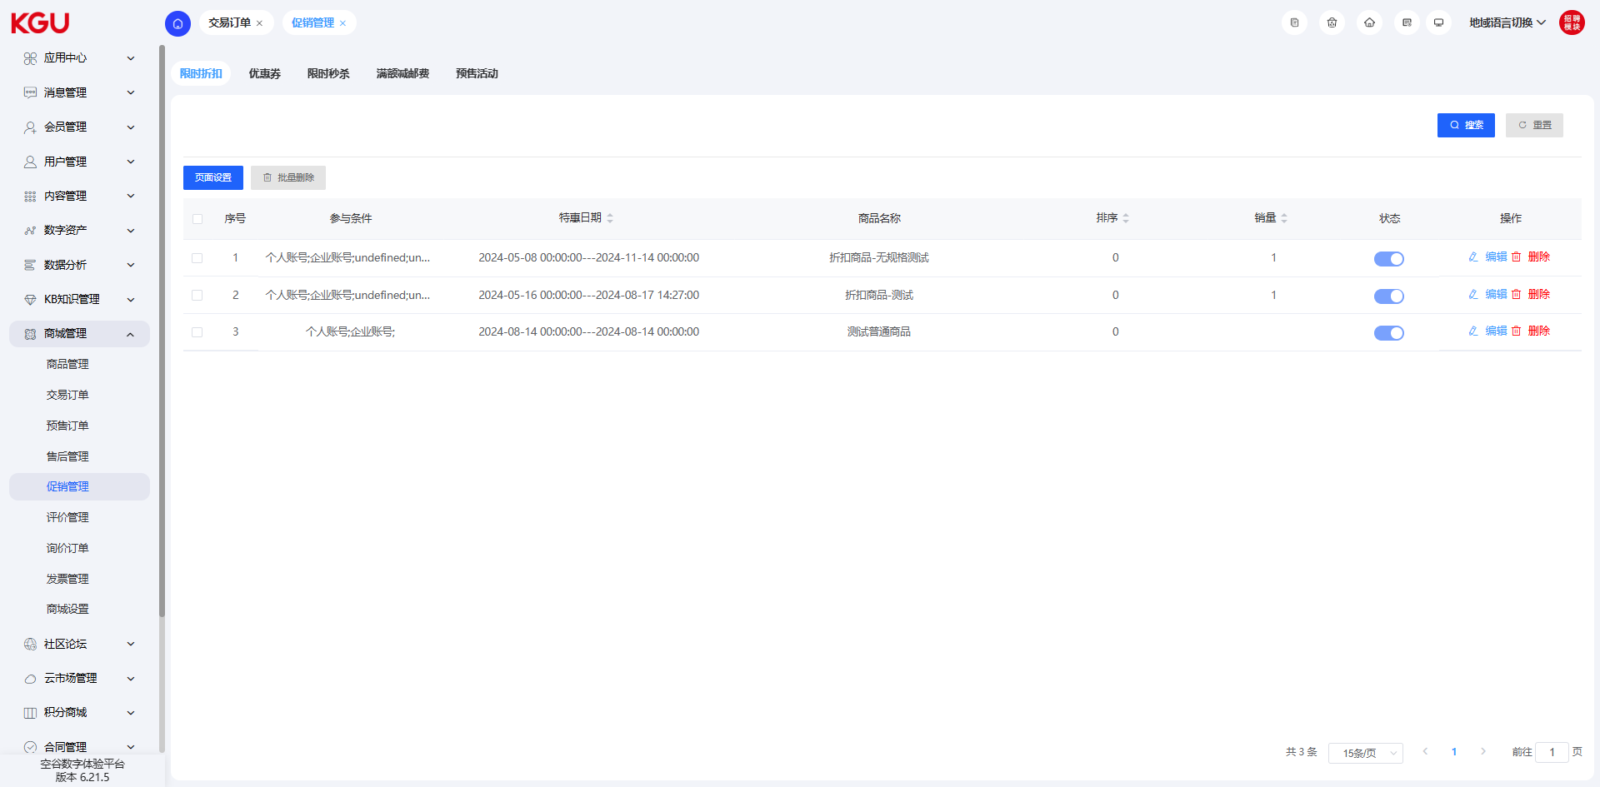
图 4.9.5(1) Promotion Management-促销管理
The limited-time discount management module provides comprehensive management functions for commodity discounts, including query, add data, delete, batch delete and edit. The specific functions are as follows:
Query: The limited-time discount information can be found and retrieved through this function to quickly locate the required discount.
Add Data: Allows users to add new limited-time discount data, including setting the discount amount or discount rate, setting the effective time and expiration time, etc.
Delete: A single limited-time discount can be deleted for necessary adjustments and updates.
Batch Delete: Supports batch deletion of multiple unnecessary limited-time discounts to improve operation efficiency.
Edit: Existing limited-time discounts can be edited, including modifying the discount amount or discount rate, updating the effective time and expiration time, etc. This allows flexible adjustment of discount settings to meet different promotion needs.
限时折扣管理模块提供了对商品折扣的全面管理功能，包括查询、添加数据、删除、批量删除和编辑。具体功能如下：
查询：可以通过该功能查找和检索限时折扣信息，快速定位所需折扣。
添加数据：允许用户添加新的限时折扣数据，包括设置折扣金额或折扣率、设定生效时间和失效时间等。
删除：可以删除单个限时折扣，以便进行必要的调整和更新。
批量删除：支持批量删除多个不再需要的限时折扣，提高操作效率。
编辑：允许对现有限时折扣进行编辑，包括修改折扣金额或折扣率、更新生效时间和失效时间等。这样可以灵活地调整折扣设置，满足不同的促销需求。
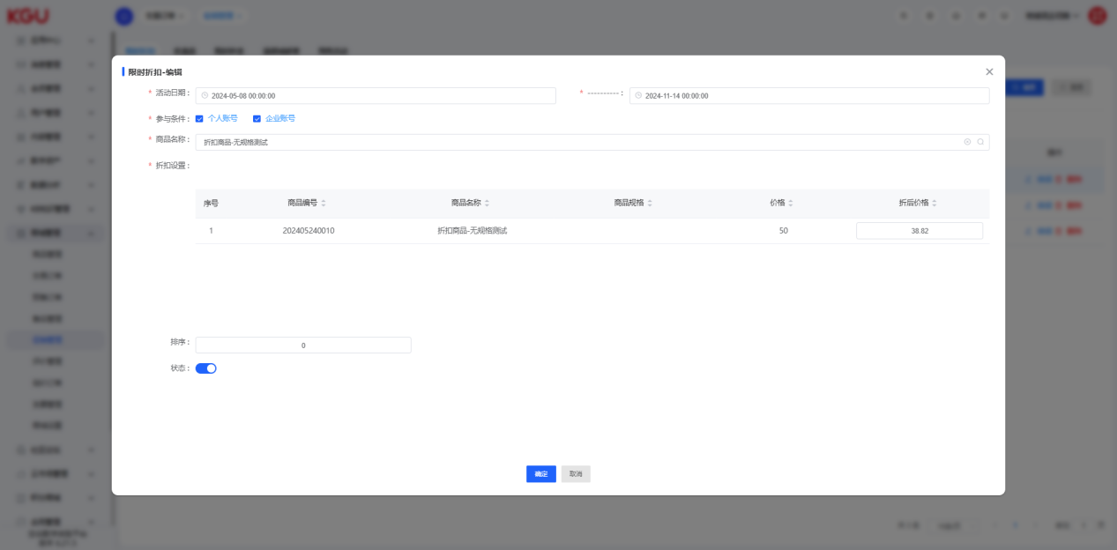
图 4.9.5(2) Promotion Management-促销管理
Activity Name: Used to identify the name of the discount.
Associated Commodity Category: The third-level category to which the discounted commodity belongs. Note: A specific third-level category must be selected to take effect.
Associated Commodity Name: Filter the commodities that can enjoy the discount through the selected category. Note: If no specific commodity is selected, the discount will apply to all commodities under the selected third-level category.
Discount: The discount amount or discount rate. For example, when set to 5%, the discounted price is 85% of the original price.
Validity Period: The start time and end time of the discount.
Participation Conditions: Divided into ordinary members and corporate members. If set to corporate members, ordinary members cannot enjoy the discount.
Sales Volume: The total number of discounted commodities purchased during the event, with a default value of 0.
Sort: Used to control the display order of discounts in the data list for easy management and search.
Status: Controls the available status of the discount. By manually enabling or disabling the status, you can decide whether to enable the discount.
活动名称：用于标识折扣的名称。
关联商品分类：打折商品所属的三级分类。注意：必须选择具体的三级分类才能生效。
关联商品名称：通过选择的分类筛选可享受折扣的商品。注意：如果未选择具体商品，该折扣将适用于所选三级分类下的所有商品。
折扣：优惠金额或折扣率。例如，设置为5%时，折扣价为原价的85%。
有效期：折扣的开始时间和结束时间。
参与条件：分为普通会员和企业会员。如果设置为企业会员，普通会员将无法享受该折扣。
销售：活动期间购买折扣商品的总量，默认为0。
排序：用于控制数据列表中折扣的显示顺序，方便管理和查找。
状态：控制折扣的可用状态。通过手动开启或关闭状态，决定是否启用该折扣。

Coupon-优惠券
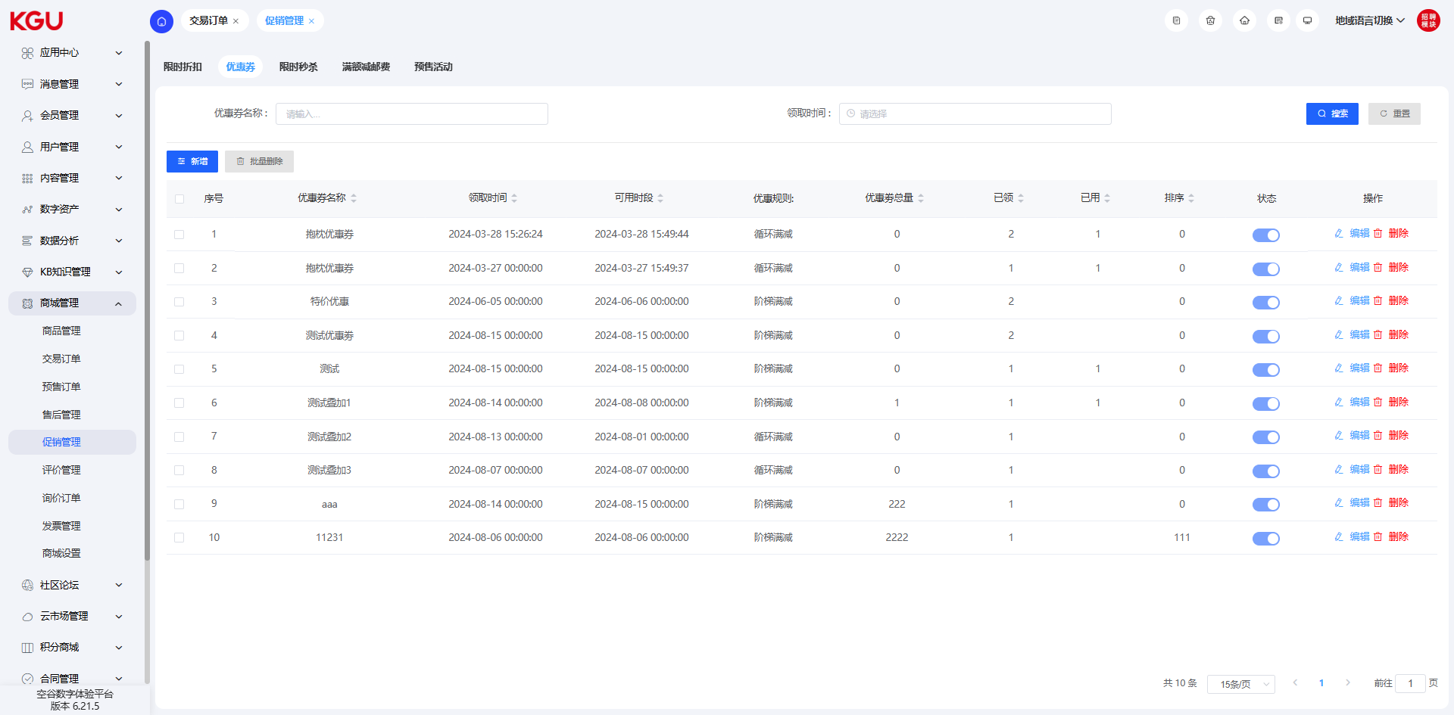
图 4.9.5(3) Promotion Management-促销管理
The coupon management module provides comprehensive coupon management functions, with the following specific functions:
Query: The coupon information can be quickly found and retrieved through this function to quickly locate the required coupon.
Add Data: Allows users to add new coupon data, including setting the coupon name, discount amount or discount rate, setting the validity period, etc.
Delete: A single coupon can be deleted for necessary adjustments and updates.
Batch Delete: Supports batch deletion of multiple unnecessary coupons to improve operation efficiency.
Edit: Existing coupons can be edited, including modifying the name, discount amount or discount rate, updating the validity period, etc. This allows flexible adjustment of coupon settings to meet different promotion needs.
Coupon Name: Used to identify the name of the coupon received on the front-end.
Coupon Description: A brief explanation and introduction of the coupon.
Associated Commodity Category: The third-level category to which the discounted commodity belongs. Note: A specific third-level category must be selected to take effect.
优惠券管理模块提供了全面的优惠券管理功能，具体功能如下：
查询：通过该功能可以快速查找和检索优惠券信息，以便快速定位所需优惠券。
添加数据：允许用户添加新的优惠券数据，包括设置优惠券的名称、折扣金额或折扣率、设定有效期等。
删除：可以删除单个优惠券，以进行必要的调整和更新。
批量删除：支持批量删除多个不再需要的优惠券，提高操作效率。
编辑：允许对现有优惠券进行编辑，包括修改名称、折扣金额或折扣率、更新有效期等。这样可以灵活地调整优惠券设置，满足不同的促销需求。
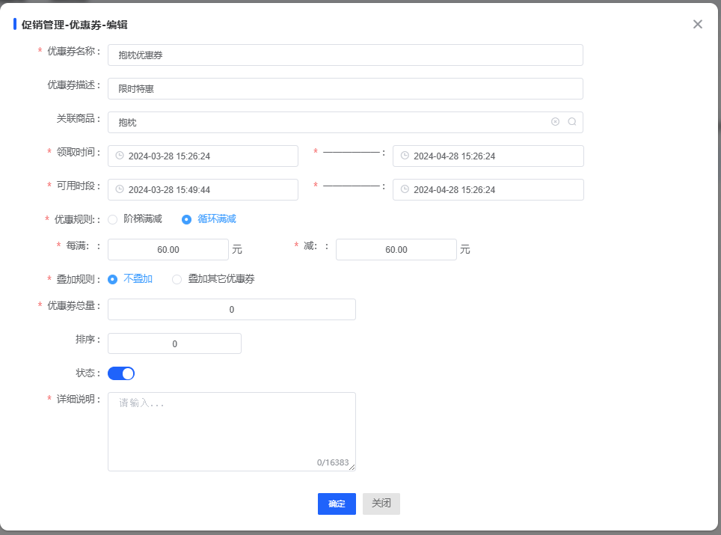
图 4.9.5(4) Promotion Management-促销管理
Associated Commodity Name: Filter the commodities that can use the discount through the selected category. Note: If no specific commodity is selected, the coupon will apply to all commodities under the selected third-level category.
Total Number of Coupons: The total number of coupons available for collection.
Collectible Period: Set the time period during which coupons can be collected.
Valid Period: Set the time period during which coupons can be used.
Discount Rule: Divided into step-by-step full reduction and cyclic full reduction, and the corresponding discount conditions are set according to the selected type.
Stacking Rule: Divided into non-stacking and stacking with other activities, used to set whether coupons can be used together with other activities.
Participation Conditions: Divided into ordinary members and corporate members. If set to corporate members, ordinary members cannot enjoy the coupon.
Sort: Used to control the display order of coupons in the data list for easy management and search.
Status: Controls the available status of the coupon. By manually enabling or disabling the status, you can decide whether to enable the coupon.
优惠券名称：用于标识前台领取的优惠券的名称。
优惠券描述：对优惠券进行简短的说明和介绍。
关联商品分类：优惠商品所属的三级分类。注意：必须选择具体的三级分类才能生效。
关联商品名称：通过选择的分类筛选可用优惠的商品。注意：如果未选择具体商品，该优惠券将适用于所选三级分类下的所有商品。
优惠券总量：可领取的优惠券总量。
可领时段：设定可以领取优惠券的时间段。
可用时段：设定可以使用优惠券的时间段。
优惠规则：分为阶梯满减和循环满减，并根据选择的类型设置相应的优惠条件。
叠加规则：分为不叠加和叠加其他活动，用于设定优惠券是否可以与其他活动同时使用。
参与条件：分为普通会员和企业会员。如果设置为企业会员，普通会员将无法享受该优惠券。
排序：用于控制数据列表中优惠券的显示顺序，方便管理和查找。
状态：控制优惠券的可用状态。通过手动开启或关闭状态，决定是否启用该优惠券。

Limited-time Seckill (No Data)-限时秒杀（暂无数据）
The system can set the function of purchasing commodities at a specific price within a specified time period.
系统可以设置在指定时间段内以特定的价格购买商品的功能。

Free Shipping on Full Purchase (No Data)-满额减邮费（暂无数据）
Free shipping on full purchase is a common promotion strategy that can encourage customers to purchase more commodities to reach a certain shopping amount to reduce or waive the shipping fee, but the commodities must be free shipping commodities. The following are the functions of free shipping on full purchase:
Add: You can add rules for free shipping on full purchase. The add function allows you to set the shopping amount that meets the conditions and the corresponding reduced shipping fee amount. You can set multiple different free shipping on full purchase rules according to needs.
Query: You can query the added free shipping on full purchase rules. The query function allows you to view the currently set free shipping on full purchase rules, including the shopping amount and reduced shipping fee amount.
Modify: If you need to adjust the existing free shipping on full purchase rules, you can use the modify function. The modify function allows you to change the shopping amount and reduced shipping fee amount to make adjustments according to needs.
Delete: If a certain free shipping on full purchase rule is no longer applicable or needed, you can use the delete function to remove it. The delete function can help you keep the rule list concise and effective.
Enable: Sometimes you may need to temporarily disable a certain free shipping on full purchase rule for later re-enabling. The enable function allows you to re-activate the previously disabled rule when needed.
Through the add, query, modify, delete and enable functions, you can easily manage the free shipping on full purchase rules to meet the needs of customers to reduce or waive the shipping fee when purchasing commodities to reach a certain amount. Please set appropriate rules according to the actual situation to improve the customer's shopping experience and satisfaction.
满额减邮费是一种常见的促销策略，可以鼓励客户购买更多商品以达到一定的购物金额从而减少或免除邮费，但必须为包邮商品。以下是满额减邮费的功能：
添加：您可以添加满额减邮费的规则。添加功能可以让您设置满足条件的购物金额和对应的减免邮费金额。您可以根据需要设置多个不同的满额减邮费规则。
查询：您可以查询已经添加的满额减邮费规则。查询功能可以让您查看当前已设置的满额减邮费规则，包括购物金额和减免邮费金额。
修改：如果您需要调整已有的满额减邮费规则，您可以使用修改功能。修改功能允许您更改购物金额和减免邮费金额，以便根据需要进行调整。
删除：如果某个满额减邮费规则不再适用或不再需要，您可以使用删除功能将其移除。删除功能可以帮助您保持规则列表的简洁和有效。
启用：有时您可能需要暂时禁用某个满额减邮费规则，以便稍后重新启用。启用功能可以让您在需要时重新激活之前禁用的规则。
通过添加、查询、修改、删除和启用功能，您可以轻松管理满额减邮费规则，以满足客户购买商品达到一定金额可以减少或免除邮费的需求。请根据实际情况设置适当的规则，以提升客户的购物体验和满意度。

Pre-sale Activity (No Data)-预售活动（暂无数据）
When adding a commodity, in the commodity type, the commodity can be set as a pre-sale commodity. When purchasing a pre-sale commodity, it cannot be added to the shopping cart, and only the direct purchase function can be used. After completing the payment and purchase, the order will become a pre-sale order.
在添加商品的时候，在商品类型中，可以将该商品设置为预售商品，预售商品在购买的时候，不可以添加进购物车，仅可以使用直接购买的功能，完成支付购买后，该订单会成为一条预售订单。

4.9.6 Review Management-评价管理

Commodity Review (No Data)-商品评价（暂无数据）
The commodity review module is used to manage consumers' reviews of commodities, including information such as commodity classification, user ID, review content, average time, number of likes, score, and reply messages to reviews. The specific functions are as follows:
Query: Quickly find reviews through keywords, filter conditions or other search methods to quickly locate the required review information. You can perform targeted searches according to needs to obtain reviews of specific commodities or users.
Delete: Delete the specified commodity review, which will be deleted from the system after confirmation. You can select the review to be deleted and perform the confirmation operation to remove the review from the system. This can keep the review list clean and accurate.
Edit: Modify and update the existing commodity reviews, including modifying the attached pictures, content, star rating, status, etc. You can select the review that needs to be edited and perform corresponding modification and update operations to maintain the accuracy and practicality of the review information. Through the edit function, you can timely respond to user feedback or correct errors in the review.
Status: The default is enabled. The status of the review can be manually switched to decide whether to display the review on the front-end. You can set the review to enabled or disabled status according to needs, control the display and visibility of the review on the front-end. This can flexibly manage the review content and ensure that the displayed reviews meet the requirements and policies.
Through these functions of the commodity review module, you can easily manage and maintain commodity reviews, quickly find review information, delete unnecessary reviews, timely respond to user feedback, and control the display and visibility of reviews on the front-end, improving user experience and commodity service quality.
商品评价模块用于管理消费者对商品的评价，包括商品的分类、用户ID、评价内容、平均时间、点赞数、分数以及评价的回复消息等信息。具体功能如下：
查询：通过关键字、筛选条件或其他搜索方式快速查找评价，以便快速定位所需的评价信息。您可以根据需要进行针对性的搜索，以获取特定商品或用户的评价。
删除：删除指定的商品评价，确认后将从系统中删除。您可以选择要删除的评价，并进行确认操作，以便从系统中移除该评价。这样可以保持评价列表的整洁和准确性。
编辑：对已存在的商品评价进行修改和更新，包括修改配图、内容、星级、状态等。您可以选择需要编辑的评价，并进行相应的修改和更新操作，以保持评价信息的准确性和实用性。通过编辑功能，您可以及时回应用户的反馈或更正评价中的错误信息。
状态：默认为开启状态，可以手动切换评价的状态，以决定前台是否显示该评价。您可以根据需要将评价设置为开启或关闭状态，控制评价在前台的展示和可见性。这样可以灵活管理评价内容，确保展示的评价符合要求和政策。
通过商品评价模块的这些功能，您可以方便地管理和维护商品评价，快速查找评价信息，删除不需要的评价，及时回应用户反馈，并控制评价在前台的展示和可见性，提升用户体验和商品服务质量。

Reply Management (No Data)-回复管理（暂无数据）
The reply message management function is used to manage the reply messages of reviews, including the following specific functions:
Add Reply: Add reply information for customers in the background. The reply status is enabled by default. Only replies with enabled status can be displayed on the front-end, allowing customers to see the reply content and get timely responses.
Edit Reply: Modify and update the existing replies. You can select the reply that needs to be edited and perform corresponding modification and update operations to ensure the accuracy and timeliness of the reply information. Through the edit reply function, you can timely correct errors in the reply or update the reply content, providing accurate and timely replies to customers.
Delete Reply: Delete the specified reply, which will be permanently deleted from the system after confirmation. You can select the reply to be deleted and perform the confirmation operation to completely remove the reply from the system. Through the delete reply function, you can keep the reply list clean and accurate, ensuring that only relevant and valid reply information is displayed.
Through these reply message management functions, you can easily add, edit and delete the reply information of reviews, ensuring that customers can get accurate and timely replies. At the same time, you can control the status of the reply to decide whether to display it on the front-end, providing a better user experience and service quality
回复消息管理功能用于管理评价的回复消息，具体包括以下功能：
添加回复：在后台为客户添加回复信息。回复状态默认开启，只有状态开启的回复才能在前台显示，让客户能够看到回复内容并得到及时回应。
编辑回复：对已存在的回复进行修改和更新。您可以选择需要编辑的回复，并进行相应的修改和更新操作，以保证回复信息的准确性和时效性。通过编辑回复功能，您可以及时修正回复中的错误或更新回复内容，提供准确和及时的回复给客户。
删除回复：删除指定的回复，确认后将从系统中永久删除。您可以选择要删除的回复，并进行确认操作，以便从系统中完全移除该回复。通过删除回复功能，可以保持回复列表的整洁和准确性，确保只展示相关和有效的回复信息。
通过这些回复消息管理功能，您可以方便地添加、编辑和删除评价的回复信息，确保客户能够获得准确和及时的回复。同时，您可以控制回复的状态，决定是否在前台显示，提供更好的用户体验和服务质量。

4.9.7 Inquiry Order-询价订单
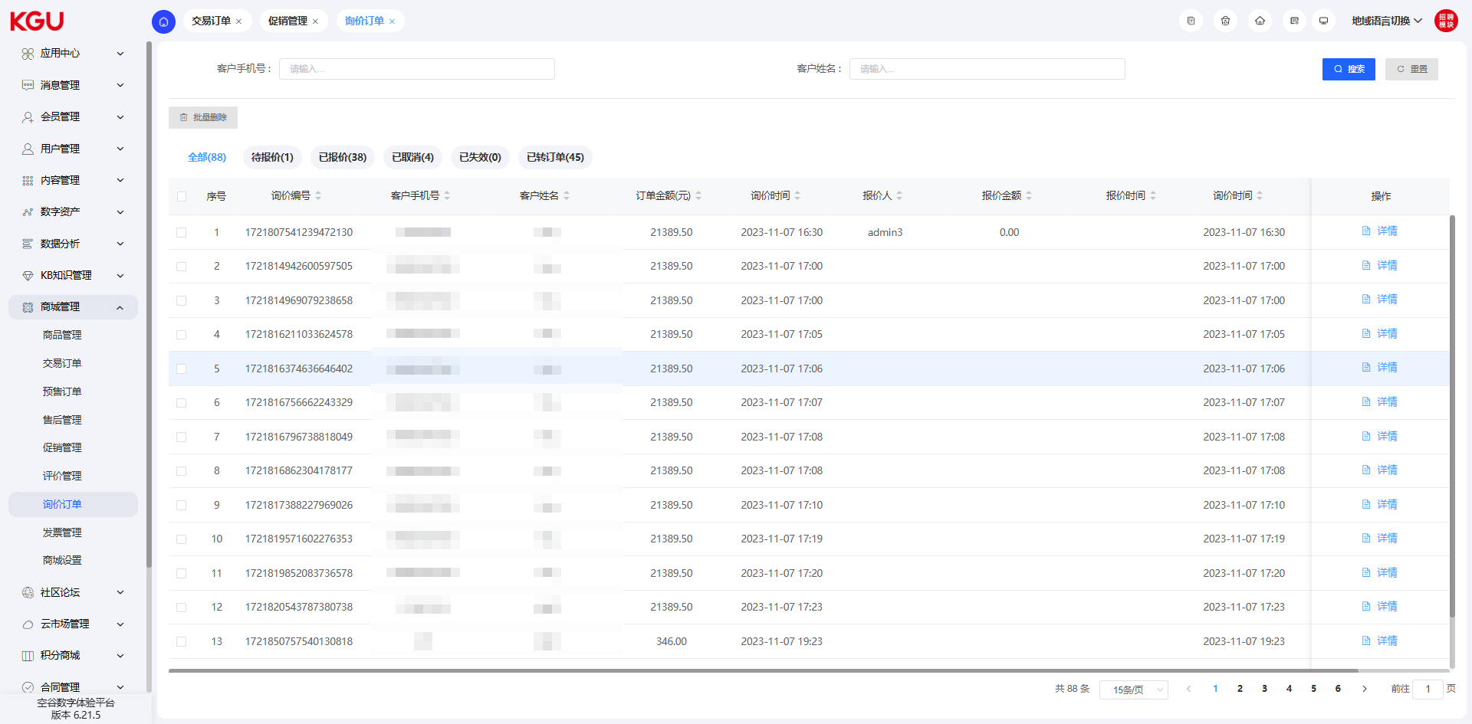
图 4.9.7(1) Inquiry Order-询价订单

Pending Quotation-待报价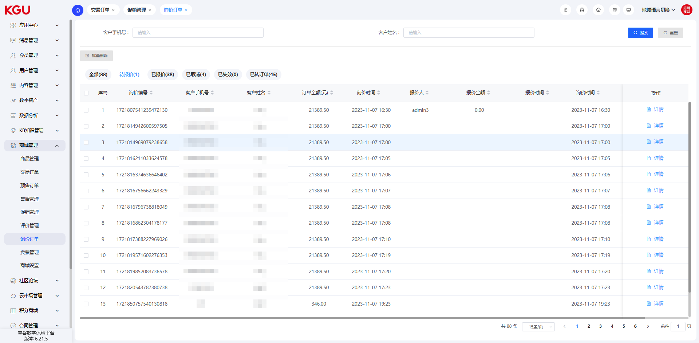
图 4.9.7(2) Inquiry Order-询价订单
After the customer submits an inquiry application, the administrator enters the background to quote the order. There are several points to note when processing the order:
Quotation Validity Period: The administrator needs to complete the quotation within a certain period of time. Once the quotation validity period is exceeded, the inquiry form will automatically become invalid. It is recommended that the administrator process the order in a timely manner to ensure that the quotation is completed within the validity period.
Inability to Enjoy Commodity Discounts and Coupons: Since the inquiry form is a special type of order, the inquiry application submitted by the customer cannot enjoy the discounts and coupons of the commodities. When quoting, the administrator needs to set the price as the original price or a special price negotiated with the customer.
客户提交询价申请后，管理员进入后台对订单进行报价。在处理订单时，有几点需要注意：
1.报价有效期：管理员需要在一定的时间内完成报价。一旦超过报价有效期，询价单将自动失效。建议管理员及时处理订单，确保在有效期内完成报价。
2.无法享受商品折扣和优惠券：由于询价单是特殊类型的订单，客户提交的询价申请无法享受商品折扣和优惠券的优惠。管理员在报价时，需要将价格设定为原价或与客户协商的特殊价格。
管理员可以根据客户的询价申请，结合市场价格和相关策略，合理定价并向客户提供报价信息。

Quoted-已报价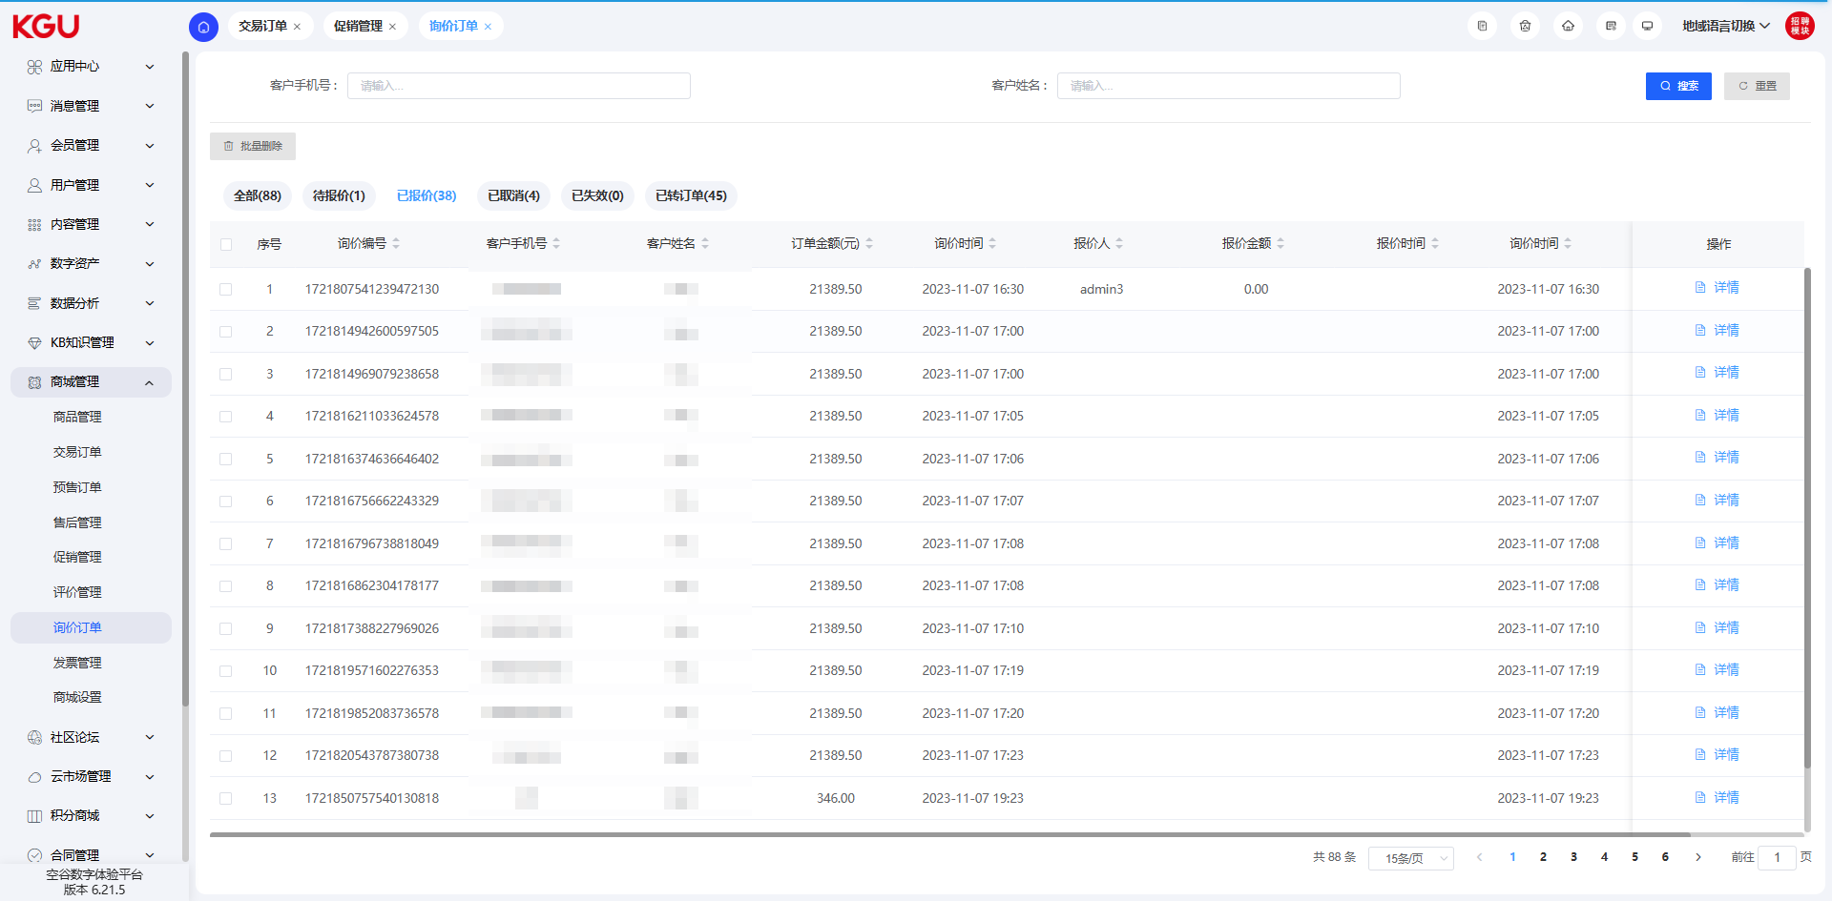
图 4.9.7(3) Inquiry Order-询价订单
If the customer is satisfied with the quotation, they can click the "Convert to Transaction Order" button to jump to the settlement page for payment. In this way, the customer can quickly convert the inquiry process into an actual transaction process and complete the payment operation.
If the customer is not satisfied with the quotation result, they can contact the customer service, sales or distributor and request another quotation in the background. This can provide the customer with a better quotation plan to meet their needs.
Please note that responding to customer dissatisfaction and needs in a timely manner is an important aspect of providing good customer service, ensuring customer satisfaction and improving order success rates.
客户对报价满意后可以点击转为交易订单按钮，跳转至结算页进行支付。这样客户可以快速将询价过程转化为实际的交易流程，并完成支付操作。
如果客户对报价结果不满意，他们可以联系客服、销售或经销商，并在后台再次进行报价。这样可以为客户提供更好的报价方案，满足他们的需求。
请注意，及时响应客户的不满意和需求是提供良好客户服务的重要方面，确保客户满意度和订单成功率的提高。

Cancelled-已取消
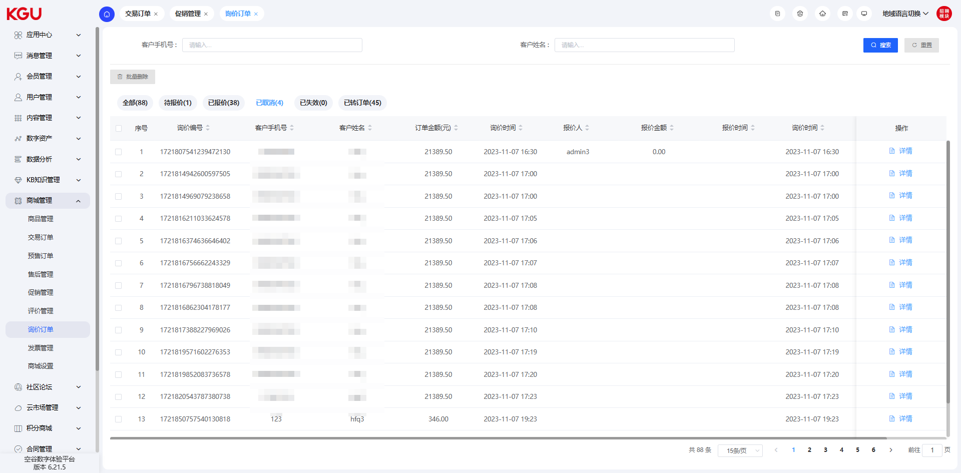
图 4.9.7(4) Inquiry Order-询价订单
Orders cancelled by users are in the "Cancelled" status.
用户取消的状态状态为已取消。

Invalid-已失效
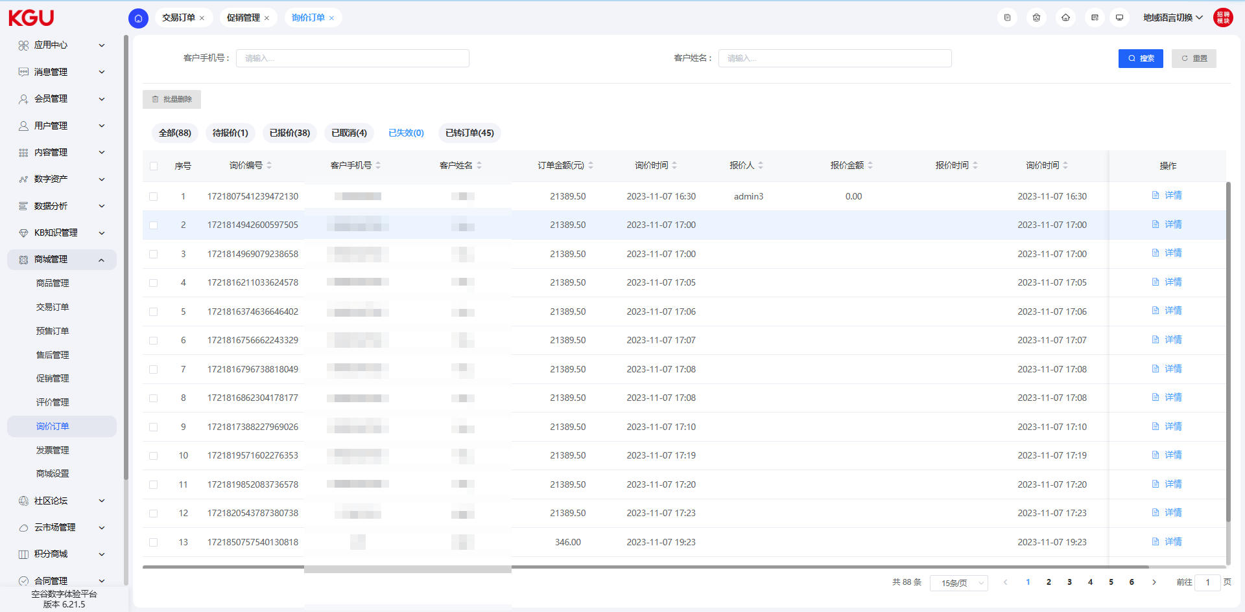
图 4.9.7(5) Inquiry Order-询价订单
The inquiry order has a time limit. After exceeding the set time limit, the inquiry will become "Invalid".
询价订单具有时效性，超过设置的时效性后，该询价定义会变为已失效状态。

Converted to Order-已转订单
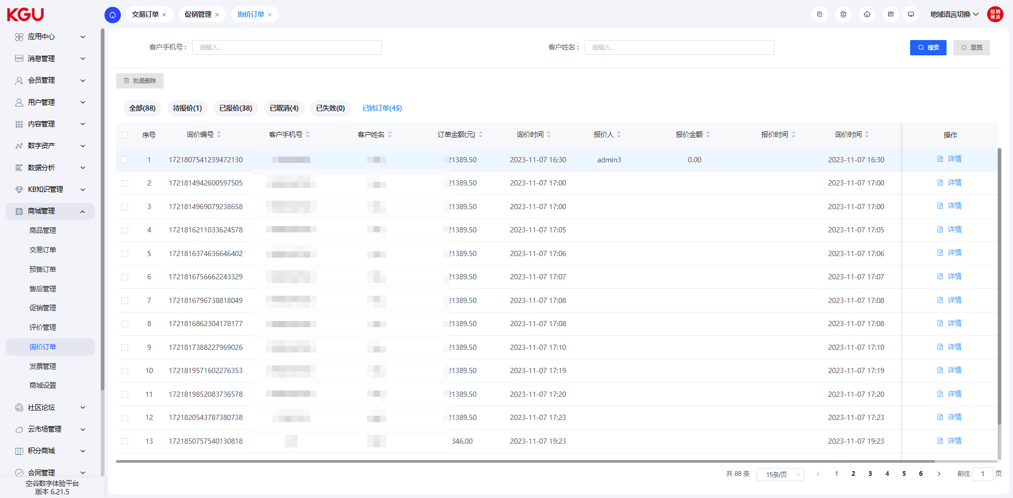
图 4.9.7(6) Inquiry Order-询价订单
Once the customer completes the payment, the inquiry order will be converted to the "Converted to Order" status. This indicates that the customer has confirmed and accepted the quotation and completed the payment operation. The change in the order status will reflect the progress and current status of the order.
By converting the inquiry order to "Converted to Order", the system can automatically move the order to the next process, such as order processing, shipment and after-sales service. This helps to improve the efficiency of order processing and ensure that the order can be delivered to the customer on time.
一旦客户完成支付，询价订单将会转变为已转订单的状态。这表示客户已经确认并接受了报价，并进行了支付操作。订单状态的变化将反映出订单的进展和当前的状态。
通过将询价订单转为已转订单，系统可以自动将订单进入下一步的流程，例如订单处理、发货和售后服务等。这有助于提高订单处理的效率，并确保订单能够按时交付给客户。

4.9.8 Invoice Management-发票管理

Pending Review (No Data)-待审核（暂无数据）
After logging in to the background, the administrator can enter the pending review invoice page. On this page, the administrator can review the pending review invoices. If the review is passed, the invoice status will be changed to "Pending Invoicing", indicating that the review has been passed and the invoicing operation is pending. If the review is not passed, the invoice status will be changed to "Rejected", indicating that the review has not been passed.
Through the administrator's review, the accuracy and compliance of the invoice information can be ensured, and the invoice issuance and management process can be further promoted.
管理员登录后台后，可以进入待审核发票的页面。在该页面中，管理员可以对待审核的发票进行审核操作。如果审核通过，发票的状态将被改为"待开票"，表示已通过审核待进行开票操作。如果审核不通过，发票的状态将被改为"已拒绝"，表示审核未通过。
通过管理员的审核，可以确保发票信息的准确性和合规性，进一步推动发票的开具和管理流程。

Pending Invoicing (No Data)-待开票（暂无数据）
The administrator can select the invoices to be invoiced in the background and export the corresponding invoice information. The exported invoice information can include the invoice title, taxpayer identification number, invoicing amount and other relevant information.
In addition, the administrator can also click the "Upload Invoice" button to upload the invoice voucher. The uploaded invoice voucher can be a picture or file, which is used as the basis and proof for invoicing.
After completing the upload, the administrator can click the "Save" button to modify the invoice status to "Invoiced". This indicates that the invoice has completed the invoicing operation and can proceed to the subsequent invoice management and processing.
Through these operations, the administrator can effectively manage the invoice information, ensure an accurate invoicing process, and provide customers with reliable invoice vouchers.
管理员可以在后台选择代开票的发票，并导出相应的发票信息。导出的发票信息可以包括发票抬头、纳税人识别号、开票金额等相关信息。
此外，管理员还可以点击上传发票按钮，将发票凭证进行上传。上传的发票凭证可以是图片或文件，用于作为开票的依据和证明。
完成上传后，管理员可以点击保存按钮，将发票状态修改为"已开票"。这表示该发票已经完成开票操作，并且可以进行后续的发票管理和处理。
通过这些操作，管理员能够有效管理发票信息，确保准确的开票流程，并为客户提供可靠的发票凭证。

Invoiced-已开票
The administrator can view the invoice information that has been invoiced on the invoiced page.
On the invoiced page, the administrator can see a list of invoices that have been invoiced. Each invoice includes relevant information such as invoice number, invoice title, invoicing date, and invoicing amount.
The administrator can browse the invoice list and view the detailed information of each invoice. This detailed information may include customer information, commodity details, invoice vouchers, etc.
By viewing the invoiced page, the administrator can manage and track the invoices that have been issued, ensuring the accuracy and timeliness of the invoice information.
管理员可以在已开票的页面查看已经完成开票的发票信息。
在已开票的页面，管理员可以看到已开票的发票列表，每张发票包括发票号码、发票抬头、开票日期、开票金额等相关信息。
管理员可以浏览发票列表，并查看每张发票的详细信息。这些详细信息可能包括客户信息、商品明细、发票凭证等。
通过查看已开票的页面，管理员可以对已开具的发票进行管理和跟踪，确保发票信息的准确性和及时性。

Rejected-已拒绝
Invoicing application forms that fail the review will be changed to the "Rejected" status.
审核未通过的开票申请单会变为已拒绝的状态。

4.9.9 Mall Settings-商城设置
The mall settings module provides the following functions for managing commodity sorting, inventory reduction methods, order allocation methods, tax items and invoice export:
Commodity Sorting: Used to set the display order of commodities in the mall. Through this function, you can adjust the arrangement order of commodities to optimize the user's browsing and shopping experience.
Inventory Reduction Method: Provide different methods to reduce commodity inventory to meet the needs of the mall. You can choose to reduce inventory one by one, reduce inventory in batches or other suitable methods to ensure the accuracy and timeliness of inventory reduction.
Order Allocation Method: Used to specify the order allocation method to ensure that orders can be efficiently allocated to the corresponding processors. You can set order allocation rules to allocate orders to appropriate teams or individuals for processing according to different conditions, improving the efficiency of order processing.
Tax Item Management: Used to manage different tax items involved in the mall to correctly calculate and apply taxes. Through this function, you can manage the name, tax rate and other relevant information of tax items to ensure the accuracy and compliance of tax calculation.
Invoice Export Management: Provides an invoice export function to facilitate the mall to perform relevant financial management operations. You can export the invoice information of the order through this function for invoice management, reimbursement and financial records.
Through these functions of the mall settings module, you can flexibly configure the mall's operation rules and tax regulations, provide a better shopping experience, and ensure the smooth operation and compliance of the mall.
商城设置模块提供了以下功能，用于管理商品排序、减库存方式、订单分配方式、税目和发票导出：
商品排序：用于设置商品在商城中的展示顺序。通过该功能，您可以调整商品的排列顺序，以优化用户浏览和购物体验。
减库存方式：提供不同的方式来减少商品库存，以满足商城的需求。您可以选择逐个减少库存、批量减少库存或其他适合的方式，确保库存减少的准确性和及时性。
订单分配方式：用于指定订单的分配方式，以确保订单能够高效地分配给相应的处理方。您可以设定订单分配规则，根据不同的条件将订单分配给适当的团队或个人进行处理，提高订单处理效率。
税目管理：用于管理商城中涉及的不同税目，以便正确计算和应用税费。通过该功能，您可以管理税目的名称、税率和其他相关信息，确保税费计算的准确性和合规性。
发票导出管理：提供了发票导出的功能，方便商城进行相关财务管理操作。您可以通过该功能导出订单的发票信息，以便进行发票管理、报销和财务记录。
通过商城设置模块的这些功能，您可以灵活地配置商城的运营规则和税务规定，提供更好的购物体验，并确保商城运营的顺畅和合规性。
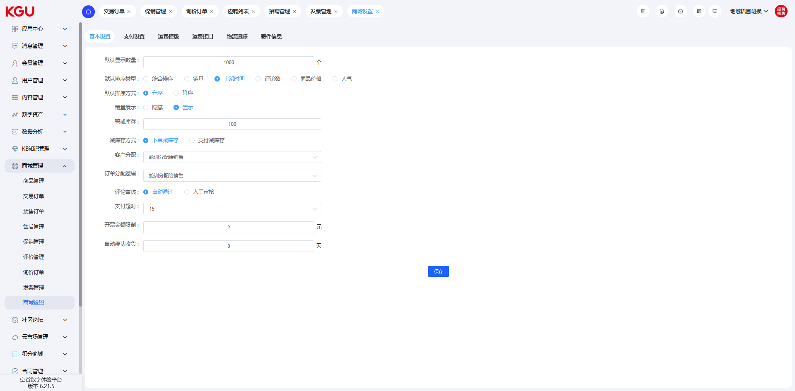
图 4.9.9 Mall Settings-商城设置

4.10 Points Mall-积分商城
The system supports the points mall function. Members can obtain points through consumption, activity participation, etc., and then use the points to redeem the required commodities or services. The main functions include: points commodity management, points order management, points record viewing and points configuration.
系统支持积分商城功能，会员可以通过消费、活动参与等方式获得积分，再将积分用于兑换所需的商品或服务。主要功能包括：积分商品管理、积分订单管理、积分记录查看及积分配置等功能。

4.10.1 Points Commodities-积分商品
In the points commodity function, you can set the commodity information, price, shipping fee, the number of points required for redemption and the membership level required for redemption.
在积分商品功能中，可以设置商品信息、价格、邮费及兑换所需积分信息及兑换所需的会员等级信息。

4.10.2 Points Orders-积分订单
When members consume or redeem points on the front-end, corresponding order information will be generated. In the order, you can view the redeemed product information, user information and maintain the shipment information of the order.
会员在前台进行消费或者进行积分兑换时，会生成相应的订单信息，在订单中可以查看兑换产品信息、用户信息及对订单的发货信息进行维护。

4.10.3 Points Records-积分记录
In the points record list, the administrator can view the points records generated by members when logging in, checking in, posting or replying to posts on the front-end, and consuming in the mall.
在积分记录列表中，管理员可以查看会员在前台进行登录、签到、发帖或者回复帖子，以及在商城消费时产生的积分记录信息。

4.10.4 Points Configuration-积分配置
In the points configuration function, the administrator is used to configure and manage the rules for generating points and the value of the generated points. The system has built-in some common point-generating behaviors, and also supports configuring more point-generating rules according to the actual operation situation.
在积分配置功能中，管理员用以配置管理产生积分的规则及产生积分的数值。系统内置一部分常见的产生积分行为，也可以支持依据实际运营情况来配置更多的产生积分规则。

4.11 Contract Management-合同管理

4.12 Recruitment Module-招聘模块
The system has a built-in cloud market function. Users can purchase KGU's products and services in the cloud market, such as SMS traffic, translation traffic and support interfaces.
系统内置云市场功能，用户可以在云市场中购买空谷的产品和服务、例如短信流量、翻译流量及支持接口等功能。

4.12.1 Recruitment List-招聘列表
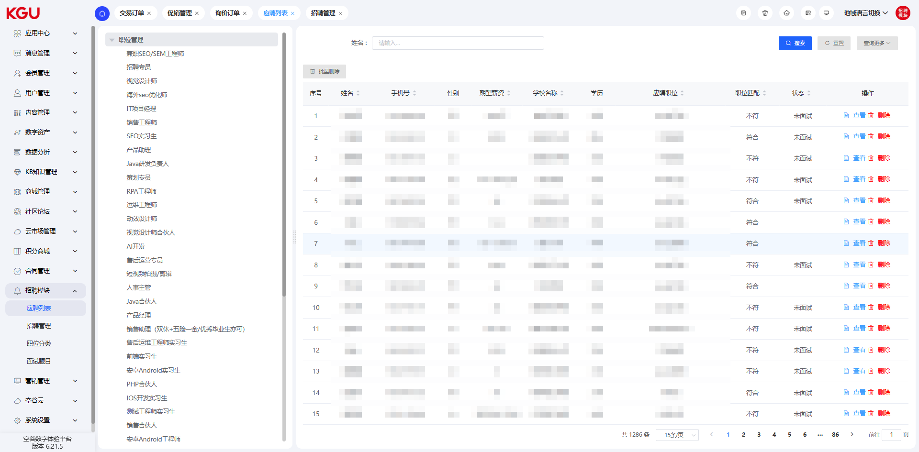
图 4.12.1(1) Recruitment List-招聘列表
In the application list, you can view the information of all current applicants, and at the same time display the job matching degree and the status of the application process.
在应聘列表中，可以查看当前应聘的所有人员信息，同时可以展示职位匹配度及应聘流程的状态。
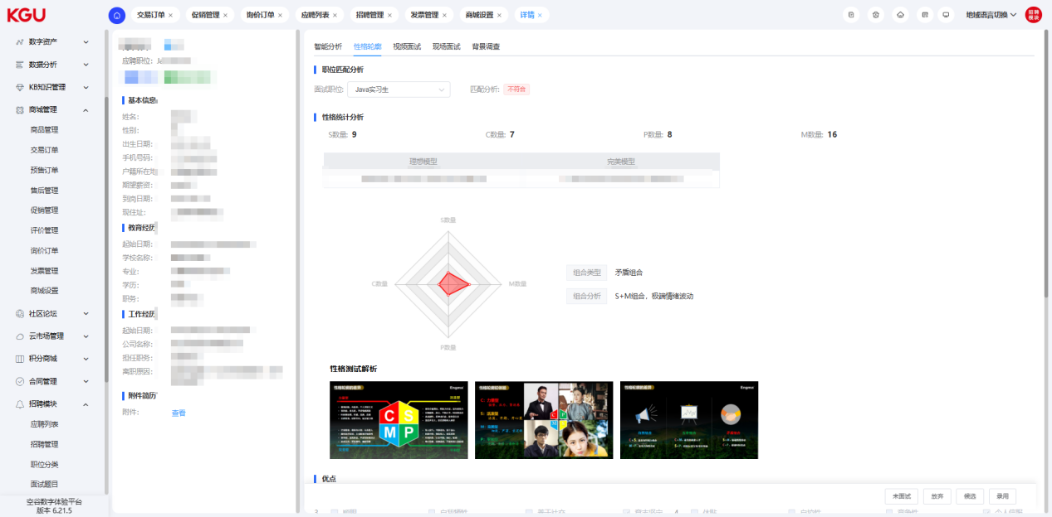
图 4.12.1(2) Recruitment List-招聘列表
In the application list, clicking the "View" button allows you to view the detailed information of the current applicant. In the detailed information, you can view the applicant's educational experience and work experience information.
在应聘列表中，点击查看按钮可以查看当前应聘人员的详情信息，在详细信息中，可以查看到应聘人员的教育经历、工作经历信息。

Personality Profile-性格轮廓
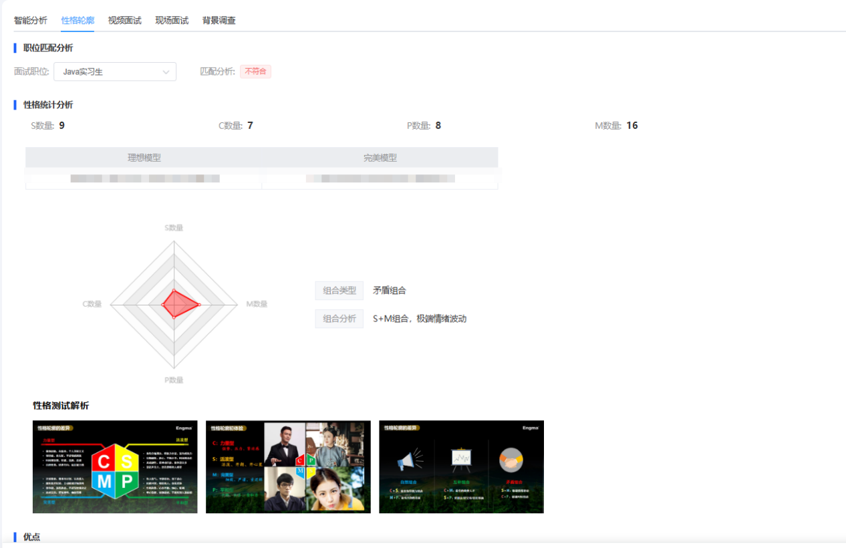
图 4.12.1(3) Recruitment List-招聘列表
When submitting a resume, the applicant will fill out a personality profile test questionnaire. Through this test, you can have a general understanding of the current applicant's personality background, and this information can be used as a reference for employment decisions.
应聘人在提交简历时会填写一份性格轮廓测试试卷，通过这份测试可以对当前应聘人员有一个大概的性格背景了解，这些信息可以做为录用决策的一个参考依据。

Video Interview-视频面试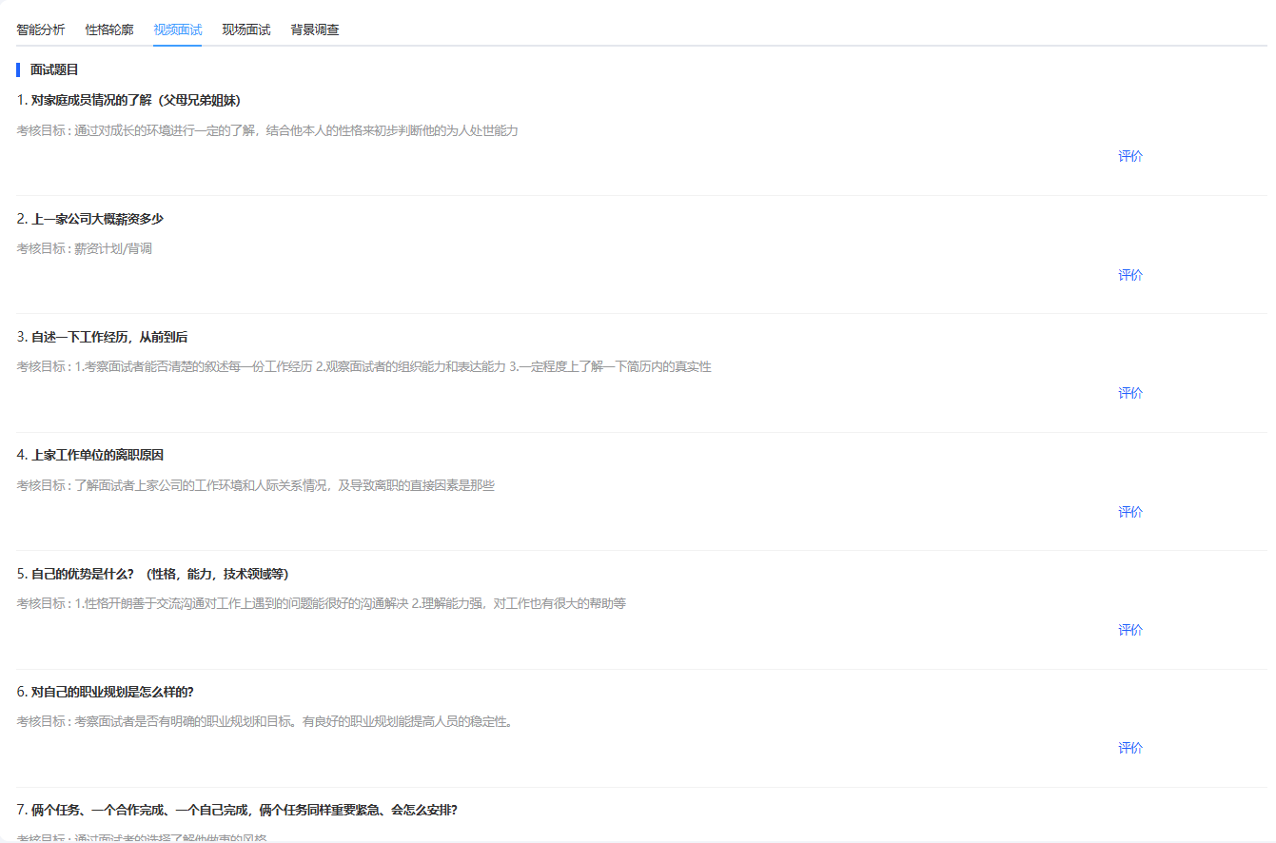
图 4.12.1(4) Recruitment List-招聘列表
During the video interview, some interview questions can be preset, and the interviewer can evaluate the applicant's answers to these interview questions and record them, finally forming a video interview opinion for reference by subsequent interviewers.
在视频面试的时候，可以预设一些面试问题，并且可以对应聘者回答这些面试问题进行评价和记录最终形成一个视频面试意见，供后续面试者参考。

On-site Interview-现场面试
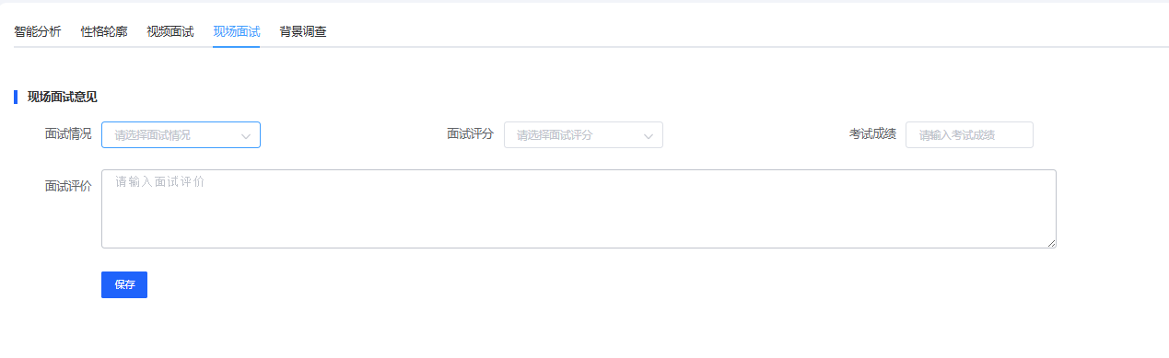
图 4.12.1(5) Recruitment List-招聘列表
For the on-site interview situation of the applicant, the recruiter can also fill in the corresponding recruitment opinions as a reference for subsequent employment decisions.
对于应聘者的现场面试情况，招聘人员也可以填写对应的招聘意见，做为后续录用与否的参考。

Background Check-背景调查
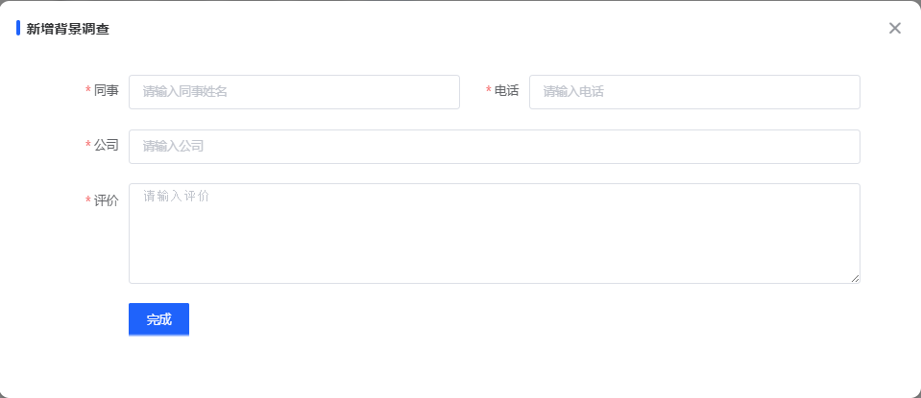
图 4.12.1(6) Recruitment List-招聘列表
In the background check function, you can fill in and save the results of the background check.
在背景调查功能中，可以填写背调的结果并保存。

4.12.2 Recruitment Management-招聘管理
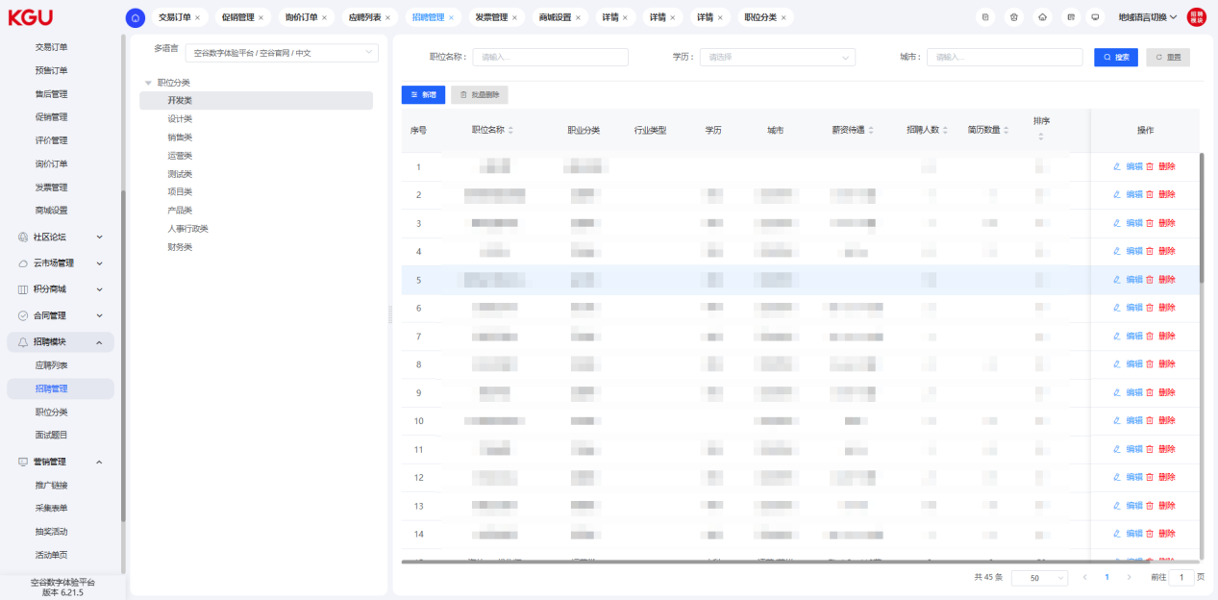
图 4.12.2(1) Recruitment Management-招聘管理
In the recruitment management function, you can view and manage all recruitment position information.
在招聘管理功能中，可以查看和管理所有的招聘职位信息。
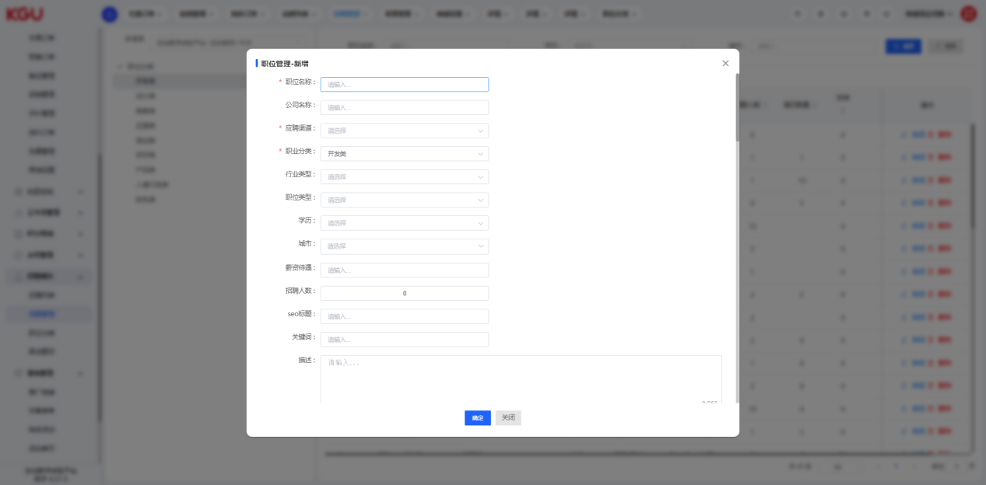
图 4.12.2(2) Recruitment Management-招聘管理
When creating recruitment information, you need to fill in the corresponding position name, salary, number of recruits, job description and skill requirements.
创建招聘信息时，需要填写对应的职位名称、薪资待遇、招聘人数、职位描述和技能要求信息。

4.12.3 Job Classification-职位分类
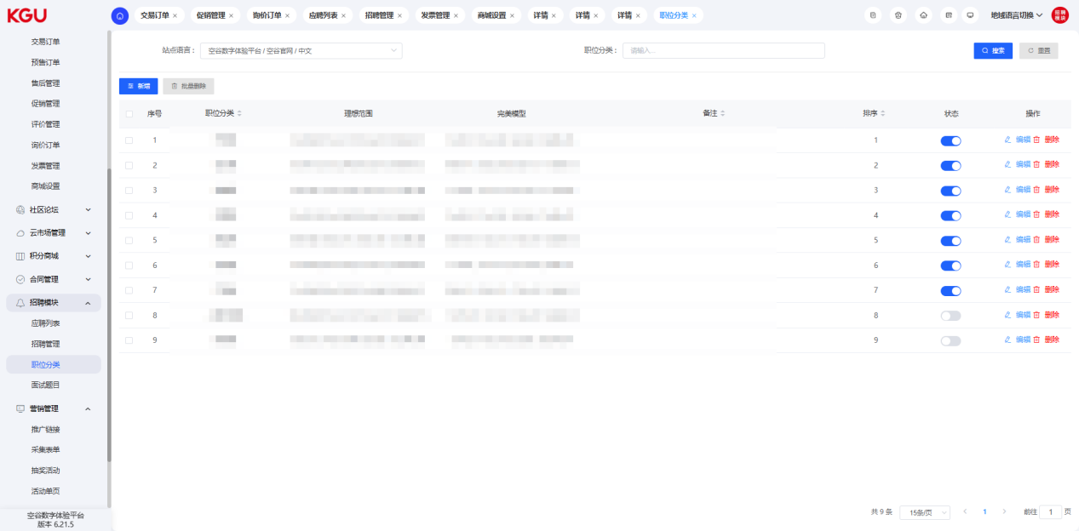
图 4.12.3 Job Classification-职位分类
When creating a job classification, you not only need to set the classification information and hierarchy, but also need to fill in the parameter information of the corresponding ideal personality model and perfect model. Through the setting of personality parameters, the system can display the matching results of the applicant's personality test on the application list page.
创建职位分类的时候，不仅需要设置分类信息和层级，而需要填写对应的性格理想模型和完美模型的参数信息。通过性格参数的设置，系统可以将应聘人员性格测试对应的匹配结果展示在应聘列表页面中。

4.12.4 Interview Questions-面试题目
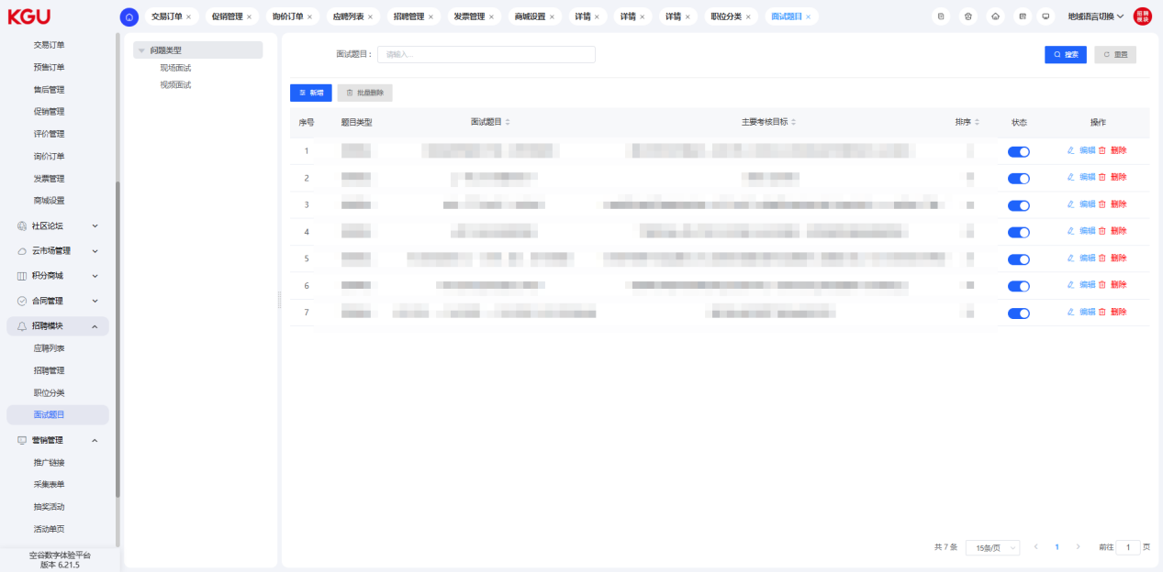
图 4.12.4 Interview Questions-面试题目
In the interview question function, you can set the interview question information in the video interview process and offline interview process. Through the setting of interview questions, recruiters can more easily manage the questions they need to ask during the interview, and fill in the evaluation information of the applicant's answers. This interview result information can be used as a decision-making basis for whether to hire.
在面试题目功能中，可以设置在视频面试流程和线下面试流程中的面试题目信息。通过面试题目的设置，可以帮助招聘人员更方便的管理自己要进行面试的问题，并且填写对应聘人员回答的评价信息，这些面试结果信息可以用于做为是否录用的决策依据。

4.13 Language Management-语言管理

4.14 KGU Cloud (Old Framework, to be Adjusted and Upgraded)-空谷云（老框架，待调整升级）

4.15 System Settings-系统设置
Through the system settings function, you can set the company's organization, personnel, roles and their corresponding permission information, manage the background menu and permissions, and set workflow information.
通过系统设置功能，可以设置公司的机构、人员、角色及其对应的权限信息，管理后台菜单及权限，设置工作流程等信息。

4.15.1 Organization/Personnel/Role-机构/人员/角色

Organization Maintenance-机构维护
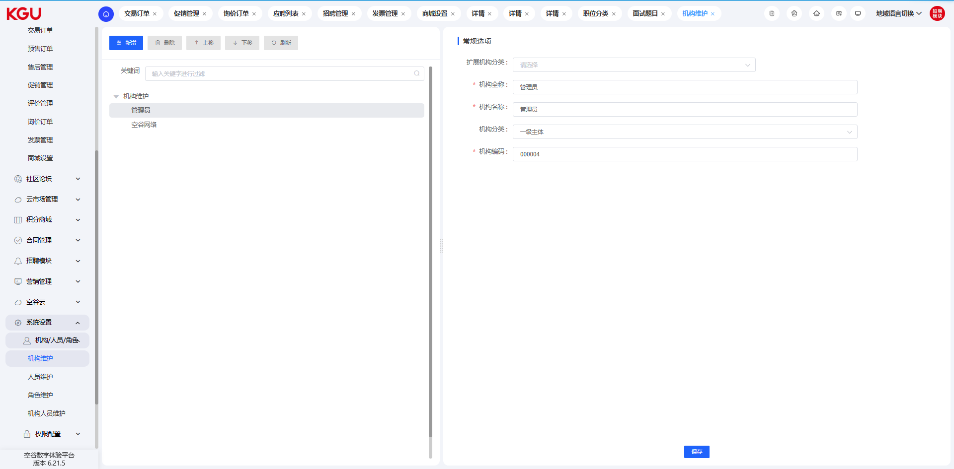
图 4.15.1(1) Organization/Personnel/Role-机构/人员/角色
The organization maintenance function can define the level information of the organization according to the information or the actual organizational structure of the company, so as to realize the isolation function of data between different organizations.
机构维护功能可以根据信息或者公司的实际组织架构情况来定义机构的层级信息，以便用于数据在不同机构之间的隔离功能。

Personnel Maintenance-人员维护
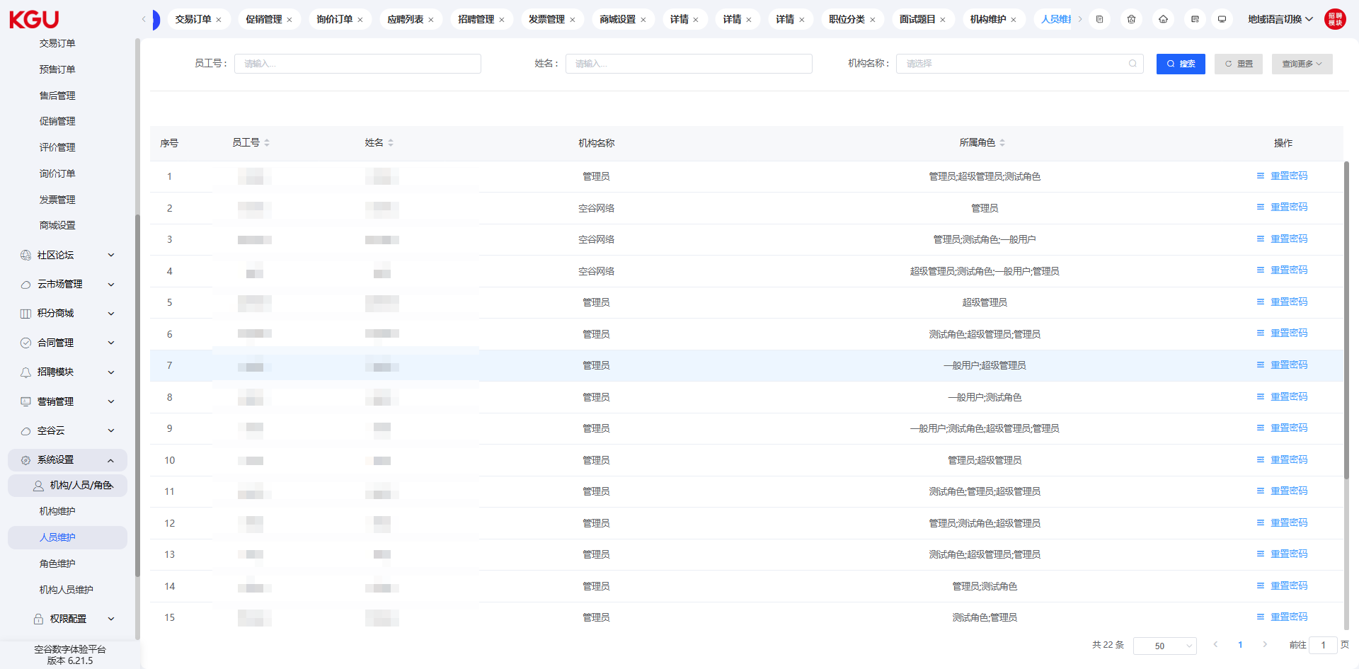
图 4.15.1(2) Organization/Personnel/Role-机构/人员/角色
It can manage the personnel accounts in the background, and configure the organization to which the personnel login account belongs and the associated role function.
可以对后台进行人员账号管理，配置人员登录账号所属机构及关联角色功能。

Role Maintenance-角色维护
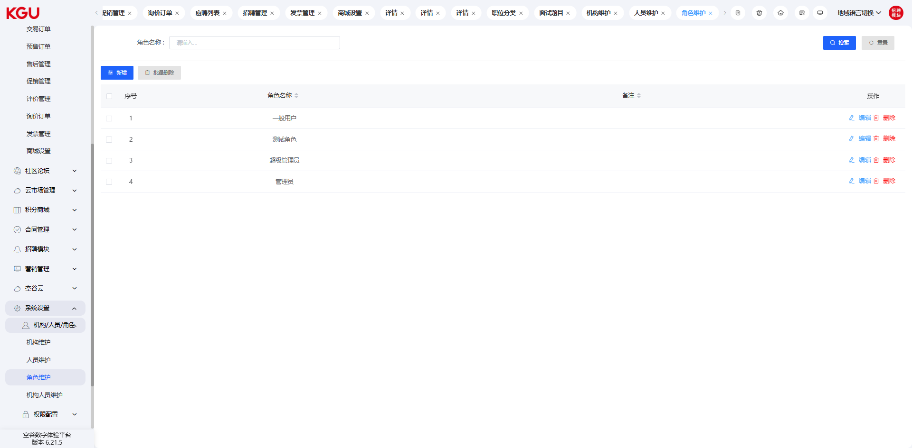
图 4.15.1(3) Organization/Personnel/Role-机构/人员/角色
Set and manage the roles in the system to realize the management of user operation permissions and menu functions through roles.
对系统中的角色进行设置和管理，用于实现通过角色来管理用户操作权限及菜单功能。

Organization Personnel Maintenance-机构人员维护
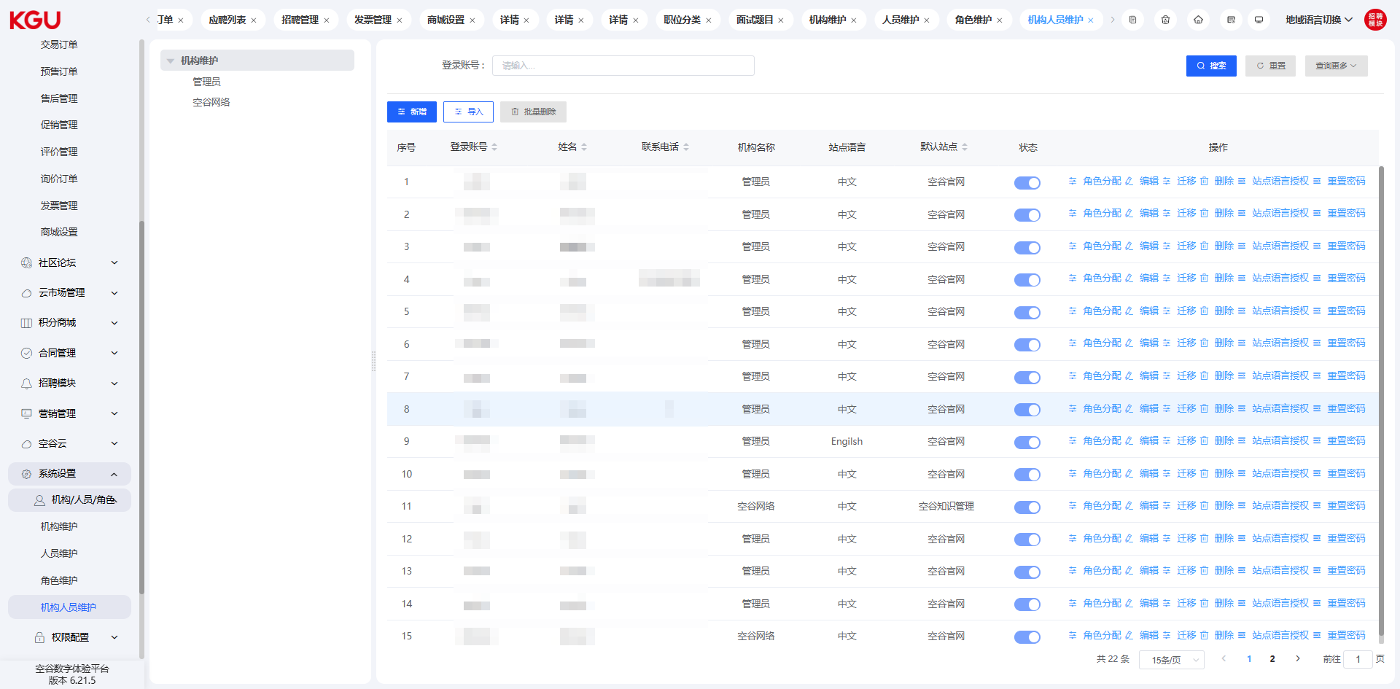
图 4.15.1(4) Organization/Personnel/Role-机构/人员/角色
In the organization and personnel maintenance, set the personnel information under the organization.
在机构和要员维护中，设置机构下的人员信息。

4.15.2 Permission Configuration-权限配置

Menu Configuration-菜单配置
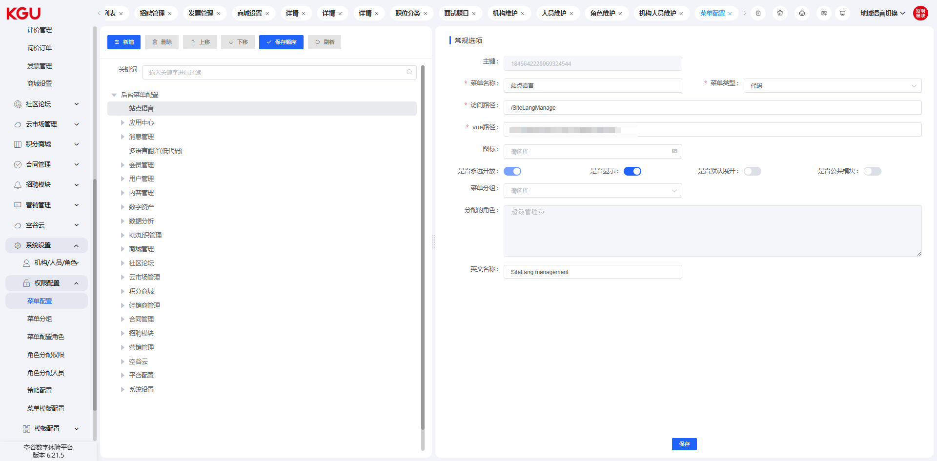
图 4.15.2(1) Permission Configuration-权限配置
Through the menu configuration function, you can manage the menu options of the background, i.e., the menu list on the left.
通过菜单配置功能，可以管理后台的菜单选项，即左侧的菜单列表。

Menu Grouping-菜单分组
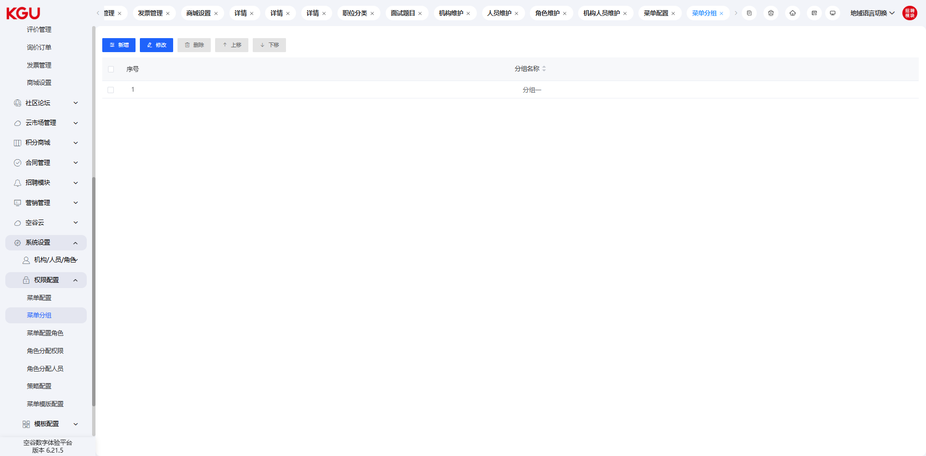
图 4.15.2(2) Permission Configuration-权限配置
If grouping function is needed, it can be managed through menu grouping.
如果需要分组功能，可以通过菜单分组进行管理操作。

Menu Configuration Role-菜单配置角色
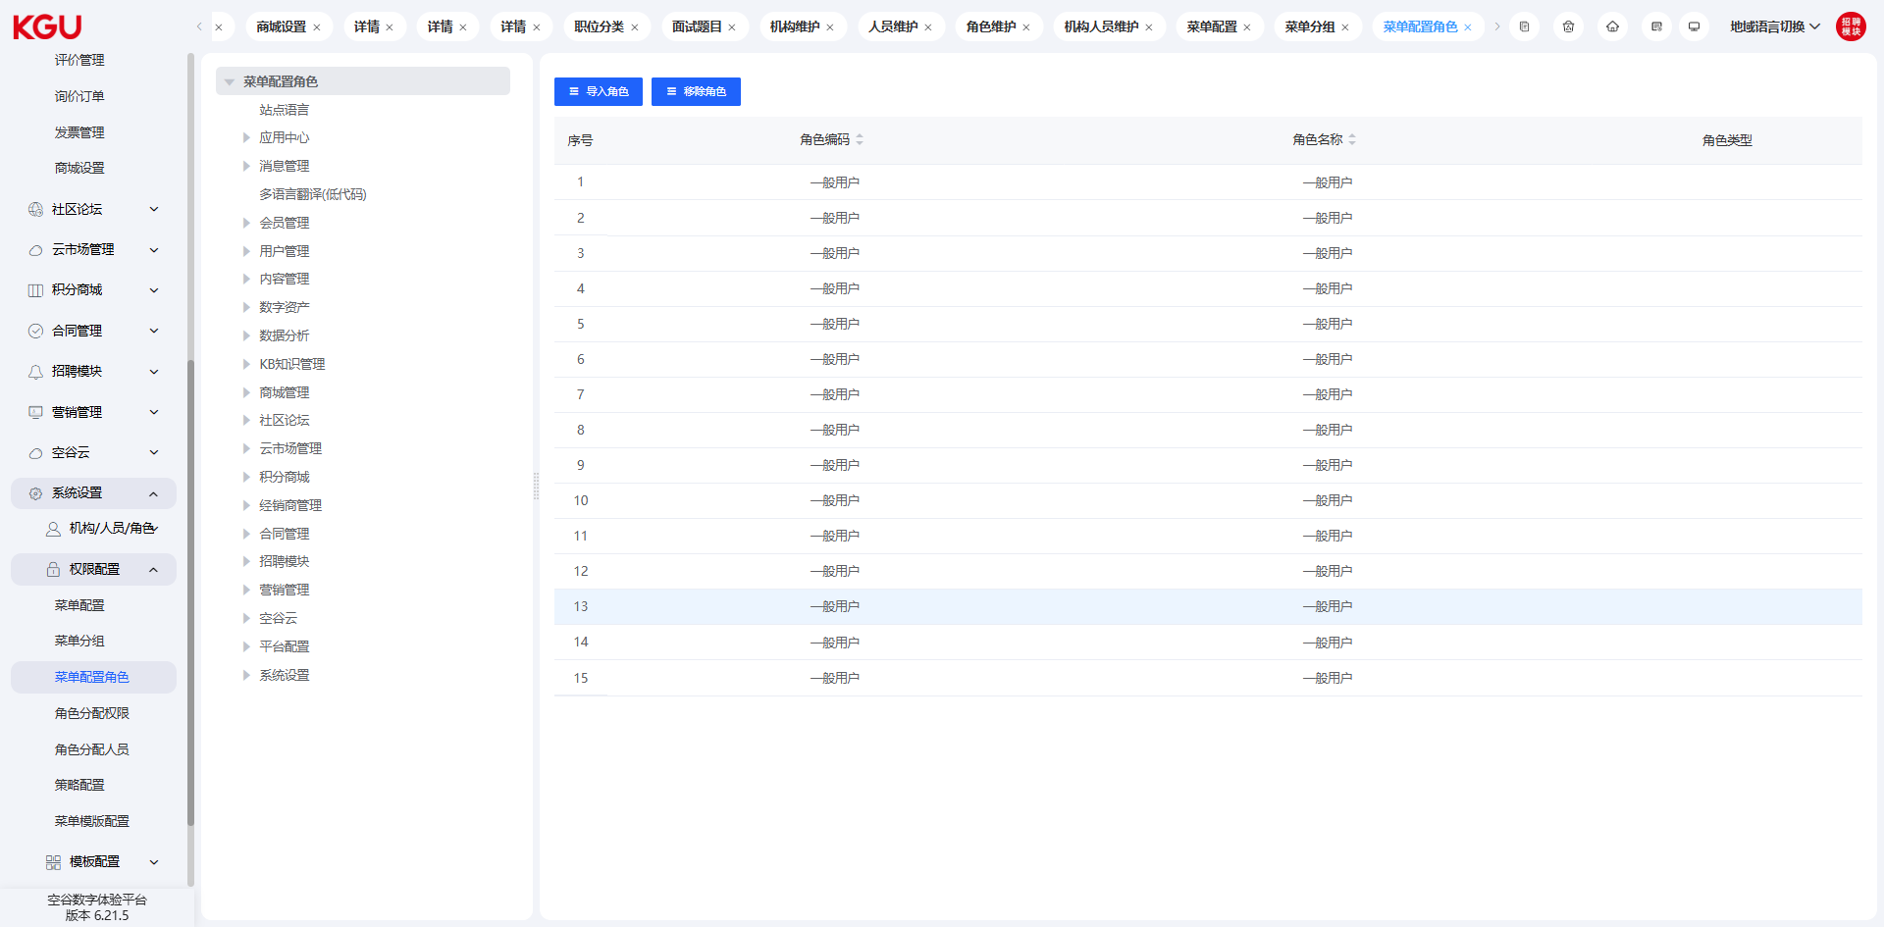
图 4.15.2(3) Permission Configuration-权限配置
On the menu configuration role interface, different roles can be configured for different menus.
在菜单配置角色界面，可以对不同的菜单配置不同的角色。

Role Assignment Permission-角色分配权限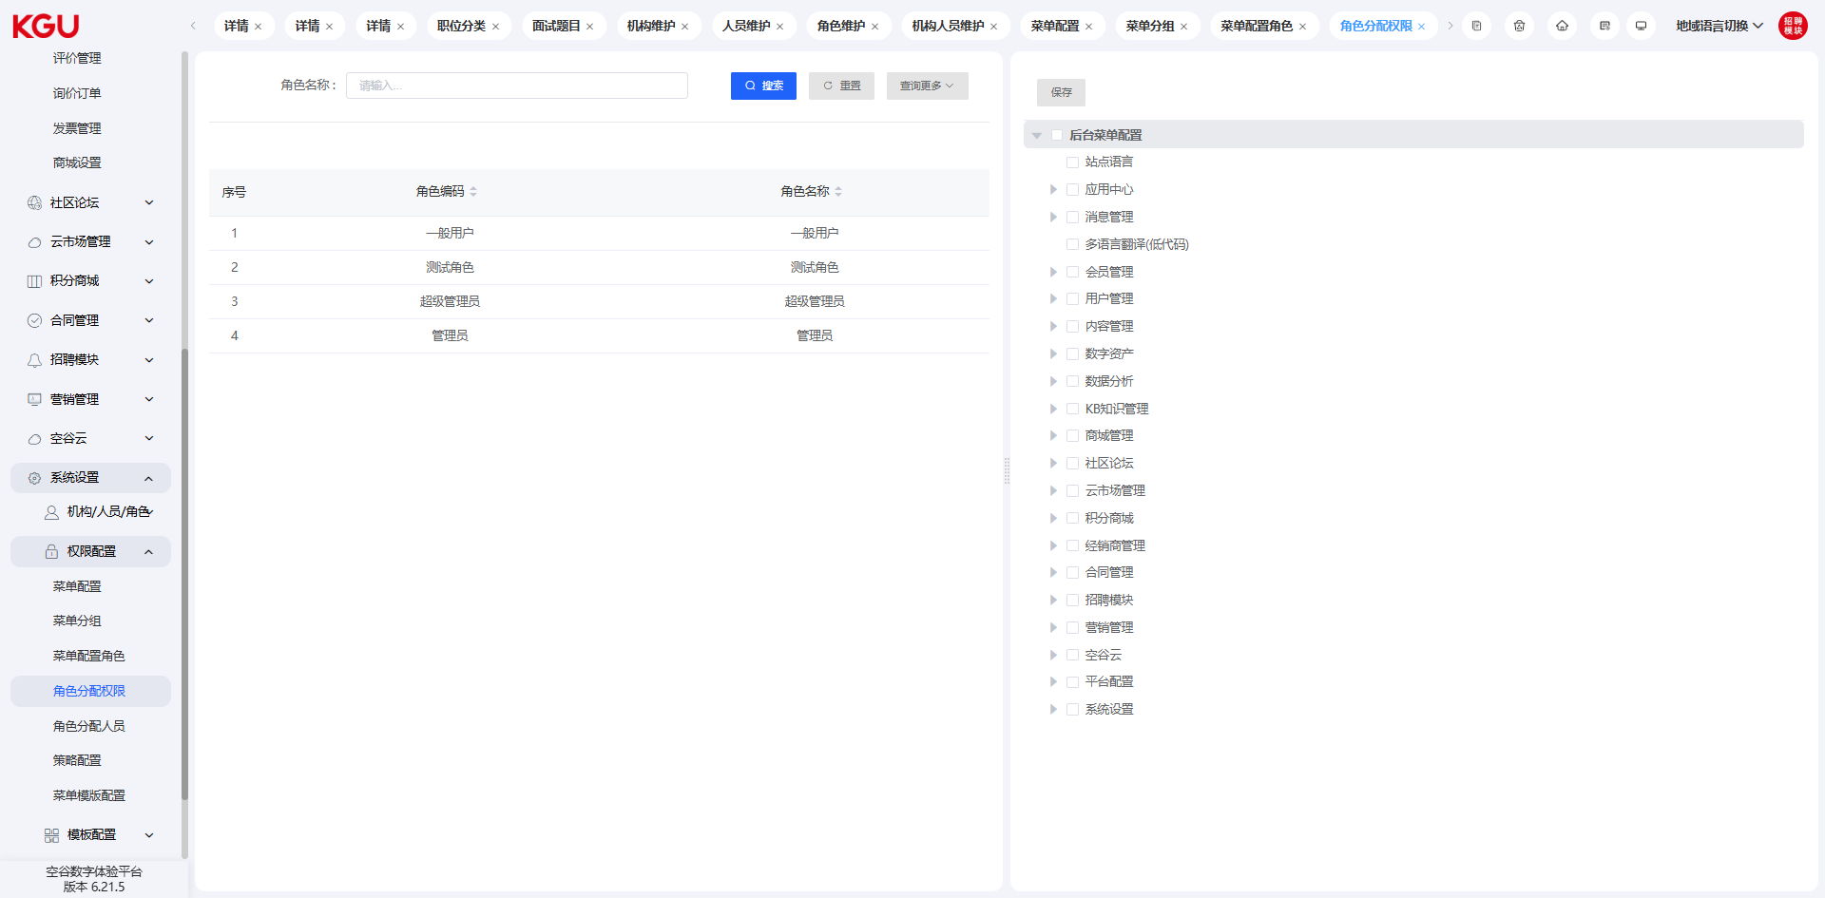
图 4.15.2(4) Permission Configuration-权限配置
On the role assignment permission interface, the menu permissions can be defined according to the role.
在角色分配权限界面，可以按角色来定义不同的菜单权限。

Role Assignment Personnel-角色分配人员
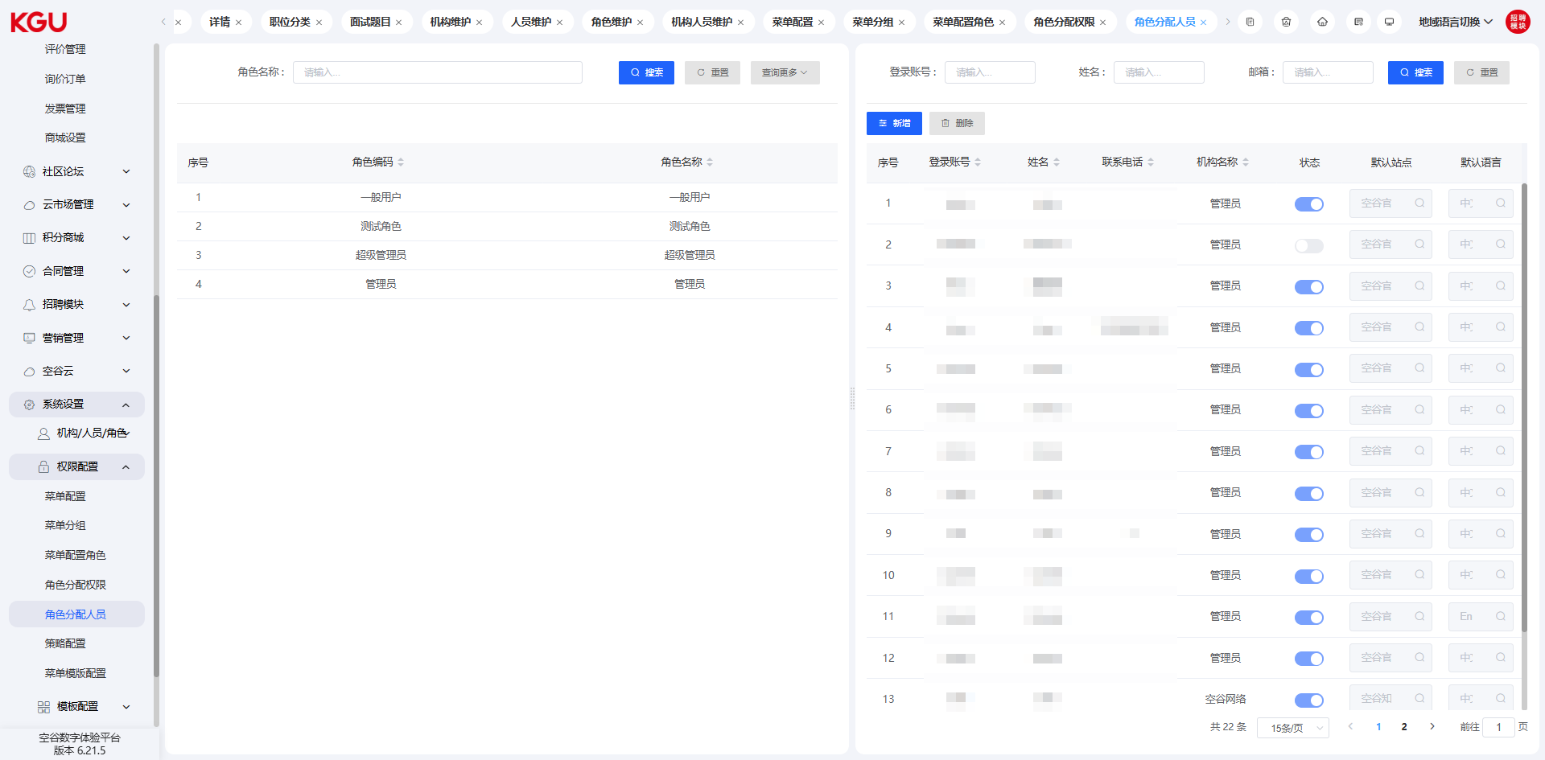
图 4.15.2(5) Permission Configuration-权限配置
On the role assignment personnel interface, you can set the personnel who can be assigned permissions.
在角色分配人员界面，可以设置可以分配权限的人员。

Policy Configuration-策略配置
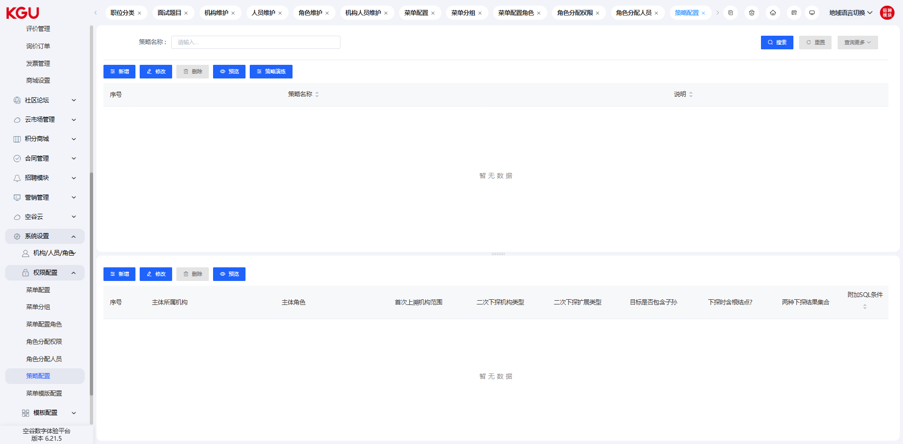
图 4.15.2(6) Permission Configuration-权限配置

Menu Template Configuration-菜单模板配置
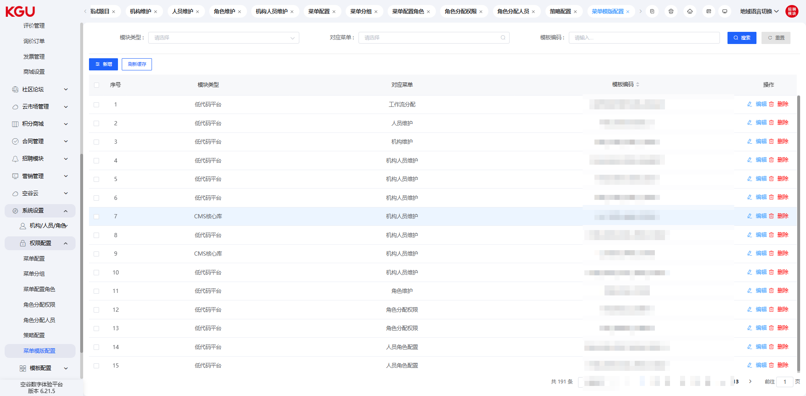
图 4.15.2(7) Permission Configuration-权限配置

4.15.3 Template Configuration-模板配置

Template Configuration-模板配置
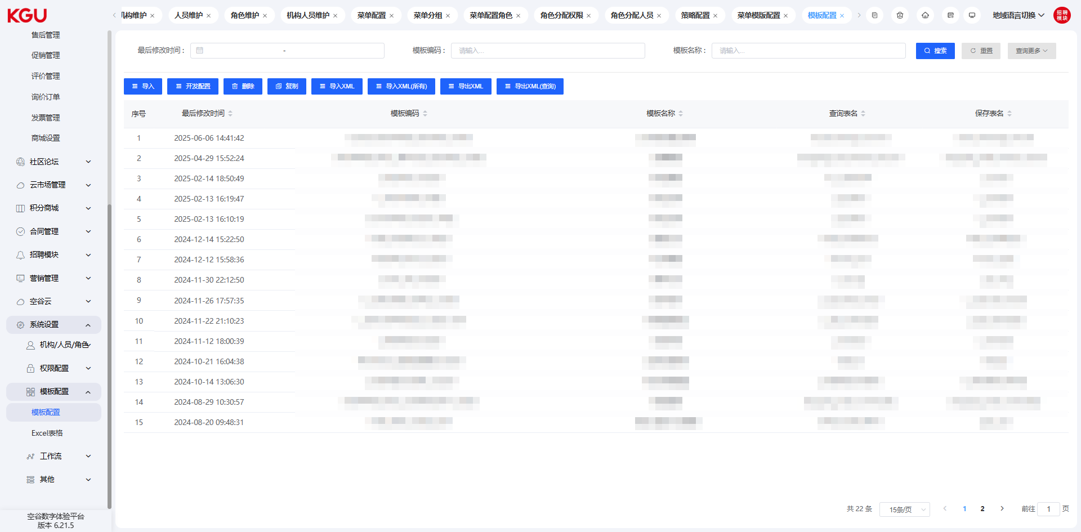
图 4.15.3(1) Template Configuration-模板配置

Excel Table-Excel 表格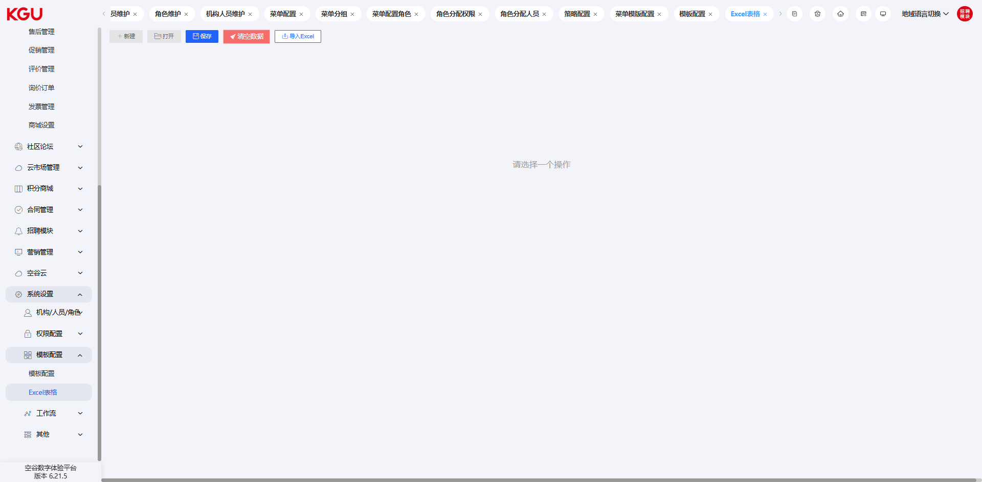
图 4.15.3(2) Template Configuration-模板配置

4.15.4 Workflow-工作流
The workflow function can define and manage workflow and approval process information.
工作流功能可以定义和管理工作流程及审批流程信息。

Create Workflow-创建工作流
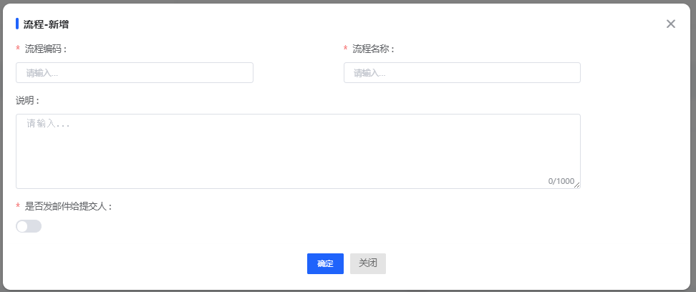
图 4.15.4(1) Workflow-工作流
On the published workflow interface, click the "Add" button in the upper left corner to create a workflow. Fill in the workflow code and workflow name to complete the creation.
In the workflow list, click the "Edit" button on the right to edit the workflow.
在已发布的工作流界面，点击右左上角的【新增】按钮，可以进行工作流的创建，填写流程编码，流程名称后，即可完成创建。
在工作流列表中，点击右侧的【编辑】按钮，可以对工作流进行编辑操作。

Maintain Workflow-维护工作流
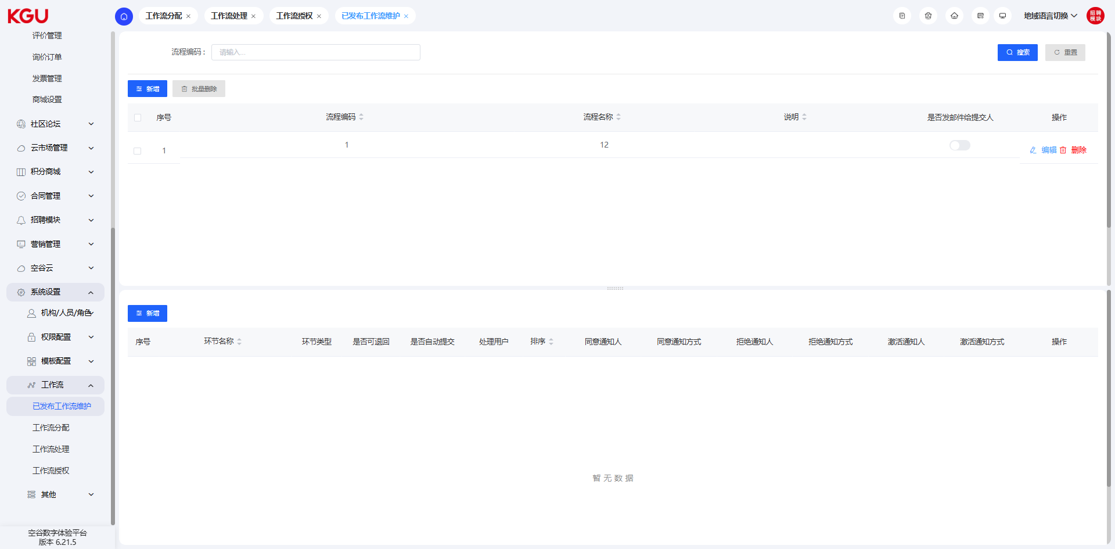
图 4.15.4(2) Workflow-工作流

After completing the workflow creation, you can define the nodes of the workflow and node information. Select the workflow that needs to set the process, and the lower area of the interface will display the process node information of the workflow. You can create and edit the workflow nodes.
完成工作流创建后，可以定义工作流程的节点及节点信息。选中需要设置流程的工作流，界面下方区域会展示该工作流程的流程节点信息，可以创建编辑工作流程节点。
In the process node, you can set the type of the node (start, middle, end), the approval method (preemption, joint signing), and also define the process submission method, processing organization information, etc. Specific configurations can be flexibly set according to the actual business scenario.
在流程节点中，可以设置该节点的类型（开始、中间、结束）、审批方式（抢占、会签），也可以定义流程提交方式，处理机构信息等。可在具体配置时，根据实际的业务场景进行灵活配置。

Workflow Allocation-工作流分配
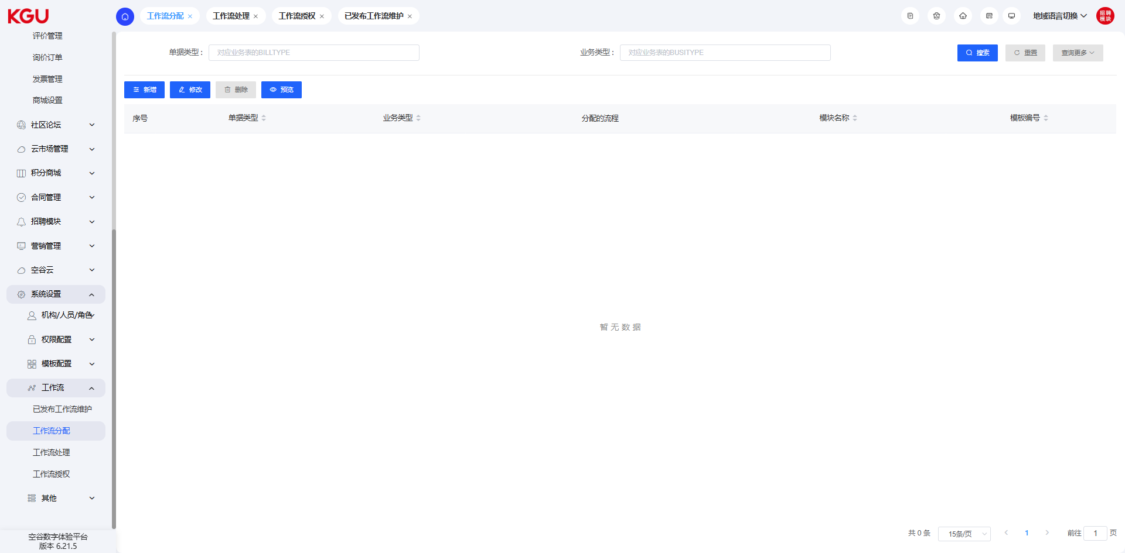
图 4.15.4(3) Workflow-工作流

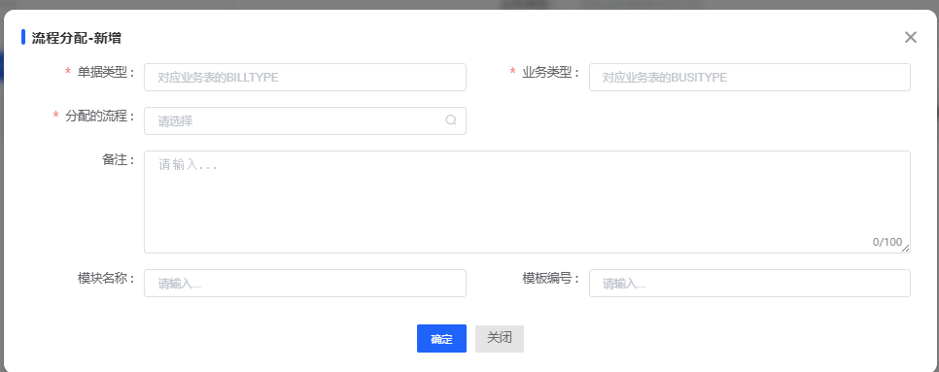
图 4.15.4(4) Workflow-工作流
In the workflow allocation, the published workflow can be bound to the corresponding business process through the document type and business type.
在工作流分配中，可以将发布的工作流程通过单据类型和业务类型与对应的业务流程进行绑定。

Workflow Processing-工作流处理
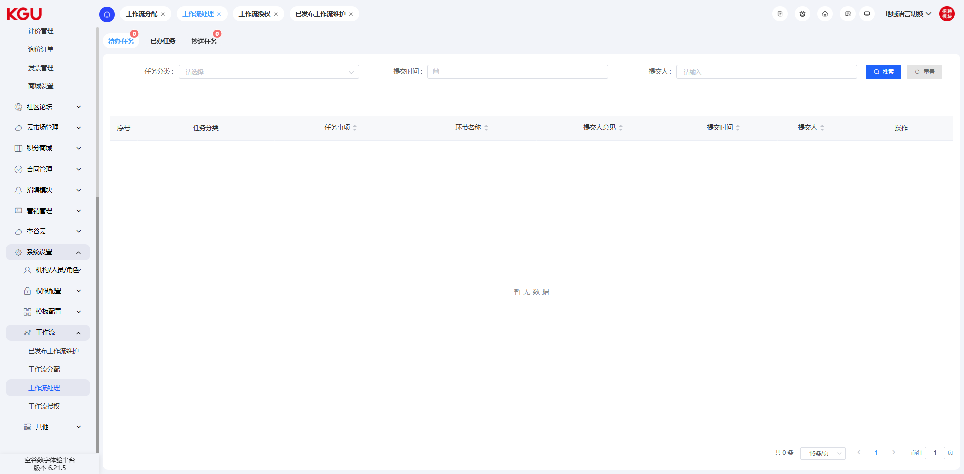
图 4.15.4(5) Workflow-工作流
In the workflow processing, you can view and process all workflow information related to the current account. When the system generates approval information related to the current logged-in personnel, a corresponding prompt bubble will be displayed in the upper right corner of the main interface. Clicking it will enter the workflow processing interface.
The system supports the batch approval function. Check multiple processes and click the "Batch Approval" button to perform the approval operation.
在工作流处理中，可以查看和处理与当前账号相关的所有工作流信息。当系统产生了与当前登录人员相关的审批信息时，在主界面的右上角会显示相应的提示小气泡，点击即可进入工作流处理界面。
系统支持批量审批功能勾选多条流程扣，点击【批量审批】按钮，即可进行审批操作。

Workflow Authorization-工作流授权
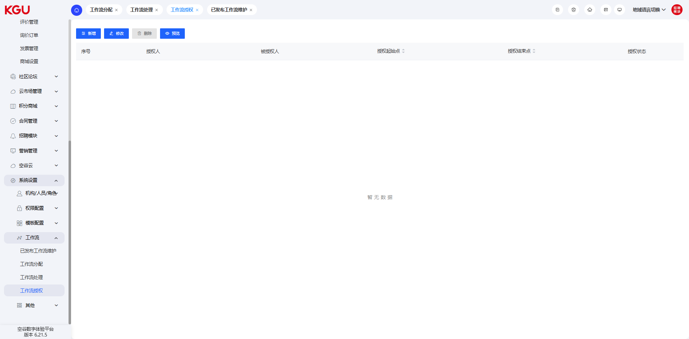
图 4.15.4(6) Workflow-工作流
In the workflow authorization, you can temporarily set the personnel who need to act as an agent for the work. The set agent personnel can temporarily replace the personnel in the process to process the workflow.
在工作流授权中，可以临时设置需要代理工作的人员，设置的代理人员可以临时替代流程中的人员进行工作流的处理。

4.15.5 Others-其它

System Parameter Setting-系统参数设置
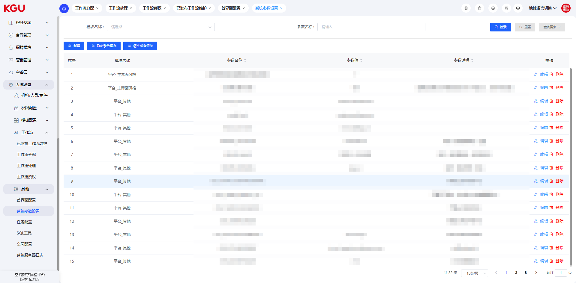
图 4.15.5 Others-其它
In the system parameter setting, different parameters can be defined, which are used to control the functions on the interface, such as: whether the login interface displays a verification code, whether certain function entrances are displayed on the interface, etc.
在系统参数设置中，可以定义不同的参数，这些用来控制界面上的功能，例如：登录界面是否显示验证码，界面上是否显示某些功能入口等待。

4.16 Marketing Management-营销管理
The marketing management function is mainly used to track promotion effects, set collection form information, set lottery activity information and create activity single-page information. It can assist operators in implementing different promotion plans.
营销管理功能主要用于跟踪推广效果、设置采集表单信息、设置抽奖活动信息及创建活动单页信息的功能，可以协助运营人员执行不同的推广计划。

4.16.1 Promotion Links-推广链接
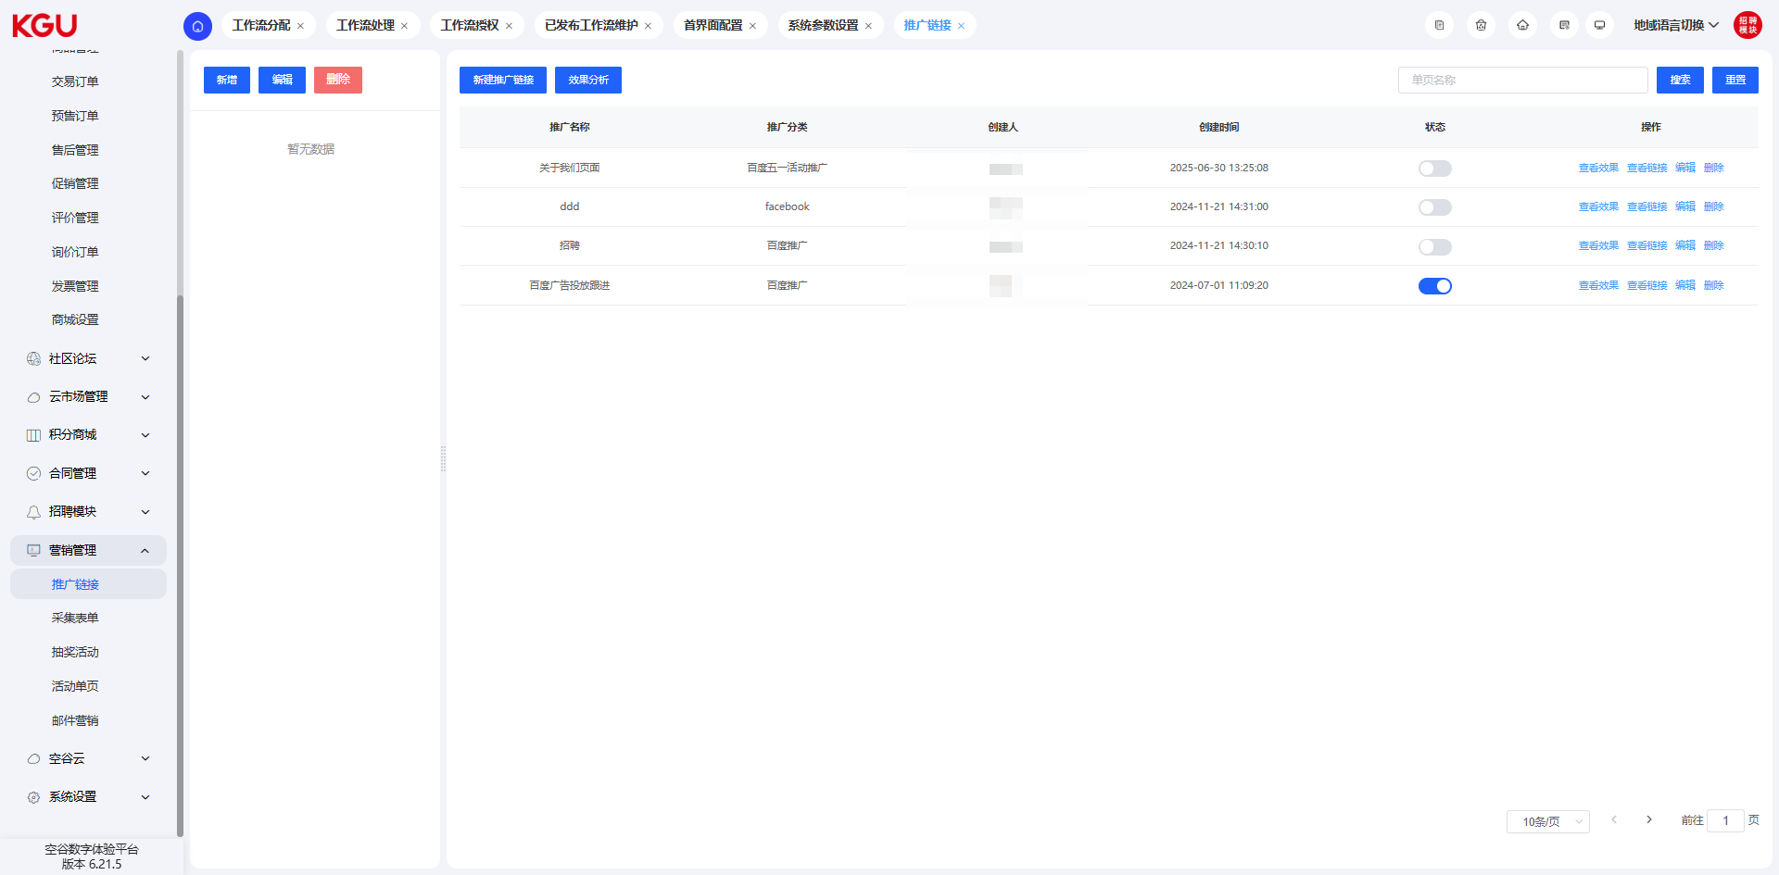
图 4.16.1(1) Promotion Links-推广链接
In the promotion link list, you can view and manage the addresses of promotion activity links.
在推广链接列表中，可以查看和管理推广活动链接的地址。
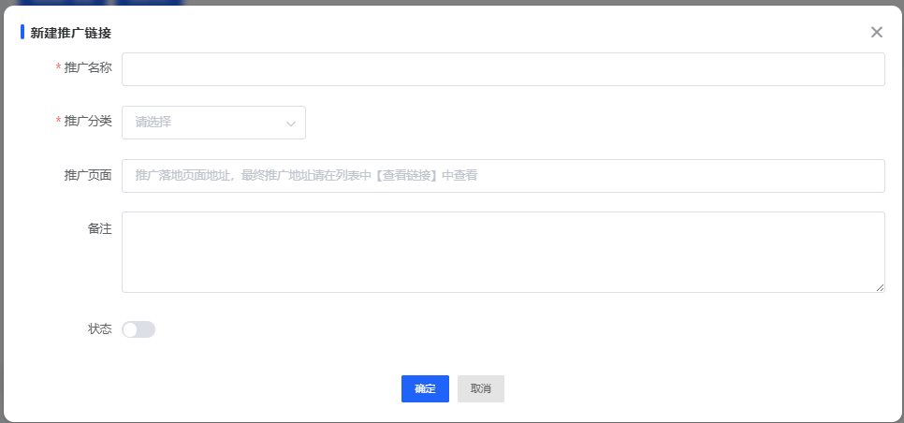
图 4.16.1(2) Promotion Links-推广链接
When adding a new promotion link, you need to fill in the promotion name, select the promotion category, and fill in the promotion page and remark information. It should be noted that the address of the promotion page must be an address managed by the KGU system; otherwise, it cannot take effect and count data.
新增推广链接的时候，需要填写推广名称，选择推广分类及填写推广页面和备注信息。需要注意的是，推广页面的地址必须为空谷系统管理的地址，否则无法生效及统计数据。
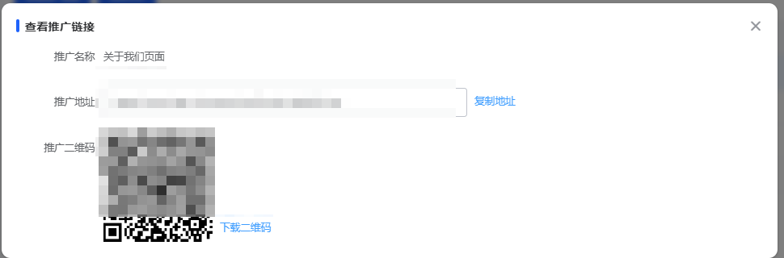
图 4.16.1(3) Promotion Links-推广链接
Clicking "View Link" in the list allows you to view the address information of the corresponding promotion link. This address information can be used to track the promotion effect.
点击列表中的查看链接，可以查看对应的推广链接的地址信息，这些地址信息可以用于跟进推广效果。
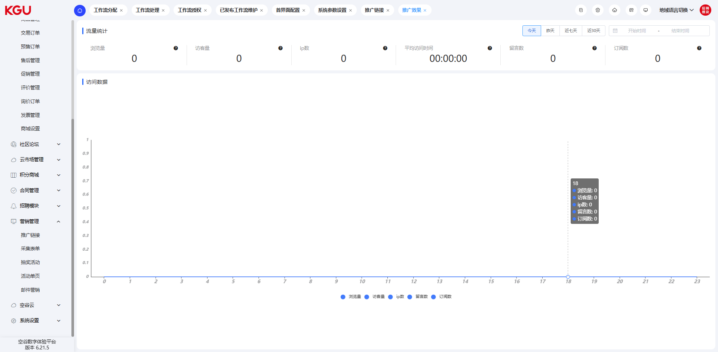
图 4.16.1(4) Promotion Links-推广链接
Clicking "View Effect" in the list allows you to view the promotion effect information of the current promotion link, including page views, number of visitors, number of IPs, average access duration, and viewing access data by time.
点击列表中的查看效果，可以查看当前推广链接的推广效果信息，包括浏览量、访客量、ip数、平均访问时长及按时间查看访问数据。
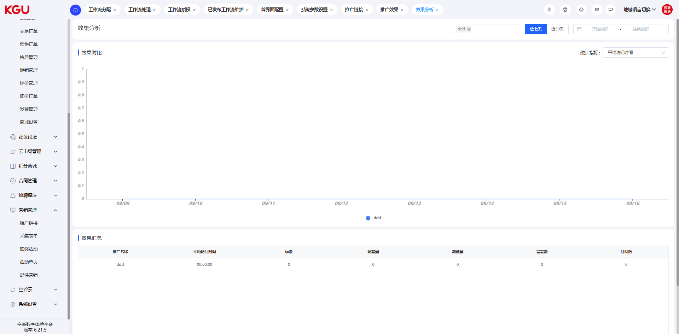
图 4.16.1(5) Promotion Links-推广链接
Clicking "Effect Analysis" in the list interface allows you to view the promotion effect comparison of different promotion channels.
点击列表界面中的效果分析可以查看当前不同推广渠道的推广效果对比。

4.16.2 Collection Form-采集表单
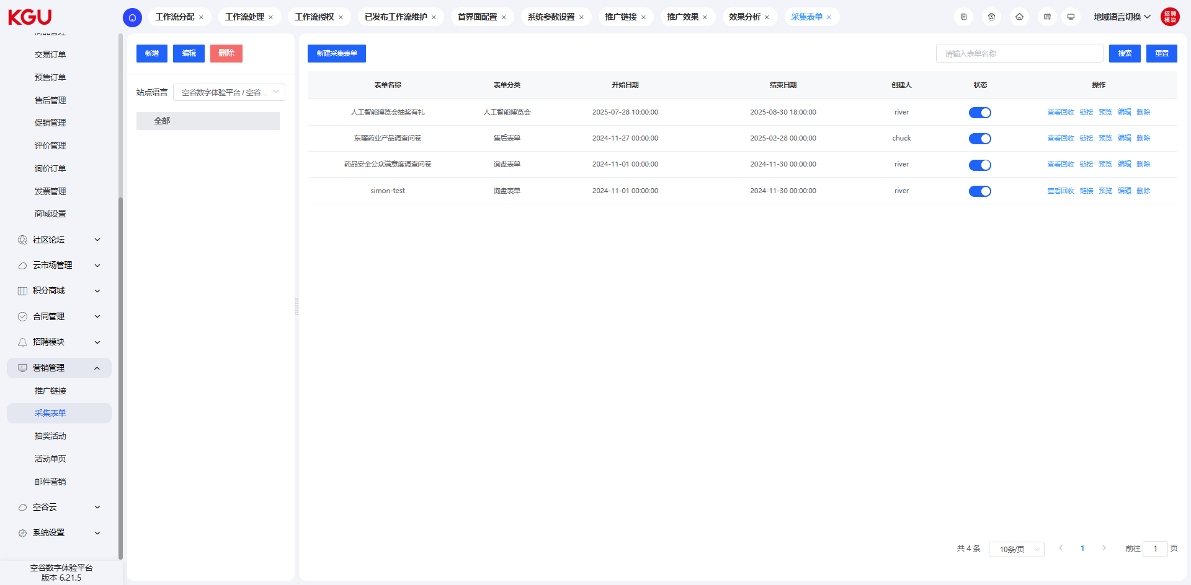
图 4.16.2(1) Collection Form-采集表单
Through the collection form function, you can define different collection questionnaire information. The address of these forms can be generated in QR code format, so that users can scan the code and fill in it at the event site.
Clicking "View Collection" in the collection form allows you to view the collection status of the current form. If the current collection form is associated with a lottery activity, you can also view the corresponding lottery results.
通过采集表单功能，可以定义不同的采集问卷信息，这些表单的地址可以生成二维码格式，以便在活动现场供用户扫码后填写。
点击采集表单中的查看回收链接，可以查看当前表单的回收情况，如果当前采集表单有关联抽奖活动，也可以查看到对应的抽奖结果。
创建采集表单
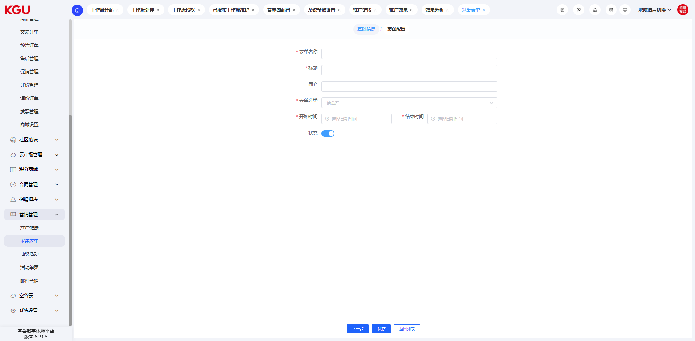
图 4.16.2(2) Collection Form-采集表单
When creating a collection form, you need to fill in the above information to distinguish different forms. The form can be set with a start and end date. After setting, the form can only be submitted within the specified time.
When creating a form, you can set the association with the lottery. When associating the lottery, you need to set the verification method to prevent users from exploiting vulnerabilities to brush prizes.
创建采集表单时，需要填写以上信息，以便区分不同的表单，表单可以设置开始和结束日期，设置后，仅在指定的时间内才可以提交表单。
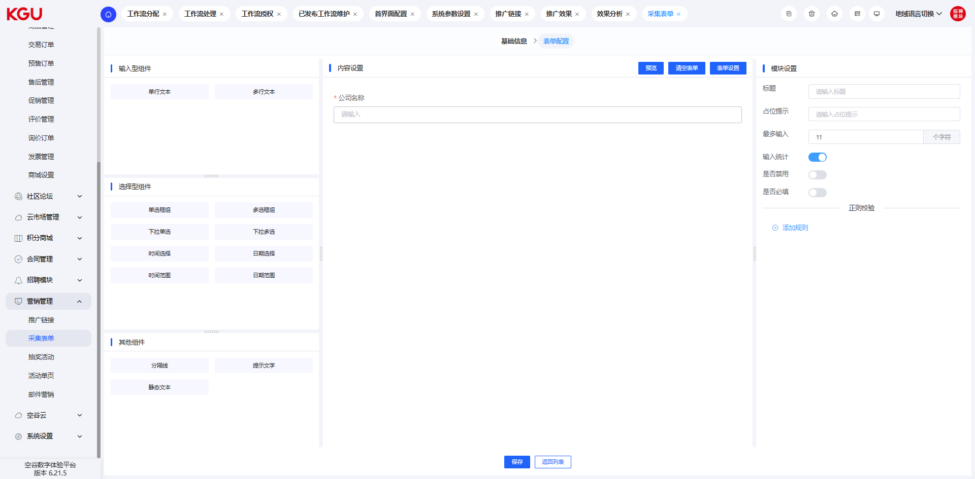
图 4.16.2(3) Collection Form-采集表单
创建表单的时候，可以设置抽奖的关联，关联抽奖的时候，需要设置验证方式，避免用户利用漏洞刷取奖品。
In the form configuration page, you can drag the component content to the editing area to realize the visual configuration of the form. Currently, three types of components are supported: single-line text, multi-line text, and drop-down selection. They can meet the content configuration of basic forms.
表单配置
在表单配置页面，可以拖动组件内容到编辑区域中，实现表单的可视化配置。目前支持的组件有三种，分别为：单行文本、多行文本，下拉选择三种。可以满足基础表单的内容配置。

4.16.3 Lottery Activity-抽奖活动
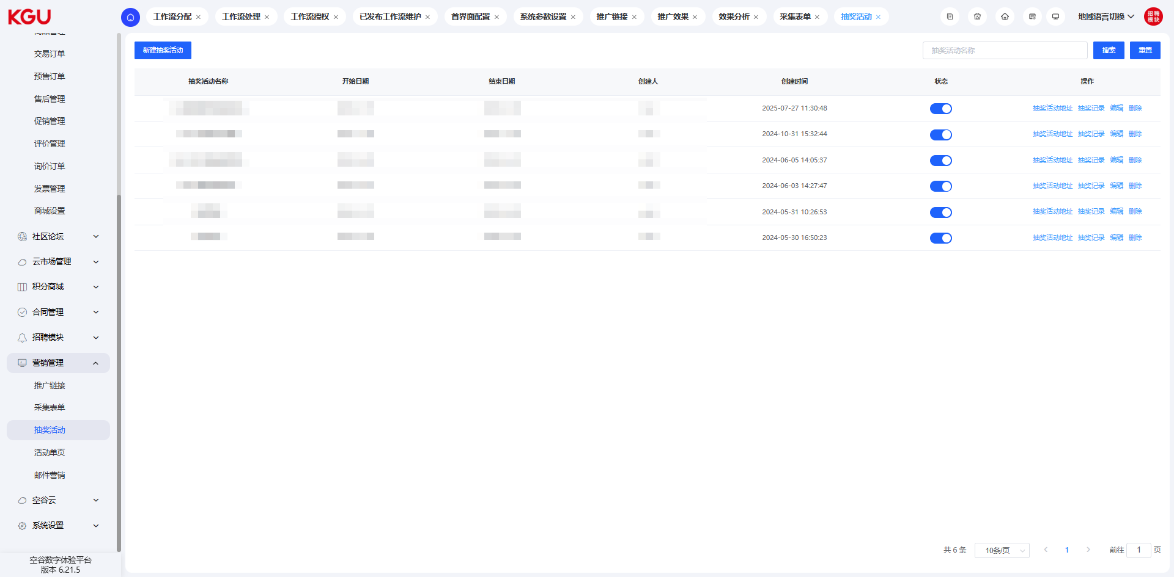
图 4.16.3(1) Lottery Activity-抽奖活动
Different lottery activities can be set. These lottery activities are associated with the collection form to increase the attractiveness of the activity.
可以设置不同的抽奖活动，这些抽奖活动与采集表单进行关联，以便增加活动的吸引力。
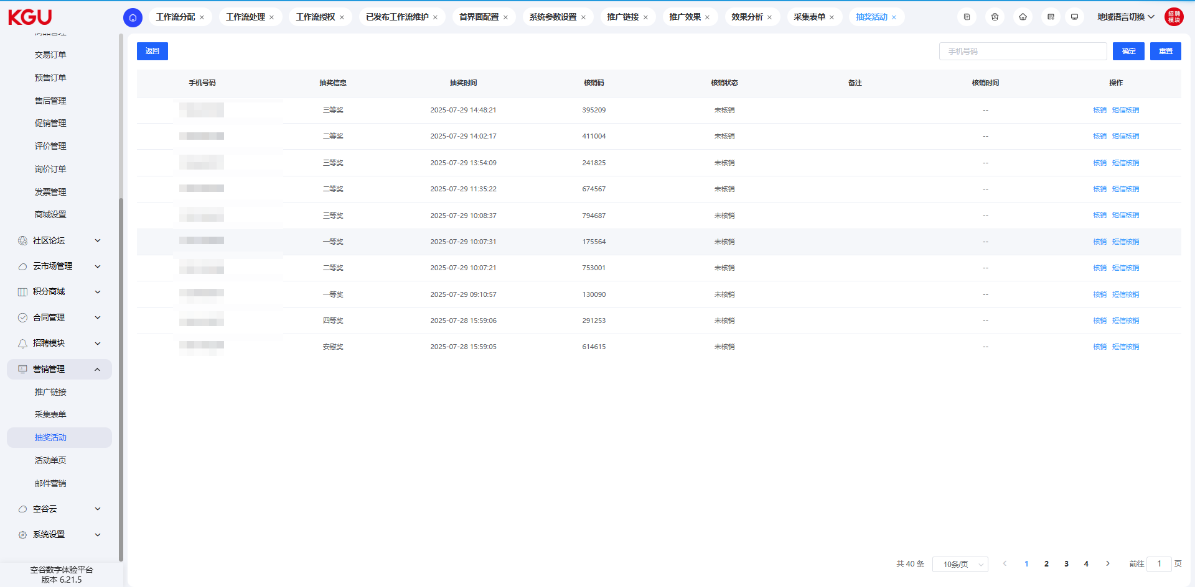
图 4.16.3(2) Lottery Activity-抽奖活动
On the lottery activity list page, clicking "Lottery Records" allows you to view the lottery record information of the current activity.
在抽奖活动列表页面，点击抽奖记录可以查看当前活动的抽奖记录信息。
创建抽奖活动
图 4.16.3(3) Lottery Activity-抽奖活动
When creating a lottery activity, you need to fill in the corresponding lottery information and set the start and end times.
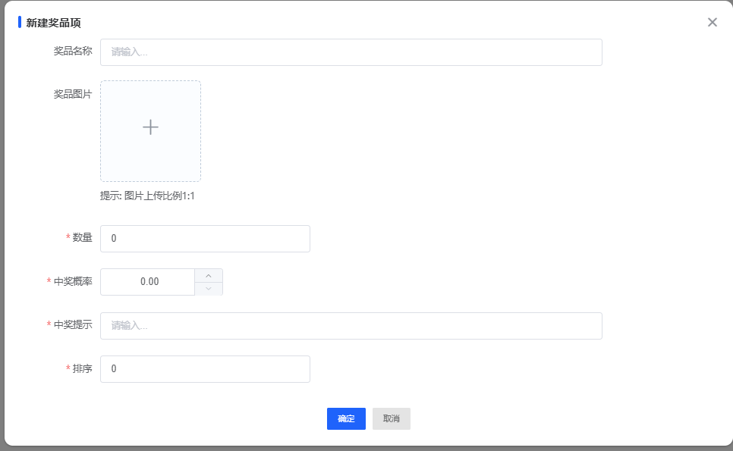
图 4.16.3(4) Lottery Activity-抽奖活动
创建抽奖活动时，需要填写相应的抽奖信息，设置开始和结束时间。
When adding prizes, you need to set the prize name, prize picture, quantity, winning probability and winning prompt. During the lottery, the system will first determine whether a certain prize is still in stock. If not, it will no longer participate in the lottery.
添加奖品时，需要设置奖品名称、奖品图片、数量、中奖概率及中奖提示。抽奖时，系统会优先判断某个奖品是否还有库存，如果没有时，则不再参与到抽取中。

4.16.4 Activity Single Page-活动单页
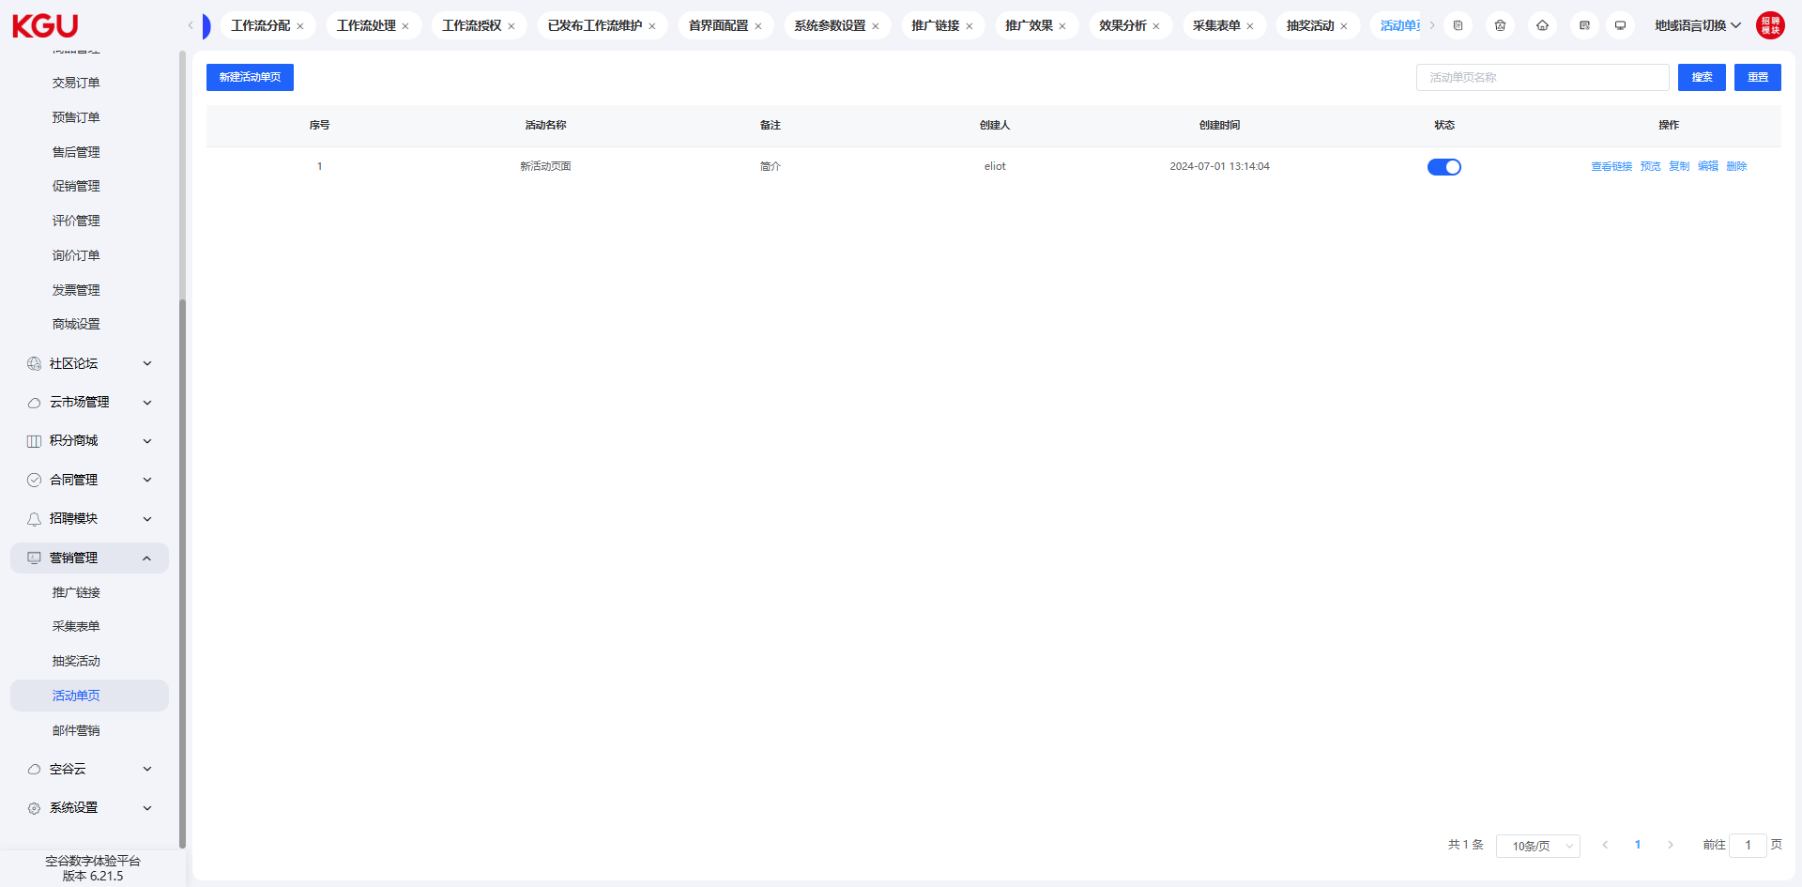
图 4.16.4(1) Activity Single Page-活动单页
On the list page of the activity single page, you can view and manage the single-page data in the system.
在活动单页的列表页面可以查看和管理系统中的单页数据。
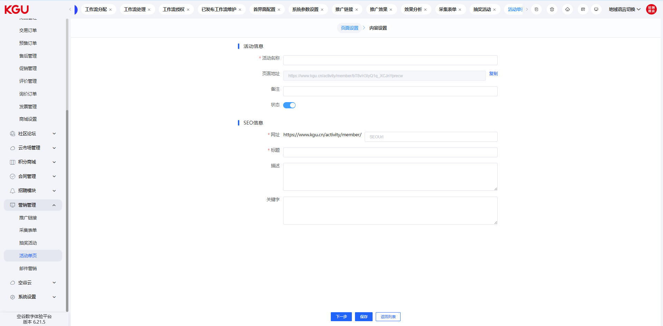
图 4.16.4(2) Activity Single Page-活动单页

When creating an activity single page, you need to fill in the activity name, title, introduction and activity content. After filling in and clicking "Confirm", the system will generate the display content of the corresponding page.
创建活动单页时，需要填写活动名称、标题、简介及活动内容等信息，填写完成并点击确定后，系统会生成对应页面的展示内容。
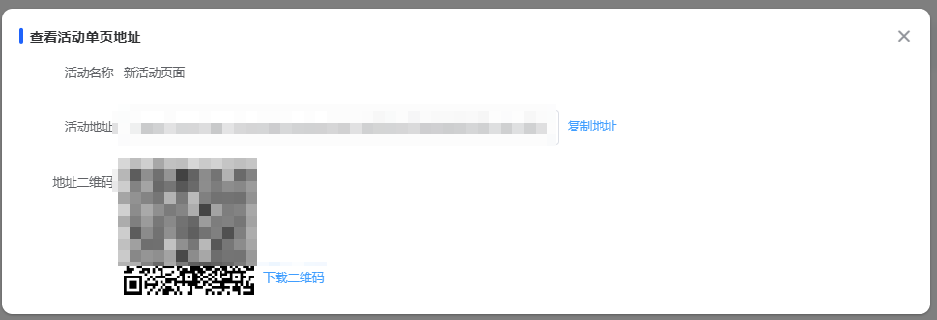
图 4.16.4(3) Activity Single Page-活动单页
In the list of activity single pages, you can click "View Link" to view the link address or QR code address of the current activity.
在活动单页的列表中，可以点击查看链接以查看当前活动的链接地址或者二维码地址。

4.16.5 Email Marketing-邮件营销
The functions of the email marketing module are mainly divided into four parts: marketing emails, recipient addresses, template management and email settings. Among them, marketing emails are used to manage mass emails and view sending status and statistical results; recipient addresses are used to manage recipient information. In this system, recipient information can be imported by yourself or automatically collected through collection forms; template management can be used to manage system templates and self-created email templates; email settings are used to configure email servers, send and receive accounts, and manage built-in email templates.
邮件营销模块的功能主要分为四部分，分别是营销邮件、收件地址、模板管理及邮件设置。其中，营销邮件是用来管理群发邮件及查看发送状态和统计结果；收件地址是用来管理收件人信息，在本系统中，收件人信息可以自行导入也可以通过采集表单自动收集；模板管理可以用来管理系统模板及自创邮件模板；邮件设置是用来配置邮件服务器，发送及接收账号以及内置邮件模板管理功能。

Marketing Emails-营销邮件
Marketing emails are used to manage mass emails and view sending status and statistical results. On the list page, you can view all marketing emails created in history, support searching by email name or filtering results by improvement status.
营销邮件是用来管理群发邮件及查看发送状态和统计结果，在列表页面可以查看历史创建的所有营销邮件，支持过邮件名称进行搜索或者是通过改善状态进行筛选结果
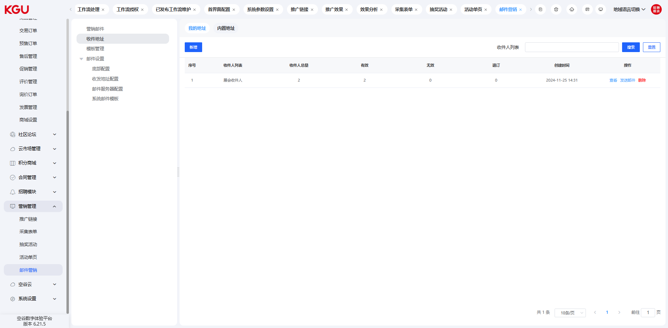
图 4.16.5(1) Email Marketing-邮件营销
新增营销邮件
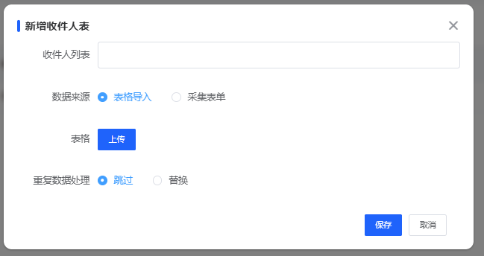
图 4.16.5(2) Email Marketing-邮件营销
When adding a new marketing email, you need to fill in the email name (the name of the marketing email here is mainly used to distinguish different marketing emails, not the topic of the sent email). The other filling fields are as follows:
Address Type: The address types are "My Addresses" and "Built-in Addresses", which can be managed in the "Recipient Addresses" menu. Select the corresponding type, then select the recipient list under that type.
Sending Scope: The sending scope is divided into "All", "Valid Only", and "Invalid Only". In a set of recipient addresses, the system will mark the status of the address through the sending result every time it conducts marketing. Successful sending is recorded as "Valid", and failed sending is recorded as "Invalid". This status only reflects the situation of the previous sending and does not necessarily mean that the email address is invalid.
Sender Address: That is, through which email the current marketing email is sent.
Reply Address: When the recipients in the list reply after receiving the email, the email will be replied to this email.
Email Subject: The subject of the sent marketing email, that is, the subject seen by the customer when receiving the email.
Preview Text: Text displayed in some email clients that support preview.
新增营销邮件时，需要填写邮件名称（此处的营销邮件名称主要是用来区别不同的营销邮件的命名，并非发送出去的邮件的话题）。其他填写字段如下：
地址类型：地址类型为我的地址和内置地址，这两个可在收件地址菜单中进行管理，选择对应类型，然后选择该类型下的收件人列表即可。
发送范围：发送范围分为全部、仅有效、仅无效三类。在一组收件地址中，系统每次营销时，都会通过发送结果对地址进行状态标记，发送成功记录为有效，发送失败记录为无效，这种状态仅反映上单次发送情况，未必代表该邮件地址就是无效的。
发件人地址：即通过哪个邮箱将本次营销邮件发送出去。
回复地址：列表中的收件人在收到邮件后进行回复时，邮件将回复到此邮件中。
邮件主题：发出的营销邮件的主题，也就是客户收到邮件时看到的主题。
预览文字：在某些支持预览的邮件客户端中显示的文字。
内容设置
There are three ways to set the email content: visual editing, rich text editing, and editing based on templates.
Visual Editing: Combine different styles of email content by dragging frames and modules.
Rich Text Editing: Create and edit relatively simple email content through a rich text input box.
Select Template: Modify based on built-in templates or personal templates to achieve the desired email content.
设置邮件内容的方式分为三种，一种是可视化编辑，一种是通过富文本编辑，一种是基于模板进行编辑。
可视化编辑：通过拖动框架及模块的方式组合出不同风格的邮件内容；
富文本编辑：通过富文本输入框创建编辑实现较简单的邮件内容；
选择模板：基于内置模板或者个人模板修改来实现想要的邮件内容。
可视化编辑
When editing visually, the page effect is achieved mainly through different combinations of frames and modules.
Frames:
Frames are used to define the structure of the content in a set of horizontal areas. There are 6 types of frames: single column, double column (1:1), double column (2:1), double column (1:3), triple column, and quadruple column. These 6 different frames can be flexibly combined to form different styles.
Modules:
Modules are used to define the content within the frame structure. There are 6 types of modules: text, picture, video, divider, button, and social media.
When creating email content, you need to first drag the frame into the content editing area, then drag the module into the frame, and then use different module contents to achieve the desired page effect.
可视化编辑时，主要通过框架和模块的组合不同组合方式来实现不同的页面效果。
框架
框架是用来定义当前一组横向区域内容的结构。框架分为6种，分别为单栏，双栏（1:1）、双栏（2:1）、双栏（1:3）、三栏、四栏。这6种不同的框架，可灵活组合出不同的样式。。
模块
模块是用来定义框架结构内的内容。模块分为6种，分别为文本、图片、视频、分隔线、按钮、社交媒体。
创建邮件内容时，需要先将框架拖入到内容编辑区域，再将模块拖到框架内，然后利用不同的模块内容实现所需的页面效果
富文本编辑
Rich text editing function is consistent with conventional content editing, and the editing setting of the marketing email page is realized through the functions of the editor.
Sending Confirmation:
After completing the email content editing, you will enter the sending confirmation page.
富文本编辑功能与常规的内容编辑一致，通过编辑器的功能实现营销邮件页面的编辑设置。
发送确认
完成邮件内容编辑后，会进入到发送确认的页面
On the sending confirmation page, you can view the information to be sent and the preview interface.
在发送确认页面可以查看要发送的信息及预览的界面。
If you need to test the sending, you can fill in a recipient address, and the system will first send a marketing email to this address to check the effect of the received email.
The system supports the scheduled sending function. After clicking the "Scheduled Sending" option, you can set the time for scheduled sending.
View Sending Effect:
如果需要测试发送时，可以填写一个收件人地址，系统会先发送一封营销邮件到该地址，以便查看收到邮件的效果。
系统支持定时发送功能，点击定时发送选项后，可以设置定时发送的时间
发送效果查看
The system supports the viewing function of sending items. You can find the email with the corresponding subject in the marketing email list and click the "View Effect" button to view it.
系统支持发送项目的查看功能，可以在营销邮件列表中找到对应主题的邮件并点击查看效果按钮即可查看。
In the "View Effect" interface, you can view the basic information of the email, the statistical information of the sending situation, and the detailed information of the sending situation. You can also filter by sending status and subscription status.
在查看效果界面中，可以查看邮件的基本信息，发送情况统计，发送情况详情信息，并可支持通过发送状态进行筛选，通过订阅状态进行筛选。

Recipient Addresses-收件地址
Recipient addresses are divided into two categories: "My Addresses" and "Built-in Addresses". "My Addresses" are recipient addresses created and managed by users themselves; "Built-in Addresses" are email addresses that come with the system, including website member lists and website subscription customer lists. Built-in addresses are related to front-end functions. Only when there are member accounts and subscription entries on the front-end will there be corresponding data in these two built-in address lists.
Sender Address Management:
收件地址分为两类，一类为我的地址，这类地址为用户自行创建管理的收件地址；另一类为内置地址，内置地址是系统自带的邮件地址，包括网站会员列表及网站订阅客户列表。内置地址与前台的功能有关，仅当前台有会员账号及订阅入口时，这两个内置地址列表才会有相应的数据产生。
我的地址
发件地址管理
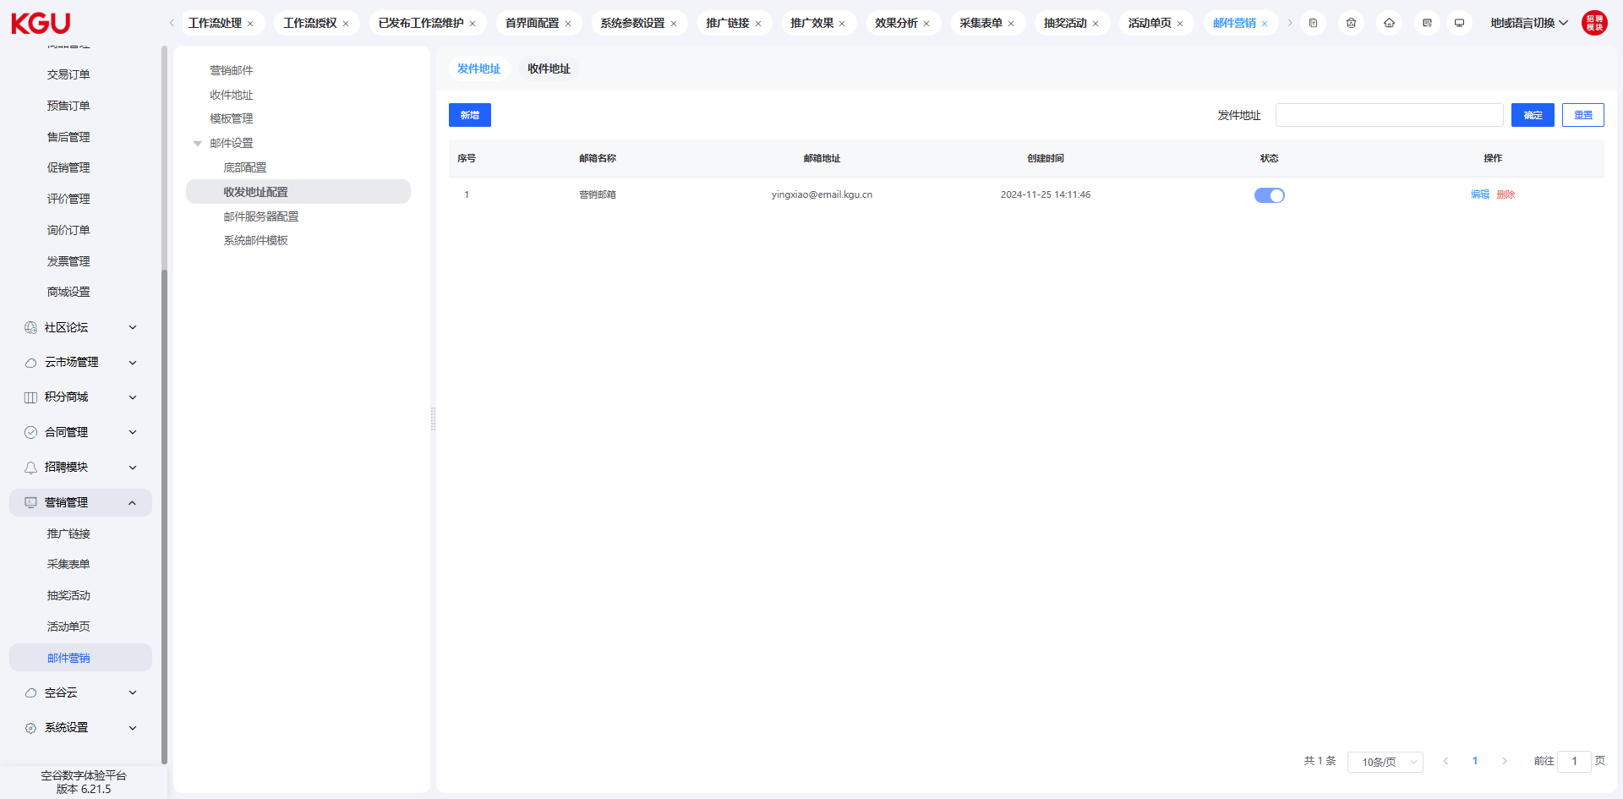
图 4.16.5(3) Email Marketing-邮件营销
Sender addresses are used to manage the addresses for sending marketing emails to the outside world. Such addresses need to use the email server function provided by cloud service providers. Currently, Alibaba Cloud's email server is supported.
In the sender address function, you can configure and manage different sender addresses to distinguish different marketing activities. In addition, frequently changing the sender address can also improve the success rate of sending.
Adding Sender Address:
发件地址是用来管理对外发出营销邮件的地址，这类地址需要使用云服务厂商提供的邮件服务器功能，目前支持的为阿里云的邮件服务器。
在发件地址中功能中，可以配置管理不同的发件地址，以便区分不同的营销活动。另外经常更换发件地址，也可以提高发送的成功率。
新增发件地址
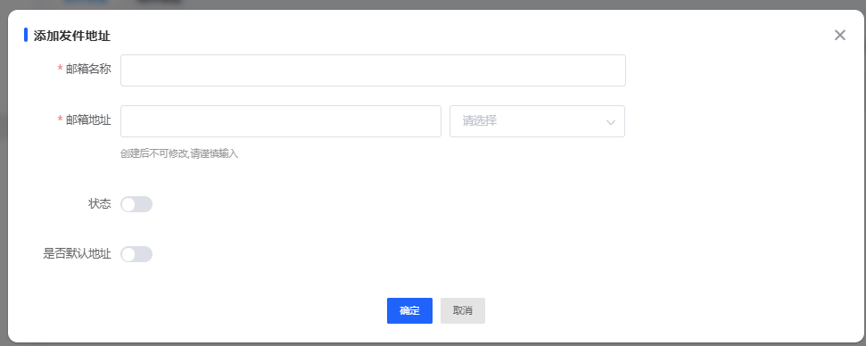
图 4.16.5(4) Email Marketing-邮件营销
Click the "Add" button in the sender address list to create a new sender address (precondition: correctly complete the email server configuration item).
点击发件地址列表中的新增按钮，可以创建新的发件地址（前置条件：正确完成邮件服务器配置项）。

Template Management-模板管理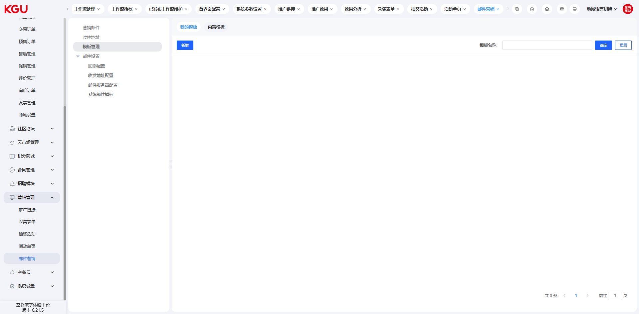
图 4.16.5(5) Email Marketing-邮件营销

In the template management, you can configure different email templates according to the actual business. When sending marketing emails later, you can edit based on the templates to improve work efficiency.
在模板管理中，可以根据实际业务配置不同的邮件模板，后续发送营销邮件时，可以基于模板进行编辑，提高工作效率。
新增模板
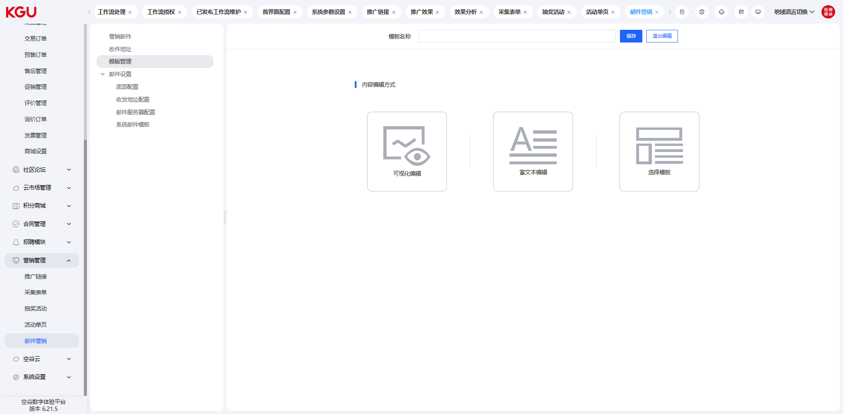
图 4.16.5(6) Email Marketing-邮件营销
When adding a new template, three methods are supported: visual editing, rich text editing, and modification based on built-in templates. Users can choose according to their actual situation.
新增模板时，支持三种方式，分别为可视化编辑、富文本编辑及基于内置模板修改三种方式，用户可以根据自己的实际概况进行选择。
可视化编辑创建模板
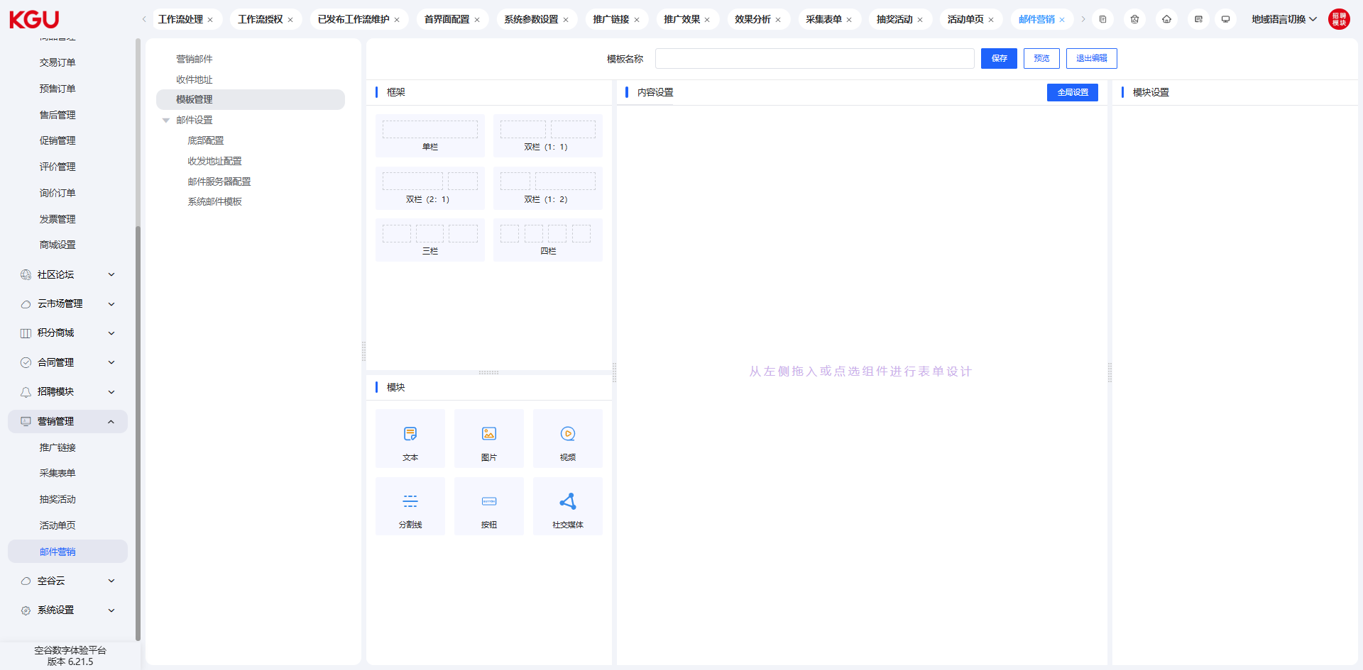
图 4.16.5(7) Email Marketing-邮件营销

Email Settings-邮件设置
Bottom Configuration:
底部配置
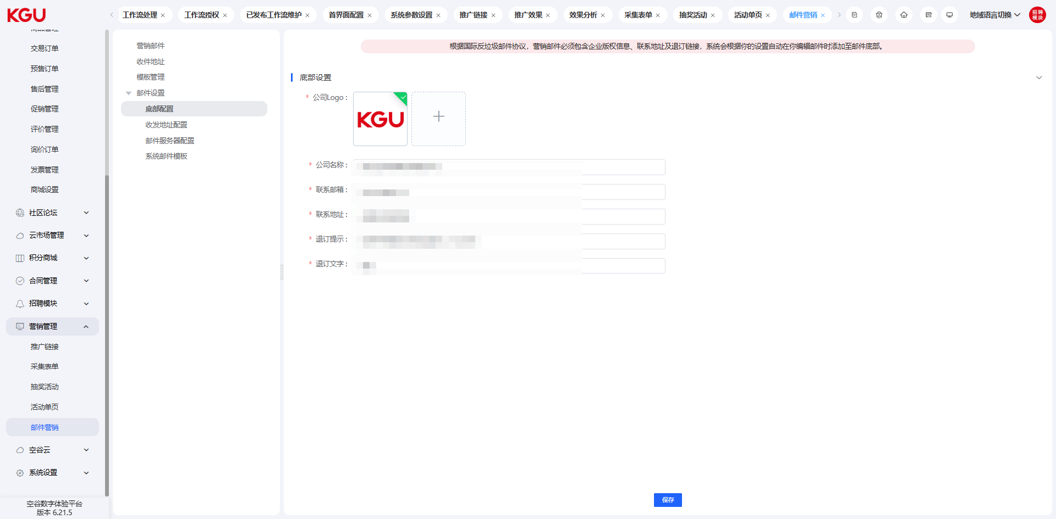
图 4.16.5(8) Email Marketing-邮件营销
According to the international anti-spam agreement, marketing emails must include corporate copyright information, contact address and unsubscribe link. Therefore, it is necessary to configure the corresponding corporate information and unsubscribe link information.
根据国际反垃圾邮件协议，营销邮件必须包含企业版权信息、联系地址及退订链接，因此需要配置相应的企业信息及退订链接信息。

Recipient Address Management:
收件地址管理
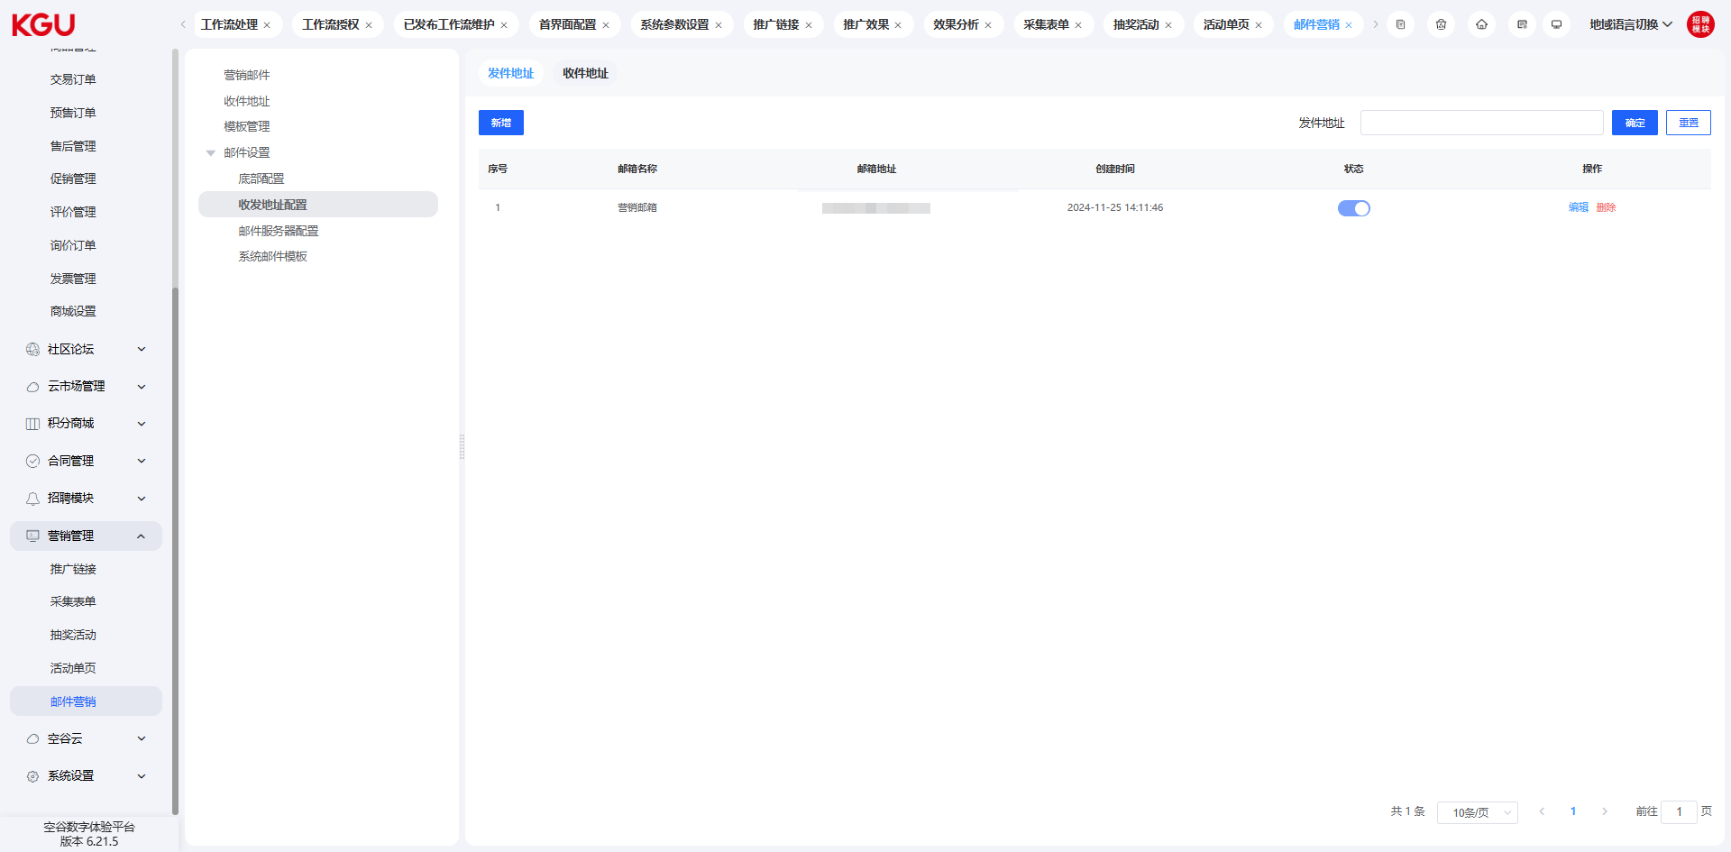
图 4.16.5(9) Email Marketing-邮件营销
Recipient addresses are used to manage the reply address information of marketing emails. When customers who receive the marketing emails reply directly, the reply email will be sent to the recipient address set.
收件地址是用来管理营销邮件的回复地址信息，收到营销邮件的客户直接回复邮件时，该回复邮件会发送到设置的收件地址中。
Adding Recipient Address:
添加收件地址
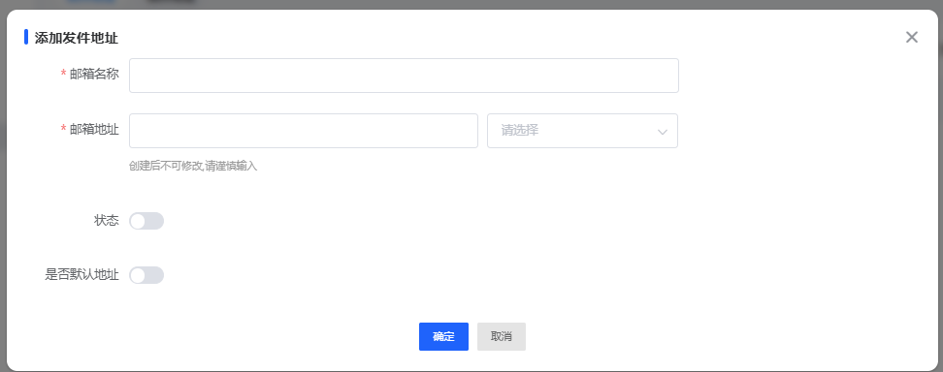
图 4.16.5(10) Email Marketing-邮件营销
When adding a recipient address, the system will send a verification code email to the recipient address email. After receiving the verification code and filling it in correctly, the addition can be completed.
Multiple recipient addresses can be set here to be applied in different business scenarios.
添加收件地址的时候，系统会向收件地址邮箱中发送一封验证码邮件，收到验证码并正确填写即可完成添加，
在此可以设置多个收件地址，以便应用在不同的业务场景。

Email Server Configuration:
邮件服务器配置
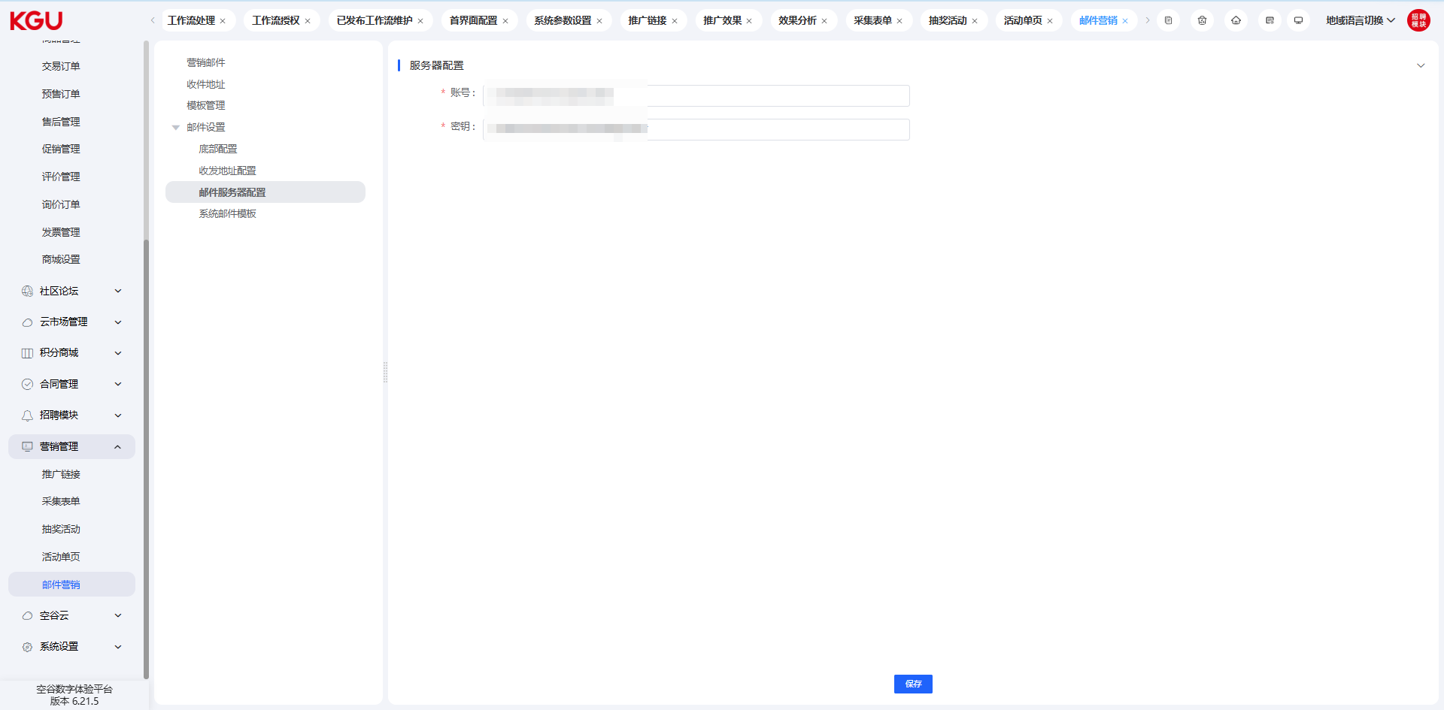
图 4.16.5(11) Email Marketing-邮件营销
The email server configuration item configures the server account and secret key for sending marketing emails to the outside world. Currently, the system supports Alibaba Cloud's email server interface. You need to purchase the corresponding function on Alibaba Cloud first to obtain the account and secret key. For details, please refer to https://help.aliyun.com/zh/direct-mail/product-overview/directmail-features?spm=5196.9846995.J_9895555840.1.11581165drEqBz
邮件服务器配置项中配置的是对外发送营销邮件的服务器账号和密钥，目前系统支持的是阿里云的邮件服务器接口，需要先在阿里云购买相应的功能才可获得账号和密钥，具体可参考 https://help.aliyun.com/zh/direct-mail/product-overview/directmail-features?spm=5196.9846995.J_9895555840.1.11581165drEqBz
System Email Template:
系统邮件模板
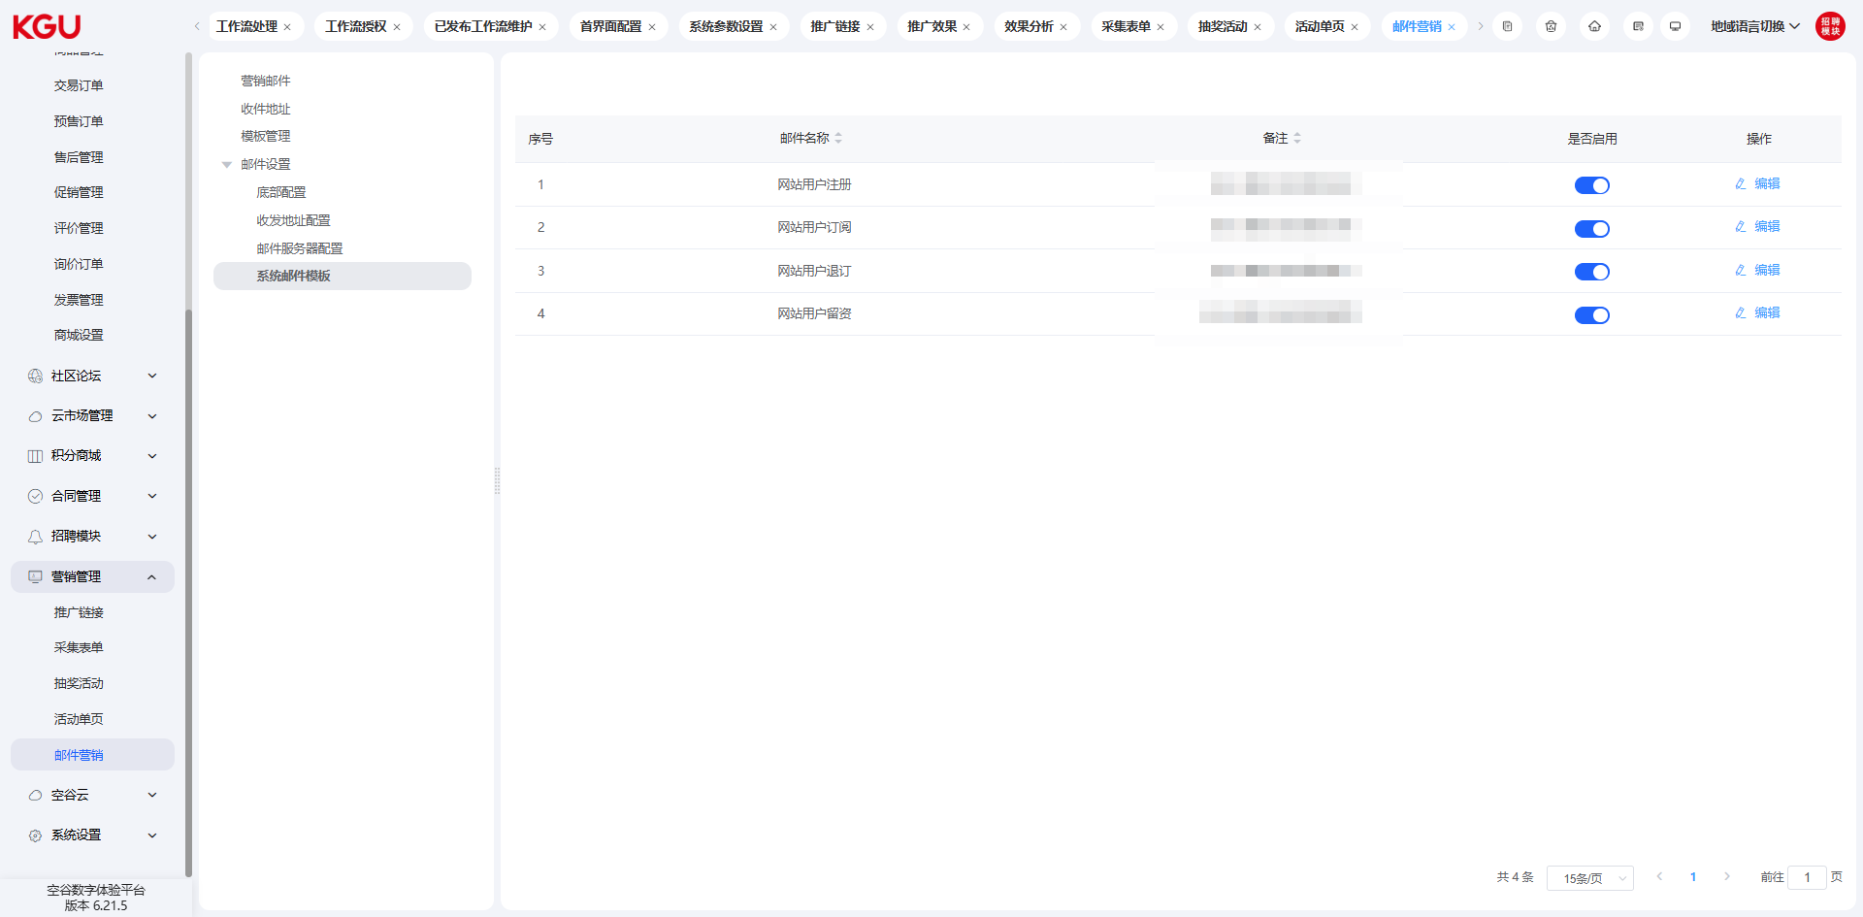
图 4.16.5(12) Email Marketing-邮件营销

In the system email template, four common scenario email notification functions are built-in, including user registration, user subscription, user unsubscription, and user information submission. When a user has an action in the corresponding scenario, the system will send the email defined in the template to the customer.
在系统邮件模板中，内置了4种常见场景的邮件通知功能，包括用户注册、用户订阅、用户退订、用户留资场景，当用户有对应场景的动作时，系统会发送模板中定义的邮件给客户。
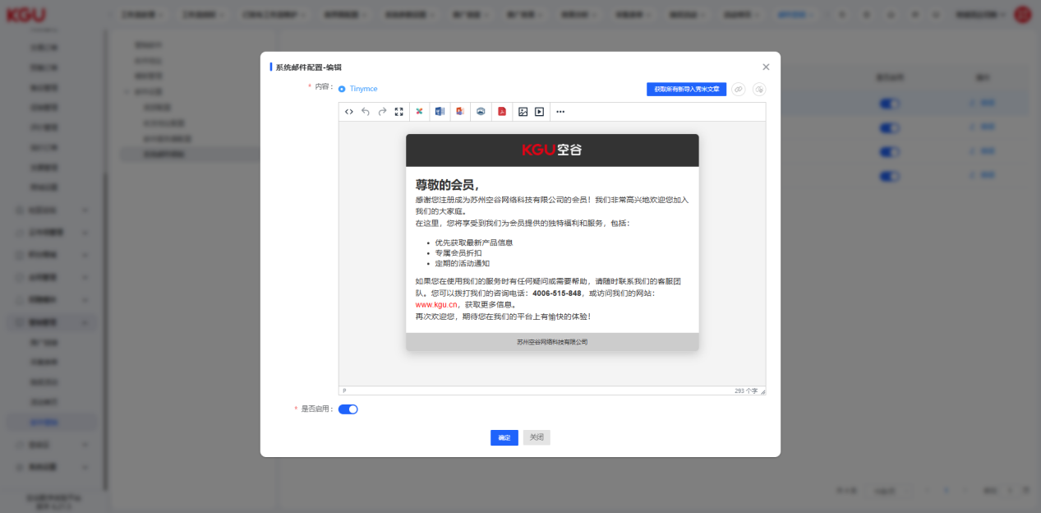
图 4.16.5(13) Email Marketing-邮件营销

图清单
图 2.1 Account login-账号登录 13
图 2.2 Password recovery-密码找回 14
图 3 Interface Layout -界面布局 15
图 3.1 Top Information Bar -顶部信息栏 17
图 3.2 Left Navigation Bar -左侧导航栏 18
图 4.1 Digital Desktop -数字桌面 19
图 4.1.1 Pending Tasks -待办事项 20
图 4.1.2(1) Work Order Information -工单信息 20
图 4.1.2(2) Work Order Information -工单信息 21
图 4.1.2(3) Work Order Information -工单信息 22
图 4.1.3 After-sales Service -售后服务 23
图 4.1.4 Operating Status -运行状态 24
图 4.1.5 Server Information-服务器信息 25
图 4.1.6 Domain Name Information-域名信息 25
图 4.1.8 Visited Columns-访问栏目 26
图 4.1.9 Latest Content-最新内容 27
图 4.1.9.1 Access Data-访问数据 28
图 4.1.9.2 Search Engines-搜索引擎 28
图 4.1.10 Regional Distribution-地域分布 29
图 4.1.11 Resolution Analysis-分辨率分析 30
图 4.2.1 Basic Information-基本信息 31
图 4.2.2 Configuration Center-配置中心 33
图 4.2.2(1) Basic Configuration-基本配置 33
图 4.2.2(2) Sensitive Word Configuration-敏感词配置 34
图 4.2.2(3) Storage Configuration-存储配置 35
图 4.2.2(4) Upload Restrictions-上传限制 35
图 4.2.2(5) Image Configuration-图片配置 37
图 4.2.2(6) SMS Configuration-短信配置 37
图 4.2.2(7) Email Configuration-邮箱配置 37
图 4.2.2(8) Data Analysis Configuration-数据分析配置 38
图 4.2.2(9) 404 Settings-404 设置 38
图 4.2.2(10) Push Settings-推送设置 39
图 4.2.2(11) Latitude and Longitude Acquisition Configuration - 经纬度获取配置 40
图 4.2.3 Column Management-栏目管理 40
图 4.2.3(1) Column Management-栏目管理 42
图 4.2.3(2) Column Management-栏目管理 45
图 4.2.3(3) Column Management-栏目管理 46
图 4.2.4 Data Model-数据模型 48
图 4.2.4(1) Add Data Model-新增数据模型 49
图 4.2.4(2) Set Model Attributes-设置模型属性 50
图 4.2.5 Data Dictionary-数据字典 51
图 4.2.5(1) Add Type-新增类型 51
图 4.2.5(2) Add Data Dictionary-新增数据字典 52
图 4.2.6 Tag Management-标签管理 53
图 4.2.6(1) Tag Management-标签管理 54
图 4.2.9 Friendship Links-友情链接 54
图 4.2.9(1) Add Friendship Link-新增友情链接 55
图 4.2.9 Advertising Management-广告管理 55
图 4.2.9(1) Add Advertisement-新增广告 56
图 4.2.8 Style Management-风格管理 57
图 4.2.8(1) Add Style-新增风格 58
图 4.2.10 Sitemap-网站地图 59
图 4.2.11 Operation Log-操作日志 60
图 4.2.12 Redirection Settings-重定向设置 60
图 4.3.1(1) Message Management-留言管理 61
图 4.3.1(2) Message Management-留言管理 62
图 4.3.1(3) Message Management-留言管理 62
图 4.3.2(1) Subscription Email-订阅邮箱 63
图 4.3.2(2) Subscription Email-订阅邮箱 63
图 4.4.1 Membership List-会员列表 65
图 4.4.1(1) Add Member-新增会员 66
图 4.4.1(2) Password Modification-密码修改 67
图 4.4.1(3) Password Modification-密码修改 67
图 4.4.2 Membership Roles-会员角色 68
图 4.4.2(1) Add Role-新增角色 69
图 4.4.2(2) Role Permission Setting-角色权限设置 71
图 4.4.3(1) Membership Authentication-会员认证 72
图 4.4.3(2) Membership Authentication-会员认证 73
图 4.5.1 User List-用户列表 73
图 4.5.1(1) Add/Edit User-新增/编辑用户 74
图 4.5.2 User Roles-用户角色 75
图 4.5.2(1) Column Permissions-栏目权限 76
图 4.5.2(2) Add Role-新增角色 76
图 4.5.3 Department Management-部门管理 77
图 4.6 Content Management-内容管理 78
图 4.6.1(1) General Options-常规选项 78
图 4.6.1(3) General Options-常规选项 79
图 4.6.2 Model Parameters-模型参数 81
图 4.6.3 Associated Data-关联数据 81
图 4.7.1 Operation Overview-运营概况 82
图 4.7.2 Access Software Analysis-访问软件分析 83
图 4.7.3(1) Source Analysis-来源分析 84
图 4.7.3(2) Source Analysis-来源分析 84
图 4.9.3(3) Source Analysis-来源分析 85
图 4.7.4(1) Location Analysis-所在地分析 85
图 4.7.4(2) Location Analysis-所在地分析 86
图 4.7.5(1) Visitor Summary Table-访客总表 87
图 4.7.5(2) Visitor Summary Table-访客总表 87
图 4.7.5(3) Visitor Summary Table-访客总表 88
图 4.7.5(4) Visitor Summary Table-访客总表 89
图 4.7.5(5) Visitor Summary Table-访客总表 89
图 4.7.5(6) Visitor Summary Table-访客总表 90
图 4.8.1 Course Management-课程管理 91
图 4.8.1(1) Course Creation-课程创建 91
图 4.8.1(2) Chapter Management-章节管理 92
图 4.8.1(3) Course Classification-课程分类 93
图 4.8.2 Lecturer Configuration-讲师配置 93
图 4.8.3 Transaction Orders-交易订单 94
图 4.8.4 Invoice Management-开票管理 95
图 4.9.1 Commodity Management-商品管理 97
图 4.9.1(1) Commodity Management-商品管理 98
图 4.9.1(2) Commodity Classification-商品分类 101
图 4.9.1(2) Commodity Classification-商品分类 103
图 4.9.1(3) Description Template-描述模板 105
图 4.9.1(3) Description Template-描述模板 107
图 4.9.1(4) Commodity Brand-商品品牌 108
图 4.9.1(5) Commodity Brand-商品品牌 111
图 4.9.1(6) Commodity Specification-商品规格 112
图 4.9.1(7) Commodity Specification-商品规格 113
图 4.9.2(1) Transaction Orders-交易订单 114
图 4.9.2(2) Transaction Orders-交易订单 115
图 4.9.2(3) Transaction Orders-交易订单 116
图 4.9.2(4) Transaction Orders-交易订单 117
图 4.9.2(5) Transaction Orders-交易订单 118
图 4.9.2(6) Transaction Orders-交易订单 119
图 4.9.5(1) Promotion Management-促销管理 123
图 4.9.5(2) Promotion Management-促销管理 124
图 4.9.5(3) Promotion Management-促销管理 126
图 4.9.5(4) Promotion Management-促销管理 127
图 4.9.7(1) Inquiry Order-询价订单 134
图 4.9.7(2) Inquiry Order-询价订单 134
图 4.9.7(3) Inquiry Order-询价订单 135
图 4.9.7(4) Inquiry Order-询价订单 136
图 4.9.7(5) Inquiry Order-询价订单 136
图 4.9.7(6) Inquiry Order-询价订单 137
图 4.9.9 Mall Settings-商城设置 141
图 4.12.1(1) Recruitment List-招聘列表 143
图 4.12.1(2) Recruitment List-招聘列表 144
图 4.12.1(3) Recruitment List-招聘列表 145
图 4.12.1(4) Recruitment List-招聘列表 146
图 4.12.1(5) Recruitment List-招聘列表 146
图 4.12.1(6) Recruitment List-招聘列表 147
图 4.12.2(1) Recruitment Management-招聘管理 147
图 4.12.2(2) Recruitment Management-招聘管理 148
图 4.12.3 Job Classification-职位分类 148
图 4.12.4 Interview Questions-面试题目 149
图 4.15.1(1) Organization/Personnel/Role-机构/人员/角色 150
图 4.15.1(2) Organization/Personnel/Role-机构/人员/角色 151
图 4.15.1(3) Organization/Personnel/Role-机构/人员/角色 151
图 4.15.1(4) Organization/Personnel/Role-机构/人员/角色 152
图 4.15.2(1) Permission Configuration-权限配置 152
图 4.15.2(2) Permission Configuration-权限配置 153
图 4.15.2(3) Permission Configuration-权限配置 153
图 4.15.2(4) Permission Configuration-权限配置 154
图 4.15.2(5) Permission Configuration-权限配置 154
图 4.15.2(6) Permission Configuration-权限配置 155
图 4.15.2(7) Permission Configuration-权限配置 155
图 4.15.3(1) Template Configuration-模板配置 156
图 4.15.3(2) Template Configuration-模板配置 156
图 4.15.4(1) Workflow-工作流 157
图 4.15.4(2) Workflow-工作流 157
图 4.15.4(3) Workflow-工作流 158
图 4.15.4(4) Workflow-工作流 159
图 4.15.4(5) Workflow-工作流 159
图 4.15.4(6) Workflow-工作流 160
图 4.15.5 Others-其它 161
图 4.16.1(1) Promotion Links-推广链接 162
图 4.16.1(2) Promotion Links-推广链接 162
图 4.16.1(3) Promotion Links-推广链接 163
图 4.16.1(4) Promotion Links-推广链接 163
图 4.16.1(5) Promotion Links-推广链接 164
图 4.16.2(1) Collection Form-采集表单 164
图 4.16.2(2) Collection Form-采集表单 165
图 4.16.2(3) Collection Form-采集表单 166
图 4.16.3(1) Lottery Activity-抽奖活动 167
图 4.16.3(2) Lottery Activity-抽奖活动 167
图 4.16.3(4) Lottery Activity-抽奖活动 168
图 4.16.4(1) Activity Single Page-活动单页 169
图 4.16.4(2) Activity Single Page-活动单页 169
图 4.16.4(3) Activity Single Page-活动单页 170
图 4.16.5(1) Email Marketing-邮件营销 171
图 4.16.5(2) Email Marketing-邮件营销 172
图 4.16.5(3) Email Marketing-邮件营销 176
图 4.16.5(4) Email Marketing-邮件营销 177
图 4.16.5(5) Email Marketing-邮件营销 177
图 4.16.5(6) Email Marketing-邮件营销 178
图 4.16.5(7) Email Marketing-邮件营销 179
图 4.16.5(8) Email Marketing-邮件营销 179
图 4.16.5(9) Email Marketing-邮件营销 180
图 4.16.5(10) Email Marketing-邮件营销 180
图 4.16.5(11) Email Marketing-邮件营销 181
图 4.16.5(12) Email Marketing-邮件营销 182
图 4.16.5(13) Email Marketing-邮件营销 182

